

Inverclyde Council
Annual Complaints Report
1 April 2018 – 31 March 2019
CONTENTS

Item | Heading
1 | Background
1.1 | Current Procedures
1.2 | Governance Arrangements
2 | Summary of Performance
2.1 | Number of complaints received
2.2 | Complaint trends
2.3 | Timescales
2.4 | Complaint Outcomes
2.5 | Complaint themes
2.6 | Learning from complaints
2.7 | Scottish Public Services Ombudsman (SPSO) Appeals
2.7.1 | SPSO reviews
3.0 | Developments
4.0 | Positive comments
5.0 | Conclusion

Background

In April 2013 the Council introduced a revised complaints handling procedure moving from a three stage to a two stage process in line with the guidance by the Scottish Public Services Ombudsman (SPSO). At the same time a new corporate wide system for recording complaints through LAGAN was rolled out across the Council.

In 2015 an audit was undertaken to provide management and the Audit Committee with an assessment of the adequacy and effectiveness of the governance, risk management and controls surrounding a number of key risks faced by both the Council and Inverclyde HSCP regarding complaints. There was a requirement to improve on a number of areas.

A corporate working group was established following the audit with representation across all services and chaired by a Corporate Director. The purpose of the working group was to address areas in the Council’s complaint handling.

The Council’s internal objectives to address issues that were identified in historic complaint handling were agreed to ensure that the Council has a robust approach to complaint handling. The complaint officer post has strengthened the robustness of the Council’s complaint handling approach in the following areas:

• Increased awareness of the Council’s complaint handling procedures.
• Ensuring training needs of staff with responsibility for complaint handling are identified and addressed.
• Improved corporate oversight of the complaints process.
• Improved monitoring of complaints.
• Regular review of the Council’s complaint handling procedures for effectiveness.

The local authority complaint handler network (LACHN) is a national forum for local authority complaint handlers to meet quarterly to assist in the development of professional practice in relation to complaint handling. Inverclyde Council are represented at this forum by the complaint officer alongside representatives from 32 Scottish Local Authorities. The SPSO attend these meetings to support the ongoing development of complaint handling within local authorities and to achieve consistency in approach.

Inverclyde Council uses Inverclyde Leisure to deliver council services in the leisure industry and Riverside Inverclyde for urban regeneration within the area. While these organisations are separate to the Council they are subject to its control and the Council is responsible for ensuring the services provided meet the required standards and adhere to the complaint handling procedure. In doing this we must establish mechanisms to identify and act on complaint handling performance issues found.

The SPSO through LACHN network issued a survey to all local authorities to complete regarding complaint handling reporting being submitted to the network to review prior to formal reporting being issued to SPSO. The survey questions highlighted the requirements for Council’s to report complaint handling performance for ALEOs. Inverclyde Council have two ALEO’s they are Inverclyde Leisure and Riverside Inverclyde and they are required to adhere to reporting on complaints handled although they were not included at the time of the implementing the model complaint procedure. Actions have been taken to address this and Inverclyde Council are now adhering to the reporting requirements set out by the SPSO.

Following the results of the survey that was completed by all of the local authorities, the SPSO confirmed that they would be moving to a quarterly submission of complaint handling statistical data from all Councils. This was intended to ease the collation of management information on annual basis. Inverclyde Council agreed to supply this statistical data each quarter, as it is currently prepared for the CMT on a quarterly and annual basis. The draft report is issued to the LACHN for discussion at the network meeting and any inconsistences in data interpretation and analysis is resolved before the formal annual submission to the SPSO each year.

  - Current Procedures

Inverclyde Council co-ordinates the reporting of complaints to the SPSO this includes the HSCP, ALEOs, Inverclyde Leisure and Riverside Inverclyde. Each area is responsible for recording their complaints and providing their management information to Inverclyde Council to enable the consolidated statistical report to be produced quarterly and annually.

Inverclyde Council, the HSCP and both ALEOs, Inverclyde Leisure and Riverside Inverclyde follow the Model Complaint Handling procedure although there are slight differences between the health and social work complaints, the procedure provides a quick, simple, streamlined process with a strong focus on local, early resolution. This enables issues or concerns dealt with close to the event which gave rise to the complainant making the complaint.

As far as possible the complainant should be actively and positively engaged with the process from the outset.

Frontline resolution stage one: Frontline resolution should be attempted where there are straightforward issues potentially easily resolved with little or no investigation. This should be completed within 5 working days.

Investigation stage two: Where complaints cannot be resolved at the frontline stage or those which are complex, serious or high risk, a thorough investigation will be undertaken. This typically requires more thorough examination in order to establish facts prior to reaching conclusion. This should be completed within 20 working days.

Escalated investigation stage two: Where the complainant remains dissatisfied with the way the Council dealt with their complaint at frontline resolution, the complainant can request a detailed investigation under stage two of our complaints handling procedure. This must be undertaken before the complainant can take their complaint to the SPSO to review.

Scottish Public Service Ombudsman: Appeals of complaint outcomes are reviewed by the SPSO.

  - Governance Arrangements

Governance arrangements are in place to report and analyse complaints within Inverclyde Council as follows:

Heads of Service Meetings
Service Review Meetings
Corporate Management Team Meetings

Inverclyde Council and HSCP log their complaints into LAGAN system. Health and social work complaints are logged in two systems – datix for health complaints and LAGAN for social work complaints. Inverclyde Leisure and Riverside Inverclyde record their complaints on a complaint log spreadsheet.

This is supported by the Information Governance and Complaint Officer who promotes the complaint handling procedure and provides strategic direction for complaint handling to ensure a responsive, efficient and improved complaint handling service which meets the regulatory standards. Oversight and monitoring of complaint handling performance is undertaken to ensure the feedback mechanism is delivering continuous improvement. Quarterly recommendations on improvement areas are discussed with the Corporate Management Team.

- Summary of Performance

2.1 Number of complaint received and closed

In the reporting period 1 April 2018 – 31 March 2019 Inverclyde Council, Inverclyde Leisure and the HSCP received and handled 342 complaints in the period and closed 316 complaints within this period.

The SPSO requires Inverclyde Council to include ALEOs and HSCP complaint statistical information in the quarterly and annual reports. It should be noted that oversight and day to day matters relating to complaints are supported separately.

This is the first year that the Council have reported a collective report on complaint handling performance that includes Inverclyde Council, HSCP, Inverclyde Leisure and Riverside Inverclyde.

Inverclyde Leisure had a loss of data for the period 1 January 2018 – 31 March 2018 this is a low volume based on their average number of complaints received; however impacts the extent of complaint finally recorded in 2017/18.

 | Number complaints received
 | 2018/19 | 2017/18 | 2016/17 | 2015/16
Inverclyde Council | 256 | 288 | 181* | 146
HSCP | 44 | 55
Inverclyde Leisure | 29** | 8
Riverside Inverclyde | 13
*Members are reminded that essential changes were made to the LAGAN in order to improve the complaint management system in preparation for it to be adopted as the universal complaint recording system for the Council. During this process closed complaint data was lost which impacts on the extent of complaints finally recorded in 2016.
** Inverclyde Leisure had a loss of data for the data covering the period 1 January 2018 to 31 March 2018 which will have will have impacted the extent of complaints finally recorded in 2018/19 the collective reporting of complaints.
Inverclyde Council’s and the HSCP’s complaints received volumes have decreased when comparing to the complaint data for 2018/19 and 2017/18 as outlined in the graph below. The period 2018/19 reflects a full year of accurate recording of complaints which will support accurate benchmarking of future years.
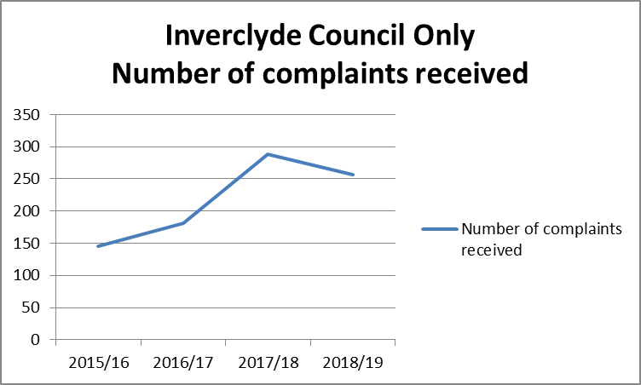

The table below outlines closed complaint breakdown by investigation stage and comparable data volumes for the periods in 2019/18 to 2016/17 inclusive.
 | Closed complaint breakdown by investigation stages
 |  | No of frontline resolution  stage 1 |  |  | No of complaint investigations  stage 2 |  |  | No of escalated investigations  stage 2
 |  | 2018/19 | 2017/18 | 2016/17 | 2018/19 | 2017/18 | 2016/17 | 2018/19 | 2017/18 | 2016/17
Inverclyde  Council |  | 214 | 225 | 121 | 8 | 17 | 23 | 13 | 21 | 7
HSCP |  | 17 | 33 | 31 | 22 | 26 | 25 | 0 | 0 | 0
Inverclyde  Leisure |  | 29 | 7 | 1 | 0 | 0 |  | 0
Riverside  Inverclyde |  | 12 |  |  | 1 |  |  | 0

In respect of the complaints received there are occasions where they partially investigated and either withdrawn or are found not be appropriate for the complaint handling procedure and removed from the overall numbers. These are noted in the table below which is largely evidential in the Council’s handling of complaints.

Complaints removed from the overall volumes

 | Service requests |  |  |  | Withdrawn |  | Not Council related / Invalid
 | 2018/19 | 2017/18 | 2016/17 | 2018/19 | 2017/18 | 2016/17 | 2018/19 | 2017/18 | 2016/17
Inverclyde Council | 7 | 6 | 8 | 19 | 25 | 8 | 10 | 4 | 13
HSCP | 0 | 0 | 0 | 0 | 0 | 0 | 0 | 0
Inverclyde Leisure | 0 | 0 |  | 0 | 0 |  | 0 | 0
Riverside Inverclyde | 0 |  |  | 0 |  |  | 0

2.2 Complaint Trends

The table below provides a monthly breakdown of complaints received within each service over the period 1 April 2018 to 31 March 2019. For Inverclyde Leisure, Riverside Inverclyde and HSCP the breakdown is only provided for the annualised volumes.

 | April 18 | May 18 | June 18 | July 18 | Aug 18 | Sept 18 | Oct  18 | Nov 18 | Dec  18 | Jan  19 | Feb  19 | Mar  19 | Totals
Chief Executive Office | 0 | 0 | 0 | 0 | 0 | 0 | 0 | 0 | 0 | 0 | 0 | 0 | 0
Environmental & Public Protection | 5 | 9 | 17 | 13 | 10 | 12 | 5 | 5 | 12 | 6 | 6 | 4 | 104
Finance | 3 | 4 | 4 | 5 | 8 | 5 | 2 | 7 | 6 | 5 | 3 | 10 | 67
Legal & Property Services | 0 | 0 | 0 | 0 | 0 | 1 | 2 | 0 | 0 | 2 | 0 | 1 | 6
Regeneration & Planning | 0 | 0 | 0 | 1 | 0 | 0 | 1 | 0 | 1 | 0 | 0 | 0 | 3
Roads Shared Service | 5 | 4 | 0 | 0 | 2 | 1 | 4 | 2 | 0 | 1 | 0 | 4 | 23
Education | 1 | 8 | 6 | 0 | 3 | 7 | 3 | 8 | 3 | 10 | 7 | 10 | 66
Inclusive Education, Culture and Communities | 1 | 0 | 0 | 0 | 0 | 0 | 1 | 1 | 0 | 1 | 1 | 0 | 5
Org Develop Policy & Communications | 0 | 0 | 0 | 0 | 0 | 0 | 0 | 0 | 0 | 0 | 0 | 0 | 0
Inverclyde Leisure |  |  |  |  |  |  |  |  |  |  |  |  | 29
Riverside Inverclyde |  |  |  |  |  |  |  |  |  |  |  |  | 13
HSCP |  |  |  |  |  |  |  |  |  |  |  |  | 44

Outlined in the chart below is the percentage of complaints received by each service compared against the total number of complaints received. The Chief Executive office and the Organisational Development, Policy and Communications Service did not receive any complaints in the period.

Following the restructuring within Services earlier in 2018 this has brought the Environment and Commercial Service and the Public Protection Service came under the one Service. The Roads Shared Service team has also been reported on their own. Therefore the overall percentage of complaints reported within the Environment and Public Protection Service has increased as a result of the merging of the teams into the service and the Roads Shared Service now stands alone for reporting purposes. It should be noted that comparable data for the same period the previous year is not possible as a result of this change.
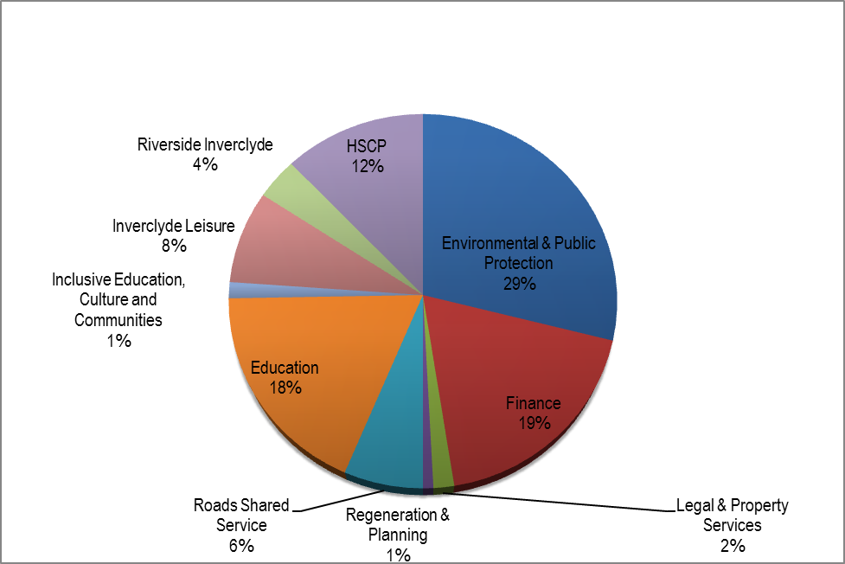

Complaint data for year on year comparison will be formulated going forward to enable trends on incoming volumes to be tracked and compared for Inverclyde Council, HSCP and both ALEOs, Inverclyde Leisure and Riverside Inverclyde.

2.3 Timescales

The Council aim to resolve complaints quickly and close to where we provided the service. Where appropriate this could mean an on-spot-apology and explanation if something has clearly gone wrong and immediate action to resolve a problem. We have 5 working days to respond to your complaint within the stage one process.

Sometimes we will have to make some enquiries before we can respond to complaints if we cannot resolve the complaint at this stage, we will explain why, we may decide it is appropriate to extend the time to deal with the complaint by a further five days or we move to stage two investigation if this is felt to be appropriate. In either scenario we will keep you informed and manage your expectations on timescales.

Stage two deals with two types of complaint: those that have not been resolved at stage one and those that are complex and require a more detailed investigation.

Where you have escalated your complaint to stage two because you remain dissatisfied with the outcome of our handling of your complaint, we refer to this as Escalated Investigation.

When handling a complaint using stage two we will

- Acknowledge receipt of your complaint within three working days;
- Where appropriate, discuss your complaint with you to understand why you remain dissatisfied and seek clarification on what outcome your looking for; and
- Provide you a full written response to your complaint as soon as possible and within 20 working days.

If our investigation is likely to take longer than 20 working days, we will agree revised time limits with you and keep you updated on progress.

Investigating officers are advised of the required dates for timescales on receipt of the complaint. Additional reminders are in place to support timely completion.

The table below outlines the Inverclyde Council’s collective performance measures on timescales management across all stages of the complaint procedure.

Performance measures | Collective Inverclyde Council 2018/19
No of complaints – closed at stage 1 within 5 days | 222
% Complaints Meeting timescale | 81.6%
Ave working days taken stage 1 complaints | 4.1 days
No of complaints – closed at stage 2 within 20 days | 21
% Complaints Meeting timescale | 67.7%
Ave working days taken stage 2 complaints | 18.1 days
No of complaints – closed at escalated stage 2 within 20 days | 13
% Complaints Meeting timescale | 100%
Ave working days taken escalated stage 2 complaints | 14 days

The table below outlines the management of complaints within the prescribed timescale broken down by each areas complaint. The comparable data is not available for Inverclyde Leisure as they have adopted the reporting of complaints within the period 2017/18.

 |  | Inverclyde Council  Consolidated |  | Inverclyde Council Only |  |  | HSCP
Stage 1 Frontline resolution | Performance Area | 2018 /19 | 2017 /18 | 2018 /19 | 2017 /18 | 2016 /17 | 2018 /19 | 2017 /18 | 2016 /17
Stage 1 Frontline resolution | No of complaints – closed at stage 1 within 5 days | 222 | 214 | 171 | 182* | 104 | 12 | 22 | 30
Stage 1 Frontline resolution | % Complaints Meeting timescale | 82% | 81% | 80% | 78% | 86% | 71% | 88% | 96%
Stage 1 Frontline resolution | Ave working days taken stage 1 | 4.1 | 4.4 | 4.4 | 3.81 | 3 | 7.5 | 4.1 | N/A
Stage 2 Investigation | No of complaints – closed at stage 2 within 20 days | 21 | 31 | 7 | 9** | 20 | 13 | 18 | 15
Stage 2 Investigation | % Complaints Meeting timescale | 68% | 78% | 88% | 90% | 86% | 59% | 79% | 60%
Stage 2 Investigation | Ave working days taken stage 2 | 18.1 | 15.5 | 18.4 | 16.3 | 11.7 | 18.2 | 18.2 | N/A
Stage 2 Escalated Investigation | No of complaints – closed at esc stage 2 within 20 days | 13 | 18 | 13 | 18 | 0 | 0 | 0 | 0
Stage 2 Escalated Investigation | % Complaints Meeting timescale | 100% | 85.7% | 100% | 85.7% | 0 | 0 | N/A | 0
Stage 2 Escalated Investigation | Ave working days taken esc stage 2 | 14.0 | 13.8 | 14.00 | 13.8 | 0 | 0 | 0 | N/A

*One complaint has been included within stage one resolution as time extension was granted allowing 10 days for the complaint to be resolved and reported within timescales.

** Two complaints have been included in the stage two resolutions as time extension was granted allowing 25 days for the complaint to be resolved and reported within timescales

 |  | Inverclyde  Leisure*** |  | Riverside Inverclyde****
Stage 1 Frontline resolution | Performance Area | 2018 /19 | 2017 /18 | 2018/19
Stage 1 Frontline resolution | No of complaints – closed at stage 1 within 5 days | 29 | 5 | 12
Stage 1 Frontline resolution | % Complaints Meeting timescale | 100% | 83% | 100%
Stage 1 Frontline resolution | Ave working days taken stage 1 | 1 | 3 | 1.6
Stage 2 Investigation | No of complaints – closed at stage 2 within 20 days | 0 | 2 | 1
Stage 2 Investigation | % Complaints Meeting timescale | 0 | 67% | 100%
Stage 2 Investigation | Ave working days taken stage 2 | 0 | 13.3 | 14
Stage 2 Escalated Investigation | No of complaints – closed at esc stage 2 within 20 days | 0 | 0 | 0
Stage 2 Escalated Investigation | % Complaints Meeting timescale | 0 | N/A | 0
Stage 2 Escalated Investigation | Ave working days taken esc stage 2 | 0 | 0 | 0

*** Inverclyde Leisure data only available from the period 2017/18
****Riverside Inverclyde data only available from the period 2018/19

Services must maintain focus on ensuring complaints received are recorded and that the complaint handling procedure is followed by officers, in particular with regards to timescales to resolve complaints at stage one and stage two. When comparing in isolation Inverclyde Council’s complaint handling performance we have seen timescales to resolve complaints increase in both frontline resolution stage one complaints and stage two complaints investigations which impacts the average days. HSCP’s frontline resolution complaint handing has increased the average number of days to deal with a complaint which is an area that will need attention.

2.4 Complaint Outcomes

The graph below outlines the outcomes of investigations of all collective complaints following complaint investigation at each of the 3 stages a complaint may be taken through.

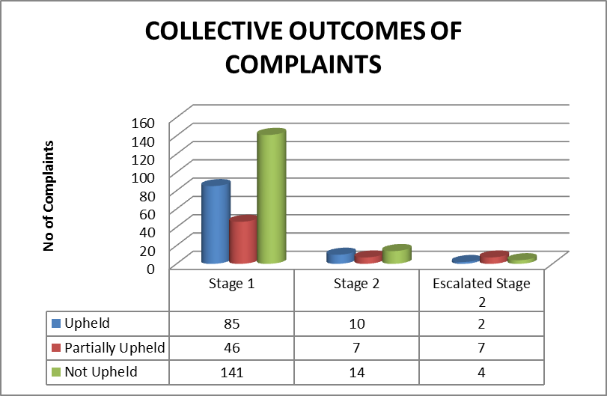

The pie chart outlines the collective outcomes of all complaint investigations as a percentage of all complaints received.

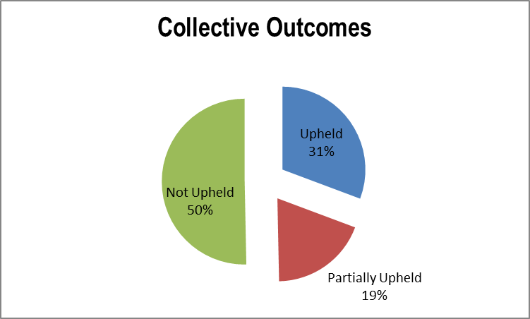

2.5 Complaint themes

Of the complaints which were upheld or partially upheld, they were examined for key themes. In some situations the complexity of some complaints were multi faceted although the true root cause was used to define this into a single theme. In doing this we have only included the complaints from Inverclyde Council and HSCP only, as this level of information is recorded in the complaint handling system.

The top complaint theme was for these complaints was where the service delivered was below the expected standards at 33% of all complaints received.

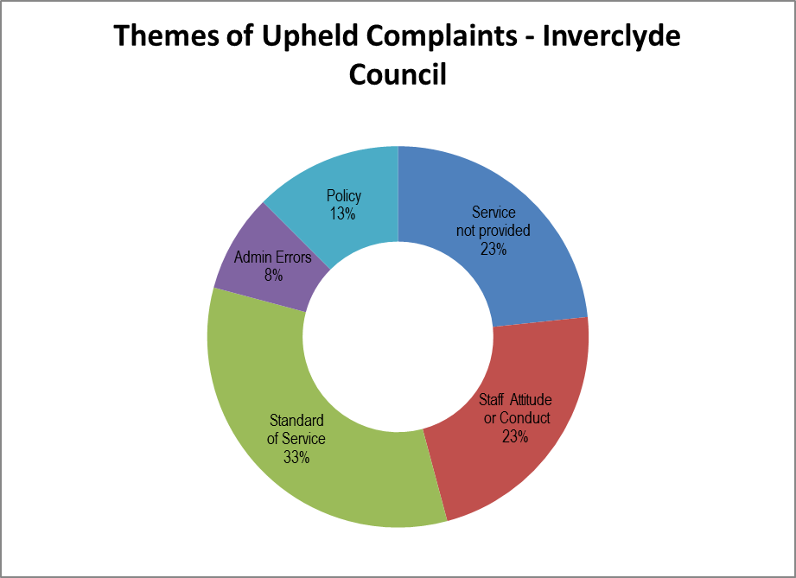

2.6 Learning from complaints

Inverclyde Council is committed to reflecting on occassions when we may not get it right in order to highlight opportunities for improvement. As such, where a complaint has been upheld or partially upheld, the service determines what actions are required to support continuous improvement and prevent a repeat of circumstances that led to the complaint.

Service improvement recording commenced in November 2016 for Inverclyde Council only. Service improvement tracking requires to be developed for both ALEOs and the HSCP as this is not currently in place.

The Service Improvement table overleaf provides a selection of complaints across Services on the type of complaints received together with a update on the service improvements that have been implemented during the reporting period.

Service | Improvements Made
Environmental & Public Protection | A Disabled Person Parking Permit (DPPP) had been granted to a resident although the customer was not happy with the delays to complete road markings on the disabled parking bay; the complainant raised a complaint about the time taken to put the road markings on the disabled bay.  During the complaint investigation the Council established improvements were required to the letters that we issued as they were not clearly stating the timescales for marking out of the disabled bay.  Learning was taken from this complaint and the letters have been reviewed and improved to make the timescales involved clearer.
Finance | A customer's son had contacted the Council Tax office to arrange for his father’s account to be closed due to the sale of his father’s property. He requested that the billing address for future correspondence be sent to him as he holds Power Of Attorney for his father. A Council Tax Reminder was issued to his father's address in error. A complaint was received as the Council had not actioned his request.  Learning has been taken from this complaint; procedures have been reviewed and enhanced to prevent re-occurrence. Staff guidance has been updated and a team briefing completed with relevant staff.
Education | A complaint was received from parent enquiring about the right of exclusion in relation to a matter that arose at school.  The investigation into this matter established that incorrect advice was given. On discovery of this the Council apologised and provided the correct advice.  Learning was taken from this complaint and the feedback was shared with the relevant staff involved for future use.
Roads – Shared | A complaint was received from a concerned resident about the positioning of road signs on the pavement of a busy road where roads works were being carried out. The positioning of the road signs were creating an obstruction and caused concerns for the safety of pedestrians. When dealing with the matter within the Council there were breakdowns in communication between services which hindered timely resolution and understanding of the matter.  Learnings have been taken from this complaint and revised information on planned road works will be shared within Roads and Customer Services to ensure the awareness of works underway is available to answer resident queries. The positioning of the signs was addressed with our supplier and actions were taken on discovery of the hazard to move the signs to prevent the issues that this posed for pedestrians.
Environment & Public Protection | A complaint was raised by a resident who was unhappy with the standard of grass cutting completed on communal ground that the Council is responsible for. An inspection of the location was undertaken and the Council agreed that the standard of the job was not to the expected standard. The job was reallocated and the grass was cut to the expected standard and the resident was satisfied with the action taken.
Legal & Property Services | A complaint was received about an issue with an alarm going off in one of the schools on numerous occasions late at night over a 3 month period of time.  The complainant was dealing with an officer in the Property service prior to raising the complaint to overcome the issues encountered. The officer reported the matter to school to raise the matters directly with the alarm firm. However, a further instance of the alarm going off on a Saturday morning occurred and the time to resolve was lengthy following this the complaint was raised.  The Council arranged for an Engineer to attend the school to investigate the cause of the activations which was confirmed as a faulty door contact. The fault with the door was repaired. The external security firm who assist with alarm response and key holding at the weekend should have responded within quicker timescale than they did. This matter has been addressed through the internal process & the issues have been resolved.
Finance | A complaint was received from a customer wanted to renew their parking permit. They felt that the officer dealing with their query sounded impatient and was not listening to their concerns.  Our investigation established that the appropriate advice was not given on how to renew your permit online and the service delivered was not to the Council’s high standards.  Learning was taken from this matter and discussed with the officer concerned.
Environment & Public Protection | A service user sent emails which were not responded to timely resulting in delays with a service request for overgrown trees being assessed and appropriate action taken following the advice provided.  The service is reviewing their internal procedure to ensure requests are actioned timely and expectations are managed effectively.
Education | A complaint was received in connection with delays in the communication of an alleged incident that happened in the school.  On further investigation into this matter learnings were identified with the recording of the incident.  A review of procedures has been completed and incidents will now be recorded in the school’s electronic system. Additional training has been provided to relevant staff.

Roads – Shared | A complaint was received about errors made when processing an appeal for a Penalty Charge Notice.  A review of the process was undertaken by the third party provider and where there is dubiety over the contact details they will append a note to the system in order that an informative update can be obtained.  A reminder was issued to staff around the importance of attention to detail to minimise errors.

The SPSO has highlighted in it’s annual letter to the Council the importance of ensuring a robust stage two investigation is completed by the complaint handler and that the complainant is provided with all of the relevant information before they are referred to the SPSO to investigate their complaint. Whilst Inverclyde Council have not had any complaints this year where this this has been an issue it is an important reminder. It is equally important, to ensure that when the SPSO requests information at the investgation stage of the complaint that they are provided with full information at his point rather than waiting to provide this at the provisional decision stage.

The SPSO has also highlighted that it is important that the Council responds to provisional decisions, if only to say we have no comments to add, as it can make a difference to the outcome and wording of the SPSO’s final decision. In circumstances where a complaint is upheld, the SPSO has reminded the Council to confirm to the SPSO whether it has agreed with its final recommendations as this will be reflected in their final decision. Not only does it demonstrate positive outcomes and approaches, it also helps the Council to display its commitment to learning from complaints.

2.7. Scottish Public Services Ombudsman right to appeal

Following a stage two investigation and written response, if a complainant remains dissatisfied with the outcome they have the right to appeal that decision with the Scottish Public Services Ombudsman (SPSO).

The table below outlines the number complaints received at the SPSO for Inverclyde Council and HSCP.

 | Complaints received at the SPSO
 | 2018/19 | 2017/18 | 2017/16
Inverclyde Council | 15 | 15 | 21
HSCP | 6
2.7.1 SPSO Reviews

The Ombudsman did not investigate any complaints for Inverclyde Council during the period 2018/19.

There were 7 complaints that were taken forward at the Early Resolution stage and 8 at the Advice stage. The decisions reached on these are noted below and did not progress to a full investigation following the SPSO’s review of the complaint.

Early Resolution | Out of jurisdiction (discretionary) | 0
Early Resolution | Out of jurisdiction (non-discretionary) | 1
Early Resolution | Outcome not achievable | 2
Early Resolution | Premature | 0
Early Resolution | Proportionality | 3
Advice | Not duly Made or withdrawn | 4
Advice | Out of jurisdiction (discretionary) | 0
Advice | Premature | 4

The Ombudsman reviewed one complaint for the HSCP. The complaint was not upheld following their investigation into the complaint.

There were 2 complaints that were taken forward at the Early Resolution stage and 3 at the Advice stage. The decisions reached on these are noted below and did not progress to a full investigation following SPSO’s review of the complaint.

Early Resolution | Out of jurisdiction (discretionary) | 0
Early Resolution | Out of jurisdiction (non-discretionary) | 0
Early Resolution | Outcome not achievable | 0
Early Resolution | Premature | 0
Early Resolution | Proportionality | 2
Advice | Not duly Made or withdrawn | 3
Advice | Premature | 0

3.0 Developments

The SPSO has introduced a change in practice in respect of the way decisions on cases are reviewed by the SPSO. This change was introduced during February and April 2019. This is a change in practice in respect of the way decisions on cases reviewed by the SPSO are dealt with. The change follows the principles of natural justice and fairness regarding the issuing of decisions and the need to provide local authorities with the opportunity to comment on the draft decisions before a final decision is issued.

This is known as a preliminary decision. The preliminary decision will be issued to both the complainant and the Council providing them both with an opportunity to highlight any factual errors or provide new information that they think will influence the outcome of the complaint. This may allow contractors and former employees to also comment on the provisional decision; the change also amends the format of the decision letters that are issued. Anonymised decision notices will be issued along with a covering letter to each party, ensuring that individual’s cannot be identified from the decision itself. A review of the decision by the Ombudsman will still be possible following the issue of the decision.

Additionally a new Support & Intervention Policy was introduced in April 2019. The intention behind the policy is to encourage learning and support for all Local Authorities. The policy will address issues arising with complaint handling, engagement with the SPSO and the Scottish Welfare Fund Independent Review Service. There will be 5 levels of support & intervention:

1. Officer level drawing attention on trends
2. Arranging meetings with Local Authorities
3. Creation of a tailored Support Plan(s)
4. Ombudsman Intervention
5. Report sent before Scottish Parliament

The SPSO has recommended that all Local Authorities should be completing customer satisfaction surveys regularly to gain true insight on how well they are handling complaints. They are creating a model satisfaction survey which we are looking to introduce as part of our ongoing quality assurance of complaint handling. This will provide valuable insight on how well we are managing our complaint handling procedure and highlight opportunities to strengthen our approach.

The SPSO are planning further changes in the coming year. From 1 October 2019 the format of the decision letter that the SPSO issues will change following feedback from local authorities on the changes introduced earlier this year. The SPSO will issue an identical anonymised “decision notice” setting out their reasoning, conclusions and recommendations, with a tailored covering letter to each party for both provisional and final decisions. The new letters will continue to outline the background and context, for the complaint that they accepted for investigation, a description of their investigation and what they found in relation to each head of complaint. It will also set out evidence on which they relied on to make their decision, including where approprate, independant professional advice, and relevant policies and guidance This move to decision notices removes personal data from the decision itself and supports the “privacy by design” approach in line with Data Protection legislation.

The SPSO has confirmed that they will be working to assess the effectiveness of the model complaint handling procedures in place across the public sector in Scotland in the coming year. The Council have provided feedback on areas where the procedure works well and where it may be improved. The SPSO have drafted a revised model complaint handling procedure which brings some changes to the current practices and reporting that this is provided. It is expected that the revised procedure will be implemented in April 2020.

The SPSO has highlighted in its annual letter to the Council that the complaint handlers need to ensure that a robust stage two investigation is completed ensuring that all relevant information has been provided to the complainant before the complainer referred to the SPSO to investigate their complaint. Whilst Inverclyde Council have not had any complaints this year where this has been an issue it is an important reminder. It is equally important to ensure that when the SPSO requests information at the investgation stage of a complaint that they are provided with full information at this point, rather than waiting to provide this at the provisional decision stage.

The SPSO has also highlighted that it is important that the Council responds to provisional decisions, if only to say we have no comments to add, as it can make a difference to the outcome and wording of the SPSO’s final decision. In circumstances where a complaint is upheld, the SPSO has reminded the Council to confirm to the SPSO whether it has agreed with its final recommendations as this will be reflected in their final decision. Not only does it demonstrate positive outcomes and approaches, it also helps the Council to display it’s commitment to learning from complaints.

Inverclyde Council will be publishing the complaint handling statistical reports on a quarterly basis which meets the expectations and standards set by the SPSO and phasing in of Satisfaction Surveys for Complaint Handling. These are all developments that will be implemented in the coming year.

The complaint handling procedure was implemented into the Council’s Educational Establishments on 21 October 2019. In preparation for this, training has been undertaken for staff members investigating complaints and for the support staff who will be responsible for the adminstration of the complaints using the complaint handling procedure. The Education establishments will be handling the stage one complaints and any stage two complaint investigations will continue to be handled by Education Headquarters.

4.0 Positive Comments

A selection of positive comments and compliments that the Council has received from Service User across Services are noted below. This reflects the positive gratitude that service users have expressed from their experience with Council staff in the delivery of services.

The customer wanted to pass on their thanks to the staff member who put the service request through to the relvant service. The matter was dealt with quickly.

Customer phoned in to thank staff member for the tree that got pruned on South Street. The staff member did a “fanstastic job”.

.
The customer telephoned the Customer Service Centre and said “that the staff member was incredibly helpful at a very stressful time.” The customer thought the world of the staff member and said that she was great.
The customer called to thank the roads department for placing the grit bin on Dunlop street after they requested it.

The customer expressed their thanks to the Street Cleaning Team for the clean-up of Mackie Avenue in Port Glasgow.

A service user wrote in following reading an article in Inverclyde Now about the My Inverclyde site. They had a look on the site and thier first impressions were that ”its brilliant”. They definetely think it will be a benefit and a promising one stop place for information.

The customer wanted to thank the staff member for his excellent customer service and courtesy whilst dealing with the complaint that was made.

Customer called the Customer Service Centre to pass on their thanks for the speedy removal of fly tipped items from Belhaven Street.

Customer wants to thank the staff member for all of his help, the staff member went the extra mile and the customer said that they really appreciated all the help that was provided.

Customer asked to speak to a supervisor to convery her gratitude to the member of staff who was assisting her with her Council Tax enquiry. She said “What a nice person the staff member was, she put her my mind at ease. I was worrying all weekend about this. The member of staff reassured me and I am so grateful it’s all sorted out”

The customer said that the Customer Service Centre were great in sorting out his mother in law’s community alarm bill.

A customer was very thankful for the assistance that the staff member provided her at the Customer Service Centre in relation to making a new application for Council Tax Reduction since the passing of her late husband. She stated “That from all the different organisation’s she had made contact with the Customer Service Centre have been by far the most helpful.”

5.0 Conclusion

Inverclyde Council is committed to investigating, learning from and taking action as a result of individual complaints where it is found that standards have fallen below the level we expect and where services could be improved. By listening to the views of service users who make a complaint, we can improve our services.

The SPSO has noted that there has been a decrease in complaints received about Local Authorities when comparing against last years performance. This has been attributable to a combination of effective complaint handling within local authorities and services now being delivered by Health and Social Care partnerships for which the SPSO have seen a large increase in complaints.

Going forward, additional reporting requirements from the SPSO will require complaint information to be published on a quaterly basis which will focus on learning across Inverclyde Council

