|  |
| --- |
| **Covid 19 (coronavirus) – briefing** |

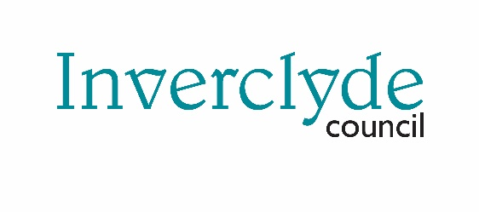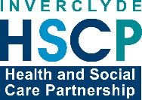

Issued 20 March 2020

|  |
| --- |
| **Below is the latest briefing on the activity in managing the response to COVID 19 (Coronavirus).** |

**Public safety messages**

Below are visuals created by NHS to promote important public health messages. These are available to download at our web page [www.inverclyde.gov.uk/coronavirus](http://www.inverclyde.gov.uk/coronavirus)

Please share these with colleagues, customers, friends and family to protect yourself, others and the NHS.

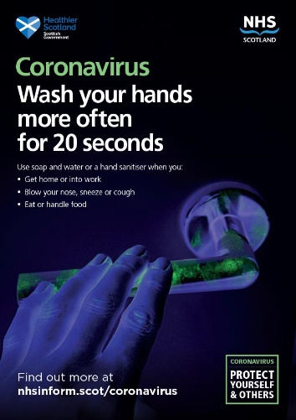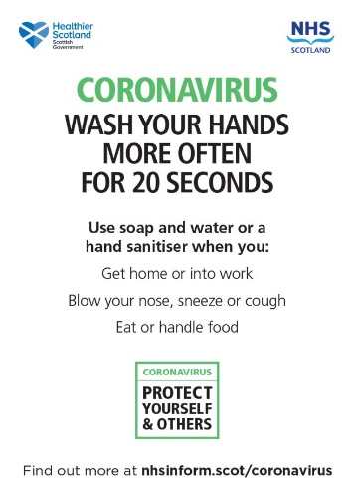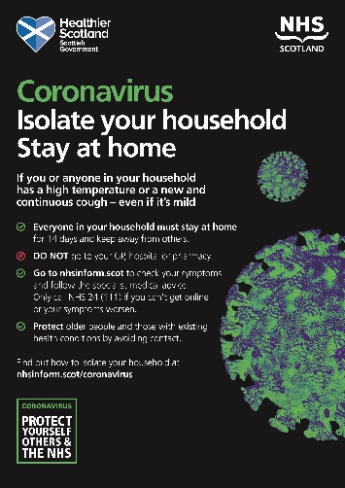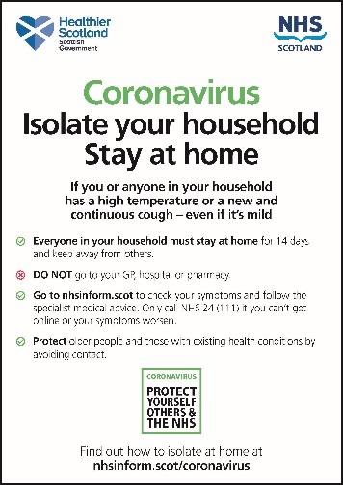

**Key workers childcare**

While schools and nurseries across Inverclyde will close after today (Friday 20 March 2020), the council will provide basic education facilities to ensure key workers, including those employed in the emergency services, care sector and other critical service areas can continue to go to work.

The council has created a short online survey for key workers to let us know their details to help us plan resources.

The survey can be accessed at [**www.surveymonkey.co.uk/r/DQ6DZT6**](http://www.surveymonkey.co.uk/r/DQ6DZT6)and through the council website at [**www.inverclyde.gov.uk/coronavirus**](http://www.inverclyde.gov.uk/coronavirus)

**Council customer service centre**

Words to come from Anne Marie

**School lunches during closure period –**

Q: At the moment all Inverclyde P1 – P4 children are entitled to Free Meals.

So, the question is: are all P1-P4 children equally entitled to a Free Meal at the various centres across Inverclyde or are these Free Meals available only to P1-P4 children whose parents are economically disadvantaged?