|  |
| --- |
| **Coronavirus (Covid-19) – briefing** |



Issued 6 April 2020

|  |
| --- |
| **Below is the latest briefing on the activity in managing the response to coronavirus (Covid-19).**  **Local updates, council service changes and links to trusted sources of health guidance are published at *www.inverclyde.gov.uk/coronavirus*** |

**New Covid-19 staff testing centre**

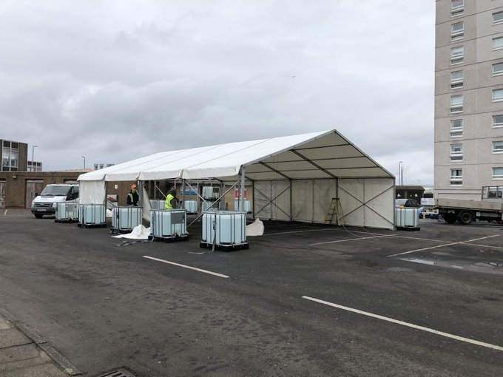A new coronavirus (covid-19) testing centre is set to open in Inverclyde this week.

The drive through testing centre, based at Port Glasgow Health Centre, will focus on supporting NHS staff to return to work.

The testing centre will be by appointment only and testing will take place to support healthcare staff being able to return to work if they could need to self-isolate for 14 days as someone they live with has symptoms.

The person with symptoms will be tested to find out of the worker is able to return to work.

A second group of staff may also be tested and these would be symptomatic healthcare workers however this is not yet agreed. Whilst there is a pathway in place for NHSGGC staff to be referred for testing the process for testing non NHS staff still requires to be agreed at a board level and we would wish to prioritise a number of staff such as care at home staff.

Testing consists of a nasal and throat swab and in some circumstances a sputum sample. No clinical assessments will take place on site, where someone is unwell and deteriorating they should follow the advice to telephone NHS 111 where they may be diverted to the Greenock community assessment centre.

During the testing the person remains in the car. It is expected to be open Mon - Fri from 9am until late afternoon, though this is still to be finalised..

It will have a working capacity of 100 tests per week initially and staff will wear the appropriate personal protective equipment (PPE) as specified in national guidance.

A full operating procedure is in place and Inverclyde HSCP is being supported by colleagues from Public Health to ensure it is delivered to the agreed standards.

The site is at Port Glasgow Health Centre staff car park. A marquee has been erected and the area fenced off.

Entrance to the site, which is by appointment only and drive thru, is from Bay Street adjacent to the swimming baths and a temporary traffic order to suspend parking in this area will be in force from today (Monday 6April 2020). Exit is via the existing one-way exit in to the council car park. Wardens will be on site to support flow of traffic in and out of centre. Additional CCTV is also being put in place and Police Scotland have been made aware that the site is being readied.

**Social distancing guidance for business**

The Scottish Government has issued updated social distancing guidance for businesses in Scotland to help provide clarity on protecting employees in the fight against coronavirus (covid-19).

It provides further information for employers and makes clear that those providing essential services must follow social distancing requirements.

It asks that the owners of businesses and operators of workplaces not required to close by law to consider whether what they do is essential to the efforts in the fight against the virus or benefit the wellbeing of society.

It also asks those employers if they can demonstrate and provide their workforces with reassurance that they are consistently practising safe social distancing and complying with all other standard health and safety requirements.

If the answer to either of these questions is no, workplaces are advised to close.

The guidance is published at: <https://www.gov.scot/publications/coronavirus-covid-19-business-and-social-distancing-guidance/>

**Support to put meals on tables**

A joint Scottish Government and COSLA statement was issued this weekend about food funding for councils:

Families unable to access food as a result of the coronavirus (COVID-19) outbreak will get support from local authorities with £30 million of new investment from the Scottish Government Food Fund.   
  
The funding will support those most in need including families with children who are eligible for free school meals, older people, those with long-term health conditions and pregnant women.  
  
Councils will have flexibility to use this additional resource in ways that best meet emerging local needs and circumstances, working with community groups and businesses to support home delivery, provide financial help and meet dietary requirements.

Allocations include more than £4.7 million for Glasgow, £2.2 million for Fife and £2.1 million for North Lanarkshire.  
  
The funding, one part of the £350 million Communities Fund, will be distributed to councils across Scotland by COSLA.

*Communities Secretary Aileen Campbell said:  “This pandemic is impacting on all our lives but for some it is more than a disruption, it is severely restricting their ability to access food for themselves and their families.   
  
“It is vital that we work together to ensure the most vulnerable people in our communities receive the support they need.   
  
“Local authorities are uniquely placed to respond swiftly in partnership with community groups and organisations to help those struggling.*

*“We know that free school meals are vital for families across the country and an important way of ensuring their children receive the nutritious food they need. That is why it is so important that support continues while schools remain closed.*

*“This fund will help ensure the most vulnerable people in our society during this outbreak receive support. The guidance shared with local authorities today supports local thinking about how funding can best be targeted and deployed.”   
  
COSLA Children and Young People spokesperson Councillor Stephen McCabe said:  
  
“Access to food is a current and vital concern for many people in our communities. Councils are committed to working flexibly, ensuring local access for those who are vulnerable or isolating and to maintain access to free school meals for entitled families.   
  
“Local Authorities will continue to work with and for local people to ensure provision that is right for them. We welcome the food fund guidance produced by Scottish Government that supports this local decision making.”   
  
COSLA Resources spokesperson Councillor Gail Macgregor said:*

*“As a result of Covid-19, greater numbers of people are at risk of food insecurity. Councils are facing additional challenges in ensuring food reaches those most in need.*

*“In these challenging times, we welcome the Scottish Government’s announcement of additional funding.”*

**Background**   
  
[The £350 million Communities Fund](https://www.gov.scot/news/helping-communities-affected-by-covid-19/) was announced by Communities Secretary Aileen Campbell on 18 March 2020.   
  
Since it was announced, over £100 million of new support has been delivered to local authorities to assist their efforts. This includes £50 million in hardship funding, £22 million to bolster the Scottish Welfare Fund and £30 million from the Food Fund.  
  
[The guidance](https://www.gov.scot/publications/coronavirus-covid-19-food-fund-guidance-to-local-authorities/) shared with local authorities outlines seven key principles to support local thinking about how funding can best be targeted and deployed.   
  
People worried about food during the COVID-19 crisis should contact their local authority for further information on the help and support available to them.

|  |  |  |
| --- | --- | --- |
| **Local authority** | **Allocation (millions)** |  |
| Inverclyde | **0.565** |  |

**Home care training**

A second call was issued last week to council and HSCP staff to volunteer to support the care at home service. Training is provided and this week 33 people are being trained to allow them to work with the team that supports our vulnerable residents.

**Tower Hill parking**

Vehicle access to Tower Hill in Gourock will be restricted from today (Monday 6 April 2020) to support social distancing rules and avoid people driving large distances to beauty spots.

**Foodbank – change to service**

The i58 Project – Inverclyde Foodbank has changed their service delivery.

Clients will no longer have to collect their food parcels from the foodbank in Greenock and instead it will be delivered to their home. It is important that when making the referral that a contact number is provided for the client for the foodbank to contact them.

The foodbank will be delivering parcels Monday, Wednesday and Friday between 2pm and 4pm. The foodbank premises will still be open if clients turn up to collect, however they will require a valid referral as normal.

**Business donations**

A range of local businesses have come forward to offer kind donations to support key workers manage the response to coronavirus (covid-19). Diodes has donated a range of PPE and continues to offer its support using its own supply chain. The team at Kwik Fit have today (Monday 6 April 2020) donated a range of equipment to support health and social care services including aprons and car seat covers. The council and HSCP will carry out publicity to thank them for their kind donations.

**SEPA support for business**

The Scottish Environment Protection Agency (SEPA) today [6 April 2020] confirmed the next steps in its regulatory approach in response to the COVID-19 pandemic.

In a strategic statement from SEPA Chief Executive, Terry A’Hearn and Chairman, Bob Downes, the agency outlines the philosophy it will follow to supporting the 33 sectors of the economy it regulates, in addition to the 13 critical national infrastructure sectors identified by Scottish Government.  A separate ‘over-arching’ approach document outlines the agency’s approach to compliance, enforcement, monitoring, permitting and regulatory position statements in the immediate period.

The response, outlined on a new SEPA Coronavirus (COVID-19) website, aims to support the national focus on food security, the provision of clean water and the maintenance of critical infrastructure and support services by helping Scottish businesses adapt in this next period.

The site will also host temporary regulatory positions and guidance which will be published in the coming days in response to specific issues across sectors and regulated businesses.

*Terry A’Hearn, Chief Executive, Scottish Environment Protection Agency, said:*

*“Scotland, as are many nations, is facing a public health emergency unprecedented in recent times.  SEPA will play our role in working together with other regulators, public and private sector organisations and communities to help Scotland respond.  With our statutory purpose focused on protecting and improving the environment and human health in ways that, as far as possible, create social and economic success, we will help Scottish businesses adapt to this next period.*

*“The Scottish Government has designated 13 critical national infrastructure sectors vital to the functioning of society.  Many of these are sectors we regulate and we’ll help that national focus on food security, the provision of clean water and the maintenance of critical infrastructure and the support services on which we all rely.*

*“We know that all businesses we regulate are trying to operate in extraordinary circumstances.  We know they are trying to look after the health of their own workforces.  We know they may have supply-chain and other challenges.”*

*“So, where businesses are unable to fully meet their compliance obligations, they should prioritise conditions which directly protect the environment over those of an administrative nature.  They should contact SEPA, work closely with us and document the choices and actions they take.*

*“The positions are a direct response to circumstances no-one wanted to see.  We ask Scottish businesses to adapt responsibly and we expect the majority will.  Our message is clear: if you try to do the right thing in this next period, you will find a helpful and supportive regulator.  If you deliberately do the wrong thing, you’ll get the uncompromising regulator your behaviour deserves.”*

*Mr. A’Hearn added: “we will continue to use a variety of means of checking and assessing compliance, including phone calls, issuing written advice, remotely managed technologies such as drones, targeted site and field visits, and other forms of intelligence gathering.*

*“We will be proportionate in our approach to enforcement and monitoring by regulated businesses and where SEPA is not fully able to undertake its planned monitoring, we will maintain a field and laboratory standby position.  This will enable us to respond to incidents with the highest environmental risk and impacts on the health and wellbeing of communities.”*

The updates can be found in full on SEPA’s [Coronavirus (COVID-19) Response hub](https://coronavirus.sepa.org.uk/).