|  |
| --- |
| **Coronavirus (Covid-19) – briefing** |

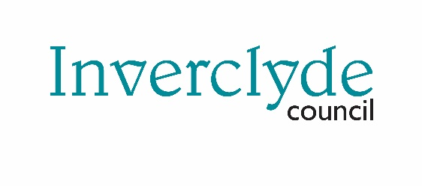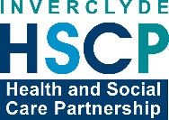

Issued 30 March 2020

|  |
| --- |
| **Below is the latest briefing on the activity in managing the response to coronavirus (Covid-19).**  **Local updates, council service changes and links to trusted sources of health guidance are published at *www.inverclyde.gov.uk/coronavirus*** |

**Shielding**

Shielding is a measure to protect people who are clinically extremely vulnerable by minimising all interaction between those who are extremely vulnerable and others.

The Government is strongly advising people with serious underlying health conditions (listed below), which put them at very high risk of severe illness from coronavirus (COVID-19), to rigorously follow shielding measures in order to keep themselves safe.

Underlying health conditions:

* Solid organ transplant recipients.
* People with specific cancers:  
  -people with cancer who are undergoing active chemotherapy or radical radiotherapy for lung cancer  
  -people with cancers of the blood or bone marrow such as leukaemia, lymphoma or myeloma who are at any stage of treatment  
  -people having immunotherapy or other continuing antibody treatments for cancer  
  -people having other targeted cancer treatments which can affect the immune system, such as protein kinase inhibitors or PARP inhibitors  
  -people who have had bone marrow or stem cell transplants in the last 6 months, or who are still taking immunosuppression drugs
* People with severe respiratory conditions including all cystic fibrosis, severe asthma and severe COPD.
* People with rare diseases and inborn errors of metabolism that significantly increase the risk of infections (such as SCID, homozygous sickle cell).
* People on immunosuppression therapies sufficient to significantly increase risk of infection.
* Women who are pregnant with significant heart disease, congenital or acquired.

Planning meetings have been taking place to map out the council and health and social care support for the national ‘shielding’ plans to support extremely vulnerable residents.  
  
A phone-line has been installed to provide a local contact support to people in Inverclyde receiving national communication about this from the NHS.

**School lunches food parcels**

Food parcels were delivered to 2,500 homes across Inverclyde to provide support to families entitled to free school meals and clothing grants.  
  
Parcels were prepared at Greenock Town Hall (right) and delivered across the area over the weekend.

**Eye protection**

The council’s health and safety service is examining eye protection in council schools to assess its potential use to support colleagues in health and care where this is required.

Any appropriate eye protection will be made available to health and social care staff while schools are closed.

**Home care visits**

5,665 care at home visits have been carried out this weekend by the care at home service both council and external providers. A message will be shared on social media thanking all our staff and providers for providing this level of service during the coronavirus (covid-19) pandemic.

**Volunteering campaign launched**

A national volunteering campaign has been launched by the Scottish Government.

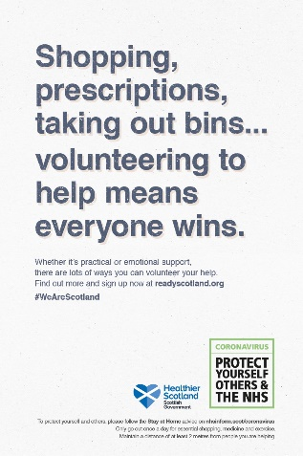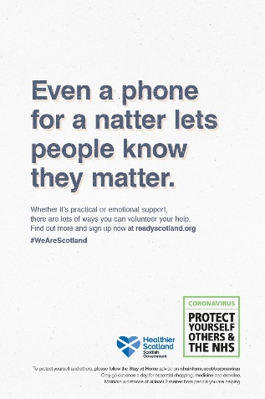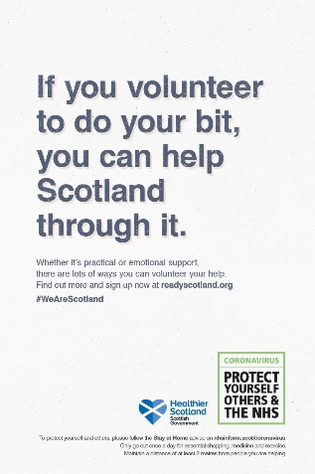

The ‘Scotland Cares’ campaign has been launched by the Scottish Government to encourage people to volunteer during the coronavirus (COVID-19) pandemic.

Those wanting to volunteer to support their communities have three options which are signposted from the Ready Scotland website:

* returning NHS workers will be directed to existing voluntary arrangements in NHS Scotland
* people wishing to offer their support to our public services, including the NHS and local authorities, will be directed to a site co-ordinated by the British Red Cross
* those looking for opportunities with other charities or community groups in their area will be directed to Volunteer Scotland for information

**Tenants to be given extra protection**

The Scottish Government has announced that private and social tenants will be given increased protection from eviction during the coronavirus pandemic.

Emergency legislation will increase the minimum notice period for private and social tenants to up to six months depending on the grounds used, helping to protect them from eviction.

The Coronavirus (Scotland) Bill, to be introduced to the Scottish Parliament on 31 March, will contain substantial further powers and measures to ensure essential public services can continue throughout the coronavirus outbreak.