|  |
| --- |
| **Coronavirus (Covid-19) – briefing** |

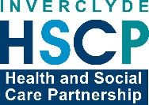

Issued 3 April 2020

|  |
| --- |
| **Below is the latest briefing on the activity in managing the response to coronavirus (Covid-19).**  **Local updates, council service changes and links to trusted sources of health guidance are published at *www.inverclyde.gov.uk/coronavirus*** |

**New PPE guidelines issued**

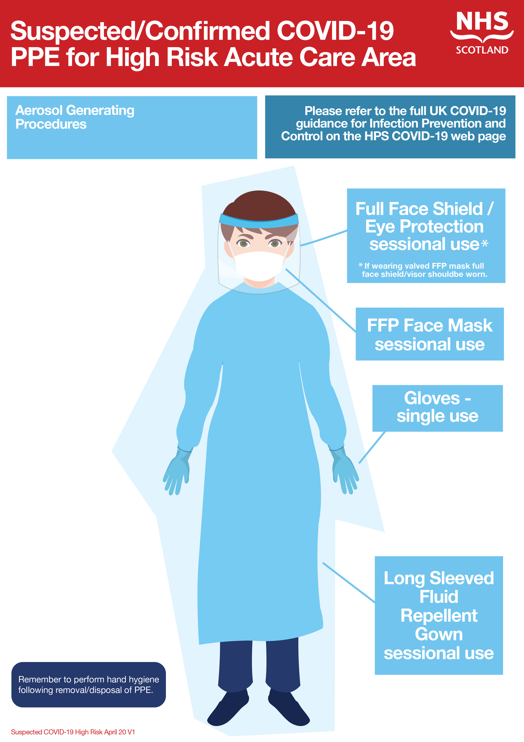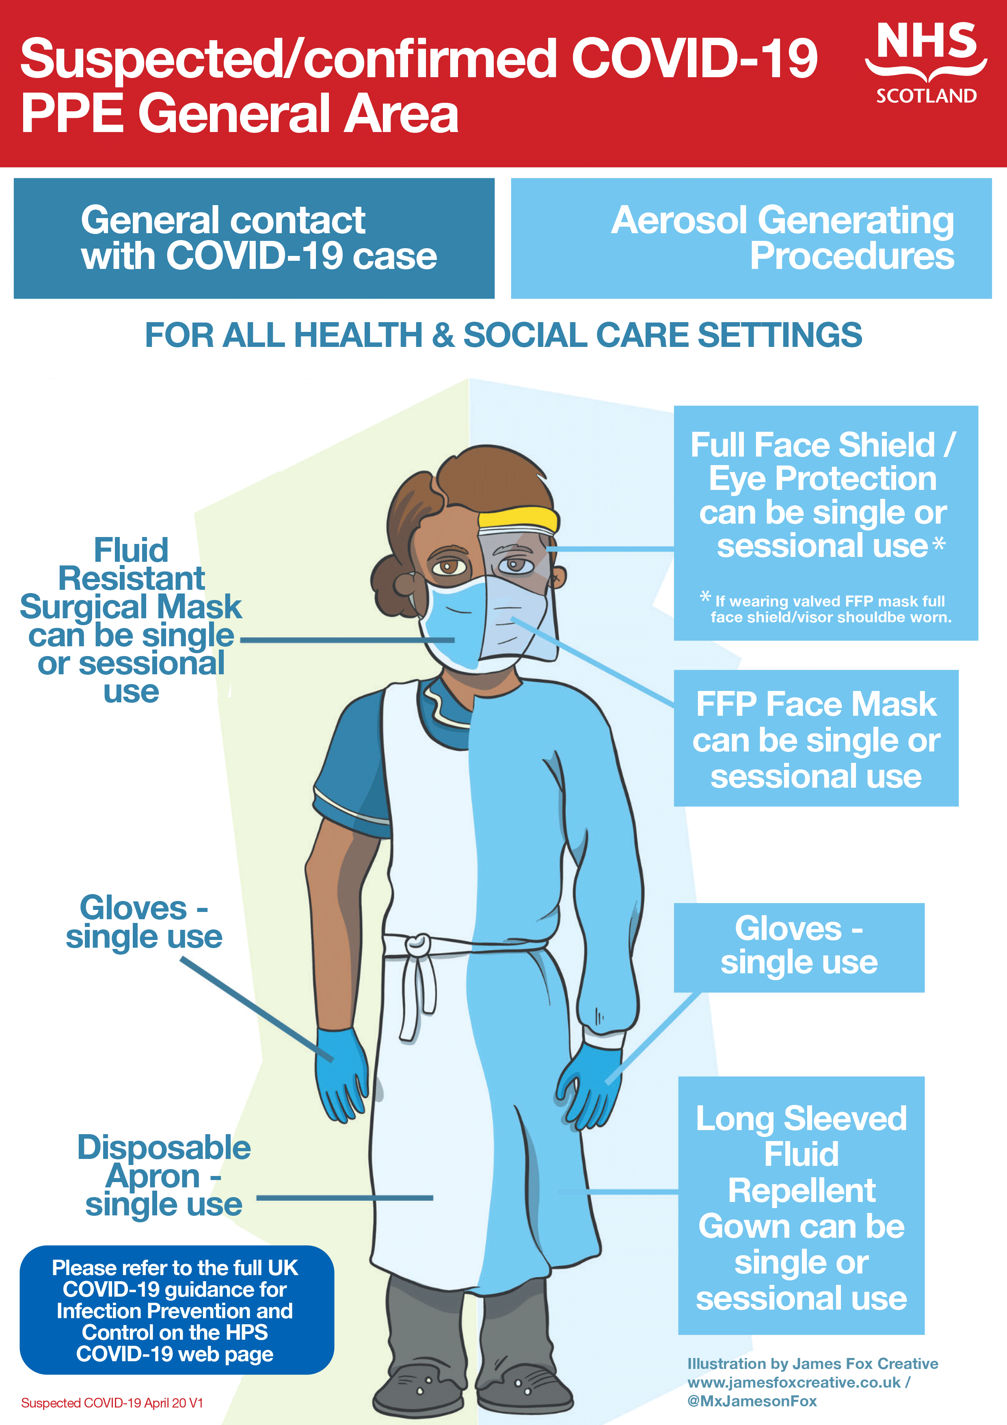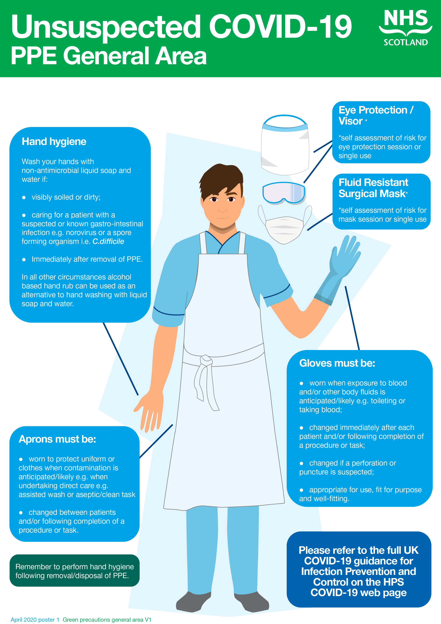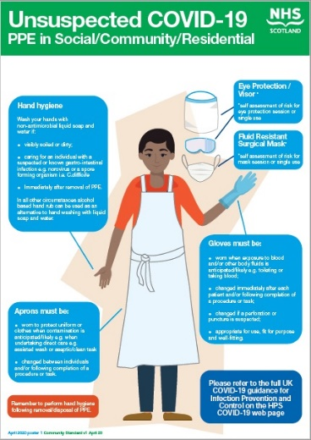New guidelines for personal protective equipment (PPE) has been issued.

In publishing the guidance the Chief Nursing Officer and Chief Medical Officer for Scotland highlighted:

The In response to the emerging epidemiology and evidence, urgent work has been under way to review the existing UK-wide Personal Protective Equipment (PPE) guidance and today the revised guidance will be published.

This guidance is issued jointly by the Department of Health and Social Care, Health Protection Scotland (HPS), Public Health Wales, Public Health Agency Northern Ireland, Public Health England (PHE) and NHS England as official guidance and can be accessed via the COVID-19 section of the Health Protection Scotland (HPS) website.

It outlines what PPE frontline health and social care workers should be wearing in different settings and scenarios. The guidance has had input from Royal Colleges and is endorsed by expert scientific groups.

The updates reflect the fact that COVID-19 is now widespread in the community, meaning clinicians and care workers are more likely to see people with the virus, some of who will not have symptoms yet.

The guidance itself recommends the safest level of PPE to protect health and social care workers and it specifies the type of PPE that should be worn in the various healthcare and social care settings where patients or residents could be cared for.

**Above are graphics published by NHS Scotland highlighting the levels of PPE in a range of healthcare settings. These are available to download at Public Health Scotland website and on** [**www.inverclyde.gov.uk/coronavirus**](http://www.inverclyde.gov.uk/coronavirus)

**COSLA statement on PPE**

Local government body COSLA has issued the following statement about the new PPE guidance:

COSLA has been urging Scottish Government to provide guidance to the Local Government workforce for the range of essential services it provides and we are pleased that this has now been done. We recognise that this is a very worrying time for the workforce and COSLA has been working closely with our Trade Union partners to develop FAQs which the workforce can easily access. The guidance and FAQs are science led and designed to give our valued Local Government Workforce the reassurance that they both want and deserve at this time.

COSLA President Alison Evison said: "This is information that our workforce can trust and be fully confident in. I have said since day one of this Pandemic that the Local Government workforce across our communities is doing an amazing job and we need to do everything we can in partnership with Scottish Government and Trade Unions to protect, support and safeguard these vital workers and the Guidance and FAQs does this.

"Where PPE is needed, Scottish Government must now ensure that there is sufficient supply and effective distribution. We will work closely with the Scottish Government to Provide information as required for PPE across Local Government."

Johanna Baxter, Head of Local Government, UNISON said: "UNISON welcomes the joint work undertaken with COSLA to address members’ concerns. We also welcome the clarity provided by this revised National guidance and it is right and appropriate this guidance is science-led.

"It should provide a level of reassurance to our members that they will be able to use their professional judgement to assess the appropriate PPE needed for the vital roles they are undertaking.

"The government now need to ensure, as a matter of urgency, that there are sufficient PPE supplies made available to protect those who are working hard to protect all of us."

**Key worker childcare hubs open over Easter**

Parents who are key workers requiring childcare should make contact with the hub linked to your child’s school/establishment.  Hub contact details are published at [www.inverclyde.gov.uk/coronavirus](http://www.inverclyde.gov.uk/coronavirus)

Childcare hubs should be used by key workers if their situation is critical. Our hubs are open over the Easter holiday period including bank holidays.

Moorfoot primary childcare hub featured on BBC radio Scotland this morning and again tonight on BBC Scotland News.

**Customer services**

The council’s customer services centre, currently by appointment only, will change its times to   
9am – 3pm (Monday to Friday). Visit [www.inverclyde.gov.uk/coronavirus](http://www.inverclyde.gov.uk/coronavirus) for information on services available and contact numbers for the customer services team.

**Rental holiday available for business**

Businesses renting properties from Inverclyde Council could have their rents deferred for up to 24 months to support businesses struggling with the effects of coronavirus (covid-19).

A deferral would result in invoices continuing to be issued in normal terms however the repayment of the invoices could be spread over a fixed period, negotiated with the lessee of up to 24 months from date of issue. This relieves the immediate burden on cash flow on the business but still ensures that the terms of the lease are fulfilled.