|  |
| --- |
| **Coronavirus (Covid-19) – briefing** |



Issued 26 March 2020

|  |
| --- |
| **Below is the latest briefing on the activity in managing the response to coronavirus (Covid-19).** |

**Useful advice for young people**

Colourful visuals were created this week to promote on social media to get useful information, advice and support to young people across Inverclyde who may be concerned about coronavirus (covid-19).

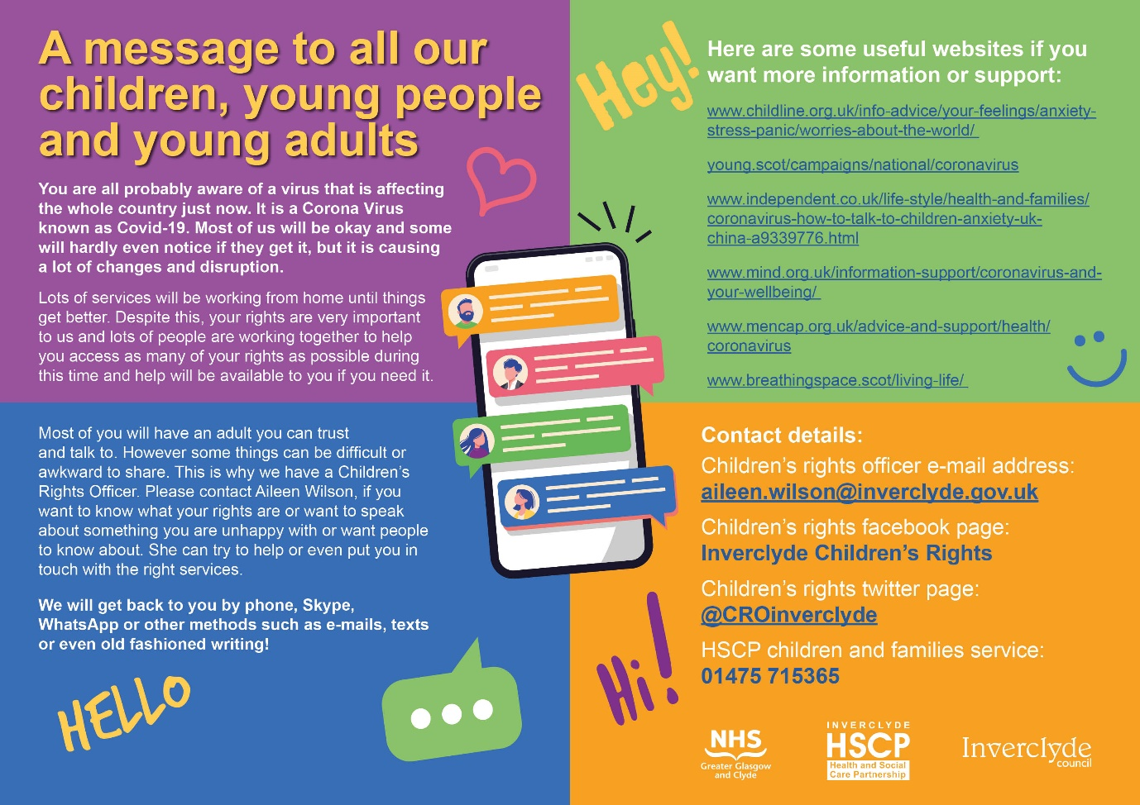

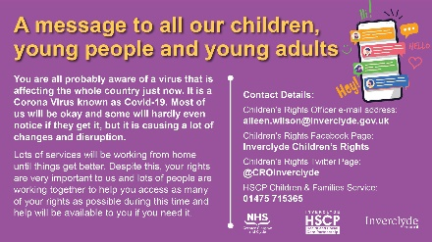

**Licensing - MOTs**

DVSA has announced that MOT tests across the UK have been suspended for six months due to the coronavirus (Covid-19) pandemic .Legislation due to be introduced on 30 March 2020 will come into immediate effect .

The council will suspend licenced vehicle testing from close of business on Monday 30 March 2020. Between now and Monday 30 March 2020 only vehicles with an MOT expiry date prior to 1 April 2020 will be tested .

All operators must note that the standard of roadworthiness of a licenced vehicle has not been relaxed . All operators and drivers require to comply fully with the vehicle standards stated in the taxi inspection manual.

**Council tax**

Council tax updated information has been published on the council website:

* If your income or earnings are impacted by the current COVID 19 pandemic and you expect to struggle to meet your next council tax payment, check to see if you qualify for help by using the online benefits calculator: <https://www.inverclyde.gov.uk/health-and-social-care/information-advice/advice-services/what-benefits-am-i-entitled-to>
* If you pay council tax over 10 months you may be able to spread the cost over 12 months if you move to direct debit.  You can arrange this at [www.inverclyde.gov.uk/counciltaxonline](http://www.inverclyde.gov.uk/counciltaxonline) or by calling 01475 712561
* Inverclyde HSCP Advice Service is ready to provide advice and assistance in relation to welfare benefits including Council Tax Reduction.  The service can be contacted using an online chat service: <https://www.inverclyde.gov.uk/advice-and-benefits> by email: [triage.advice@inverclyde.gov.uk](mailto:triage.advice@inverclyde.gov.uk) or you can leave a message on their telephone answer service by calling 01475 715299 and an advisor will call you back.
* You can find out about Council Tax Reduction at <https://www.inverclyde.gov.uk/advice-and-benefits/housing-benefit-and-council-tax-reduction/council-tax-reduction>

**School lunch changes**

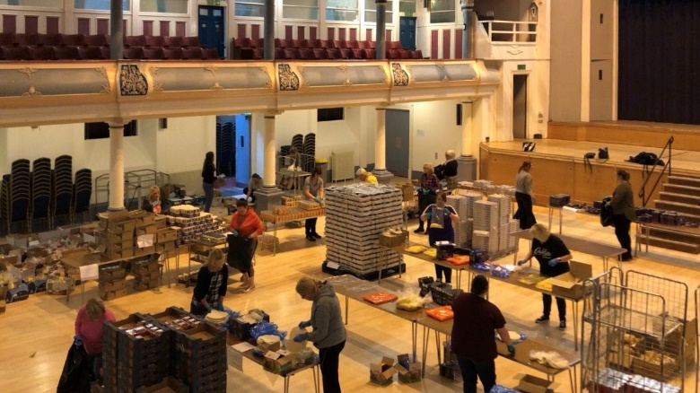Below is an update t announcing a change to free school lunches from Friday to support the stay at home message while still supporting families:

FOOD parcels are on their way to some 2,500 Inverclyde schoolchildren to ensure they do not go hungry while schools are closed due to the coronavirus outbreak.

Bags packed full of nutritious supplies are being delivered to households across the district for pupils who would normally receive free school meals and a clothing grant.

*Food preparation at Greenock Town Hall*

They contain enough food to provide lunches for two weeks, replacing packed lunches which were distributed from 12 community hubs from Monday-Friday this week.

The bags will be delivered direct to homes to ensure pupils, their parents or carers do not have to leave the house in line with the latest health and safety rules from the authorities to help reduce the spread of Covid-19 (coronavirus).

Food bags were prepared in accordance with the latest health and safety rules set out by medical professionals and the UK and Scottish Governments to help mitigate the spread of coronavirus.

Staff kept at least two metres apart, sanitised their hands regularly and wore protective rubber gloves at all times.

Deliveries will begin from 2pm on Friday once the 12 packed lunch hubs have closed.

The new fortnightly food bags contain things like pasta, tinned soups, tortilla wraps, cheese, baked potatoes, mayonnaise, jelly, fruit pots and yoghurts.

The ‘Cookalong’ guide includes step-by-step recipes to make home-made dishes such as vegetable pizza, tomato pasta, and cheesy pasta.

**Inverclyde advice services update**

**Universal credit claims -** We would advise peoplewho have lost their jobs or have had to reduce their hours to seek advice before submitting a claim to Universal Credit. This is because of how earnings are taken into account when assessing Universal Credit entitlement. Final salary or higher earnings will impact on the amount of Universal Credit if it is received within the first Universal Credit assessment period. This can result in people waiting for their first payment for an extended period of time or receiving a lesser payment and as a result having to claim an advance of Universal Credit that is repayable. Submitting claims for Universal Credit is done on line:

<https://www.gov.uk/apply-universal-credit>

If you are eligible for Universal Credit you need to make an appointment for your new claim interview. This interview will take place by telephone with a work coach. You will be given the number to call to book this appointment when you have submitted your claim.DWP have acknowledged people claiming Universal Credit are currently experiencing extended waiting times to complete this telephone claims process.

The Standard rate of Universal Credit will be increased by £20 a week for one year from 6 April 2020;

Suspending the Minimum Income Floor for self –employed claimants affected by the economic impacts of coronavirus; and

Increasing Housing Benefit and Universal Credit so that the Local Housing Allowance will cover at least 30 per cent of market rentals in an area.

**Scottish welfare fund (SWF) -** The Scottish Government has provided additional funding to the SWF to help respond to the coronavirus outbreak. The SWF pay Crisis Grants and Community Care Grants.

Crisis Grant eligibility:

* A Person can apply for a grant to cover:
* Immediate short-term living expenses needed as the result of an emergency;
* Living expenses or items where the need for them has arisen because of a disaster.

Community Care Grant eligibility:

The key test for a Community Care Grant is that the application is for someone setting up, or maintaining an established home in the community. It can also be paid to ease exceptional pressures on claimants or their families. There must be a risk this may not be possible without a grant. The risk does not have to be immediate. Decision Makers should use their discretion in deciding what constitutes ‘risk’ or ‘exceptional pressure’.

Applications for SWF grants in Inverclyde can be made by telephone to: 01475 71444, Monday to Friday 9am to 3pm.

**Housing costs -** The Government is implementing emergency legislation designed to ‘ensure everyone gets the support they need at this very difficult time’:

Social and private landlords will not be able to start proceedings to evict tenants for at least a 3 month period. At the end of the 3 month period the Government says that landlords and tenants will be expected to work together to establish an affordable repayment plan, taking account of tenants individual circumstances;

Mortgage lenders will support customers who are experiencing issues with their finances as a result of coronavirus, including the option of a 3 month payment holiday. Customers who are concerned about their financial situation should get in touch with their lender at the earliest opportunity to discuss matters.

**Coronavirus job retention scheme -** On Friday 20 March 2020 the Government announced a range of further measures to attempt to protect jobs and incomes. The measures included a new coronavirus job retention scheme set up to help pay peoples wages. Employers will be able to contact HMRC for a grant to cover most of the wages of their workforce who remain on the payroll but temporarily not working during the coronavirus outbreak. All employers will be eligible for the scheme. Any worker placed on the coronavirus job retention scheme can keep their job, with the Government paying up to 80% of a workers wages, up to a total of £2500 a month. This will be backdated to 1 March 2020, will be open for 3 months, and may be extended if necessary. Employees eligible for the scheme are known as ‘Furloughed Workers’. Guidance on the scheme can be found at:

<https://www.gov.uk/government/publications/guidance-to-employers-and-businesses-about-covid-19-guidance-for-employees#furloughed-workers>

**Fit notes (isolation notes) -** Isolation Notes will provide employees with evidence for their employer that they have been advised to self-isolate due to coronavirus, either because they have symptoms or they live with someone who has symptoms, and so cannot work.

People who need to claim Universal Credit or Employment and Support Allowance because of coronavirus will not be required to produce a fit note or an isolation note.

Isolation Notes can be accessed from:

<https://www.nhs.uk/conditions/coronavirus-covid19>

Or

<https://111.nhs.uk/covid-19>

**HMRC helpine -** HMRC have set up a helpline specifically for self-employed people and businesses affected by coronavirus. Contact the helpline at: 0800 0159 599.

The general business support line for Scotland is: 0300 303 0660

**HSCP advice services -** The above are some of the changes made to date. Further updates can be found at:

<https://www.gov.uk/browse/benefits>

<https://www,gov.uk/government/topical-events/coronavirus-covid-19-uk-government-response>

Inverclyde HSCP Advice Service can provide advice and assistance in relation to welfare benefits and money advice. We can be contacted on: 01475 715299, or email: [triage@advice@inverclyde.gov.uk](mailto:triage@advice@inverclyde.gov.uk)