|  |
| --- |
| **Coronavirus (Covid-19) – briefing** |



Issued 27 March 2020

|  |
| --- |
| **Below is the latest briefing on the activity in managing the response to coronavirus (Covid-19).** |

**Emergency Support Workers**

The council is opening a special recruitment drive to help deliver **vital work across a number of our services during the coronavirus (covid-19) crisis.**

If you are interested and can help us focus our efforts to protect vulnerable people, deliver care and support core services, we want to hear from you. Roles include home support workers.

Please note:

* Shortlisted applicants will be asked to take part in a telephone interview.
* People with underlying health conditions, covered by the government and NHS guidance on social distancing, and should not apply.
* These posts will be sessional, on an adhoc basis, and last for the duration of the covid-19 crisis.
* Posts are open to part time hours.

Further information and application form can be found on the council recruitment portal MyJobScotland, here: <https://bit.ly/2QPf05f>

<https://myjobscotland.gov.uk/councils/inverclyde-council/jobs/emergency-support-worker-sessional-187170>

**Registration services**

The following update has been made to the delivery of registration services:

To support you and ensure you can comply with the stay at home rules in place, we have made these changes to our registration service:

* Death registrations are being conducted by telephone appointment only. Contact us on 01474 714250 or email registrars@inverclyde.gov.uk
* Birth registrations are suspended until further notice. Work is being carried out by the UK government to ensure that parents are not disadvantaged by the postponement of these
* Marriage or civil ceremonies are suspended until further notice.

**Waste services change**

From Monday 30March until further notice we will be collecting waste as follows.

A weekly collection of your black residual waste bin. Please place your black bin out on your usual collection day every week.

All food waste should be placed in the black residual waste bin. No separate food waste collection will be carried out.

If your blue bin is due to be collected from 30 March to Friday 4 April it will be emptied with a non-recycling collection. No blue bins will be collected until further notice after then.

Brown bins (garden waste) with permits should be placed out on your normal collection day but will be collected by the same vehicle as your black bin.

Brown Bins (garden waste) without a permit will not be collected.

All waste to be collected should be placed in your black bin NO side or excess waste will be collected. No separate food waste of blue bin collection will be carried out.

The sale of brown bin (garden waste) permits is suspended until further notice.

This is a temporary arrangement until further notice.

**Prescription service launched for Inverclyde**

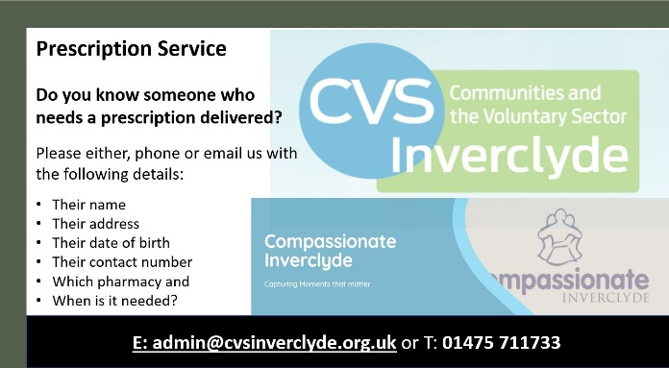CVS Inverclyde and Compassionate Inverclyde are joining forces and working closely with the community to signpost into a new Inverclyde prescription service, for local residents needing support during the COVID-19 pandemic.

The Inverclyde Community Link Worker (CLW) team, managed by CVS Inverclyde, are working alongside the #Covid19 local community groups, to connect directly to individuals in their neighbourhoods in a bid to ensure everyone in need receives their prescription on time.

If you know someone who needs a prescription delivered, simply email or call CVS Inverclyde on E: [admin@cvsinverclyde.org.uk](mailto:admin@cvsinverclyde.org.uk) or T: 01475 711733 with the following details for the person

* Name
* Address
* Date of birth
* Contact number
* Which pharmacy they use and
* When the prescription is needed

The CLW team are actively supporting the community during the COVID-19 outbreak in many ways. While each of the 14 GP practices in Inverclyde has a CLW, the team are currently based in the community and using technology to continue to help people through phone calls, video calls and text messaging. Thanks to this approach, the team are still able to take referrals from anyone who feels that they would benefit from their support.