|  |
| --- |
| **Coronavirus (Covid-19) – briefing** |



Issued 10 April 2020

|  |
| --- |
| **Below is the latest briefing on the activity in managing the response to coronavirus (Covid-19).**  **Local updates, council service changes and links to trusted sources of health guidance are published at *www.inverclyde.gov.uk/coronavirus*** |

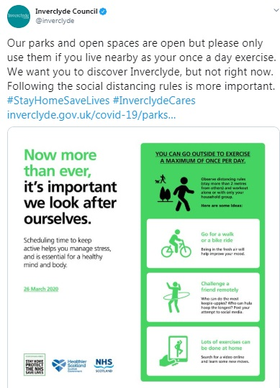

**Easter weekend public urged to stay at home #StayHomeSaveLives**

Over the Easter weekend a series of social media messages will be scheduled to encourage people to exercise but to avoid travel.

Council social media messages will also emphasis that although parks and open spaces are open across Inverclyde they should only be used if you live nearby and practice safe social distancing.

**Supported living service**

To ensure critical support is prioritised Inverclyde Health and Social Care Partnership (HSCP) and commissioned providers for supported living services will reduce service to essential tasks only on a phased basis within an agreed protocol.

Volunteer staff will be deployed to support with meal provision and medication support, if required.

The clinical advice available to the HSCP management team is to reduce risk to the service user and staff by reducing contact time to the minimum possible and deploy a social distancing approach.

To ensure providers are not penalised due to this clinical and best practice approach to minimal contact time, the HSCP will pay providers based on the average of their last three months invoices.

**Recruitment update**

A recruitment freeze was put in place at the start of the coronavirus (covid-19) pandemic across the council to manage resources and focus employees on priority areas.

Some recruitment will start again as services plan ahead for future service needs.

Initial advertising will take place for some school vacancies required ahead of the school term in August.

Other urgent recruitment needs across all services will be reviewed by the corporate management team (CMT) and assessed against the service needs and requirements to manage the council’s response to the coronavirus (covid-19) pandemic.

The following urgent school vacancies will be advertised in the coming weeks with recruitment tailored to ensure full compliance with the social distancing guidance.

* Head Teacher Secondary, Port Glasgow High School
* Head Teacher Primary, Gourock Primary
* General teacher staffing recruitment for promoted and unprompted posts across the primary, secondary and additional support needs (ASN) sector.