|  |
| --- |
| **Coronavirus (Covid-19) – briefing** |



Issued 14 April 2020

|  |
| --- |
| **Below is the latest briefing on the activity in managing the response to coronavirus (Covid-19).**  **Local updates, council service changes and links to trusted sources of health guidance are published at *www.inverclyde.gov.uk/coronavirus*** |

**Support for those at high COVID-19 risk**

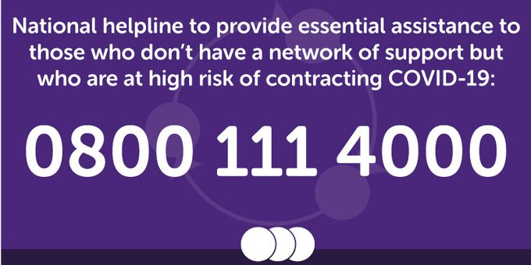National helpline established for those who do not have family or community support.

A new national helpline is being set up to provide essential assistance to those who don’t have a network of support but who are at high risk of contracting COVID-19.

The service – which opens tomorrow (Tuesday) – will offer help to those who do not have family or existing community support and cannot get online and who are over 70, disabled, require the support of mental health services, are pregnant or receive a flu jab for health reasons. This service is in addition to localised support already available for people who have received letters advising them to shield themselves. However, any of those in the shielding category who are not yet receiving assistance, who do not have family and cannot get online can access support via this new helpline.

Anyone not in these categories but still looking for support should visit readyscotland.org

The helpline – 0800 111 4000 – will initially operate during core working hours of 9am to 5pm while plans are developed and implemented to extend it to operate for a longer period each day.

Callers will be automatically connected to their local council who will support them to access the service they need, such as:

* essential food and medication
* links to local social work services for vulnerable children or adults
* emotional support
* ****contact with local volunteer groups.

**#redforgerry**

Current and former pupils and colleagues of Notre Dame High School principle teacher of mathematics, Gerry McHugh, paid their own online tribute after news this weekend that he had died as a result of coronavirus.

People posted photographs on Twitter wearing red and paying tribute to Gerry, a lifelong Manchester United supporter, using the #redforgerry hashtag.

**Guidance for non-healthcare settings**

New guidance has been issued for those working in non-healthcare settings give advice to their staff and users of their services about COVID-19.

This guidance covers:

* what COVID-19 is and how it is spread
* advice on how to prevent spread of all respiratory infections including COVID-19
* advice on what to do if someone is ill in a work​​place or other non-healthcare setting
* advice on what will happen if an individual is being investigated as a possible case or is confirmed as a case of COVID-19

Here is a link to the guidance on the health protection Scotland website: <https://hps.scot.nhs.uk/a-to-z-of-topics/covid-19/>

The link above should work through the council network, but if you have any problems accessing the Health Protection Scotland site, removing ‘www.’ should fix it.

**Wellbeing fund open for bids**

Third sector organisations across Scotland are being encouraged to apply for emergency funding to help cope with the effects of coronavirus (COVID-19).

More than 2000 charities, community and voluntary groups, and social enterprises are being offered immediate financial support from the £50 million Wellbeing Fund, which has been established to assist third sector organisations working with people impacted by the pandemic.

Communities Secretary Aileen Campbell has announced that organisations will also be able to submit an expression of interest from today to access financial support through the website of the Scottish Council for Voluntary Organisations (SCVO).

Any organisation wishing to submit an expression of interest can do so through the Coronavirus Third Sector Information Hub on the SCVO website.

The £50 million Wellbeing Fund is part of a £350 million package announced by the Scottish Government to support those most affected by the pandemic, and enable a swift response according to local need.

Of this, £10 million has been allocated for immediate priorities and £7 million committed to support around 2000 charities through small grants.

This leaves £33 million of the Wellbeing Fund now open to bids from third sector organisations.

The Scottish Government is working with Corra, Inspiring Scotland, the STV Appeal and SCVO to allocate the funding. They will be assisted by Scotland’s network of Third Sector Interfaces (TSIs) – business gateways which provide a single point of contact and support for charities and social enterprises, with an active presence in every local authority in Scotland.

SCVO: <https://scvo.org.uk/support/coronavirus/funding/for-organisations/wellbeing-fund>