|  |
| --- |
| **Coronavirus (Covid-19) – briefing** |



Issued 23 April 2020

|  |
| --- |
| **Below is the latest briefing on the activity in managing the response to coronavirus (Covid-19).**  **Local updates, council service changes and links to trusted sources of health guidance are published at *www.inverclyde.gov.uk/coronavirus*** |

**Looking beyond lockdown guidance**

The Scottish Government has published a new discussion document which reflects on the ongoing period of lockdown and outlines The Scottish Government will determine the steps required to constrain the spread of the virus while minimising overall harm to health, society and the economy.

The statement reads:

A document outlining how decisions will be taken to control coronavirus (COVID-19) while restoring a degree of normality to everyday life has today been published by the Scottish Government.

The paper - COVID-19: A Framework for Decision-Making - sets out the position during this ongoing period of lockdown and outlines the factors that must be considered as we move gradually to ease restrictions.

It also recognises that new ways of living – effectively a “new normal” – may have to be in place for some time to come.

First Minister Nicola Sturgeon said: “Today I am seeking to start a grown up conversation with the public about the complex decisions that lie ahead of us as we look beyond lockdown.

“As we have done all along, we will seek to inform the public with the best scientific advice possible, but the science will never be exact and we are in uncharted territory so we also need to make careful judgements and be prepared to adapt and change course as we go.

“We want to ease restrictions, but we cannot rule out having to reapply them should the virus run out of control.

“Every day we see evidence that this virus causes real harm, but so too do the lockdown measures we are taking to contain it. This is causing harm to the economy and living standards, to children’s education and to mental health and wellbeing.

“That is why we need to try to find a better balance than the one we have now, but as we do so we cannot take our eye off the need to suppress the virus and minimise the damage it does.

“It is only when we are sure the virus is under control that we can even start to ease any of the restrictions because the virus will not have gone away.

“As we start to lift the restrictions, the real risk is that COVID-19 runs rampant again so a return to normal as we knew it is not on the cards in the near future. What we will be seeking to find is a new normal - a way of living alongside this virus, but in a form that keeps it under control.

“Physical distancing and limiting our contacts with others will be a fact of life for a long time to come - certainly until treatments and ultimately a vaccine offer different solutions. But if we all keep doing the right things, there will be a way through – and we will find it, together.”

Here is a link to coronavirus (covid-19): framework for decision making: <https://www.gov.scot/publications/coronavirus-covid-19-framework-decision-making/>

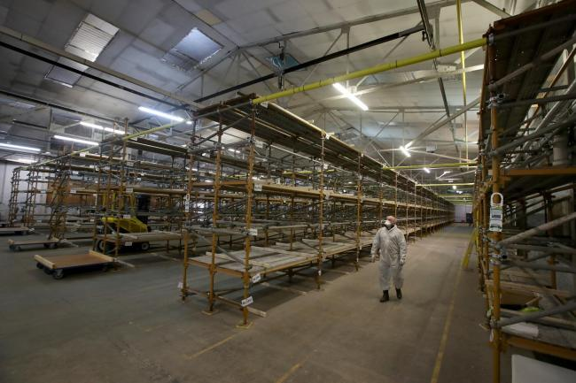**Temporary mortuary facility**

A temporary mortuary facility has been developed to support council areas in the Greater Glasgow and Clyde dealing with increased deaths as a result of covid-19.

The image on the right was taken as part of a pooled communication plan involving Scottish media. Below is some background information:

Like all local authorities across the UK, the Greater Glasgow and Clyde local authority areas alongside our partners the NHS, have been looking at various options for dealing with increased deaths as a result of the COVID-19 outbreak.

The partnership is monitoring on a daily basis the impact of COVID-19 against the planning models for the pandemic - including potential requirements for a temporary mortuary facility across the areas.

As part of this resilience partnership planning, a site has been identified in Hillington.

The site is a NHS leased building and we are working towards making this facility ready within the coming weeks for Funeral Directors across the Greater Glasgow and Clyde local authority areas to make use of - should they need too.

* Renfrewshire
* East Renfrewshire
* West Dunbartonshire
* East Dunbartonshire
* Glasgow
* Inverclyde

However, the facility will also be available to other local authorities if there is a need. The temporary mortuary facility has the capacity to store up to 1700 caskets and – should the need arise – and has the capability to operate 24/7.

**Health plea over grass and garden fires**

The council has issued the attached message to support residents with respiratory issues and to protect the community during the dry weather.

A health and safety plea has been issued following a spike in the number of garden and grass fires in parts of Inverclyde.

There has been an increase in incidents locally, including a blaze in the hills above Spango Valley in Greenock on Monday and at The Knapps in Kilmacolm on Tuesday.

Nationwide, there has also been a rise in the number of garden bonfires as people utilise and tidy up their outdoor spaces during the coronavirus lockdown and spell of nice weather.

As well as the safety risks associated with starting a fire, there are also concerns about the impact smoke is having on people’s health, particularly those suffering from respiratory conditions, including Covid-19, who require fresh, clean air to aid their illness.

People are being urged not to start fires in order to protect themselves, others and be considerate towards neighbours and people with respiratory illnesses.

Councillor Tommy McVey, Chair of the Local Police & Fire Scrutiny Committee, said: “Outdoor fires are extremely dangerous generally, but the problem is exacerbated during dry, warm and windy spells of weather, which we are currently experiencing.

“Not only does unnecessary garden and grass fires put residents and the wider public at risk, they put our vital frontline emergency services workers in harm’s way and increases the strain on resources which are already stretched because of the coronavirus pandemic.

“While people may be tempted to burn garden waste due to disruption with brown bin collections and closure of civic recycling centres in response to the coronavirus emergency, I urge them not to do this.

“Residual black/grey bins are now being emptied every week instead of fortnightly to make up for the temporary loss of other waste collections. Garden waste can also be retained and used to make your own nutrient-rich compost at home.

“Whatever you do, please refrain from lighting a garden bonfire and help the authorities by reporting those who recklessly start fires elsewhere.”

In response to the increase in fires, Inverclyde Council’s Community Wardens team are assisting Police Scotland and the Scottish Fire & Rescue Service locally with increased patrols of target areas.

The council also has a duty under the Environment Act to review and assess the air quality in Inverclyde and has powers to investigate and take action against ‘nuisance’ smoke and associated smells.

To report an incident, phone the council’s Customer Service Centre on 01475 717171 or email customerservice@inverclyde.gov.uk, call the Scottish Environment Protection Agency (SEPA) Pollution Hotline 24 hours a day on 0800 80 70 60 or dial 999 in an emergency.

The sale of garden waste permits for the collection of brown bins and the service itself are set to resume within three weeks. Currently, the sale of permits is suspended and only those with existing permits will have their brown bins emptied on regular collection days, although the garden waste itself is being emptied into a regular residual waste truck.