|  |
| --- |
| **Coronavirus (Covid-19) – briefing** |

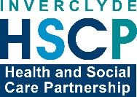

Issued 28 April 2020

|  |
| --- |
| **Below is the latest briefing on the activity in managing the response to coronavirus (Covid-19).**  **Local updates, council service changes and links to trusted sources of health guidance are published at *www.inverclyde.gov.uk/coronavirus*** |

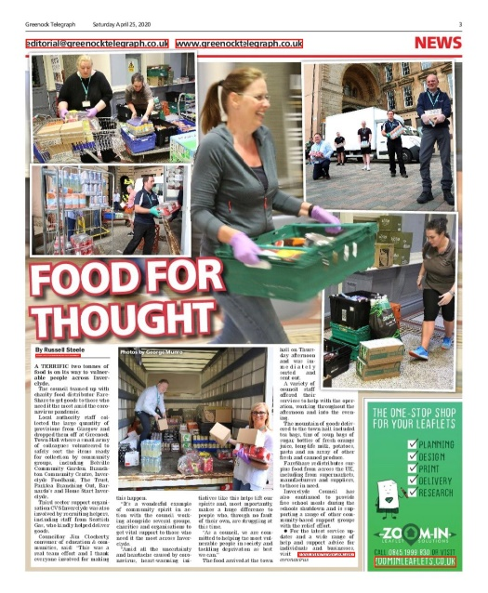**Food for thought – two tonnes of it**

Two tonnes of food was is on its way to vulnerable people across Inverclyde from last weekend.

The council teamed up with charity food distributor FareShare to get goods to those who need it the most amid the coronavirus pandemic.

Staff collected the large quantity of provisions from Glasgow and dropped them off at Greenock Town Hall where a small army of colleagues volunteered to safely sort the items ready for collection by community groups, including Belville Community Garden, Branchton Community Centre, Inverclyde Foodbank, The Trust, Parklea Branching Out, Barnardo’s and Home Start Inverclyde.

Third sector support organisation CVS Inverclyde was also involved by recruiting helpers, including staff from Scottish Gas, who kindly helped deliver goods.

**Marking workers memorial day**

Today marks International Workers Memorial Day.

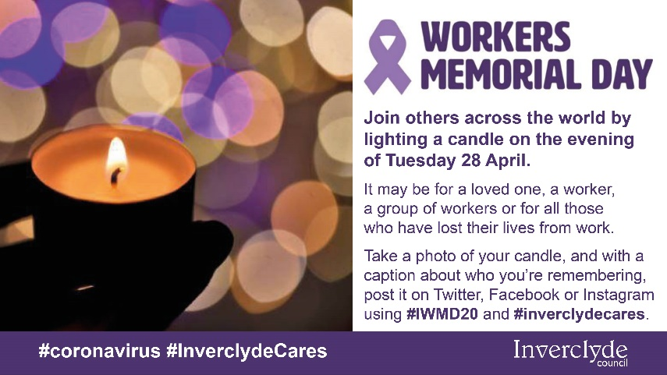A one-minute silence was held across the country to remember those who have died through their work.

Because a wreath laying ceremony could not take place in Clyde Square in the normal way, a short video was published on the council’s social media with contributions from Provost Brennan and Robin Taggart from Unison highlighting the special significance of workers memorial day at this time.

The video is available on the council social media and You Tube channel: <https://youtu.be/7-ujia4Q6_o>

**Helpline to support residents in need**

Tomorrow, 29 April 2020, Inverclyde Council and CVS Inverclyde launch a new single point of contact for residents in need during the coronavirus pandemic.

The number will be staffed by Inverclyde Council’s community learning and development staff and CVS Inverclyde, between 9am-7pm Monday-Saturday.

The service is not for people already on the shielding list who are currently being looked after, but to be a point of contact that people can call for assistance with provisions, support and advice, that will direct them to the correct support they need, within their communities.  It will also help understand the impact that this pandemic is having across our localities.

**Face coverings guidance**

The Scottish Government has issued face-covering guidance for Scotland.

The guidance is available online at: <https://www.gov.scot/publications/coronavirus-covid-19-public-use-of-face-coverings/>

The guidance includes this introduction explaining the rationale for issueing guidance for the use of face coverings:

Physical distancing, hand washing and respiratory hygiene, are the most important and effective measures we can all adopt to prevent the spread of coronavirus. Therefore the wearing of facial coverings must not be used as an alternative to any of these other precautions.

The evidence on the use of face coverings is limited, but there may be some benefit in wearing a facial covering when you leave the house and enter enclosed spaces, especially where physical distancing is more difficult and where there is a risk of close contact with multiple people you do not usually meet. Examples include, traveling on public transport or entering a food shop where it is not always possible to maintain a 2 metre distance from another customer. There is no evidence to suggest there might be a benefit outdoors, unless in an unavoidable crowded situation, where there may be some benefit

As some people can have the virus but experience no symptoms (asymptomatic infection), wearing a face covering in the situations outlined above may provide some level of protection against transmission to other people in close proximity.

However, it remains the case that anyone with symptoms and all members of their household (whether they have symptoms or not), must self-isolate and adhere to the guidance on individual and household isolation on NHS Inform. By face coverings we do not mean the wearing of a surgical or other medical grade mask but a facial covering of the mouth and nose, that is made of cloth or other textiles and through which you can breathe, for example a scarf.

When applying or removing the covering, it is important that you wash your hands first and avoid touching your face. After each use, you must wash the face covering at 60 degrees centigrade or dispose of safely. Face coverings should not be used for children under the age of two years. We are recommending that you consider using face coverings in the limited circumstances described above as a precautionary measure. Given that the evidence of impact on transmission is relatively weak, the public use of facial coverings is not being made mandatory and will not be enforced at this stage. However, we will keep this guidance under ongoing review as we consider any easing of lockdown restrictions in the weeks ahead.

**Council May holidays**

The early May holidays take place next week for May Day on Monday 4 May (public holiday) and VE Day on Friday 8 May (additional leave day).

Any essential services employees requiring to work on these dates will be contacted by their manager.

**Primary care opening hours**

Primary care services will remain open during the May public holidays.

Funded by £8.2 million from the Scottish Government, GP services and community pharmacies have been asked to remain open on the May public holidays, with NHS 24 operating with an increased number of call handlers.

**Antibody test in development**

NHS Greater Glasgow and Clyde has announced that it is collaborating on the development of an accurate and reliable antibody test in the fight against COVID-19.

With involvement of clinicians, the biorepository team and coordinated through Scottish Health Innovations Ltd; a UK-based consortium is accelerating the development of a unique lateral flow test, supporting the requirement for reliable antibody testing at scale.

Based on existing prototypes developed for Zika virus and Dengue fever and work on the herpes simplex virus; this innovative solution will be tested and validated using blood samples from previously infected COVID-19 patients.

Find out more at the NHS Greater Glasgow and Clyde health board website: <https://www.nhsggc.org.uk/about-us/media-centre/news/2020/04/rapid-antibody-test-in-development-to-support-the-fight-against-covid-19/>