|  |
| --- |
| **Coronavirus (Covid-19) – briefing** |

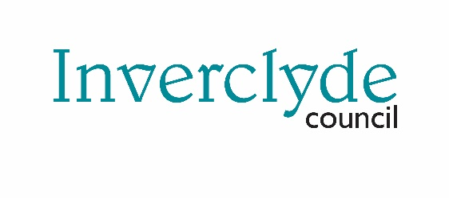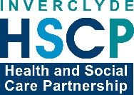

Issued 30 April 2020

|  |
| --- |
| **Below is the latest briefing on the activity in managing the response to coronavirus (Covid-19).**  **Local updates, council service changes and links to trusted sources of health guidance are published at *www.inverclyde.gov.uk/coronavirus*** |

**Self-employed hardship fund**

Inverclyde Council is now accepting applications for a new hardship fund for people who have become recently self-employed.

A one-off grant of £2,000 per person is available through the Scottish Government’s ‘newly self-employed hardship fund’ (NSEHF) for those affected by the coronavirus outbreak.

Local authorities are administering the scheme across the country.

Applicants must have become self-employed after 6 April 2019. A request for support can be made up until 31 March 2021 for those who meet the eligibility criteria.

The council aims to make payments within 10 working days.

Full details, including eligibility criteria and an application form, are now available to download from the council website at [www.inverclyde.gov.uk/covid-19/business-support](https://www.inverclyde.gov.uk/covid-19/business-support)

**Reaction to latest covid deaths statistics**

Commenting on the latest release of weekly figures of covid-19 related deaths across Scotland, Inverclyde Council Provost Martin Brennan said: “The latest statistics released by the National Records of Scotland make yet more sad reading for Inverclyde.

"The statistical report is important as it can help to drive public policy and make sure that resources and action are being targetted at the right parts of the country.

"As a community we must never forget that we have lost 93 members of the Inverclyde community to this virus. These are all family, friends, colleagues and neighbours who are grieving right now at the loss of a loved one."

Across Scotland there have been 2,272 covid-19-related deaths while in Inverclyde there have been 93. When measured against the rest of the country deaths by covid-19 in Inverclyde are 11.9 per 10,000 while the Scottish average is significantly less at 4.2 per 10,000.

Deaths in Inverclyde are further listed by location with hospital still accounting for the largest number of deaths registered. 27 people in care homes in Inverclyde have died, 11 people have died elsewhere or in the home and 55 have died in hospital.

National Records of Scotland office: <https://www.nrscotland.gov.uk/news/2020/deaths-involving-covid-19-week-17-20th-to-26th-april>

**Food provision and support**

Below is a flowchart highlighting referral pathways for food provision in Inverclyde.

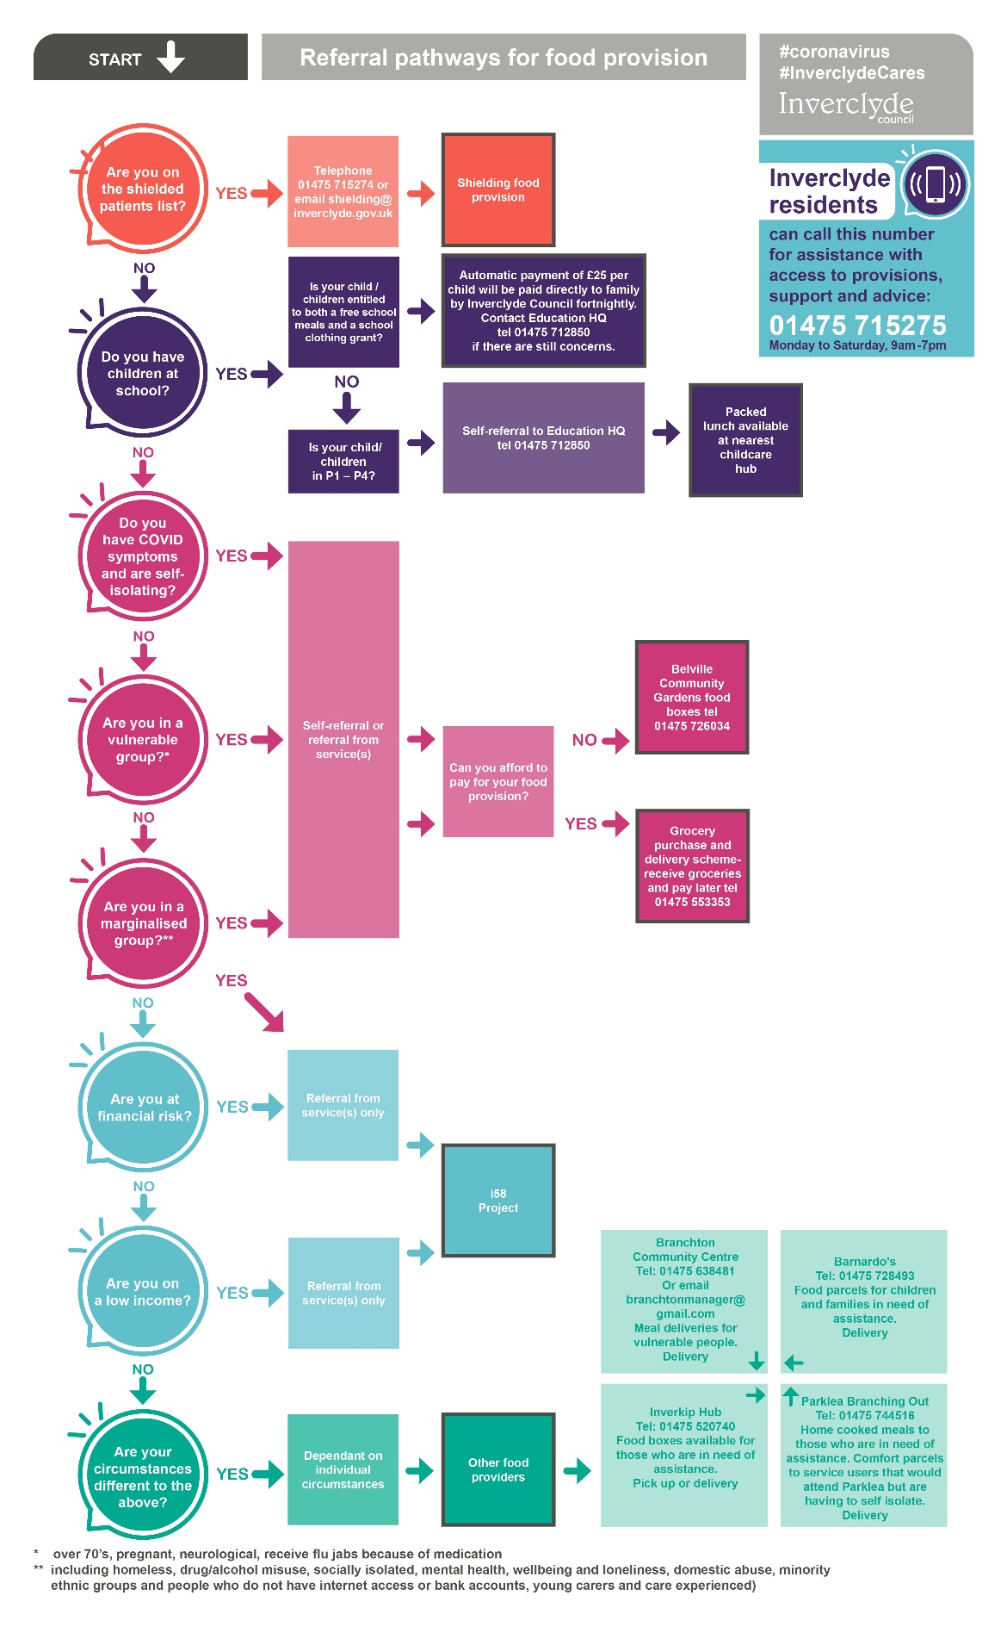

**Domestic abuse: disclosure requests increase**

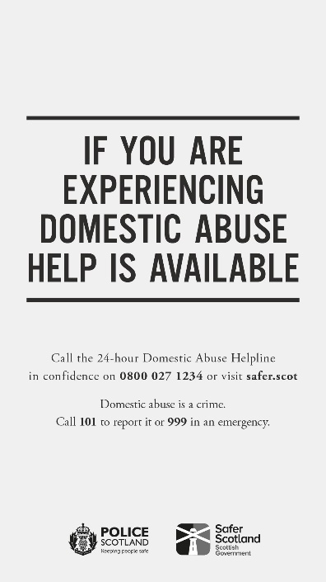Requests under Police Scotland’s domestic abuse disclosure scheme have increased by 18 per cent since lockdown began.

Nearly 260 requests for disclosure were made between the start of lockdown on 23 March to 27 April 2020, compared to 219 in 2019.

The majority of requests are being made by police officers and other professionals (including social work and NHS) raising a concern about someone they think may be at risk of domestic abuse. Police Scotland will then make a decision about whether to make a disclosure in the interests of safeguarding a person.

In the 12 months to 31 March 2020, Police Scotland received 2,648 requests for disclosure, a 66 per cent increase on the same period 2018/19 (1,596 applications).

In the same period more than 1200 disclosures were made to people indicating that their partner had an abusive past. This represents a 40 per cent increase on the same period the previous year (865 disclosures).

If you, or anyone you know, are being abused or are at risk of abuse, please contact Police Scotland on 101 or 999 in an emergency. Or if you need support please contact Scotland's domestic abuse and forced marriage helpline on 0800 027 1234, where support is available 24/7.

**New benefit for all health service staff**

The Scottish Government has announced a new payment in event of death in service.

The announcement highlights that all families of frontline NHS staff who die as a result of coronavirus (COVID-19) will receive financial support.

A total lump sum of twice the staff member’s annual earnings and continued survivor entitlements will be provided in the event of a death in service. This benefit will be available immediately and backdated if necessary.

The majority of NHS workers are already eligible for this through their NHS Pension Scheme membership, but the Health Secretary wants to ensure that all NHS staff who provide frontline services will be covered for the duration of this crisis.

The principal scheme rules will be published on Friday 1 May 2020. The NHS pension scheme, of which the majority of staff are members, gives nominated beneficiaries a death in service benefit consisting of a lump sum payment and ongoing survivor benefits.

The Scottish Government is in discussion with social care and community pharmacy colleagues to consider what appropriate provision might be made available for those staff groups.