|  |
| --- |
| **Coronavirus (Covid-19) – briefing** |



Issued 12 May 2020

|  |
| --- |
| **Below is the latest briefing on the activity in managing the response to coronavirus (Covid-19).**  **Local updates, council service changes and links to trusted sources of health guidance are published at *www.inverclyde.gov.uk/coronavirus*** |

**Emergency home support workers**

Over 80 emergency home support workers have been trained to deliver vital services to some of Inverclyde’s most vulnerable residents during the coronavirus pandemic.

The huge recruitment drive has been led by Inverclyde Health & Social Care Partnership (HSCP) to ensure continuity of help and support for those who need it.

Over the last seven weeks since lockdown began, 24 emergency home support workers have been taken on with 13 more due to start soon once their training is complete.

A further 45 volunteers have been trained to help service users and existing employees.

The recruitment drive is in response to the coronavirus outbreak which saw absence levels peak at 37 per cent due to staff having to self-isolate, shield or being forced to stay off work due to illness.

While the number of employees off work has fallen, the HSCP was quick off the mark following lockdown to draft in additional support to bolster the ranks and ensure some of the area’s most vulnerable residents continue to receive the care they need at home.

HSCP staff are currently sifting through the latest batch of applications and more staff are being recruited.

Over the past six weeks, staff across HSCP services in homecare, community pharmacy, training section, human resources and the Centre for Independent Living have worked tirelessly ensure the new recruits have the mandatory training required to start on their journey as a home support worker. It has been carried out to a high standard at locations including Hillend Centre in Greenock’s East Crawford Street, pictured, whilst adhering to coronavirus rules and restrictions, such as social-distancing.

To apply for roles, visit [www.myjobscotland.gov.uk/councils/inverclyde-council/jobs](http://www.myjobscotland.gov.uk/councils/inverclyde-council/jobs)

For the latest service updates from Inverclyde Council and Inverclyde HSCP, log on to [www.inverclyde.gov.uk/coronavirus](http://www.inverclyde.gov.uk/coronavirus)

Read the full story here: <https://www.inverclyde.gov.uk/news/2020/may/80-emergency-home-care-workers-trained>

# Furlough scheme extended until October

The coronavirus job retention scheme will remain open until the end of October, the Chancellor announced today (Tuesday 12 May 2020).  
  
The UK treasury announcement read: The furlough scheme will be extended by a further four months with workers continuing to receive 80% of their current salary.  
  
As we reopen the economy, we need to support people to get back to work. From the start of August, furloughed workers will be able to return to work part-time with employers being asked to pay a percentage towards the salaries of their furloughed staff.  
  
The employer payments will substitute the contribution the government is currently making, ensuring that staff continue to receive 80% of their salary, up to £2,500 a month.  
  
Read the full statement here: <https://www.gov.uk/government/news/chancellor-extends-furlough-scheme-until-october>

**Social care funding**  
The Scottish Government has announced £50m to help the social care sector deal with the financial implications of coronavirus (Covid-19).  
  
The announcement highlights that the funding will help address immediate challenges faced in the social care sector and support ongoing provision of social care.  
  
Health and Social Care Partnerships across Scotland have all put in place mobilisation plans to ensure the health and social care system is as well placed as possible to address the Covid-19 pandemic.  
  
Below is Inverclyde HSCP allocation:

|  |  |
| --- | --- |
| **Health & Social Care Partnership** | **Share of funding (£m)** |
| Inverclyde HSCP | 0.785 |

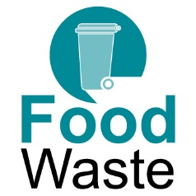  
  
**Food waste to re-start**

Food waste bin collections will resume next week. Following a temporary suspension of the service due to the coronavirus outbreak, green food waste bins will start being emptied once again from Monday 18 May. The smaller caddy type bins are collected weekly and should be placed alongside residual waste (black/grey) bins on people’s regular collections days.

**Support for health and social care**

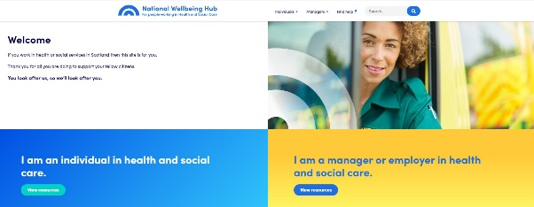A new national platform has been launched to help health and social care workers and carers look after their physical and mental health.

The new national digital wellbeing hub will enable staff, carers, volunteers and their families to access relevant support when they need it, and provides a range of self-care and wellbeing resources designed to aid resilience as the whole workforce responds to the impact of coronavirus (COVID-19).

Specifically tailored to support the challenges being faced by everyone in health and social care, the hub will provide advice on self-care and personal resilience to help users to recognise their own ‘warning signs’.

Comprehensive information about services and resources available at national and local level within NHS Boards, Health and Social Care Partnerships (HSCPs) and local authorities will also be available.

The new mental health [Clear Your Head campaign](https://clearyourhead.scot/) (pictured right) launched on 21 April to provide advice and support to help people cope during COVID-19.

Clear your head website: <https://clearyourhead.scot/>

The national Wellbeing Hub: <https://www.promis.scot/>