|  |
| --- |
| **Coronavirus (Covid-19) – briefing** |

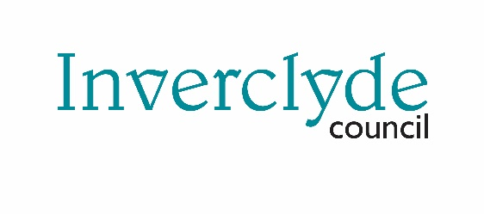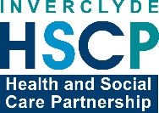

Issued 13 May 2020

|  |
| --- |
| **Below is the latest briefing on the activity in managing the response to coronavirus (Covid-19).**  **Local updates, council service changes and links to trusted sources of health guidance are published at *www.inverclyde.gov.uk/coronavirus*** |

**Latest covid death statistics**

Commenting on the latest release of covid-related deaths across Scotland, Inverclyde Council Leader, Councillor Stephen McCabe, said: “It is welcome news that the latest covid-related deaths for Inverclyde is showing a steady reduction.  While our area continues to be sitting at a higher level than other areas the reduction this week may be the one positive we have but it is no cause for celebration.

“Until there are no more reported cases consistently in our area and across the country each of us must continue to do all we can to protect our community from the worst effects of the virus .  Every single death, whether covid-related or from other reasons, is a personal tragedy touching our community and none of us should become complacent until we are free of this awful virus.

“Media reports and the more detailed analysis from the National Records of Scotland are highlighting a strong link between deprivation and levels of deaths by covid-19.  While we have been talking about the need for more analysis of this link for some weeks now the clear link now must be taken seriously to ensure that public policy interventions are directed to areas and communities of greatest need as part of our recovery.

“That recovery cannot be business as usual and must take clear account of the lessons learned from this virus and the devastation it has caused to communities and to address the underlying issues it has exploited.

“As individuals right now we can support each other by following the physical and social distancing guidance and the stay at home rules.  These are difficult for many of us and the restrictions will come at a cost.  The job you are doing is saving lives and right now we all need to make sure we concentrate on that goal of no more covid-related deaths.

The latest covid-related deaths in Inverclyde show that there have been 103 in total, an increase of four from last week.  Death per 10,000 in Inverclyde continues to be higher than all other areas of Scotland at 13 per 10,000.

**Business grants update**

The council has paid out more than £6.7m in business grants to 600 business across the area as part of the support for business.

The Scottish Government has announced extra support for charities.

Properties occupied by charities can now apply for the £10,000 ‘small business grant scheme’ to help with pressures caused by the coronavirus (COVID-19) pandemic.

The extension of the scheme is expected to result in an additional £31 million being made available to more than 3,000 small properties occupied by charities – including day centres, workshops and halls. It will apply to properties which are in receipt of any charitable rates relief or sports relief, but are otherwise eligible for the small business bonus scheme.

The full announcement is available at: <https://www.gov.scot/news/extra-support-for-charities/> and details of how to apply for the covid business support fund and for more information on support for business visit the business support and advice section at: [www.inverclyde.gov.uk/coronavirus](http://www.inverclyde.gov.uk/coronavirus)

**Crematorium change**

From Monday 18 May 2020, crematorium services will revert back to one hour after previously being reduced to half hourly.

**Scams alert**

The council is supporting a promotion by COSLA and trading standards Scotland, to help prevent local residents becoming victims of COVID 19 scams.

Officers from the council’s trading standards team have been dealing with a variety of reports of both cyber and doorstep scams in recent weeks.

Online scams have included quizzes that ask for personal information which can then be used to commit financial fraud or identity theft; fake emails, texts and calls claiming to be from HMRC, the NHS and the World Health Organisation (WHO); fake supermarket vouchers, and pop-up adverts that appear while people are shopping online apparently offering discount codes.

There have also been reports of companies offering to ‘cleanse’ properties of COVID-19 and of fraudsters cold calling households and posing as NHS or Red Cross staff.

More information and advice on scams is available at <https://www.tsscot.co.uk/coronavirus-covid-19/coronavirus-scams/>