|  |
| --- |
| **Coronavirus (Covid-19) – briefing** |



Issued 18 May 2020

|  |
| --- |
| **Below is the latest briefing on the activity in managing the response to coronavirus (Covid-19).**  **Local updates, council service changes and links to trusted sources of health guidance are published at *www.inverclyde.gov.uk/coronavirus*** |

**Testing changes**

Testing for coronavirus will now be available to anyone over five years of age with symptoms.

This means anyone who is displaying any of the three symptoms of covid-19 – continuous cough, high temperature, or loss of sense of taste or smell – will be able to book a test at the drive-through or mobile test centres.

A limited number of home test kits are also available through this programme.

Tests were previously available to over-65s, key workers and to anyone who needs to work and cannot do so from home. They were also available to household members of those groups. The extension is a four nation, UK-wide expansion of testing.

Tests can be booked online: **www.nhs.uk/coronavirus**

For those unable to access the portal, call 0300 303 2713.

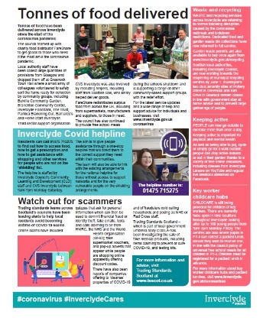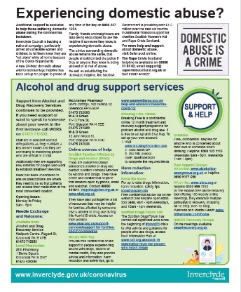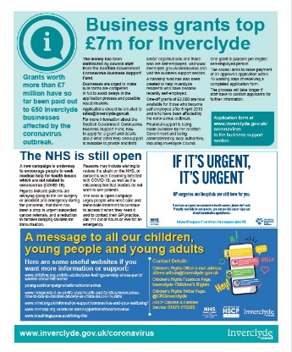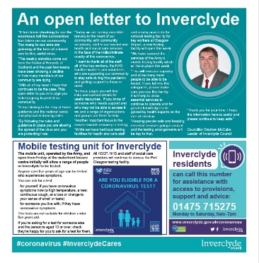Inverclyde’s mobile testing site will be open on Friday at Greenock’s Waterfront leisure centre car park. A publicity campaign will launch tomorrow (Wednesday) with targeted social media advertising, digital adverts on Inverclyde Now and a four-page supplement in the Greenock Telegraph (see below) with information on a range of services and campaigns and an appeal to the community to keep to the rules and guidance and to access testing.

**Coronavirus statutory sick pay scheme**

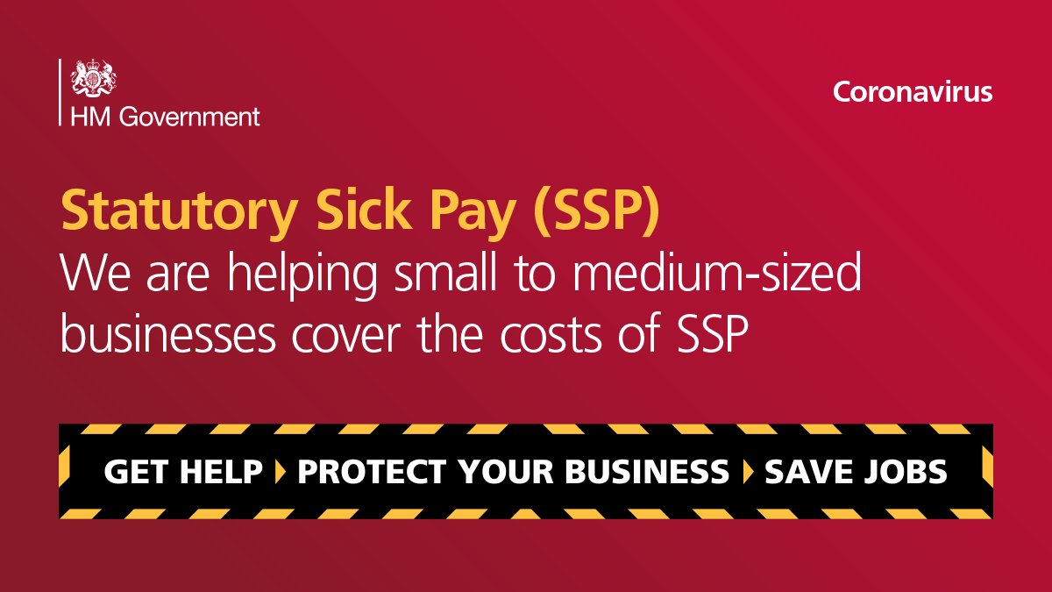A new online service will launch on May 26 for small and medium sized employers to recover Statutory Sick Pay (SSP) payments they have made to their employees.

The Coronavirus Statutory Sick Pay Rebate Scheme will allow small and medium sized employers, with fewer than 250 employees, to apply to HMRC to recover the costs of paying coronavirus-related SSP.

Employers will be able to make their claims through a new online service from May 26. This means they will receive repayments at the relevant rate of SSP that they have paid to current or former employees for eligible periods of sickness starting on or after 13 March 2020.

Employers are eligible if they have a PAYE payroll scheme that was created and started before 28 February 2020 and they had fewer than 250 employees before the same date.

The repayment will cover up to two weeks of SSP, and is payable if an employee is unable to work because they:

* have coronavirus; or
* are self-isolating and unable to work from home; or
* are shielding because they’ve been advised that they’re at high risk of severe illness from coronavirus

To prepare to make their claim, employers should keep records of all the SSP payments that they wish to claim from HMRC. Further guidance is available on GOV.UK

**Tackling violence against women and girls**

The Scottish Government has announced that councils will get more support to deal with increased levels of domestic abuse and gender-based violence during the coronavirus (COVID-19) outbreak.

The statement highlights that new guidance developed in partnership with COSLA will help women and children continue to get the best support that they deserve.

The guidance signposts to local resources, and assists decision-makers in identifying women and children at risk as well as the short, medium and long term steps they can take to support their recovery and wellbeing.

The guidance is part of a range of measures introduced to tackle higher levels of abuse and violence, including a £1.5 million funding package for the women’s aid and rape crisis network. It will help to maximise the effective protection and provision of support for those experiencing gender-based violence, both during this immediate crisis period and in the longer term.

Scotland’s 24hr Domestic Abuse and Forced Marriage Helpline is available on 0800 027 1234.

Rape Crisis Scotland Helpline is available on 08088 01 03 02. Calls to this number are free. Or email support@rapecrisisscotland.org.uk or text 07537 410027.

Link to new guidance: <https://www.cosla.gov.uk/__data/assets/pdf_file/0023/17762/COVID-19-Supplementary-VAW-Guidance-FINAL.pdf>

**Council’s policy and resources executive**

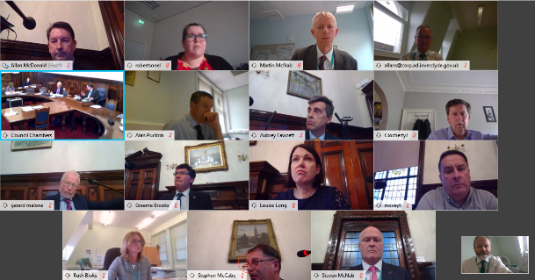The council’s policy and resources executive sub-committee met today (19 May 2020).

This was the first meeting of the council to take place by video conference with most participants dialling in remotely to ensure adherence to social and physical distancing rules.

The sub-committee is the only operational committee in Inverclyde Council after all others were cancelled and the delegation of full powers in the emergency to the Council’s policy and resources executive sub-committee.

The full sub-committee papers are published online at: <https://www.inverclyde.gov.uk/meetings/meeting/2260>

* A review of the council’s response to coronavirus (covid 19) where councillors were able to scrutinise the actions and activity of the council in responding to the pandemic and its effect.
* Councillors reviewed a report on covid-19 testing and access arrangements for key workers and the community including updates on the new temporary mobile testing facility and changes to the criteria for testing.
* A presentation was made to councillors showing a snapshot of the arrangements Inverclyde’s schools put in place to support young people and parents/carers to deliver home learning during the national lockdown.
* Councillors reviewed a report and approved a recommendation for delegated power to agree a tender for a delivery partner for energy efficiency services locally.
* Councillors reviewed contracts awarded by the council between 1 October 2019 and 31 March 2020.
* An update was presented to councillors on the proposal for the temporary lay-up of cruise ships including the correspondence between the council and Peel Ports.

Meeting notes from the Policy and Resources Executive sub-committee are published shortly after the meeting takes place at the council’s dedicated coronavirus section of the council website: <https://www.inverclyde.gov.uk/covid-19/council-emergency-committee>

**Cruise ship response**

Following a reply to the council from Peel Ports, the council has issued the following response to the media when asked for comment on the letter about a proposal to lay-up ships in the Clyde:

Inverclyde Council leader, Councillor Stephen McCabe, said: “Clearly their reply to the council is a wee bit ungracious.  Given the uncertain times we are living in we can forgive ungraciousness especially when noses are clearly out of joint over this issue.

“However, there is a clear failure to grasp genuinely held concerns from elected representatives both in the Council chamber and in the chamber of the Parliament over the pressure on health services.

“Especially at a time when we are suffering as a community and a country with so much loss.  There can be no doubt that Inverclyde has been and will continue to be a welcoming place for cruise ship visitors coming to Scotland and nothing in this situation is likely to affect that reputation.  Or for that matter our reputation as a port of safe harbour for anyone in distress – we don’t need to look back further than when one of Peel’s customers broke its moorings recently and the council and community without hesitation came together to much acclaim by passengers and crew to support them.

“Peel has confirmed that there are no current plans in place to anchor ships and that helps to reduce any concerns we had of the potential for unnecessary pressure on health services in the area.  It does not remove those concerns entirely.  It is clear that there is a gap exposed here over this situation and it may be that there is a need for a more defined national response.

“It could be that a grown up conversation needs to take place across the country about the role of port authority and whether in modern Scotland it is appropriate that this sits with a commercial organisation.  Our parliamentarians may wish to consider whether this situation has exposed a need for legislation on this issue.”

The policy and resources executive sub-committee decided that officers meeting representatives from Peel Ports officers should meet with Peel, find out their plans, convey the councils strong opposition at this time and to find out more about the representations of the areas MP and MSP to find out their status and report back to assess whether the Council should make joint representation to the UK and Scottish Government.

Background papers and letters are available to view here: <https://www.inverclyde.gov.uk/meetings/meeting/2260>