|  |
| --- |
| **Coronavirus (Covid-19) – briefing** |

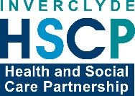

Issued 21 May 2020

|  |
| --- |
| **Below is the latest briefing on the activity in managing the response to coronavirus (Covid-19).**  **Local updates, council service changes and links to trusted sources of health guidance are published at *www.inverclyde.gov.uk/coronavirus*** |

**Scottish route map published**

[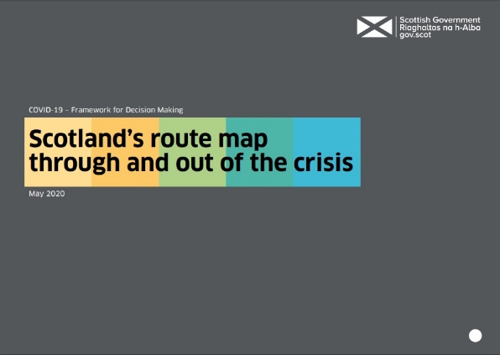](https://www.gov.scot/publications/coronavirus-covid-19-framework-decision-making-scotlands-route-map-through-out-crisis/)The Scottish Government has published its route map for covid-19 today.

The full document is available to download at the Scottish Government website: <https://www.gov.scot/publications/coronavirus-covid-19-framework-decision-making-scotlands-route-map-through-out-crisis/>

The route map gives an indication of the order in which the country will seek to change the current restrictions using practical examples of what people, organisations and businesses can expect to see change over time.

[BBC Scotland](https://www.bbc.co.uk/news/live/uk-scotland-52664448) has produced a brief summary of the four phases:

Lockdown – Stay at home except for exercise, medicine and essential work

Phase 1 – Virus not yet contained but cases falling. Start of easing from 28 May allowing some meeting outdoors.

Phase 2 – Virus controlled. Construction, factories, warehouses, laboratories, and small shops start to resume work. Professional sport can begin again.

Phase 3 – Virus suppressed. Schools should reopen from 11 August. Non-essential offices, gyms, museums, libraries and cinemas can open along with some live events. Larger shops, pubs, restuarants, hairdressers and dentists reopen.

Phase 4 – Virus no longer ‘significant threat’. University and college campuses reopen in full, mass gatherings allowed. All workplaces open and public transport is back at full capacity.

**Business grants update**

Scottish Government Coronavirus Business Support Fund criteria has been expanded to include more ratepayers to help with pressures caused by the coronavirus (COVID-19) pandemic.

Properties occupied by charities eligible for the Small Business Bonus Scheme but in receipt of Charitable Rates Relief or operating in the retail, hospitality or leisure sector are eligible and ratepayers who receive Sports Relief can now apply.

The scheme is expanded to businesses with multiple properties and it has now been clarified that estate agents, letting agents and events companies may also be eligible depending on the main focus of their business activity.

More information at: <https://www.inverclyde.gov.uk/covid-19/business-support>

**Foodbank – public holiday update**

Please note that Inverclyde Foodbank will be closed on Monday 25 May 2020 due to the public holiday. The Foodbank will reopen and resume deliveries on Wednesday 27 May 2020. Referrals for those who are likely to be in need at the start of next week are encouraged to be processed where possible before 1pm on Friday 22 May 2020 to enable delivery that afternoon.

Please also note that all parcels contain supplies for 3-5 days of food. If you have any queries please don't hesitate to be in touch by email or by calling 01475 787177.

**Emergency coronavirus legislation agreed**

The Scottish Parliament has supported new emergency measures related to covid-19 (coronavirus) pandemic.

The statement from the Scottish Government read:

The Coronavirus (Scotland) (No.2) Bill, now passed by Parliament, gives powers to Scottish Ministers to temporarily intervene and manage care home services where there is a serious risk to the life, health or wellbeing of any person in that home for any reason connected with COVID-19.

The Bill also includes an additional £19.2 million investment in the Carer’s Allowance Supplement, the introduction of notice to leave periods for students in purpose-built student accommodation, and additional protections for those facing bankruptcy.

During the debate, Housing Minister Kevin Stewart has also confirmed an additional £5 million will be made available to local authorities through Discretionary Housing Payments, to support tenants who are now under severe financial pressures.

There are also legislative changes in areas including non-domestic rates relief, proceeds of crime and the wider operation of Scotland’s criminal justice system. The Bill also ensures that COVID-19 grant funding goes to those companies that pay their fair share of tax by excluding those who seek to minimise their tax arrangements to the detriment of the wider economy.

The Coronavirus (Scotland) (No.2) Bill and supporting documents can be read on the Scottish Parliament website at: <https://beta.parliament.scot/bills/coronavirus-scotland-no2-bill>

**Reminder – coronavirus testing**

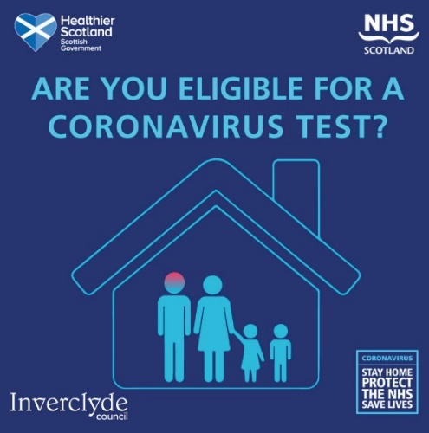Testing for coronavirus is available to anyone over five years of age with symptoms.

This means anyone who is displaying any of the three symptoms of covid-19 will be able to book a test at the drive-through or mobile test centres.

The symptoms are: continuous cough, high temperature, or loss of sense of taste or smell.

A limited number of home test kits are also available through this programme.

Tests were previously available to over-65s, key workers and to anyone who needs to work and cannot do so from home. They were also available to household members of those groups. The extension is a four nation, UK-wide expansion of testing.

Tests can be booked online: [**www.nhs.uk/coronavirus**](http://www.nhs.uk/coronavirus) For those unable to access the portal, call 0300 303 2713.

**Emma Thompson donates PPE to IRH**

Actress Emma Thompson donates PPE to Inverclyde Royal Hospital through Mail Force charity

Renowned actor, screenwriter and activist Emma Thompson has kindly donated PPE to Inverclyde Royal Hospital through the Mail Force charity campaign. She has also sent a video message to NHSGGC staff you can watch below.

Thompson, who has always split her time between London and the West of Scotland, is currently staying with her family in Dunoon. She saw that Inverclyde was one of the worst hit areas in Scotland by COVID-19 and reached out to support.

Thanks to her donation, the charity Mail Force, has donated 5,000 aprons to Inverclyde Royal Hospital. Aprons are one of the vital pieces of personal protective equipment needed to protect staff and patients from COVID-19. The aprons will go towards building Inverclyde Royal Hospital’s reserve stock. NHS Greater Glasgow and Clyde currently has good supplies across its hospitals.

Read the full story here: <https://www.nhsggc.org.uk/about-us/media-centre/news/2020/05/actress-emma-thompson-donates-ppe-to-inverclyde-royal-hospital-through-mail-force-charity/>