|  |
| --- |
| **Coronavirus (Covid-19) – briefing** |

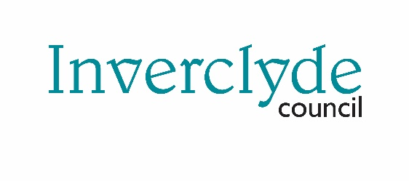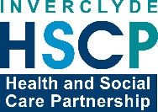

Issued 26 May 2020

|  |
| --- |
| **Below is the latest briefing on the activity in managing the response to coronavirus (Covid-19).**  **Local updates, council service changes and links to trusted sources of health guidance are published at *www.inverclyde.gov.uk/coronavirus*** |

**Sick pay scheme opens for applications**

Small businesses and employers across the UK who have paid statutory sick pay to staff taking coronavirus-related leave will be able to claim back the money from today (Tuesday 26 May 2020).

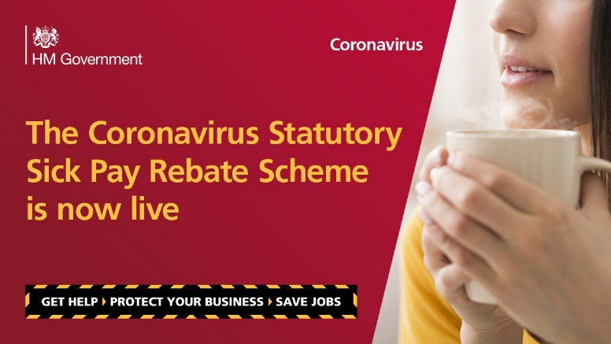The scheme, run by HMRC, covers all types of employment contracts, including:

•full-time employees

•part-time employees

•employees on agency contracts

•employees on flexible or zero-hour contracts

•other SSP eligibility criteria apply

•tax agents can make claims on behalf of their employers

•Connected companies and charities can also use the scheme if their total combined number of PAYE employees are fewer than 250 on or before 28 February 2020. Employees do not have to provide a doctor’s fit note in order for their employer to make a claim under the scheme make a claim.

•The repayment will cover up to two weeks of SSP from either 13 March 2020, if an employee had coronavirus, symptoms or is self isolating because someone they live with has symptoms, or from 16 April 2020 if an employee was shielding because of coronavirus.

•Employers can furlough their employees who have been advised to shield in line with public health guidance and are unable to work from home, under the Coronavirus Job Retention Scheme. Once furloughed, the employee should no longer receive SSP and would be classified as a furloughed employee. Where an employee has been notified to shield and has not been furloughed, the rebate will compensate up to 2 weeks of SSP from 16 April.

Here is a link to online guidance and application: <https://www.gov.uk/guidance/claim-back-statutory-sick-pay-paid-to-employees-due-to-coronavirus-covid-19>

**Coronavirus (COVID-19): Test and Protect**

The Scottish Government has released information about new test, trace and isolate programme which will be promoted as ‘test and protect’.

How test and protect works

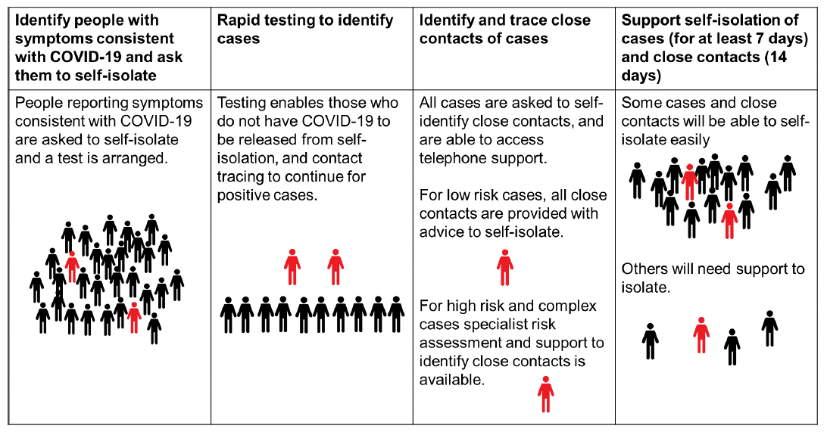

Here is a link to summary guidance: <https://www.gov.scot/publications/coronavirus-covid-19-test-and-protect-summary/>

Here is a link to Information and support for people who are asked to self-isolate because of COVID-19: <https://www.gov.scot/publications/coronavirus-covid-19-test-and-protect/>

Here is a link to advice for employers on helping staff who need to self-isolate at home: <https://www.gov.scot/publications/coronavirus-covid-19-test-and-protect-advice-for-employers/>