|  |
| --- |
| **Coronavirus (Covid-19) – briefing** |



Issued 28 May 2020

|  |
| --- |
| **Below is the latest briefing on the activity in managing the response to coronavirus (Covid-19).**  **Local updates, council service changes and links to trusted sources of health guidance are published at *www.inverclyde.gov.uk/coronavirus*** |

**Test and protect**

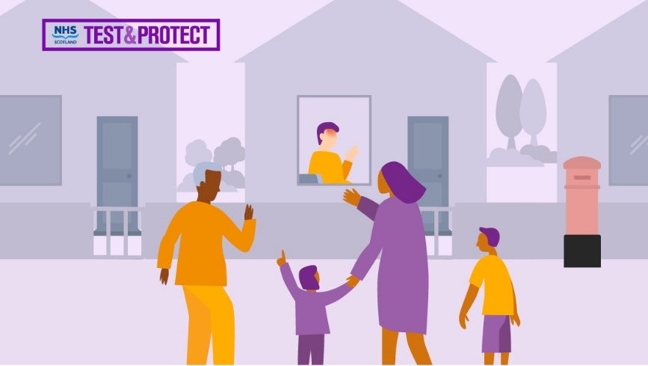Test and protect is NHS Scotland’s new approach to controlling the spread of coronavirus (COVID-19) in the community.

The system will help to prevent you from spreading the virus, and protect the country from a second peak.

But, just like lockdown, it can only work if we all play our part.

From today (Thursday 28 May 2020), if you have any of the symptoms of COVID-19 – a new continuous cough, temperature or loss or change of taste or smell – you should immediately visit NHS Inform or call 0800 028 2816 if you can’t get online.

It is really important you do this as soon as you suspect you have symptoms. The quicker the NHS can tell if you have the virus, the better chance we all have of stopping it spreading.

When you contact the NHS you will be able to book a test at a mobile testing unit, a drive-through testing centre or order a home testing kit.

While you wait for that result, it is important that you and everyone in your household self –isolates.

If you test positive, you will need to self-isolate for 7 days, and your household for 14.

That has always been the case. What’s new is that now, as we begin to ease some of the lockdown measures, in order to keep the virus suppressed, we will also need to trace your close contacts and advise them to isolate for 14 days, with support.

So if you get a positive test result you will be asked who you have been in close contact with. This includes people in your household, people you have had direct face to face contact with for any length of time, and those you have been within 2 metres of for 15 minutes or more.

This NHS system is entirely confidential, when the people you have been near are contacted they will not be told who it is that they have been in contact with. This information is only collected and used by NHS Scotland for the purposes of tracing your contacts. The Scottish Government will not have access to it.

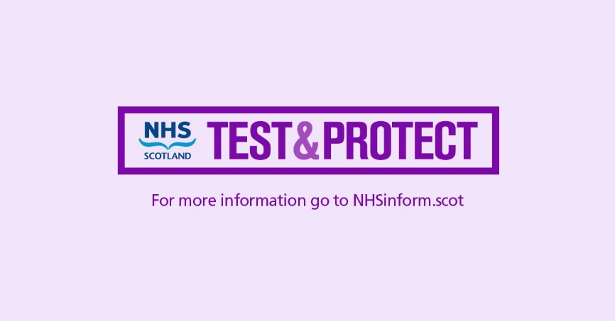If you receive a call or a message from a contact tracer to say you have been in contact with someone who has tested positive, they will ask you to self-isolate immediately. It is hugely important you do this in order to stop the spread of the virus.

It is only by all playing our part, getting tested, providing information and agreeing to isolate, that we can cut the numbers of people getting the virus.

You can find guidance on the Scottish Government website to help you self-isolate, which includes advice on what to do if you care for someone who is shielding, and how you can access food and medicine. It’s also a good idea to take steps to ensure that you are prepared in advance, in case you are ever asked to isolate.

For those who cannot leave their home and who cannot get the help they need from family, friends or online, the National Assistance Helpline (0800 111 4000) is available Monday to Friday, from 9am 5pm.

We have also published guidance for employers which makes clear that they should support anyone who needs to self-isolate as part of Test and Protect. We are also working with the UK Government to ensure that people are fully protected by their employment rights and benefits, such as Statutory Sick Pay as a minimum.

Of course, the best way to avoid having to isolate, is to follow the rules on physical distancing and stay 2 metres apart from anyone outside of your own household.

Test and Protect will be part of all our lives for the foreseeable future, until we know we have fully suppressed the virus, or there is a treatment or a vaccine that we can be confident will protect people properly.

So as we slowly change the lockdown restrictions, for everyone to enjoy more freedoms, we must all play our part by isolating when we are asked to.

For more information go to [NHSinform.scot](https://www.nhsinform.scot/)

Coronavirus (COVID-19): Test and Protect - advice for employers: <https://www.gov.scot/publications/coronavirus-covid-19-test-and-protect-advice-for-employers/>

**Business grants update**

The latest data on business grants issued across Scotland shows that Inverclyde Council has processed £8.1m of grants to 731 businesses.

**Easing out of lockdown**

Scottish Government announcement today that Scotland is now at ‘phase 1’ of the route map out of lockdown.

At the Scottish Government daily briefing the First Minister announced “careful and cautious” changes to the current lockdown regulations.

The focus of our Phase 1 changes is on outdoor activity.

In the First Minister’s speech, she highlighted:

* From tomorrow (Friday 29 May 2020), most outdoor work that has been put on hold can resume, and the construction industry will be able to restart site preparation – that’s the first phase of its restart plan. It will require to consult further with government before moving on to the second stage of that plan. See further guidance published by The Scottish Govenrment for the construciton sector at: <https://www.gov.scot/publications/coronavirus-covid-19-construction-sector-guidance/>
* From tomorrow (Friday 29 May 2020), garden centres and plant nurseries can reopen some of their services, and we will no longer be discouraging drive-through food outlets from re-opening as well.
* However, non-essential shops, and pubs, restaurants and cafes - except for takeaway - must remain closed at this stage.
* [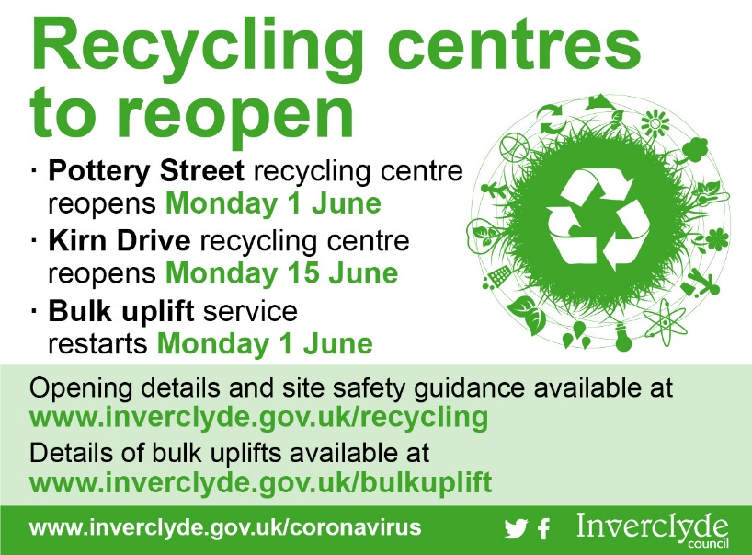](https://www.inverclyde.gov.uk/recycling)Household waste recycling centres can re-open from Monday. More information on Inverclyde’s arrangements is available at: [https://www.inverclyde.gov.uk/  
  news/2020/may/recycling-centres-set-to-reopen](https://www.inverclyde.gov.uk/news/2020/may/recycling-centres-set-to-reopen)
* Other business premises should remain closed at this stage, unless providing essential goods and services, and we ask all businesses to let staff work from home wherever possible.
* From Monday onwards, 1 June, teachers and other staff will be able to enter schools for the purpose of preparing for a re-opening of all schools on 11 August, for a blended in school / at home model of learning. See correspondence in this edition of Coronavirus (covid-19) briefing sent to staff in schools and establishments.
* Childminding services and fully outdoor nursery provision will start to reopen from next Wednesday too. However, there will continue to be limits on the number of children that can be cared for, and guidance for childminders will issue on Monday.
* During Phase 1, some key public services - for example some respite care, children’s hearings and some key health programmes - will also begin to restart their work, and further announcements on timing will be made in due course.
* Some non-contact outdoor leisure activities will be allowed to restart – again from tomorrow. This applies to activities where you can safely keep a two metre distance from others at all times and follow strict hygiene practices - for example golf, tennis, bowls and fishing.
* You will also be able, from tomorrow (Friday 29 May 2020), to sit or sunbathe in parks and open areas.
* You will be able to travel – preferably by walking or cycling - to a location near your local community for recreation. However we are asking you, for now, to please stay within, or close to, your own local area, ideally less than five miles. And don’t use public transport unless it is absolutely necessary.
* It is still the case that you should not go to our island communities, except for essential reasons.
* From tomorrow, (Friday 29 May 2020), the regulations on meeting other people will change.
* You and your household will be able to meet with another household out of doors – for example in a park or in a private garden. This should be in small groups - and to give you greater guidance on that, we are asking that the total number of people between the two households meeting up should be a maximum of eight. Please keep it to less than that if you can. Before you meet up with people from another household you should stop, think, read the guidance and make sure you are protecting yourself and others. In particular, you must stay outdoors and stay at least two metres away from people from the other household. That is crucial.

The overall advice continues to be:

* Still stay at home as much as possible – the virus has not gone away. Lockdown is being modified slightly - it is not over.
* Make sure you are still seeing far fewer people than you might normally do.
* Don’t meet up with more than one other household at a time, don’t meet more than one a day and keep to a maximum of eight people in a group.
* Stay two metres apart when you do meet.
* Whether it’s parents, grandparents, aunties, uncles, siblings, partners from other households - don’t put your loved ones or yourself at risk.
* Wash your hands regularly and thoroughly.
* Avoid hard surfaces - and clean any that you are touching.
* If you have symptoms, get tested and follow the advice on self-isolation.

Here is a link to the routmap out of lockdown published by the Scottish Government on 21 May 2020: <https://www.gov.scot/publications/coronavirus-covid-19-framework-decision-making-scotlands-route-map-through-out-crisis/>

Here is a link to construction sectory guidance published by the Scottish Government: <https://www.gov.scot/publications/coronavirus-covid-19-construction-sector-guidance/>

Here is a link to detailed coronavirus (COVID-19): staying at home and away from others (physical distancing) guidance: <https://www.gov.scot/publications/coronavirus-covid-19-staying-at-home-and-away-from-others/>

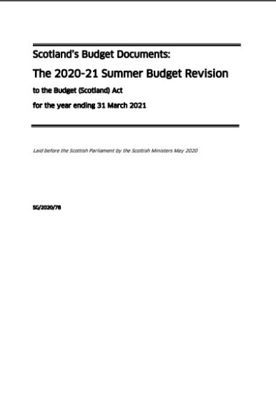**Covid-19 budget revision**

The Scottish Government has published a breakdown of spending measures as part of the response to the coronavirus (covid-19) pandemic.

The report reveals that spending on measures to counter the pandemic has reached just over £4 billion

The total includes support for business, health services and transport.

The details are contained in an exceptional summer budget revision laid before the Scottish Parliament

It is available online at: <https://www.gov.scot/publications/2020-21-summer-budget-revision/>

**Joint education message issued**

A joint communication is being issued today to all staff working in schools and early year’s establishments on behalf of the council and the trade unions.

These have been extraordinary times and the purpose of this joint letter is to explain to all staff working in schools and early year’s establishments how we in Inverclyde hope to undertake the recovery process in our establishments. We would like to begin this letter by thanking you all for your hard work and commitment over the last few months.

As a team we have continued home learning offers for almost 10,000 pupils, ensured over 3,600 children have received free school meals and we have provided childcare hubs for up to 180 young people each day. This could not have happened without the dedication and hard work of all the staff who have worked in innovative ways to get the jobs done. It also could not have happened without ongoing constructive discussions with trade unions to work in a solution focussed way.

Each of us will have had our own personal journey through COVID-19. Some of us will have lost loved ones, colleagues and friends. Everybody will be apprehensive as we begin our journey towards recovery and will have lots of questions about what this journey looks like. The purpose of this letter is to outline the proposed pathway over the next few weeks as Inverclyde begins its journey towards recovery.

The journey towards recovery is aimed at giving time for education communities to get together, to discuss concerns and to be in the best position possible to meet the needs of our young people and their families. The journey will follow national guidance and be informed by the scientific research and public health guidance.

The guidance will be constantly developing, constantly under scrutiny and constantly evaluated. On 21st May the Scottish Government outlined the strategic framework for reopening schools, early learning and childcare provision in Scotland.

This week we have engaged with staff returning to work to ask about childcare needs and your health status. We do not yet know exactly what the guidance will say about those who can return to work, but we know that the guidance asks that all staff who are able to, return to establishments in the middle of June.

Also this week facilities management have been cleaning the establishments to ensure that they have had a thorough clean prior to staff returning. We have also agreed enhanced cleaning schedules for establishments on their return and worked with the health and safety team to work through guidance on risk assessments.

Work has begun on toolkits which are meant as a supportive measure to help establishments undertake their recovery plans. Establishments have begun to work with the school estates management team to look at the physical distancing required to open schools and early year’s settings and we know that national guidance on this will be issued in the very near future.

Currently people who are subject to the 12 week self-isolation period from the original guidance and not because of recent symptoms may well be doing so until the 18th June.

This guidance will be subject to review and ongoing communication.

Next week (week beginning the 1st June) the senior management teams of establishments will begin to plan for the childcare hubs to be run from every school and early years’ establishment rather than rely on 9 hubs across Inverclyde.

This is because we recognise that as school staff return to school, they will require childcare and we want to be in the best position to be able to offer this for all of our staff. We will begin to open the establishments for staff who are able to attend.

This means that time has been allowed for teams to meet together, to plan and to be part of risk assessments and planning. It also gives the senior management teams an opportunity to answer questions and alleviate concerns you may have.

Please be assured that if you should not be at work there is no requirement for you to attend. By allowing a phased approach we hope to be able to allow time to work through any issues raised and to proceed in small steps towards everybody returning to school or their early year’s setting.

You may well have questions about the schedule for this week and management teams will be in touch to be as flexible as possible to match your own circumstances. We accept that members of staff with very young children (under 3) may have particular concerns about childcare arrangements. We ask that members of staff seek solutions for childcare e.g. shared between a child’s parents if possible but we will not expect staff with very young children to use childcare hubs.

In the week beginning the 8th June childcare hubs will be run from all schools and early year’s establishments. This helps to disperse the workload around all establishments and means that everyone is working together to support each other as we move towards welcoming targeted pupils the following week and an opening in August.

Children at key transition points (such as P1 and S1) and those with additional support needs are apprehensive about coming back to school and we hope to welcome some of our youngsters to visit the buildings to provide reassurance from 10th June. This is not intended to be a formal 2 day induction process.

In the week beginning the 15th June, it is expected that all those staff who are able can return to school. Childcare should be in place for most members of staff who require this (although particular arrangements may be in place for those with very young children). Care must be taken to manage workload at this point, especially for teaching staff who may be providing remote learning, setting up classrooms and providing childcare.

Therefore by becoming part of effective rota systems we hope that everyone can play their part to be as supportive as possible to colleagues and to ensure that we are able to provide childcare for the most vulnerable young people and children of keyworkers. All staff groups should return to school or their establishment but there may be some occasions where staff cannot maintain social distancing if they all attend e.g. a small office, and if this is the case then a rota system can be set up.

Term finishes on 26th June and all teaching will stop on this date. Childcare hubs will continue to run over the summer for children of key workers and for the most vulnerable. There is a requirement to provide this service throughout the summer holiday period and we will be working with some staff to ask for help to provide supervision for the hubs over this period. You will appreciate that this is new for all of us and we will do our very best to provide staffing to meet the demand.

The term will begin on the 11th rather than the 14th August. Because this is three days earlier than previously planned, the academic year will finish 3 days earlier in June 2021. This will mean that all term time contracts have an exact amount of teaching and contact days.

Throughout the recovery phase and the reopening of establishments there will continue to be regular meetings between officers and the trade unions. At the regular meetings any issues can be picked up. If you have any concerns then these should be raised in the first instance with your line manager to address.

Whilst we have a road map through the recovery process, nobody has all of the answers and we will not always get everything correct first time. However through joint working and good communications we very much hope to be as supportive as possible to keep our staff safe and to welcome back our young people to ensure we continue to give them the best start in life.

**Coronavirus travel information: Scotrail**

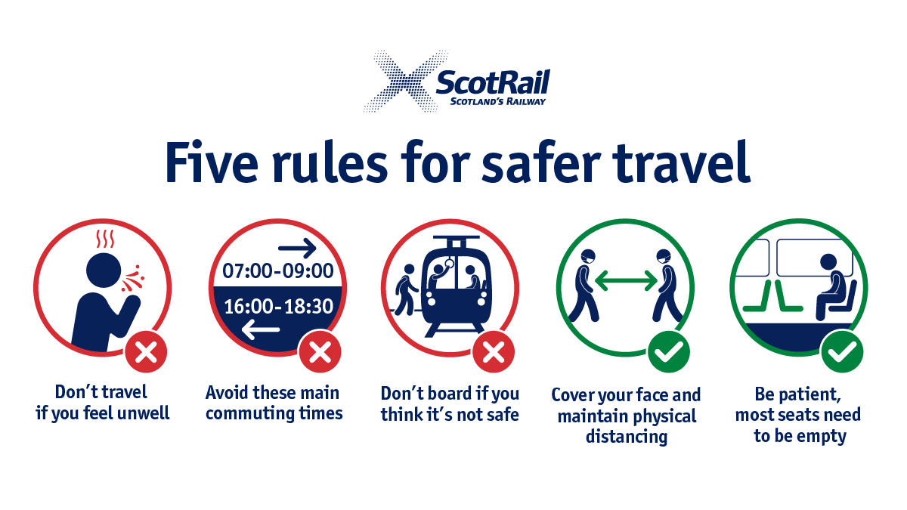Scotrail has published guidance and advice on safe rail travel for anyone travelling for essential journeys.

Their message, published below, includes their five steps to safe rail travel (right):

Scotland’s Railway is playing a critical role help our country emerge from the Coronavirus pandemic – providing transport for key workers such as NHS staff, emergency workers and carers.

The Government has made it clear that public transport remains for essential journeys only, so that key workers and our staff can maintain a physical distance from each other. If your journey is not essential, please do not travel.

If you do need to travel with us, please think about your safety, and the safety of others.

We urge you to use a face-covering at stations and on trains, and if you think it’s not safe to board a train, don’t do it and wait for another service.

We are continuing to operate a revised timetable, with a focus on providing a service in areas of the country, and at times, where people need it most. The timetable includes earlier and later services for NHS workers at hospitals after consultation with health boards, and through feedback from customers on the services that are still being well used.

Our major stations have floor markings and other signs to outline a safe distance of two metres, while some station facilities such as waiting rooms are closed. In order to maintain a physical distance from others, please expect an increase in the time it takes to buy a ticket at a station and board a train.

There may be occasions over the coming months when boarding your normal train may not be possible in busier times. Buying tickets in advance through the ScotRail app or website will reduce your need to wait. Our timetable will be kept under regular review, and we'll react to any further developments.

The full statement is available at: <https://www.scotrail.co.uk/about-scotrail/news/scotrail-urges-customers-play-their-part-and-cover-their-face-while-travelling>

**Colleges and universities phased return planning**

Scotland’s colleges and universities are gearing up for a phased campus return for the next academic year as COVID-19 lockdown restrictions are gradually lifted.

When institutions suspended face-to-face teaching in March to protect staff and students, they were able to quickly switch to online teaching and assessment, providing students with equipment to access online learning.

Under the Scottish Government’s route map through and out of the coronavirus crisis, the third phase would see universities and colleges return next term with most planning for an initial combination of digital and blended learning with public health measures, including physical distancing in place.

Any changes to the approach outlined in the Scottish Government’s route map will be evidence based, with the safety of students and staff being of paramount importance.

Read the full statement here: <https://www.gov.scot/news/colleges-and-universities-preparing-for-phased-return/>