|  |
| --- |
| **Coronavirus (Covid-19) – briefing** |



Issued 2 June 2020

|  |
| --- |
| **Below is the latest briefing on the activity in managing the response to coronavirus (Covid-19).**  **Local updates, council service changes and links to trusted sources of health guidance are published at *www.inverclyde.gov.uk/coronavirus*** |

**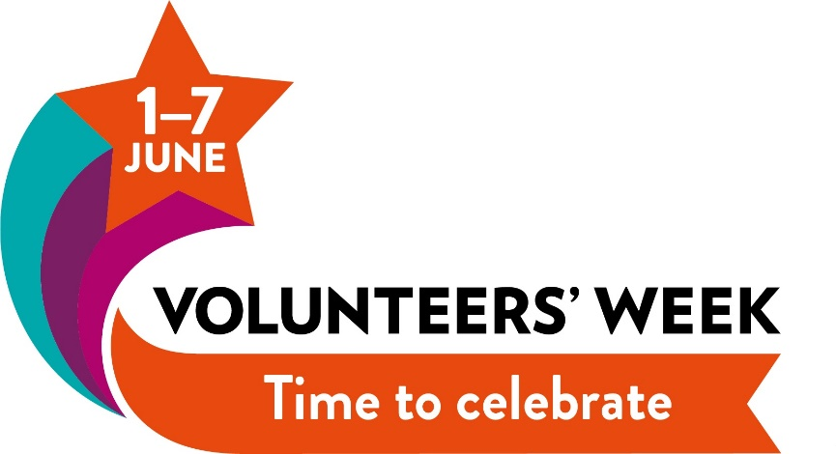  
Celebrating volunteers’ week**

This week is volunteers’ week across the country and residents are being encouraged to thank and support the hundreds of volunteers across the UK.

Inverclyde Council Leader, Councillor Stephen McCabe, sent a video message thanking volunteers and the work of CVS Inverclyde:

“I just want to thank all of Inverclyde’s volunteers, supported by CVS for all the wonderful work they do throughout the year but especially at this time of major challenge for our community. Thank you.”

Visit [www.cvsinverclyde.org.uk](http://www.cvsinverclyde.org.uk) to find out more about CVS Inverclyde and local opportunities to get involved in volunteering across Inverclyde.

**Coronavirus testing reminder**  
Testing for coronavirus is available to anyone over five years of age with symptoms.

This means anyone who is displaying any of the three symptoms of covid-19 will be able to book a test at the drive-through or mobile test centres. The symptoms are: continuous cough, high temperature, or loss of sense of taste or smell. Home test kits are also available through this programme.

[](http://www.nhsinform.scot/coronavirus)Tests can be booked online: [www.nhsinform.scot/coronavirus](http://www.nhsinform.scot/coronavirus)  For those unable to access the portal, please call 0800 028 2816.

**Schools update to parents**

The letter below has been issued to parents and carers of children at Inverclyde Council schools today from education director Ruth Binks:

*The Scottish Government has outlined the strategic framework for reopening schools, early learning and childcare provision in Scotland. The purpose of this letter is to outline the proposed next steps schools and early years settings in Inverclyde will take towards reopening. Our plans will follow national guidance which is informed by the available scientific research and public health guidance. The national guidance will be constantly developing and there may be a need for plans to change in light of this.*

*During the last few weeks we have set up regular meetings with the chairs of parent councils, the youth council and representatives from the workforce to discuss with them the various options ahead. This week we will issue a survey to all parents to ask you about your anticipated childcare needs as we move forward.*

*The table below outlines the proposed next steps until the end of this term:*

*Monday 8th June*

* *Existing childcare hub pupils to attend their normal establishment*

*Monday 10th June – end of term*

* *Schools and early years settings will be in contact with parents of those at key transition points (those starting P1/S1) to arrange visits in small groups*
* *Schools and early years settings will be in contact with any pupils who require enhanced transition arrangements*

*All our schools and early years’ establishments will re-open in August. The Government has asked that all schools re-open on 11th August and please note this date is earlier than Inverclyde establishments had planned to return. The allocation of in-service days is yet to be finalised nationally and we will contact you as soon as the exact dates are known.*

*Because of the continued need to socially distance there will be a mix of blended learning at schools and early years’ establishments. This means that your child will be in their school/establishment for some days and learning from home for others. We are currently working through exactly what this will look like and further information will be available in the coming weeks.*

*When you receive your survey about your intended childcare arrangements, it is important that you return this to us quickly so that this can help us in our planning. We cannot say at this stage whether this childcare will be at your child’s school or another venue.*

*Each of us will have had our own personal journey through COVID-19. Some of us will have lost loved ones, colleagues and friends. Everybody will be apprehensive as we begin our journey towards recovery and will have lots of questions about what this journey looks like. Schools and establishments are busy working through the guidance and preparing to welcome your child back. They are carrying out risk assessments and ensuring that all possible measures are put in place to keep your child as safe as possible.*

*In the meantime, your head teacher/head of establishment will keep in contact with you over the coming weeks about the particular arrangements in place for your child’s education.*

*Additional Information for Parents of Children in Early Learning and Childcare (Nurseries)*

*Early Learning and Childcare Admissions – Session 2020 / 21*

*If your child will be in early learning and childcare next session then this part of the letter provides an update on your child’s nursery allocation for session 20 /21. You may be aware that Scottish Government has removed the legislation for the implementation of 1140 hours due to the impact of COVID-19. Within Inverclyde good progress has been made with the 1140 hours implementation plan: this includes new staff being recruited, buildings remodelled and expanded and many establishments already providing 1140 hours of provision. This progress means we can go ahead and offer expanded hours for all eligible children during session 2020 / 2021.*

*COVID-19 restrictions will impact on starting dates and attendance patterns. Most placements will be significantly reduced to ensure staff and children’s safety and wellbeing. Guidance on this from Scottish Government will be published on 15th June 2020. As restrictions are lifted placements will increase until your child is able to access his / her full entitlement.*

*The Head of Centre / Headteacher of your child’s nursery will write to you on Friday 19th June 2020 with details of your child’s 1140 hours allocation for session 2020 / 21 and his/ her COVID-19 placement and start date.*

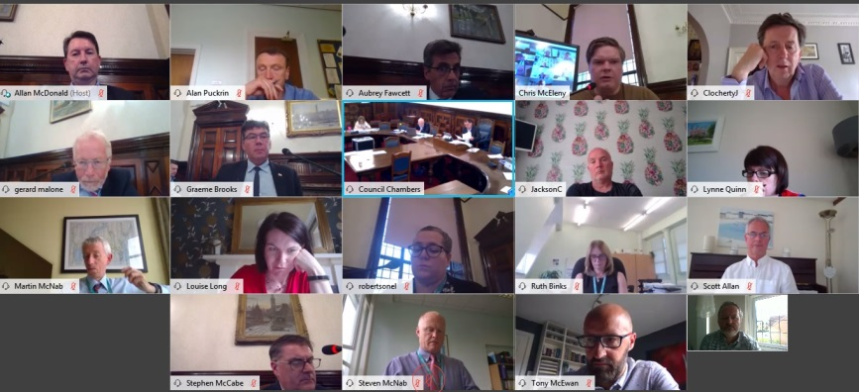**Council policy & resources executive committee**

The council’s policy and resources executive sub-committee met today (2 June 2020).

This was the first meeting of the council to take place by video conference with most participants dialling in remotely to ensure adherence to social and physical distancing rules.

The sub-committee is the only operational committee in Inverclyde Council after all others were cancelled and the delegation of full powers in the emergency to the Council’s policy and resources executive sub-committee.

The full sub-committee papers are published online at: <https://www.inverclyde.gov.uk/meetings/meeting/2261>

A review of the council’s response to coronavirus (covid 19) where councillors were able to scrutinise the actions and activity of the council in responding to the pandemic and its effect.

* Councillors reviewed a report on covid-19 actions taken by the council since the last meeting, issues around testing and, in a separate report, the financial update from the council.
* Councillors received an update on the local arrangements for shielding and humanitarian assistance centre.
* A motion was proposed by Councillor Colin Jackson calling for an emergency package to prevent child poverty crisis. The motion was agreed by the council.
* Councillors heard a report highlighting the support to care homes across Inverclyde.
* A report was presented updating councillors on Inverclyde’s mental health and wellbeing services and the issues raised as a result of coronavirus (covid-19).
* Proposals were presented to councillors for the administration arrangements for a new cycle of council, committee, sub-committee and board meetings to June 2021 which were agreed for a cycle of meetings and will be subject to review.
* A report was presented highlighting arrangements for reopening schools, early learning and childcare provision as a result of physical distancing and lockdown easing.
* Councillors reviewed a report highlighting the issues, costs and arrangements required to put in place enhanced cleaning in schools and establishments as a result of covid-19 recovery plans.
* A report was presented highlighting arrangements for recovery planning across the council and health and social care services including the creation of an informal members sounding board.
* A report was examined highlighting National Records of Scotland (NRS) mid-year population estimates (2019) and population projections (2018 based) for Scottish council areas. The recommendations were amended following a change proposed by Councillor Robertson to review previous studies into repopulation issues carried out by the council and other issues around statistical data.
* A further report on the proposed temporary lay-up of cruise ships by Peel Ports highlighting the representations national politicians made to the UK and Scottish Governments on this issue.

Meeting notes from the Policy and Resources Executive sub-committee are published shortly after the meeting takes place at the council’s dedicated coronavirus section of the council website: <https://www.inverclyde.gov.uk/covid-19/council-emergency-committee>

**Blue bins on the way back**

Blue recycling bin collections will resume across Inverclyde in two weeks’ time.

The service will restart on Monday 15 June after the council struck a deal with its existing contractor to allow a temporary company to take over the reins for three months.

Fortnightly kerbside blue bin collections were suspended on 30 March, primarily because of staff shortages caused by the coronavirus pandemic.

The council does not have the means to store and process dry recyclables so that element of the service is outsourced.

While local authority staffing levels have since returned to a level that will allow household uplifts to resume, the current contractor is still experiencing problems meaning the waste cannot be collected and sorted.

Council officials have now reached an agreement that will allow another company to take over until September.

**Childminder services guidance**

The Scottish Government has published guidance to support childminding settings closed during lockdown, to reopen during Phase 1.

This guidance sets out principles for childminding services across Scotland and provides clarity on practical approaches to safely operating in a childminding setting.

Visit this page to find out more about the detailed guidance:  
<https://www.gov.scot/publications/coronavirus-covid-19-childminder-services-guidance/>

**Fully outdoor childcare providers guidance**

The Scottish Government has published guidance to support re-opening of fully outdoor nurseries regulated day care of children’s services.

The guidance aims to provide clarity of expectation with regard to practical approaches to a safe re-opening of outdoor childcare provision.

Visit this page to find out more about the detailed guidance:  
<https://www.gov.scot/publications/coronavirus-covid-19-fully-outdoor-childcare-providers-guidance/>

**Guidance for funeral services**

The Scottish Government has published guidance on funeral services which sets out what restrictions are currently in place and wider public health guidance relevant for funeral services.

The guidance recognises that there continues to be a risk of transmission of coronavirus (COVID-19) wherever families and communities come together following the death of a loved one, from any cause.

It highlights the restrictions and measures that are currently in place across Scotland and how important they are to help mitigate the potential spread and impact of the virus between households and amongst communities.

Visit this page to find out more about the detailed guidance:  
<https://www.gov.scot/publications/coronavirus-covid-19-guidance-for-funeral-services/pages/overview/>

**GP out-of-hours moves to appointment only**

NHS Greater Glasgow and Clyde has announced a new appointments system within its GP out-of-hours service on a permanent basis.

The announcement highlights that the new arrangement will help create a more robust, reliable and sustainable service by reducing waiting times, enabling discrete appointments and improving access to GP out-of-hours services while also ensuring social distancing can be observed at urgent primary care centres.

In addition to having a scheduled appointment, patients will also have the opportunity for telephone consultations with GPs. Attend Anywhere, which allows for virtual consultations to take place, is being implemented across sites later this month, and combined, the new arrangement means patients will have access healthcare without having to travel to an urgent primary care centre.

Read the full statement here: <https://www.nhsggc.org.uk/about-us/media-centre/news/2020/06/gp-out-of-hours-service-moves-to-appointment-only-as-part-of-urgent-primary-care-enhancements/>