|  |
| --- |
| **Coronavirus (Covid-19) – briefing** |

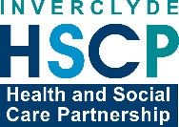

Issued 8 June 2020

|  |
| --- |
| **Below is the latest briefing on the activity in managing the response to coronavirus (Covid-19).**  **Local updates, council service changes and links to trusted sources of health guidance are published at *www.inverclyde.gov.uk/coronavirus*** |

**Mobile testing centre moved**

The mobile testing centre temporarily located in Inverclyde has moved today (Monday 8 June 2020).

The unit, operated by the Army, was based at The Waterfront Leisure Centre in Greenock, but from today will be at St Andrews Church, Auchmead Road, Greenock, Inverclyde PA16 OUJ.

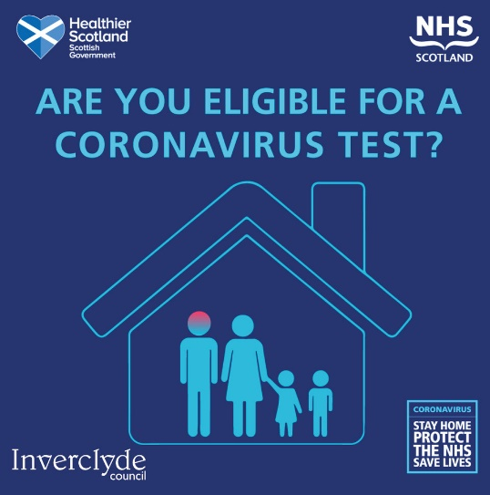Testing for coronavirus is available to anyone over five years of age with symptoms.

This means anyone who is displaying any of the three symptoms of covid-19 will be able to book a test at the drive-through or mobile test centres.

The symptoms are:

* continuous cough,
* high temperature or
* loss of sense of taste or smell.

Home test kits are also available through this programme.

Tests can be booked online: [www.nhsinform.scot/coronavirus](http://www.nhsinform.scot/coronavirus)

For those unable to access the portal, please call 0800 028 2816.

**Extra payment for carers**

The Scottish Government has announced that eligible carers can get an additional £230.10.

The announcement highlighted that the additional payment was in recognition of the additional pressure that unpaid carers are under at this time. The Scottish Government will be making a Coronavirus Carer’s Allowance Supplement payment later this month.

The full announcement is available at: <https://www.gov.scot/news/extra-payment-for-carers-to-help-through-coronavirus/>

**Updated advice for people shielding**

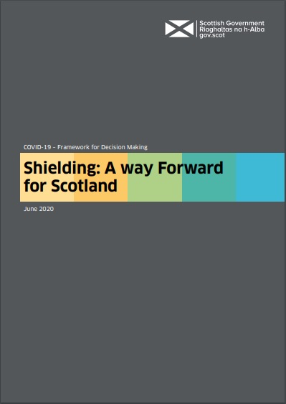The Scottish Government has issued new guidance for people on the shielding list and asking them to continue to shield and to stay at home until at least 31 July 2020.

The new guidance also highlights that they can, if they choose, go outdoors to exercise from 18 June while maintaining strict physical distancing.

Those affected will receive letters from the Chief Medical Officer explaining that the decision on outdoor exercise has been taken after careful consideration by clinical advisors.

Prevalence of covid-19 has decreased and the evidence now shows the risk of outdoor infection is very low if people stay two metres apart.

The exercise can be a run, wheel, walk or cycle but those shielding should not meet people from other households.

In all other respects, the advice for those who have been advised to shield has not changed as there remains a risk of infection in indoor and crowded places where physical distancing may not be possible. However, the CMO’s letter also sets out that work is underway to develop a new approach which allows people to better understand their individual risk and make choices which are right for them. This will be made available over the summer.

The support currently in place for those who are shielding, in terms of free grocery boxes and priority access to online supermarket delivery slots, will continue throughout this time.

Here is a link to more information and contact details for people on the shielded list: <https://www.gov.scot/publications/covid-shielding/>

Shielded residents in Inverclyde can contact Inverclyde Council on 01475 715 274 or by email at: [shielding@inverclyde.gov.uk](mailto:shielding@inverclyde.gov.uk)

The Scottish Government has also published a strategy document, titled: Shielding: a way forward for Scotland which is published at: <https://www.gov.scot/publications/coronavirus-covid-19-shielding-way-forward-scotland/>

**Childcare for key workers**From today (Monday 8 June 2020) until the end of term on Friday 26 June, pupils of key workers who had been attending the nine Inverclyde childcare hubs should now be attending their own school.

All schools and early learning centres are now open to pupils who have previously been in the hubs.

Parents should contact their child's own school or early learning centre for more information.

Planning is underway for key worker childcare provision during the school summer holidays and at the start of the new term in August.

In order to assist the education service in planning ahead for childcare, parents and carers have been asked to complete the survey via the link below, which should take no longer than 15 minutes.

The survey is found here <https://www.surveymonkey.co.uk/r/YNL9CWX> and closes on Tuesday 9 June.

**New health measures for travellers to Scotland**

New public health measures will come into force today (Monday 8 June) to help suppress coronavirus (COVID-19) and prevent new cases being brought into Scotland.

The range of measures, which will be broadly similar to those in other parts of the UK, will include:

* a requirement for residents and visitors entering the UK from abroad to self-isolate for 14 days
* the completion of an online passenger locator form by all travellers prior to travel to supply contact details, travel details and the address of where they will self-isolate
* spot checks at the border by Border Force, who may impose fines on travellers who refuse to comply
* arrangements for some of those arriving into Scotland to be contacted during their period of self-isolation for the provision of public health advice and information
* powers for police to impose a fixed penalty notice for anyone failing to comply with the mandatory conditions, with the ability to report persistent offenders to the Procurator Fiscal for potential prosecution

To read the full announcement visit: <https://www.gov.scot/news/new-health-measures-for-travellers-to-scotland/>

Here also is a link to the guidance document: <https://www.gov.scot/publications/coronavirus-covid-19-public-health-checks-at-borders/>

The plans also include a number of exemptions. The full list is available at the link below and includes specific guidance on seamen and masters:

***Seamen and masters as defined in section 313(1) Merchant Shipping Act 1995, maritime pilots as defined in para 22(1) of schedule 3A of the Merchant Shipping Act 1995, and inspectors and surveyors of ships appointed under section 256 of the Merchant Shipping Act 1995***

*You’ll need to complete the Public Health passenger locator form before you travel to the UK. You will not need to self-isolate for 14 days.*

*If you work on a ship, including fishermen, you should show a Seafarers Identification Document (SID) if you have one.*

*If you don’t have a SID, you can show your joining papers, seafarers employment agreement or a seafarers discharge book (Continuous Certificate of Discharge) instead. Alternatively, you could show a basic training certificate or declaration from the registered owners of the vessel that you are a crew member.*

Link to full list of exemptions: <https://www.gov.uk/government/publications/coronavirus-covid-19-travellers-exempt-from-uk-border-rules/coronavirus-covid-19-travellers-exempt-from-uk-border-rules>

**Test and protect**

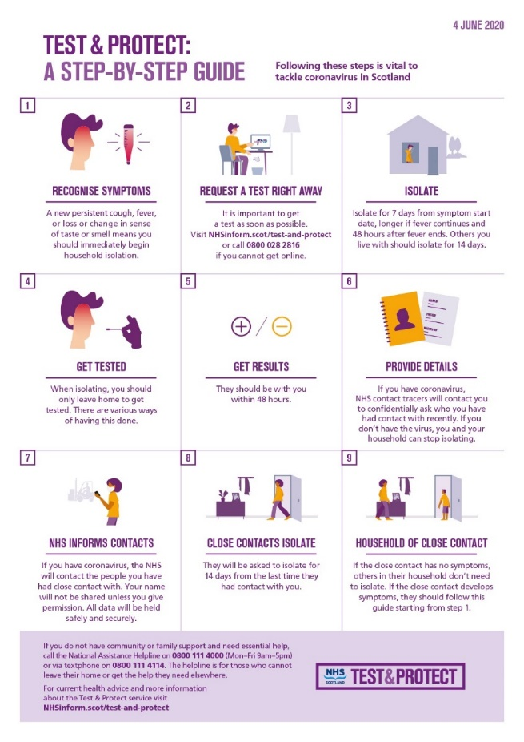Test and Protect – NHS Scotland’s approach to controlling the spread of coronavirus (COVID-19) in the community.

As the nation moves into the first phase of easing restrictions and people start to go out more, everyone is being asked to play their part in stopping the spread of the virus.

Alongside the advice that people with symptoms and their household need to stay at home, they need to also book a test at <https://www.nhsinform.scot/test-and-protect> or call 0800 028 2816 if they can’t get online.

Symptoms include a new, persistent cough, high temperature or loss or change in taste or smell.

If the test result is positive, they will be asked to provide details of all recent close contacts to NHS Scotland contact tracers.

This will be done confidentially and is a vital step in slowing the spread of the virus.

Those who are contacted will then be asked to isolate for 14 days to keep their community and loved ones safe, and they will be offered a test if appropriate.

The 14-day period is needed because if they have the virus, it may take that length of time for it to develop into an illness.

Alongside Test and Protect, continuing to keep two metres apart from others when outside as well as regular handwashing and good cough hygiene remains vital in helping to reduce the spread of the virus.

**Summer reading challenge goes online**

A reading initiative involving over 1,000 Inverclyde children annually is going online for the first time.

The Summer Reading Challenge, run by national charity The Reading Agency and delivered locally by Inverclyde Libraries, usually sees young people taking part via their nearest library but will be done via the internet this year due to the coronavirus lockdown restrictions.

It launched on Friday 5 June 2020 and is fully interactive.

The theme for 2020 is ‘silly stories’, focusing on funny books, happiness and having a laugh, accompanied by new mascots, the Silly Squad animal friends, created by award-winning author and illustrator Laura Ellen Anderson.

Last year, just over 1,100 youngsters took part in the challenge, which has been brought forward this year to support children who are currently at home and unable to attend school or the library.

Registration is now open online at www.summerreadingchallenge.org.uk and will remain open after Friday’s launch.

For those who have limited or no internet access, the council’s libraries service has produced summer reading bags, in partnership with charity Barnardo’s and the Scottish Attainment Challenge, which will be delivered to young people and families who are digitally excluded but would still like to take part.

To find out more about this and the Summer Reading Challenge, visit www.inverclyde.gov.uk/libraries, email [src@inverclyde.gov.uk](mailto:src@inverclyde.gov.uk)

**Give and go scheme at hospitals**

NHS Greater Glasgow and Clyde has highlighted the success of a personal drop off service called ‘give and go’ at hospitals including Inverclyde Royal Hospital.

The announcement read: A volunteer run ‘Give and Go’ initiative which allows friends and families to safely hand over personal items to loved ones in hospital has proven a major hit with patients across the region.

Bringing smiles to the faces of patients on a daily basis since launching in Glasgow Royal Infirmary four weeks ago, the service has since enabled thousands of personal bags to be delivered to patients unable to receive visitors. The success has seen the initiative rolled out to the QEUH, RAH, IRH and Gartnavel, with plans for a further rollout underway.

Staffed by NHS volunteers, relatives and friends are able to pass over sealed bags at designated drop-off points. Bags can contain personal items such as toiletries, snacks, mobile phones and iPads, books and clothing, which are then passed on to the patients by the volunteers.

Patients can also have personal clothing laundered and returned using the service, which follows strict infection control measures to ensure the safe handling and delivery of items.

Since launching, patients have been reunited with loved items of clothing, their favourite books, and been able to keep in touch with family through their phones and iPads.

To read the full announcement visit: <https://www.nhsggc.org.uk/about-us/media-centre/news/2020/06/give-go/>