|  |
| --- |
| **Coronavirus (Covid-19) – briefing** |

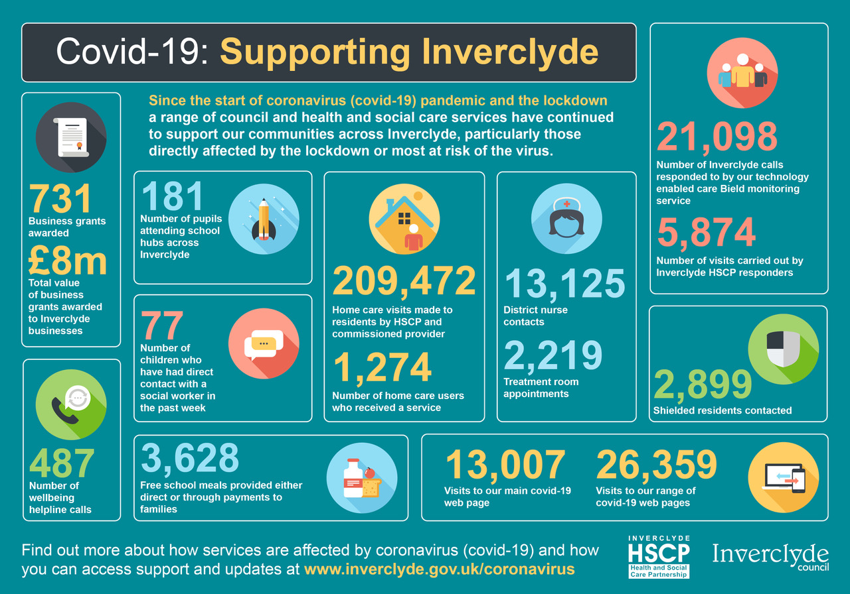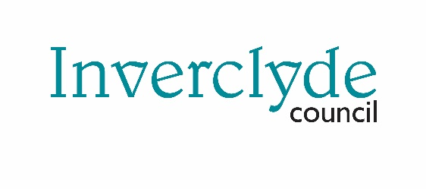****

Issued 12 June 2020

|  |
| --- |
| **Below is the latest briefing on the activity in managing the response to coronavirus (Covid-19). Local updates, council service changes and links to trusted sources of health guidance are published at *www.inverclyde.gov.uk/coronavirus*** |

The infographic above is being posted on social media this week highlighting some of the work done by the council and HSCP since the start of covid-19 to support the community.

**Port test centre closes**

The temporary drive-through testing centre for health and care staff created at Port Glasgow Health Centre will close after this week. Health and care staff and their families will continue to receive covid-19 tests and staff with symptoms or their family members with symptoms should still arrange a test immediately through the normal way. From Monday 15 June 2020 the tests will be done at the Greenock health centre assessment centre.

**Inverclyde school re-opening plans**

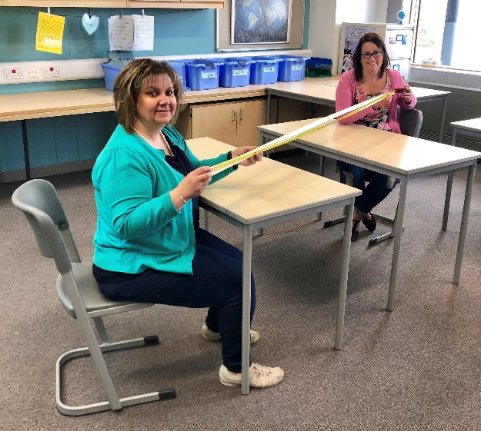Schools in Inverclyde are set to reopen to pupils for the 2020/21 term on Wednesday 12 August.

To meet social-distancing rules, a blended model of classroom and home learning for pupils is being introduced.

Primary children will attend school two days a week and secondary students for five days over a two-week period.

All pupils will be split into groups and allocated specific days in which to attend class.

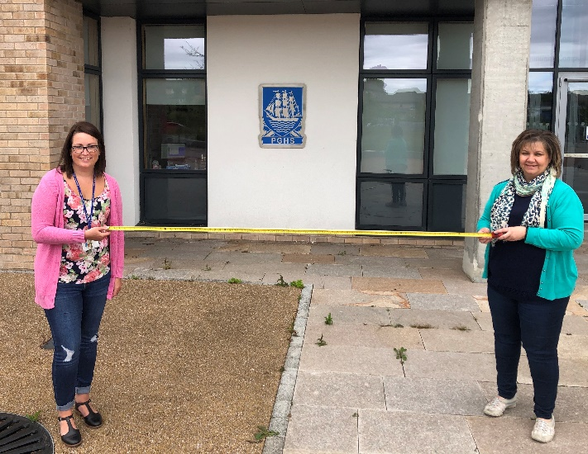School playgrounds will open an hour before teaching begins and close 60 minutes afterwards to help with the phased return and to assist parents with childcare arrangements if needed.

Pupils and parents will be notified directly about the specific arrangements today. (Friday)

Schools have already reopened for children of key workers to attend and to allow staff, including at Port Glasgow High School, *pictured*, to prepare classrooms for the new term in August, which starts on Tuesday 11 August for teachers with an in-service day.

Schools across Inverclyde are preparing for the return of pupils in August, including at Port Glasgow High School where Fiona Craig, depute head, and Jane Byrne, principal of guidance, are ensuring social and physical distancing of two metres.

High schools will be open to pupils five days a week but primaries will be closed on a Wednesday, except for children of key workers, to allow teachers to carry out planning for remote learning.

There will be an extra in-service day in September due to the earlier than normal start of term.

The council’s education service has been consulting with staff, parents and trade unions about the return to ensure the reopening of schools achieves the best possible outcome for everyone involved, especially pupils.

More information about the reopening of schools and what it means for primary and secondary students, is available at [www.inverclyde.gov.uk/coronavirus](http://www.inverclyde.gov.uk/coronavirus)

Below are copies of letters issued to parents today (Friday 12 June 2020):

**Primary schools letter:**

Further to my letter to you of Tuesday 2 June 2020, I am writing to provide further information about the planned re-opening of schools in Inverclyde in August 2020.

As we continue to follow the national guidance, head teachers of schools and early year’s settings are putting arrangements in place to ensure that your children are able to return in August to a safe and secure environment.

On behalf of all of those in education services we would like to thank you and your children for your continued support and co-operation to make sure that the arrangements put in place during the closure of schools due to Covid-19 have been as successful as possible. Also thank you to the chairs of the parent councils and our youth council who have readily engaged in discussion and debate to represent the views of parents and pupils to guide our journey.

While this letter shares with you our planning for August, please be aware that the guidelines may change and that our planning may well have to change as a result. Your school will be in touch with you to keep you as up to date with plans as possible.

We will only open schools to pupils when it is safe to do so. Schools will need to ensure that pupils and staff follow the social and physical distancing guidelines and put in place arrangements for our young people that are safe and equitable.

Following the recent government announcement, our schools will open for pupils on Wednesday 12 August 2020. Schools will not be able to open for all pupils at the same time and will use a blended learning model for education. This means there will be a mixture of face-to-face teaching, home follow up tasks and use of computer platforms.

We appreciate that parents will be anxious about educational arrangements when considering their childcare needs. We will continue to provide childcare for critical workers who have no other options available to them. Thank you for filling in the recent survey we issued. Details will be provided as soon as we are able to.

All schools will open their playgrounds an hour before teaching starts and close them an hour after. This will allow for a staggered start and is intended to provide some support for parents who need to put in place critical childcare arrangements and those pupils arriving at school by bus. Your school will be in touch with further details about this.

All primary schools in Inverclyde will follow a consistent model and pupils will attend schools for 2

days each week. Where possible we will divide each year group or class into 2 groups (group A and B). This approach will help us to provide places for siblings on the same day.

|  |  |  |  |  |
| --- | --- | --- | --- | --- |
| **Monday** | **Tuesday** | **Wednesday** | **Thursday** | **Friday** |
| Group A | Group A | Childcare only | Group B | Group B |

To optimise teaching hours, all primary schools will be closed for direct teaching on a Wednesday. This means that teachers can undertake additional planning for remote learning and support the extension of the school day.

Schools work in different ways and there are some constraints with different types of buildings. We have worked hard to overcome any constraints to achieve as much consistency as possible. We were not able to achieve a consistent model across primary and secondary schools.

There will be special arrangements for the first week of term.

On the first day of term (Wednesday 12 August 2020) primary schools will open only to those pupils in P1 and those pupils who require extra support to start school.

On Thursday 13 August 2020 Group A will attend school and on Friday 14 August 2020 Group B will attend. The model in the table above will begin the week beginning Monday 17 August 2020.

Your child’s school is currently working to allocate your child to a group. Siblings will be kept together and we will let you know transport arrangements as soon as we can. You will appreciate that there are a lot of logistics to be worked out but schools will take into account your child’s friends as much as possible when allocating groups.

Because schools are coming back from the summer break earlier than anticipated, there is a need to put an extra in-service day into the 2020/21 school calendar. This will be on Friday 4 September 2020. Revised school term dates will be sent out.

Any arrangements put in place for the recovery of education during Covid-19 will always result in a compromise and undoubtedly, the arrangements put in place will not please everyone. However, the arrangements put in place give a consistency of provision across Inverclyde and best meets the needs of learners.

Over the coming weeks schools will communicate with you directly about the particular arrangements for your child. It is especially important that you keep your contact details up to date.

We will work through all of the issues associated with recovery from Covid-19 as quickly as we can and our planning must remain agile to deal with unforeseen events and changes.

**Secondary schools letter:**

Further to my letter to you of Tuesday 2 June 2020, I am writing to provide further information about the planned re-opening of schools in Inverclyde in August 2020.

As we continue to follow the national guidance, head teachers of schools and early year’s settings are putting arrangements in place to ensure that your children are able to return in August to a safe and secure environment.

On behalf of all of those in education services we would like to thank you and your children for your continued support and co-operation to make sure that the arrangements put in place during the closure of schools due to Covid-19 have been as successful as possible. Also thank you to the chairs of the parent councils and our youth council who have readily engaged in discussion and debate to represent the views of parents and pupils to guide our journey.

While this letter shares with you our planning for August, please be aware that the guidelines may change and that our planning may well have to change as a result. Your school will be in touch with you to keep you as up to date with plans as possible.

We will only open schools to pupils when it is safe to do so. Schools will need to ensure that pupils and staff follow national social and physical distancing guidelines and put in place arrangements for our young people that are safe and equitable.

Following the recent government announcement our schools will open for pupils on Wednesday 12 August 2020. Schools will not be able to open for all pupils at the same time and will use a blended learning model for education. This means there will be a mixture of face-to-face teaching and home follow up tasks which may be delivered online.

We appreciate that parents will be anxious about educational arrangements when considering their childcare needs. We will continue to provide childcare for critical workers who have no other options available to them. Thank you for filling in the recent survey we issued. Details will be provided as soon as we are able to.

All schools will open approximately an hour before teaching starts and close approximately an hour afterwards. This will allow for a staggered start and we hope will provide some support for parents with childcare arrangements if needed. Your school will be in touch with further details about this.

Secondary pupils will all follow the same model and pupils will attend school for 5 days over a fortnight. All year groups will be divided into 2 groups (A and B). Our aim is that siblings will be in the same group and the groups will contain a mixture of S1-6.

|  |  |  |  |  |  |  |  |
| --- | --- | --- | --- | --- | --- | --- | --- |
| **Monday** | **Tuesday** | | **Wednesday** | | **Thursday** | | **Friday** |
| Week 1 | Group A | | Group B | Group A | Group B | | Group A | |
| Week 2 | Group B | | Group A | Group B | Group A | | Group B | |

All secondary schools will open to pupils on Wednesday 12 August 2020.

Your child’s school is currently working to allocate your child to a group. We will let you know transport arrangements as soon as we can. You will appreciate that there are a lot of logistics to be worked out but schools will take into account your child’s curricular choices when allocating groups.

Because schools are starting earlier than anticipated, there is a need to put an extra in-service day into the 2020/21 school calendar. This will be on Friday 04 September 2020. The revised school term dates will be issued in due course.

Any arrangements put in place for the recovery of education during Covid-19 will always result in a compromise and undoubtedly the arrangements put in place will not please everyone. However, the arrangements put in place give a consistency of provision across Inverclyde and best meet the needs of learners.

Over the coming weeks schools will communicate with you directly about the particular arrangements for your child. It is especially important that you keep your contact details up to date. We will work through all of the issues associated with recovery from Covid-19 as quickly as we can and our planning must remain agile to deal with unforeseen events and changes.

**ASN letter:**

Further to my letter to you of Tuesday 2 June 2020, I am writing to provide further information about the planned re-opening of schools in Inverclyde in August 2020.

As we continue to follow the national guidance, head teachers of schools and early year’s settings are putting arrangements in place to ensure that your children are able to return in August to a safe and secure environment.

On behalf of all of those in education services we would like to thank you and your children for your continued support and co-operation to make sure that the arrangements put in place during the closure of schools due to Covid-19 have been as successful as possible.

Also thank you to the chairs of the parent councils and our youth council who have readily engaged in discussion and debate to represent the views of parents and pupils to guide our journey.

While this letter shares with you our planning for August, please be aware that the guidelines may change and that our planning may well have to change as a result. Your school will be in touch with you to keep you as up to date with plans as possible.

We will only open schools to pupils when it is safe to do so. Schools will need to ensure that pupils and staff follow the social and physical distancing guidelines and put in place arrangements for our young people that are safe and equitable.

Following the recent government announcement our schools will open for pupils on Wednesday 12 August 2020. Schools will not be able to open for all pupils at the same time and will use a blended learning model for education. This means there will be a mixture of face-to-face teaching, home follow up tasks and use of computer platforms.

We appreciate that parents will be anxious about educational arrangements when considering their childcare needs. We will continue to provide childcare for critical workers who have no other options available to them. Thank you for filling in the survey. Details will be provided as soon as we are able to.

All schools will open an hour before teaching starts and close an hour after. This will allow for a staggered start and we hope will provide some support for parents with childcare arrangements if needed. Your school will be in touch with further details about this.

ASN schools and bases will individually look at the needs of their pupils. This may require bespoke timetables for pupils and the school will contact you to discuss the details.

Because schools are returning from the summer break earlier than anticipated, there is a need to put an extra in-service day into the 2020/21 school calendar. This will be on Friday 04 September 2020.

Further details on term dates will be sent out in due course.

Any arrangements put in place for the recovery of education during Covid-19 will always result in a compromise and undoubtedly the arrangements put in place will not please everyone. However, the arrangements put in place give a consistency of provision across Inverclyde and best meets the

needs of learners.

Over the coming weeks schools will communicate with you directly about the particular arrangements for your child. It is especially important that you keep your contact details up to date. We will work through all of the issues associated with recovery from Covid-19 as quickly as we can and our planning must remain agile to deal with unforeseen events and changes.

**Business support fund**

From this week, eligible businesses can apply for the ‘small business support grant’ if you are not a ratepayer but occupy certain types of shared space. For example, shared office, business incubator or industrial space. You must lease the space from a landlord who is the registered ratepayer for the property.

It is anticipated that the ‘small business grant’ and ‘retail, hospitality and leisure grant’ schemes will close for new applications on 10 July 2020.

More information on support for business is available at the ‘business support and advice’ page at [www.inverclyde.gov.uk/coronavirus](http://www.inverclyde.gov.uk/coronavirus)

Here is a link to the Scottish Government announcement on business grants: <https://www.gov.scot/news/more-support-for-small-business/>

**8,700 jobs supported across Inverclyde**

HM Revenue and Customs (HMRC) has published data showing how many jobs have been supported across the country as part of the coronavirus job retention scheme (CJRS) and self-employment income support scheme (SEISS).

According to the figures, 8,700 jobs across Inverclyde have been supported.

The CJRS and SEISS were announced by the Chancellor, and are run by HMRC, as part of a package of support measures for businesses affected by the coronavirus outbreak.

Businesses have furloughed 7,300 jobs across Inverclyde, up to 31 May 2020, since the CJRS was launched on 20 April 2020. This is to help UK employers who have been severely affected by coronavirus to retain their employees and protect the UK economy.

An announcement was made on 12 May 2020 that the scheme will run until the end of October to continue the support for jobs and businesses as people return to work.

The SEISS has financially supported 1,400 self-employed individuals across Inverclyde who have been adversely affected by the coronavirus outbreak and paid grants worth a total of £3.6 million up to 31 May 2020.

Further guidance on both schemes is expected to be published by HMRC on Friday 12 June 2020 at GOV.UK

A breakdown* of claims is below and here’s a link to the statistics on GOV.UK <https://www.gov.uk/government/collections/hmrc-coronavirus-covid-19-statistics>

|  |  |
| --- | --- |
| **Coronavirus job retention scheme (CJRS)** | **Number of Employments Furloughed** |
| Scotland | 628,200 |
| Inverclyde | 7,300 |

|  |  |  |
| --- | --- | --- |
| **Self-employment income support scheme (SEISS)** | **Number of Claims Made** | **£ Value of Claims Made** |
| Scotland | 146,000 | 425,000,000 |
| Inverclyde | 1,400 | 3,600,000 |

**Recycling and bin collection update**

Pottery Street recycling centre is now be open seven days a week, opening hours remain as 8am to 7pm.

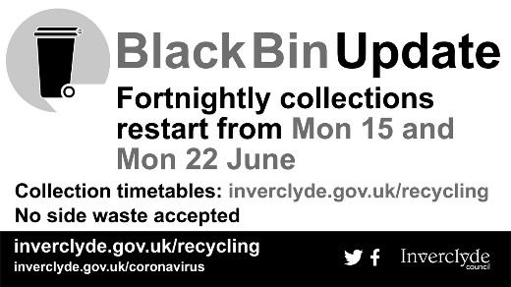Vans will still only be permitted to use the site mid-week – Mon, Tue, Wed, Thurs and Fri – and only to dispose of household waste.

Residents will be able to dispose of all materials previously taken to the site – mixed recyclates, general household waste, garden waste, wood, cardboard, glass, plastics, textiles, electrical items, fridges and washing machines, soil, rubble, oils and paint.

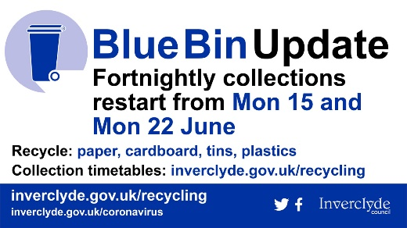Parking will be restricted within the recycling centre to accommodate social distancing however a number of cars can queue within the centre.

When the blue bins collections restart, the black bins will revert to fortnightly. Residents can check which day their bin collection will be starting from Monday 15 June 2020 using the online postcode finder at [www.inverclyde.gov.uk/recycling](http://www.inverclyde.gov.uk/recycling)

**Tourism provisional date of 15 July**

The Scottish Government has announced support for the tourism industry including a provisional date of 15 July for when businesses could open.

The announcement highlights that a new Scottish recovery tourism taskforce will assist with the ongoing reset of the sector.

The provisional date of 15 July 2020 has been set for when tourism businesses may be able to resume operations, dependent on public health advice and progression to Phase 3 of the Scottish Government lockdown route-map.

The full statement is available at: <https://www.gov.scot/news/support-for-tourism-industry/>

Visit Scotland guidance on the phased return of tourism in Scotland: <https://www.visitscotland.com/about/practical-information/covid-19-recovery-phases/>

Link to the Scottish Tourism Alliance (STA) response to the announcement: <https://scottishtourismalliance.co.uk/scottish-tourism-alliance-responds-to-announcement-that-sector-can-reopen-on-15th-july/>

**Tax relief on working from home expenses**

# Below is some useful guidance on claiming tax relief for working from home:

**Claiming tax relief on working from home expenses:**

This is a reduction in taxable pay of £6 per week. This means:

1. you need to be paying tax (which for most people means earning over £12,500 per year) and
2. the actual additional amount most employee would receive is £1.26 per week.

The information below is from the Martin Lewis money saving expert website with amended figures for Scottish taxpayers. It covers claiming tax relief on £6 per week (worth £1.26/week at 21% tax, £2.46/week at higher rate).

## How to claim the tax relief

If you normally do a self-assessment form, you can claim on it. Yet for most people, this will simply require filling in a P87 form. This can be done online (requires you to have or set up a Government Gateway user ID) or by post <https://www.gov.uk/guidance/claim-income-tax-relief-for-your-employment-expenses-p87>

You will be asked for your employer's name and PAYE reference, and your job title. For postal P87s, you'll also need your national insurance number. If you don’t know your number, it is likely to be shown on your payslip.

In the online form, there are two boxes:

1. Amount paid by you. HMRC has stated that provided you've had increased costs, just put a total amount that's equivalent to £6 per week for the period you've been working from home and that's fine, you won't need to show receipts.
2. Amount paid to you by your employer'. If your employer hasn't paid you a working from home allowance or reimbursed your homeworking expenses, just put £0.

If you're claiming through the postal form, you'll need to add a 'Using your home as an office' expense manually in the 'Other expenses' section.

You can claim retrospectively on expenses you have had. So, if you're only at home due to coronavirus, it might be best to wait until you're back at work (or a few months anyway) then make the whole claim at once. Your tax code will likely be adjusted so you pay less tax over the year, as opposed to you getting a direct refund.

Once you've submitted the claim, if you do it online you may hear back within a couple of weeks. However, obviously if HMRC is under pressure it may take longer.