|  |
| --- |
| **Coronavirus (Covid-19) – briefing** |

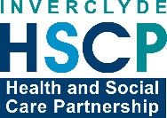

Issued 16 June 2020

|  |
| --- |
| **Below is the latest briefing on the activity in managing the response to coronavirus (Covid-19). Local updates, council service changes and links to trusted sources of health guidance are published at *www.inverclyde.gov.uk/coronavirus*** |

**B&B support fund launched**

A new support fund to support bed and breakfast’s has been launched this week.

The purpose of this fund is to provide hardship relief to B&B/small serviced accommodation providers who have not been able to access support through other schemes as a result of their banking status.

‘Small serviced accommodation’ establishments offering bed and breakfast services that are eligible for this fund are guest house, farmhouse, inn, restaurant with rooms.

This fund excludes other types of non-serviced accommodation providers such as self-catering, caravan accommodation, Air BnB, etc.

Successful applicants will receive a one-off payment of £3,000.

Individuals must apply in the council area where the business is located.

Successful applicants may continue to work or take on other employment including voluntary work while applying for or in receipt of grants.

Full eligibility criteria and how to apply can be found on the ‘business support and advice’ page at: [www.inverclyde.gov.uk/coronavirus](http://www.inverclyde.gov.uk/coronavirus)

**Policy and resources committee**

The council’s emergency committee meeting, the ‘policy and resources executive sub-committee’ takes place today (Tuesday 16 June 2020).

The meeting takes place by video conference and the agenda includes: the regular coronavirus (covid-19) scrutiny report, an update on early learning and childcare expansion programme; a report on education ICT infrastructure and pupil access to ICT from home; a report on Craigend resource centre and a request on anti-slavery reparations.

The sub-committee agenda is published online and available to view and download at: <https://www.inverclyde.gov.uk/meetings/meeting/2262>

**Kirn Drive recycling centre open**

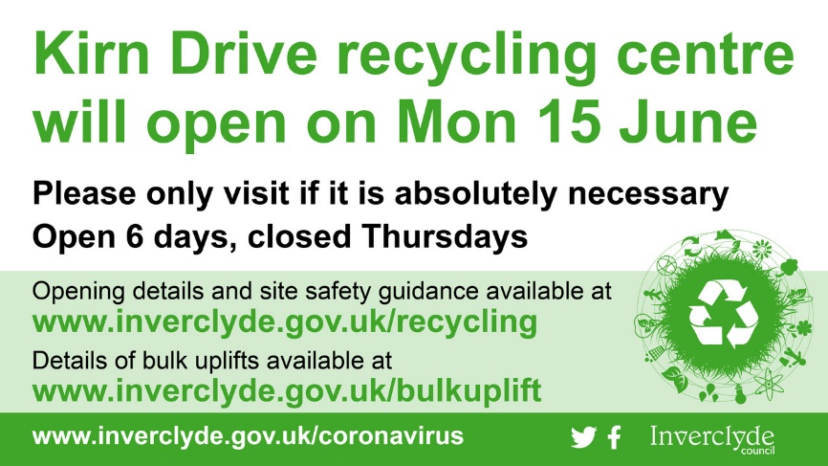The Kirn Drive depot is open this week from 8am-6pm.

Last entry will be at 5.30pm each day and the site will be closed on a Thursday.

Only residual household waste, garden waste, cardboard and wood will be accepted at Kirn Drive for the time being and no vans or trailers will be allowed in.

The site is expected to be extremely busy during the first week and there may be queues and temporary closures throughout the day to allow staff to empty skips.

The red blaes pitch on Drumshantie Road may be used as a waiting area for queuing cars and there will be a traffic management system in place to control the flow of vehicles in and out.

People using the Pottery Street or Kirn Drive depots are reminded to observe social-distancing of at least two-metres away from those outwith their own household at all times and to maintain good hand hygiene before, during and after they visit.

Due to government safety guidelines, council staff will be unable to assist with unloading vehicles.

No trailers of any kind are currently permitted at any of the depots.

Vans will not be allowed into Kirn Drive when it reopens and will only be permitted entry to Pottery Street, to dispose of household waste only, during the week and not at weekends until further notice.

For more information about Inverclyde waste and recycling services, visit [www.inverclyde.gov.uk/recycling](http://www.inverclyde.gov.uk/recycling) or call 01475 715901.

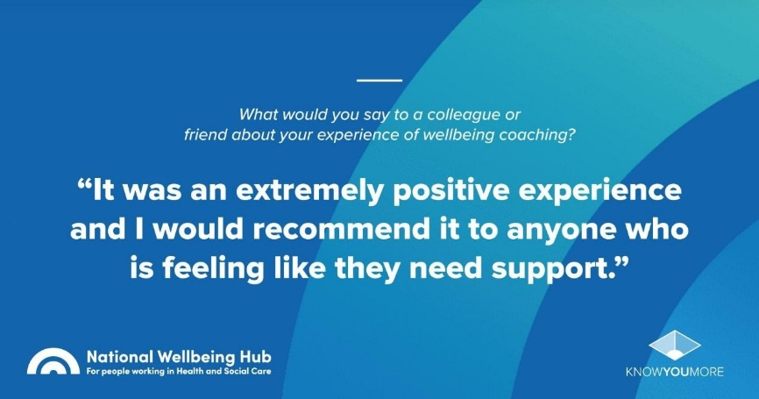**Coaching for wellbeing**

Wellbeing coaching available to health and social care staff:

During these uncertain and rapidly changing times, people may want to become more active in caring for their health and wellbeing, especially during Covid-19, but might be unsure what to focus on; look at ways of supporting and preserving their energies, making the most of their strengths and supporting team members and colleagues, during the current pandemic.

A number of Inverclyde colleagues have already taken up the chance of some coaching, which is a safe, confidential, enabling and developmental relationship, tailored to a person’s specific needs, style and context.

Working alongside a coach, will provide support to explore, understand and act on whatever is important for the person. It enables people to draw on and make the most of their strengths, experience, skills and resources.

There is the national offer, open to anyone at any level and includes the public, voluntary and independent sectors. This is delivered through Project Lift (NHS Education for Scotland), in collaboration with Scottish Government, which is for anyone who is working in health and social care to access coaching at <https://www.knowyoumore.com/wellbeingcoaching/>

Two coaching options are available, one at 90 minutes and the other 180 minutes, delivered by qualified and experienced coaches, all of whom have experience of working with and coaching health and social services staff.  The coaching takes place digitally, using whatever online tools work for the person and the coach.