|  |
| --- |
| **Coronavirus (Covid-19) – briefing** |

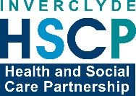

Issued 20 June 2020

|  |
| --- |
| **Below is the latest briefing on the activity in managing the response to coronavirus (Covid-19). Local updates, council service changes and links to trusted sources of health guidance are published at *www.inverclyde.gov.uk/coronavirus*** |

**Phase two changes introduced across Scotland**

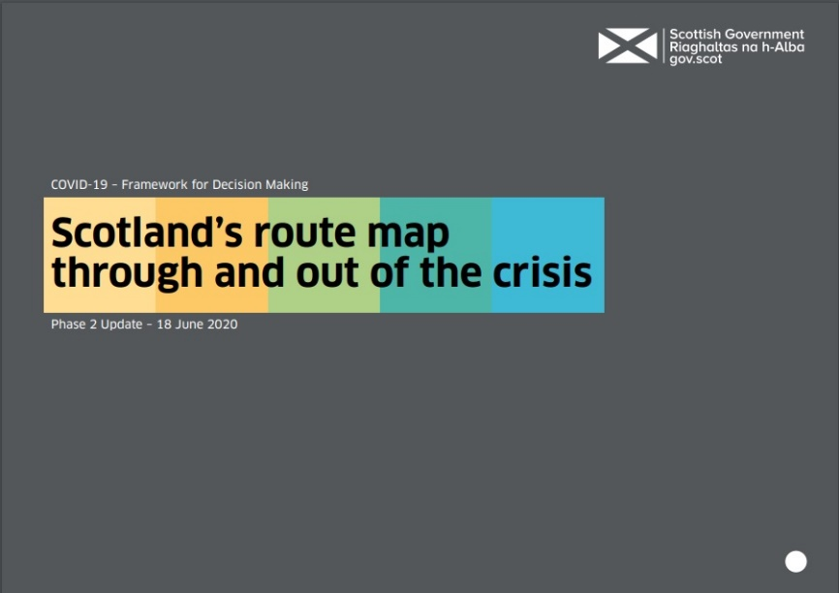The Scottish Government has introduced changes to move to phase two of the national route map through and out of the crisis.

Key changes include:

**From Friday 19 June 2020:**

* Those advised to shield will be able to take part in non-contact activities such as golf, angling, kayaking, and meet members of another household outdoors, up to a suggested maximum of eight in the group. Most importantly in both instances, strict physical distancing of two meters must be followed at all times, and they should wash their hands for at least 20 seconds when they return home
* A household not shielding can meet two other households, outside, up to a suggested maximum of eight people in the group
* Those visiting another household in a private garden will be permitted to use the household toilet, with increased hygiene measures urged. This does not include a household of someone who is shielding
* Single person households, including single parents households with children under the age of 18, will be able to form an extended household with another
* People should continue to stay in their local area as much as possible and should not travel more than around five miles for leisure or recreation

**From Monday 22 June 2020:**

* Construction sector to implement remaining stages of their own phased return
* Dental practices open to see patients with urgent care needs
* Resumption of professional sport, following public health advice
* Places of worship open for individual prayer and contemplation
* Limited College and University staff return for essential preparations for re-opening in Phase 3
* Mandatory face coverings on public transport (please see Transport Scotland for more detail)
* Accommodation can be provided for workers whose workplaces are open in the relevant phase and who need to stay away from home for work

**From Monday 29 June 2020:**

* Indoor non-office workplaces (including factories, warehouses and labs) can resume once relevant guidance is implemented. This does not include non-essential office, call-centre, culture, leisure and hospitality premises
* Restrictions of house moves relaxed
* Public gardens and zoos can open but should remain limited to local access only in this phase
* Outdoor sports courts reopen
* Playgrounds can reopen
* Registration offices can open for priority tasks
* Marriages and civil partnerships allowed with minimal attendees outside
* Street-access retail can re-open once guidance is implemented. Interiors of shopping malls/centres remain closed for non-essential shops until Phase 3
* Reintroduction of some chronic disease management
* Phased resumption of some screening services
* Phased safe resumption of essential optometry and ophthalmology services
* Outdoor markets can reopen once guidance is implemented

**Scaling up throughout phase two:**

* Public transport will increase services. Capacity will remain constrained due to physical distancing requirements – and active travel remains the preferred mode of travel.
* Increase in health care provisions for pent up demand, urgent referrals and triage of routine services
* Planning with COSLA and partners to support and, if needed, review social care and care home services
* Priority referrals to secondary care
* Public services will continue to resume and scale up, including services such as visiting support to Housing First Tenants and the resumption of area-based energy efficiency schemes.

The Scottish Government [route map document](https://www.gov.scot/publications/coronavirus-covid-19-framework-decision-making-scotlands-route-map-through-out-crisis-phase-2-update/) has been updated to reflect the move to phase two. They have also published [Coronavirus (COVID-19) Phase 2: staying safe and protecting others (physical distancing)](https://www.gov.scot/publications/coronavirus-covid-19-phase-2-staying-safe-and-protecting-others/pages/overview/) advice and guidance.

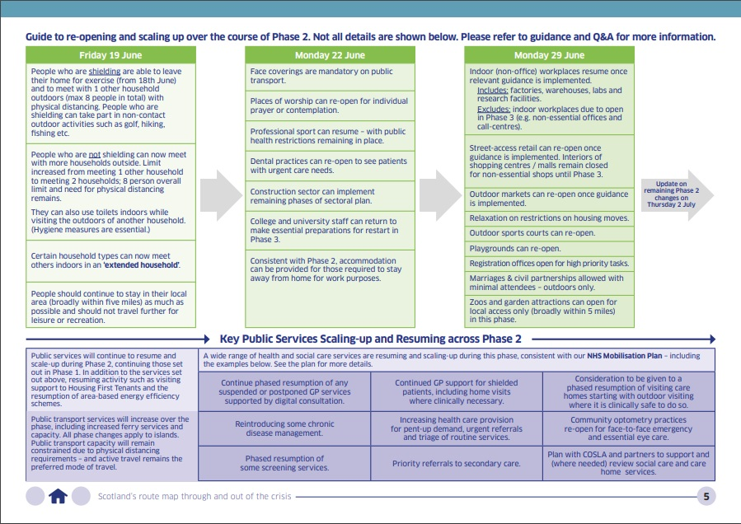

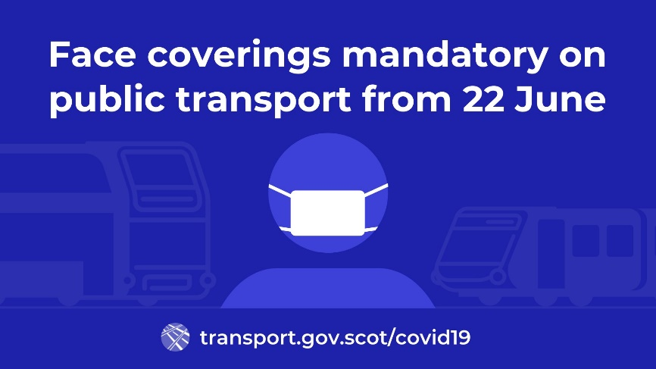**Face coverings mandatory on public transport**

From Monday 22 June 2020 face coverings will be mandatory for people travelling on public transport.

Face coverings will become mandatory on public transport from Monday 22 June, as part of operators’ preparations for progress towards recovery and to reduce the risk of transmission.

It will apply to all passengers and staff in public areas, although there will be exemptions especially for those who are not able to wear a face covering for specific medical reasons. Children under five will also be exempt.

Advice on face coverings, including how to make one and instructions for using one, will be available on the [Transport Scotland](https://www.transport.gov.scot/coronavirus-covid-19/) website.

**Mobile testing centre moving**

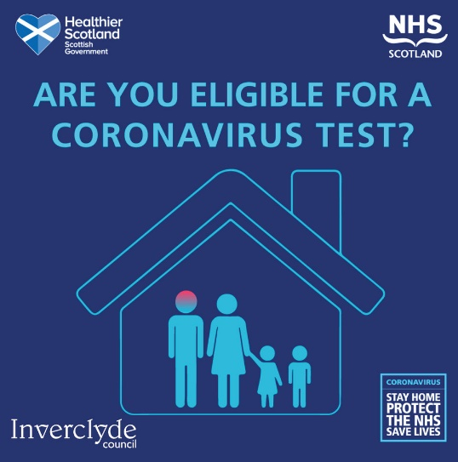The mobile testing centre temporarily located in Inverclyde will move to Port Glasgow today (Saturday 20 June 2020).

The unit, operated by the Army, has been based at The Waterfront Leisure Centre in Greenock and located at St Andrews Church in Greenock.

From today it will be relocated to Port Glasgow Health Centre.

Testing for coronavirus is available to anyone over five years of age with symptoms.

This means anyone who is displaying any of the three symptoms of covid-19 will be able to book a test at the drive-through or mobile test centres.

The symptoms are:

* continuous cough,
* high temperature or
* loss of sense of taste or smell.

Home test kits are also available through this programme. Tests can be booked online: [www.nhsinform.scot/coronavirus](http://www.nhsinform.scot/coronavirus)

For those unable to access the portal, please call 0800 028 2816.

**Parliament education committee**

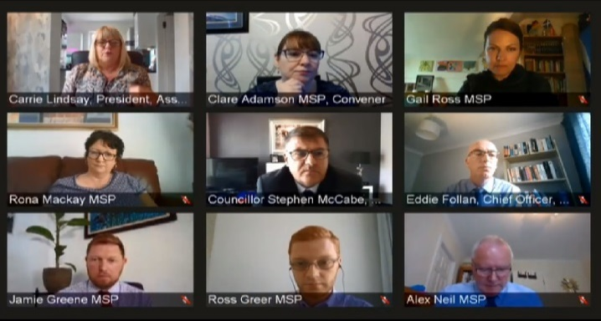Council Leader, Councillor Stephen McCabe, represented COSLA today at the Scottish Parliament’s education and skills committee.

The committee met virtually on [Scottish Parliament TV](https://www.scottishparliament.tv/) yesterday (19 June 2020) to discuss the return to schools in August, the plans by councils and the work of the national covid-19 education recovery group co-chaired by John Swinney, Deputy First Minister and Cabinet Secretary for Education and Skills, MSP and Councillor McCabe as COSLA children and young people spokesperson.

**Supporting shielding employees**

The council has issued the following message to managers with copies of risk assessments (which are also available on the council intranet, ICON, covid-19 pages):

*As the government starts to reduce lockdown and open up businesses, there is a need to review the needs of staff who are vulnerable or have underlying health conditions. The following guidance, which is based on national advice from the Scottish Government and Health Protection Scotland, has been agreed with the Trades Unions and managers will be required to contact staff members who are currently isolating due to either medical conditions, or have household members who are shielding or clinically vulnerable.*

*Employees who are self-isolating because they have underlying health problems (now referred to as clinically vulnerable) or live with some who has underlying health problems can return to work after the 18th of June. This also applies to employees who are living with someone who is shielding (extremely clinically vulnerable). However any employee who is themselves shielding and has been issued with a shielding letter should not return to work. Shielding has been extended to the 31st of July.*

*A risk assessment should be carried out for any employee returning to work after self-isolating for 12 weeks. The template for this has been drawn up by the H&S team and is available on Icon or the council website.*

*Employees who are clinically vulnerable including employees who are pregnant, can and should continue to work from home if this can be done effectively. However, this may prove difficult for employees working in certain jobs.*

*If clinically vulnerable employees are returning to work then arrangements should be in place to ensure they can maintain 2m social distancing. If this is not possible then there needs to be a discussion with the line manager to ensure that there is minimal risk and this may require adjustments to be put in place. In any event a risk assessment is required for any clinical vulnerable member who may be returning to work.*

*Employees who feel significantly anxious about returning to work to the point that it is making them feel unwell should speak to their manager to discuss other possible solutions. This may include a delay in returning to work where appropriate. There may also be a referral to occupational health in these circumstances.*

*It is recognised that there has been a disproportionate impact of the virus on employees from black and minority ethnic (BAME) backgrounds. Managers should engage with BAME staff and using the risk assessment template ensure that there is minimal risk and that suitable controls are in place to do this. This may involve working from home where this can be done effectively, strict adherence to physical distancing and hygiene requirements.*

**Safe streets campaign launched**

The council is launching the #SafeStreetsSaveLives campaign to encourage residents to put forward ideas to increase cycling and walking across the area.

The website <https://inverclydespacesforeveryone.commonplace.is> allows anyone to highlight a location and set out any issues or suggestions about how this can be improved for cycling and walking, particularly to support physical distancing measures.

**£1/2m to support families with technology**

An additional £527,000 is set to be spent by Inverclyde Council to support families accessing technology for schoolwork.  
  
The funding, agreed by the local authority’s emergency sub-committee, will mean 250 extra laptops purchased to support families and improvements to wireless internet connections (wifi) across the area’s secondary schools.

The total package of spending will include over £400,000 improving wifi and technology across schools, £20,000 to purchase a new online resource and £100,000 to purchase 250 new laptops with headsets and associated wifi access.

Read the full announcement here: <https://www.inverclyde.gov.uk/news/2020/jun/1-2m-to-support-families-with-technology>

**Free schools meals to run over summer**

Enhance free school meals provision for Inverclyde school children has been agreed by the council.

Eligible pupils will continue to be supported over the summer and up until 28 August.

Read the full statement here: <https://www.inverclyde.gov.uk/news/2020/jun/enhanced-free-school-meals-provision-over-summer>

**Get tourism ready**

National tourism body, Visit Scotland, has launched a new campaign ‘Get tourism ready’ to support tourism to get ready for re-opening. The agency is working with businesses to plan ahead for the potential re-opening of tourism businesses.

Tourism in Scotland has a provisional re-opening date of 15 July 2020.

Visit Scotland has compiled resources for tourism businesses including hospitality, accomodation, self-catering, visitor attractions, sailing and outdoor access.

Here is a link to the Visit Scotland get tourism ready website pages: <https://www.visitscotland.org/supporting-your-business/advice/coronavirus-recovery/preparing-to-open>

The Scottish Government has published [Coronavirus (COVID-19): tourism and hospitality sector guidance](https://www.gov.scot/publications/coronavirus-covid-19-tourism-and-hospitality-sector-guidance/).

**Reactions from business to phase two**

The Federation of Small Business (FSB) Scotland has responded to re-opening plans as part of the Scottish Government ‘phase two’ plans:

The statement read:

*First Minister Nicola Sturgeon this afternoon announced that shops that sell products other than food will be able to re-open from Monday 29 June, but hospitality firms like pubs, restaurants and cafes would have to wait until at least July before re-opening even if they have outdoor facilities.*

*The Federation of Small Businesses (FSB) welcomed the news that high streets would re-open and urged Scots to use their spending power to back independent shops. However FSB urged the Scottish Government to provide more reliable information for businesses, as many independent businesses had expected a swifter timetable for re-opening.*

*Colin Borland, FSB’s director of devolved nations, said: “Up and down Scotland, independent retailers will welcome the news that they’ve been given a date on which they’ll be able to re-open. We’d urge people to back these local bookshops, corner shops and boutiques because they need your spending power like never before.*

*“However some shopkeepers will be disappointed that this re-opening is more than a week away, when many were primed for Monday. And those that operate restaurants, pubs and cafes will be bitterly disappointed that they’re waiting at least another fortnight before they can welcome back customers even if they have outdoor facilities.*

*“We understand the need to exercise caution. But the Scottish Government must provide sharper detail for businesses about the re-opening programme. Some businesses will have wasted some of their precious reserves preparing to open their doors in the next few days, when actually they won’t be open for weeks. For example, pubs with beer gardens will be understandably frustrated – especially if they spent money getting cellars restocked.”*

The Scottish Chambers of Commerce (SCC) has responded the Scottish Government ‘phase two’ plans:

The statement read:

Responding to the First Minister’s statement in the Scottish Parliament today (18th June) on Scotland moving to Phase 2 of easing current lockdown measures as per the Scottish Government Roadmap, Dr Liz Cameron, Chief Executive of the Scottish Chambers of Commerce said:

“We welcome today’s further easing of some lockdown measures in Scotland. Many retailers will have some measure of relief to finally have a clearer idea of when they can re-open and what they will need to do to prepare for this while construction firms can now start working again. It will be a relief for many employers and will help to save jobs.

“Clearly current physical distancing limits at 2m is unsustainable for many businesses so we welcome the fact that this is being reviewed, with recommendations due within the next 2 weeks. We would suggest that the review be extended to consider the scientific evidence as adopted by many other countries together with the advice from the World Health Organisation. We all know that science can never be exact so it is important that a broader analysis and view is sought from others before final decisions are taken.

“There’s no doubt the challenges we face due to the global pandemic are extraordinary. But we need to move decisively and listen to the needs of employers as well as scientific advisors if we are to avoid permanent, long term economic collapse.’’

The Scottish Retail Consortium (SRC) has reacted to re-opening plans as part of the Scottish Government ‘phase two’ plans:

The statement read:

*The First Minister has announced in the Scottish Parliament that all shops, large and small - except those in shopping centres/malls which do not have street access - will be permitted to re-open from 29 June. This means many shops will have been shuttered for 14 weeks since the commencement of lockdown on 23 March.*

*David Lonsdale, Director of the Scottish Retail Consortium, said:*

*“Retailers have been eagerly awaiting a firm date for the re-opening of shops that they can work towards. The First Minister’s announcement is a significant milestone, providing much needed clarity on the path ahead. It is welcome that Government has listened to our representations and that larger shops will be able to re-open sooner than anticipated. We look forward in due course to learning of the indicative date for the re-opening of non-essential outlets in shopping centres and malls.*

*“Safety is the fundamental concern for all retailers and they have been working hard to implement the necessary social distancing and hygiene measures to operate safely over the past weeks. This a welcome vote of confidence in that effort and preparation. Now that we know which shops can open and when, retailers can begin communicating their plans with their workforces and customers.*

*“The First Minister’s call for shoppers to be considerate and respectful of shop staff is helpful. Customers will see differences to their usual shopping routine and what is expected of them too. Shoppers should be prepared for different store layouts, one-way aisles, plexiglass screens and queuing, similar to those measures seen in pharmacies and other essential retailers.*

*“The industry stands ready to play its part in getting the Scottish economy moving again. However it is crucial that there is a clear plan so shoppers can travel to and through our town and city centres, and also a short term economic stimulus package to encourage customers to start shopping again.”*

*On plans to consult on mandating shoppers wear face coverings, Mr Lonsdale added:*

*“Our members have invested significantly over a very short period in social distancing and other health and hygiene measures in order to protect staff and customers, and will continue to ensure colleagues in stores have the necessary protection as advised by Government. We have previously written to Ministers to say that if there are to be changes to the necessary protection required, then we would ask Government to engage with us at the earliest opportunity so we can discuss the practicalities and understand the requirements and timeframe for implementation. This would allow sufficient time to place orders and acquire stock.”*