|  |
| --- |
| **Coronavirus (Covid-19) – briefing** |



Issued 14 July 2020

|  |
| --- |
| **Below is the latest briefing on the activity in managing the response to coronavirus (Covid-19). Local updates, council service changes and links to trusted sources of health guidance are published at *www.inverclyde.gov.uk/coronavirus*** |

**Guidance for places of worship**

The Scottish Government has today (14 July 2020) published guidance to help places of worship safely re-open for permitted purposes. The guidance is available to view and download on the [Scottish Government website](https://www.gov.scot/publications/coronavirus-covid-19-phase-3-guidance-for-the-safe-use-of-places-of-worship/).

**Inverclyde feature on radio Scotland**

BBC radio’s flagship morning news programme, [Good Morning Scotland](https://www.bbc.co.uk/programmes/b0074hf7), will be broadcasting live from Inverclyde tomorrow (Wednesday 15 July 2020).

The programme will focus on how covid-19 has affected Inverclyde.

The programme will be broadcast from 6am until 9am from the Beacon Arts Centre, Greenock and will feature interviews with the Leader of the Council, Councillor Stephen McCabe and Leader of the Opposition, Councillor Chris McEleny.

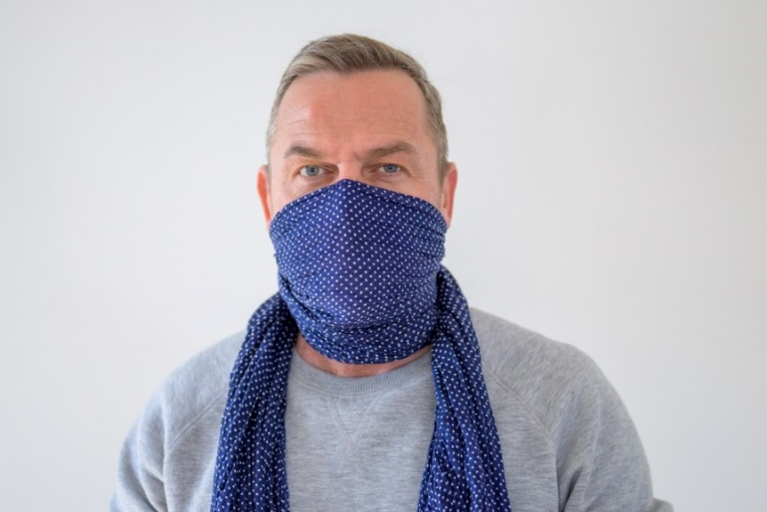**Hospital visitors urged to wear face coverings**

NHS Greater Glasgow and Clyde has urged hospital visitors to wear face covering as visiting regulations are eased across Scotland.

During the pandemic, the only patients who have been allowed an essential visitor have been children, patients with a mental health issue such as dementia, a learning disability or autism and those receiving end of life care. Now, all patients (with the exception of covid patients) will be allowed one designated visitor. Read the full announcement on the [NHS Greater Glasgow and Clyde website](https://www.nhsggc.org.uk/about-us/media-centre/news/2020/07/hospital-visitors-urged-to-wear-face-coverings-as-regulations-are-eased/).

**Social care worker death in service payment**

The Scottish Government has published information on the social care worker death in service benefit, including who can apply and how to apply.

This scheme provides a one-off payment of £60,000 to a named survivor of a social care worker who has died in service as a result of, or the suspected result of, contracting covid-19 at work.

More information is published on the [Scottish Government website](https://www.gov.scot/publications/coronavirus-covid-19-social-care-worker-death-in-service-payment/) and you can read the detailed rules for the death in service benefit scheme at the [Scottish Public Pensions Agency website](https://pensions.gov.scot/sites/default/files/2020-05/NHS_Scotland_-_Covid_19_-_Death_in_Service_-_Scheme_Rules.pdf).

[](http://www.waterfrontcinema.co.uk/)**Safe re-opening guidance for cinemas**

The Scottish Government has published guidance for cinemas and drive-in cinemas on safe re-opening during the coronavirus pandemic.

The guidance includes information on health and safety issues and specific areas for drive-in cinemas to take into account when opening.

The guidance is available on the [Scottish Government website](https://www.gov.scot/publications/coronavirus-covid-19-guidance-for-cinemas-and-drive-in-cinemas/) and includes a link to the [UK Cinema Association guidance](https://www.cinemauk.org.uk/coronavirus-covid-19/guidance-for-cinemas/).

**Tribute to outgoing Inverclyde fire chief**

Tribute has been paid to Inverclyde’s most senior firefighter who is leaving for pastures new. Councillor Tommy McVey, chair of the council’s local police and fire scrutiny committee, has thanked outgoing local senior officer (LSO) Graeme Binning for his service to the area.

Mr Binning, the area commander for the East Renfrewshire, Renfrewshire and Inverclyde division is moving to another post within the Scottish Fire and Rescue Service. He will be replaced as LSO by James McNeil.

Read the full story in the news section of the [council website](https://www.inverclyde.gov.uk/news/2020/jul/tribute-to-outgoing-inverclyde-fire-chief).

**Eat out to help out**

Hospitality businesses are being encouraged to register an HMRC scheme to support the sector.

Restaurants and other establishments serving food for on-premises consumption can now sign up to a new government initiative aimed at protecting jobs in the hospitality industry and encouraging people to safely return to dining out.

The ‘Eat Out to Help Out’ registration page is live on [GOV.UK](https://www.gov.uk/guidance/register-your-establishment-for-the-eat-out-to-help-out-scheme), allowing businesses to join the scheme.

Restaurants, bars, cafes and other establishments who use the scheme will offer a 50 per cent reduction, up to a maximum of £10 per person, to all diners who eat and/or drink-in throughout August.

Customers do not need a voucher as participating establishments will just remove the discount from their bill. Businesses simply reclaim the discounted amount through an online service, supported by HM Revenue and Customs (HMRC). Claims can be made on a weekly basis and will be paid into bank accounts within five working days.

The scheme is open to eligible establishments across the UK and can be used all day, every Monday to Wednesday, between 3 and 31 August 2020.

Businesses will receive a window sticker to show they are using the scheme and can download promotional items from [GOV.UK](https://www.gov.uk/guidance/register-your-establishment-for-the-eat-out-to-help-out-scheme).

**Clothing grant applications open**

Clothing grant applications are now being accepted for the 2020/21 school term with the council offering enhanced financial support to families.

The statutory payment in Scotland is £100 but the council provides £145 to eligible parents and carers whose child also receives a free school meal.

Find out more at the [council website](https://www.inverclyde.gov.uk/education-and-learning/schools/clothing-grant-and-free-school-meals) on the eligibility criteria and how to apply.

**Designated bathing waters: 2020 bathing season**

The Scottish Government has published a list of designated bathing waters in Scotland for the 2020 bathing season (15 July to 15 September). The list is available on the Scottish Government website and includes one location in Inverclyde: Lunderston Bay. The full list is published on the [Scottish Government website](https://www.gov.scot/publications/designated-bathing-waters-2020-bathing-season/).