|  |
| --- |
| **Coronavirus (Covid-19) – briefing** |



Issued 15 July 2020

|  |
| --- |
| **Below is the latest briefing on the activity in managing the response to coronavirus (Covid-19). Local updates, council service changes and links to trusted sources of health guidance are published at *www.inverclyde.gov.uk/coronavirus*** |

**Inverclyde special on radio Scotland**

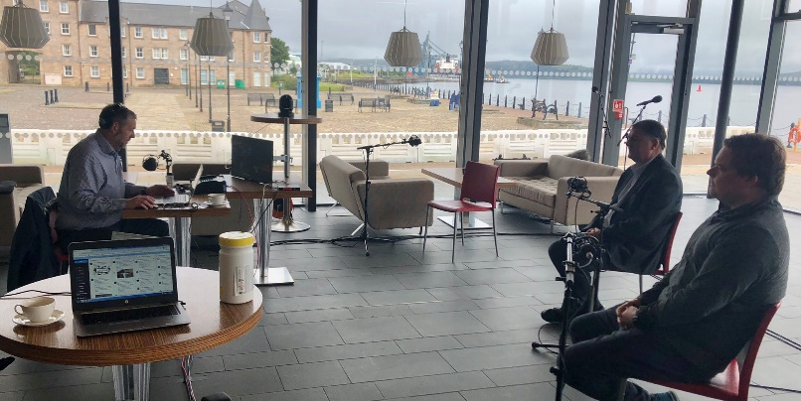Inverclyde featured today on [BBC radio Scotland](https://www.bbc.co.uk/sounds/play/m000ktry) with a range of interviewees in the programme which was broadcast live from Greenock’s Beacon Arts Centre from 6am until 9am.

Inverclyde council leader, Councillor Stephen McCabe and leader of the opposition, Councillor Chris McEleny joined host Gary Roberston (pictured rigtht) with a range of other interviews including business leader Jim McColl OBE discussing business issues and Senior Pastor Fraser Donaldson conducting the ‘thought for the day’.

Inverclyde’s education service is expected to feature tonight on Channel 4 news in an article about schools re-opening.

**Tourism sector reopens**

[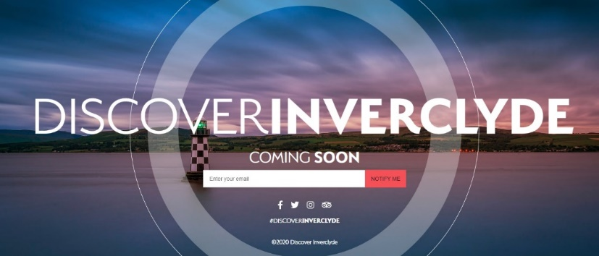](https://www.discoverinverclyde.com/)Further restrictions on tourism have been lifted across Scotland.

The majority of Scotland’s tourism sector can begin to restart from today (Wednesday 15 July 2020) after lockdown restrictions were further eased.

As part of Phase 3 of Scotland’s lockdown route map, guests can now stay in hotels and on campsites and visit tourist attractions across the country as transmission of coronavirus (COVID-19) continues to be suppressed.

Cafes, restaurants and bars can also begin accepting patrons indoors from today.

Find out more about lockdown easing across Scotland including sector specific guidance at the [Scottish Government website](https://www.gov.scot/news/tourism-sector-reopens/).

**Cultural venues start to re-open**

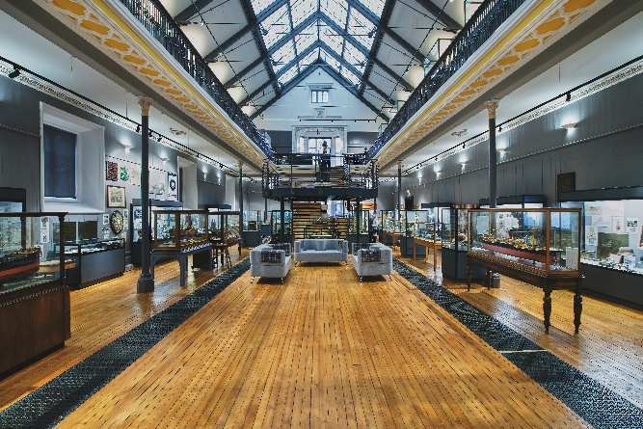The Scottish Government has put in place guidance for cultural venues across Scotland to safely start welcoming visitors.

Visitor attractions such as museums, galleries and heritage sites across Scotland can start to re-open to visitors from today (Wednesday 15 July 2020).

As part of Phase 3 of the routemap out of lockdown, cinemas, monuments and libraries can also now begin to re-open.

As venues start to welcome guests, they are expected to ensure strict physical distancing is in place and for many of these facilities advanced ticketing will be required.

The Scottish Government has published guidance which includes practical advice for venues on the steps they need to take before and after re-opening, such as:

* establishing physical distancing, taking account of organisational capacity, queue management, signage and markings
* enhanced hand hygiene measures and cleaning practice
* advice on workforce planning, including training and equality issues
* guidance for customers to ensure they know how to plan ahead and enjoy visits safely

Greenock’s Watt Institution has reopened to the public.

The facility, which incorporates the McLean Museum, can start welcoming visitors again today following the easing of more coronavirus lockdown restrictions.

The Watt Institution will be open from Wednesday-Friday each week from 11am to 2pm until further notice.

It has been closed since March due to the Covid-19 outbreak.

Also reopening to members of the public today are Greenock Central Library and the libraries in Port Glasgow and Gourock town centres.

They will be open Monday-Friday from 11am-2pm for ‘Connect and Collect’ – books ordered online or over the phone for collection in-person – and computer use.

Browsing is not currently permitted.

Perspex screens have been installed at the Watt Institution and the three local libraries for the safety of visitors and staff, there are hand sanitiser stations, people should wear masks if possible and two-metre social-distancing must be maintained.

Safety videos are available on the Inverclyde Libraries social media channels to demonstrate the changes and new safety measures before people visit.

For more information about the Inverclyde Council libraries service, including how to access ‘Connect and Collect’ and ‘Books on Wheels’ deliveries, visit the [council website](https://www.inverclyde.gov.uk/community-life-and-leisure/inverclyde-libraries).

**Care homes and human rights during COVID-19**

The Scottish Human Rights Commission has published a new briefing on care homes and human rights during covid-19.

The briefing sets out the human rights framework as it applies to the issues that have arisen in care homes, and details the requirements of human rights law to ensure effective investigations are carried out by the state.

Read the full briefing (PDF) on the [Scottish Human Rights Commission website](https://www.scottishhumanrights.com/media/2054/coronavirus-care-homes-briefing-140720_vfinaldocx.pdf).

**Inverclyde windfarm turbine delivery convoys**

Residents are being alerted to slow moving traffic as turbines are delivered this week.

The public notice below has been published by Inverclyde Windfarm:

The first phase of turbine deliveries to Inverclyde Windfarm is scheduled to take place on Thursday and Friday (16/17 July 2020).

On each day, one police-escorted convoy will depart from King George V Dock in Glasgow and travel along the M8 and A8 to Greenock, where they will use the following roads to access the site:

* Turn left onto B788 Baker Street
* Turn left onto B788 Ingleston Street
* Turn right onto B788 Kilmacolm Road
* Right into the site at entrance

The turbine components will be delivered slow moving vehicles under police escort. Police Scotland has advised us that the loads will be scheduled to leave King George V dock at 9.30am and arrive at site at approximately 11.30am however the police have absolute discretion to change these times.

The police escort is provided for the safety of other road users and as such other road users may be stopped or diverted by the police escort as the convoy progresses.

Inverclyde Renewables LLP apologises to local residents and road users for any inconvenience these deliveries may cause. We can assure residents that we are working closely with Police Scotland and Inverclyde Council to ensure that the turbine deliveries cause as little disturbance to the residents of Inverclyde as possible.

If you require any further information on this matter please contact:

* Stuart Cameron, Head of Construction Inverclyde Windfarm – 07469 855 791
* Dave Morran, Construction Manager – 07463 807 648

It is expected that Phase Two, which will comprise the bulk of deliveries, will be undertaken between 4 August and early September and further information will be posted before this date.