|  |
| --- |
| **Coronavirus (Covid-19) – briefing** |



Issued 21 July 2020

|  |
| --- |
| **Below is the latest briefing on the activity in managing the response to coronavirus (Covid-19). Local updates, council service changes and links to trusted sources of health guidance are published at *www.inverclyde.gov.uk/coronavirus*** |

**£285K funding to improve social-distancing**

Inverclyde Council has successfully bid for nearly £300,000 of funding from Sustrans Scotland on behalf of the Scottish Government to make improvements to outdoor spaces, schools and key commuting routes across Inverclyde to aid social-distancing.

The council has been awarded £285k from the first round of funding from the Spaces for People initiative following the launch of the council’s Safe Streets Save Lives [campaign](https://www.inverclyde.gov.uk/news/2020/jun/safe-streets-save-lives), which sought the views of residents about areas where improvements can be made to allow for two-metre distancing while walking, cycling or wheeling.

An application for a further £300k from the scheme is being assessed.

Almost £30 million has been made available to local authorities, health boards and other agencies across Scotland to implement temporary measures for social-distancing. Bids worth a further £8.1m are currently being considered.

The funding announcement was made by [Transport Scotland.](https://www.transport.gov.scot/news/success-for-30-million-pop-up-infrastructure-initiative/)

**Book of Remembrance**

The Book of Remembrance at Greenock Crematorium is now open to view once again on an appointment-only basis.

Entries are available in digital form to be viewed via a computer using touchscreen technology which will be sanitised after each use.

The paper version is also open to view once again.

Following the further easing of lockdown restrictions, up to 20 people are now allowed to attend funeral services at Greenock Crematorium.

The Book of Remembrance is available by appointment only and visitors will be asked to provide contact details in order to satisfy Scottish Government coronavirus contact tracing regulations.

For more information and to arrange a visit, call the crematorium office on 01475 715658.

**Eat Out to Help Out – 50% off meals**

Hospitality businesses in Inverclyde are being encouraged to sign up to the UK Government’s Eat Out to Help Out scheme which offers midweek half-price discounts to diners to help boost the hospitality industry.

Restaurants, pubs and cafes can now sign up to take part in the initiative, which will run throughout August.

The key features of the scheme are:

* all day, every Monday, Tuesday and Wednesday from 3 to 31 August 2020
* to offer a 50% discount, up to a maximum of £10 per person, to diners for food or non-alcoholic drinks to eat or drink in
* to claim the money back from the government

There is no limit to the number of times customers can use the offer during the period of the scheme. Customers cannot get a discount for someone who is not eating or drinking.

Alcohol and service charges are excluded from the offer.

Registration will close on 31 August.

Eligible claims will be paid to businesses within five working days.

For more information, full eligibility criteria and to sign up, visit the [Eat Out to Help Out page](https://www.gov.uk/guidance/register-your-establishment-for-the-eat-out-to-help-out-scheme?&utm_source=twitter&utm_medium=social&utm_campaign=covid19&utm_content=eotho#making-a-claim).

**Health and social care wellbeing hub**

A new national wellbeing helpline and online hub is now available to support health and social care workers in Inverclyde. Staff can call 0800 111 4191 or visit [www.promis.scot](http://www.promis.scot) to access a range of self-care and wellbeing resources designed to support the workforce as they respond to the impact of Covid-19.

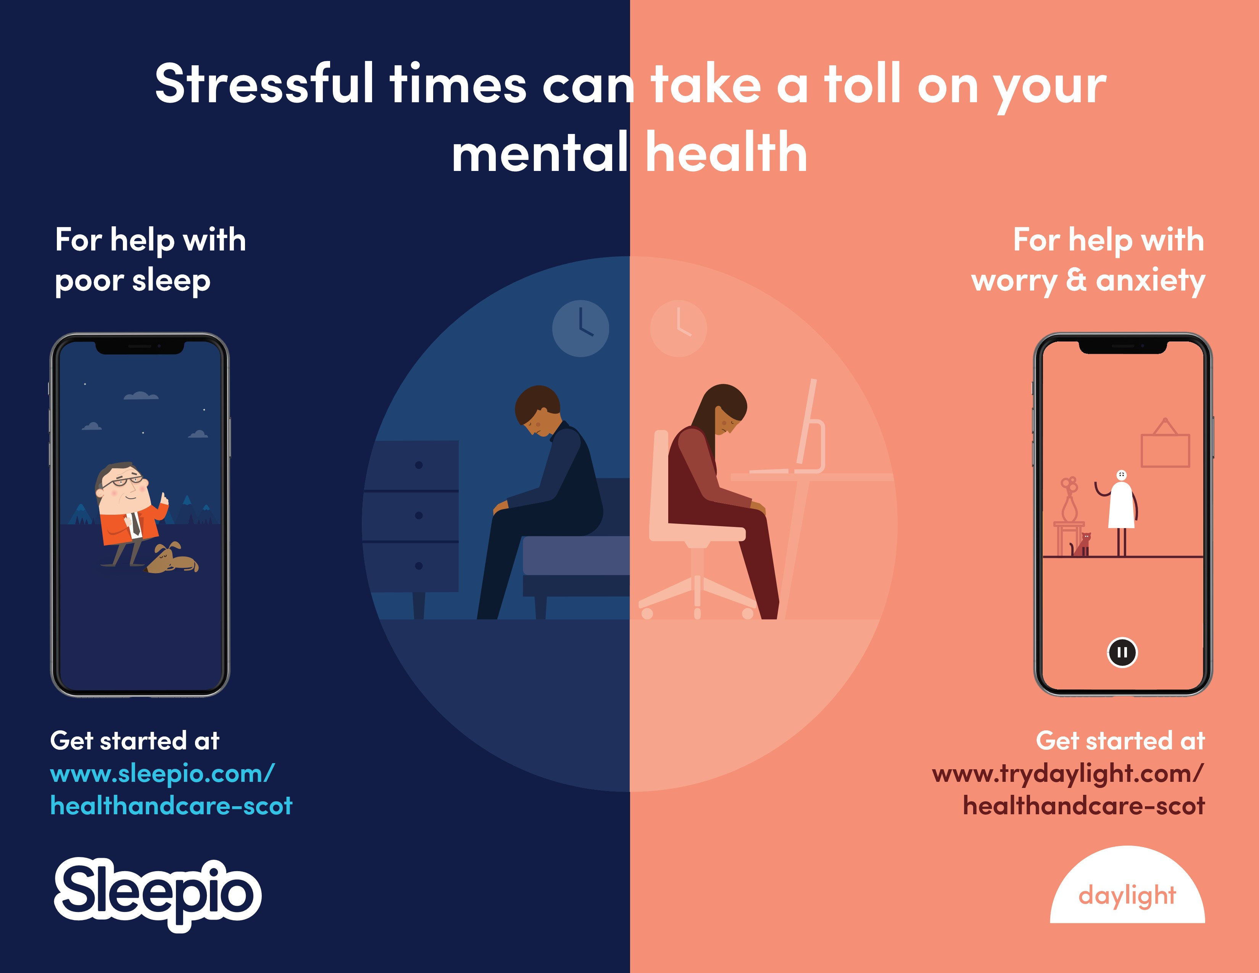The resource will help with things like worry, anxiety and sleeping at night.

This helpline number will route callers to a team of psychological wellbeing practitioners (PWPs) within NHS 24’s Mental Health Hub. The PWPs will offer callers a compassionate and empathetic response based on the principles of psychological first aid, as well as advice, signposting and onward referral to local services if required. It will operate on a 24/7 basis from 20 July initially for a period of 12 months.

**Public toilets reopened**

The phased reopening of public toilets has begun. The facilities at *Campbell Street*, Greenock; *Coronation Park*, Port Glasgow; Albert Road, *Gourock* and *Inverkip* reopened on Monday. A risk assessment has been carried out at each site. As a result, all toilets and touch surfaces will be cleaned a minimum of twice per day and attendants will continue to monitor the toilets throughout their working day.  Additional staffing has been put in place to ensure that toilets are checked/cleaned from 6pm. Appropriate safety advice signage has been installed for members of the public using the facilities. The rest of Inverclyde’s public toilets will reopen at a later date.

**Gourock Walled Gardens and Pets’ Corner open**

Gourock Walled Gardens, including Pets’ Corner, children’s play area and the public toilets, have reopened to the public. The toilets will also allow visitors to wash their hands following any contact with animals.

# **Employee health and wellbeing survey**

**With this survey we aim to understand the impact of the pandemic on employees.**

Please find below a link to a short survey on employee health and wellbeing, with an introductory message from the Chief Executive.

It will help us understand how you’re feeling, what’s working well, and what can be improved to enable you to work effectively, stay safe and maintain your wellbeing.

This short anonymised survey will only take a few minutes of your time, and will help us offer you the best support, where needed.

**We would be grateful if you could complete survey by 6 August 2020.**

The survey can be found here: [**https://www.surveymonkey.co.uk/r/6PGD7CG**](https://www.surveymonkey.co.uk/r/6PGD7CG)

Thank you for your help.