Coronavirus briefing – Friday 23 October 2020

[](https://www.inverclyde.gov.uk/covid-19)**COVID-19 BRIEFING**

**FRIDAY 23 OCTOBER 2020**

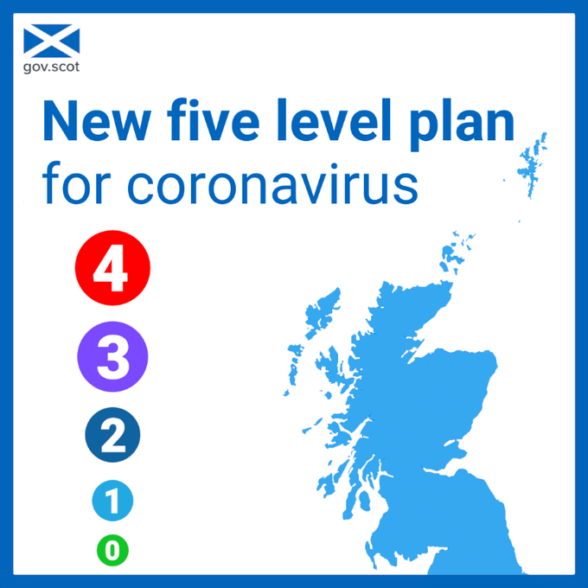**Covid restrictions: New 5-tier system launched**  
The Scottish Government announced today that a new five-tier system of coronavirus restrictions will be introduced to help curb the spread of Covid-19.

Unlike the previous restrictions which affected health board areas, the new alert system will take into account the prevalence of the virus in each of Scotland’s 32 local authority areas.

It comes into effect on 2 November when the current restrictions end and is designed to ensure people living parts of the country with low rates of infection do not have to live with the same restrictions as places with higher rates.

The government is expected to announce next week which tier each council area, including Inverclyde, will come under.

A brief rundown of the new tiered system is below but full details are available at <https://www.gov.scot/publications/coronavirus-covid-19-protection-levels/>.

***Level 0****- Closest to normality as safely as possible without a vaccine.*

*Similar to the situation in August when the virus was suppressed but still a threat. This level would allow people to meet indoors with eight people from three households and most businesses would be open, with safety measures in place.*

***Level 1****- Indoor household meetings limited to six people from two households but there would be a ‘reasonable’ degree of normality overall.*

***Level 2****- Restrictions broadly similar to those currently in place outside the Central Belt. Limitations on hospitality and no gatherings inside people's homes.*

***Level 3 –****Largely similar to the tougher restrictions currently in force apply across the Central Belt, including in Inverclyde, with much of hospitality shut down. Partial opening of restaurants would be allowed.*

***Level 4****- The highest level and only to be used if ‘unless absolutely necessary’ if cases are very high and the NHS is at risk of being overwhelmed. This would be close to the full lockdown introduced in March with non-essential shops forced to close. However, six people from two households could still meet outdoors; there would be no limit on outdoor exercise; and the government would seek to keep manufacturing and construction open.*

**New ‘walk-through’ testing centre open in Greenock**

A new ‘walk-through’ coronavirus testing centre has opened at Crawfurdsburn Community Centre in Greenock.

The UK Government-run facility is designed to make it easier for people to access a test and is in addition to the testing sites already in place at Parklea in Port Glasgow and Glasgow Airport.

* Tests must be booked in advance at: [www.nhsinform.scot/test-and-protect](http://www.nhsinform.scot/test-and-protect) or by calling 0800 028 2816.
* People should only book a test if they have coronavirus symptoms (a high temperature, a new and continuous cough, or a loss or change to their sense of smell or taste) or have been told to seek a test by a clinician or an NHS tracer.
* People travelling to and from the test centre must NOT use taxis or public transport.

**Flu jabs update**

Vaccinations are well underway but they are being administered differently this year and in greater numbers than ever before due to the coronavirus pandemic.

Most people will be invited to either Greenock Town Hall, Port Glasgow Town Hall, *pictured*, Gourock’s Gamble Halls or Kilmacolm Community Centre for their jag to allow for two-metre social-distancing.

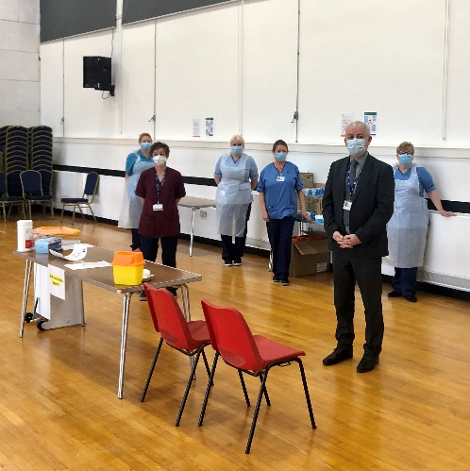

Among those who are eligible for a free jab are people aged **over 65** and anyone who has not yet been contacted about their appointment will receive a letter by the end of October.

The flu jab is routinely available on the NHS to: **adults who are 65 and over**; people with **certain medical conditions**; **pregnant** women; children aged **two and three years old** on 31 August 2020; **children in primary school**; unpaid and young **carers**; **those in the same home as people previously shielding from coronavirus**; and frontline **health or social care workers**.

GP practices have begun vaccinating those under 65 in **‘at risk’** groups and they will contact patients directly with details on how to book or to offer an appointment.

Whilst most practices will be using their own building to administer the flu jab, some will invite people to a community venue.

**Carers** and those who live with someone in the **shielding** group will be asked to attend local pharmacies.

Community nurses will still carry out home visits to those who are **housebound**.

A second phase is planned to begin in December and will include those [**aged 55 to 64**](https://www.nhsinform.scot/flu#people-aged-55-to-64) who would not usually be eligible.

Anyone who is unsure about whether they are eligible for a flu vaccination can check online at [www.nhsinform.scot/flu](http://www.nhsinform.scot/flu) or phone 0800 22 44 88 between 8am and 10pm seven days a week.

**Business disruption fund open**

Businesses which have either been forced to close or suffered a drop in trade because of Covid-19 limitations could be eligible for a one-off grant of between £1,000 and £3,000.

Payments will be distributed by local authorities, including Inverclyde Council, from a £40 million Scottish Government fund.

Grants are being offered to support businesses, particularly those in the hospitality and leisure sectors, affected by the restrictions aimed at tackling a surge in coronavirus cases which came into effect on 9 October.

The grants are aimed at the likes of pubs and restaurants, their suppliers and gyms.

For full eligibility criteria, to download an application form and to find out how to apply for funding, visit [www.inverclyde.gov.uk/covidsupportfund](http://www.inverclyde.gov.uk/covidsupportfund).

**Issued by Inverclyde Council’s corporate communications, tourism and health and safety service.  If any of your colleagues do not have access to ICON, Inverclyde Council’s intranet, or email through the council network please share this message with them.  Coronavirus updates from Inverclyde Council are published online at the dedicated** [**coronavirus pages of the council website**](http://www.inverclyde.gov.uk/coronavirus)**.**