

Legal & Property Services

FOR SALE:

DEVELOPMENT OPPORTUNITY

**Site of the former Greenock Academy School**

**Madeira Street, Greenock**

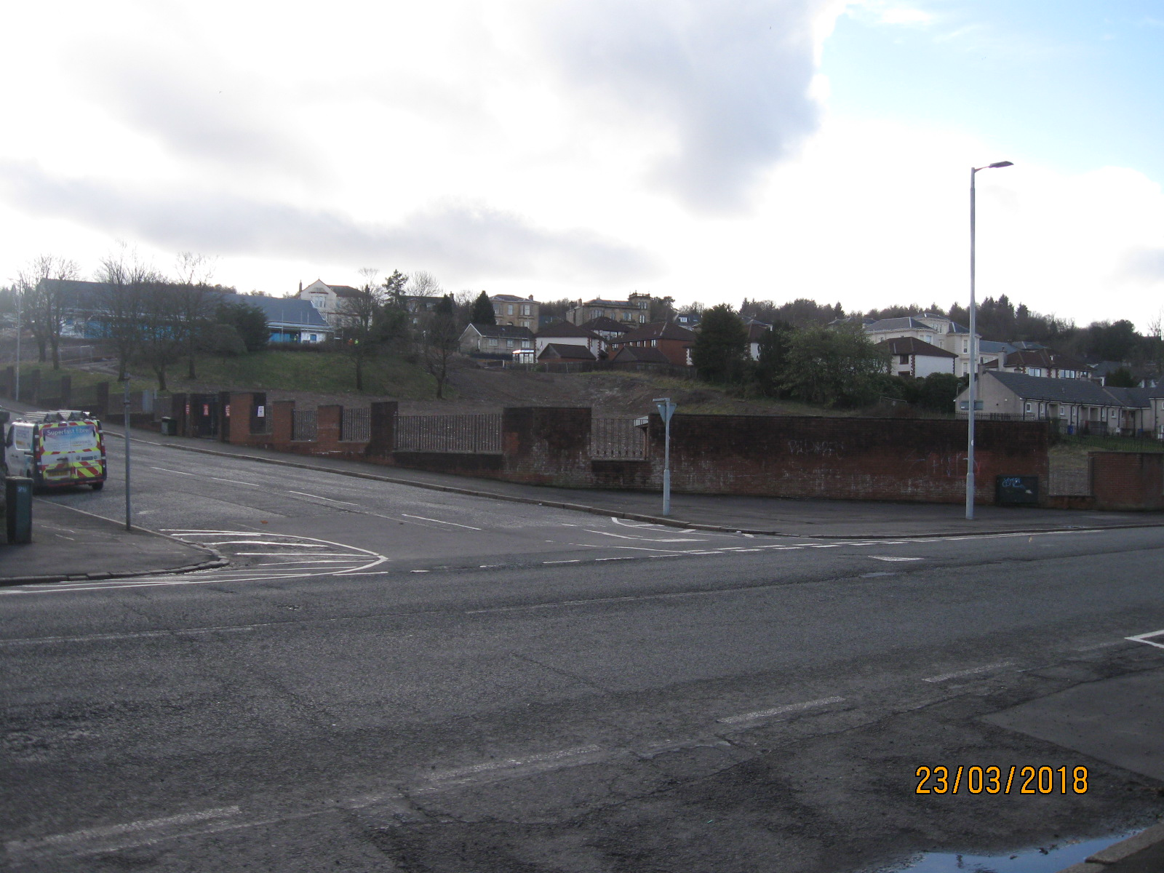

* DESIRABLE RESIDENTIAL LOCATION
* PROMINENT ROADSIDE POSITION
* SUITABLE FOR RESIDENTIAL USE SUBJECT TO PLANNING APPROVAL
* LEVEL SITE EXTENDING TO 1.001 HECTARES OR THEREBY
* OFFERS FOR SALE INVITED

|  |
| --- |
| The above Particulars are believed to be correct, but are supplied for information only and no reliance should be placed thereon. They are not deemed to form any contract or part of contract which may be entered into. Inverclyde Council does not bind itself to accept the highest rent or offer and in supplying these Particulars is not issuing instructions and will not therefore, bear liability for Agent’s or other fees. |
|  |
| Property Asset Team  Inverclyde Council, Municipal Buildings, Greenock PA15 1LY  Telephone 01475 712102 E-mail: property@inverclyde.gov.uk |

**LOCATION**

The site enjoys a prominent position on Union Street, bounded by Madeira Street and Finnart Street and lies within a predominately private residential area in the West End of Greenock, adjacent to a conservation area.

The site has good road links to Greenock Town Centre which lies approximately 1 mile to the east and Gourock town centre approximately 2 miles to the west.

**DESCRIPTION**

The subjects comprise a gently sloping rectangular site extending to 1.001 Hectares or thereby, formerly part of the site of the Greenock Academy, now demolished.

It is up to potential developers to satisfy themselves as to the suitability of this site for any potential development.

It is the responsibility of prospective purchasers to satisfy themselves as to the availability, condition and capacity of all service provisions.

The subject site is burdened by a lease of a gas governor site on the north west corner and any sale would be inclusive of this lease.

**PLANNING**

The site lies within the administrative area of Inverclyde Council and in a predominately residential area, but any specific proposals should be referred to the Planning Services utilising the contact details on the contacts page.

**ROADS GUIDANCE**

All development proposals would be required to comply with the Council’s Roads Development Guidelines, including the requirement to provide off street car parking. Prospective developers are advised to contact the Council’s Roads Department on telephone number 01475 714800 to discuss all proposals.

**RATING**

The subjects are currently assessed as ‘Ground’ and will require to be re-assessed on completion and occupation of any development.

**ENTRY**

Immediate entry on completion of legal formalities can be offered.

**VIEWING**

The site is open for viewing at any time.

**INTEREST**

All interested parties must register their interest with the Property Asset Team either by telephone on 01475 712102, via the Inverclyde Council website, or online at [property@inverclyde.gov.uk](mailto:property@inverclyde.gov.uk) in order to receive the offer package which is required prior to submitting an offer once a closing date has been announced.

**OFFERS**

Offers are invited for a purchase. The offer should include full details of any proposed development.

**CLOSING DATE**

Please note a **closing date for offers** has been set for 12 Noon Friday 17 September. It is essential to register should you wish to make an offer.

All offers should be submitted by the notified time to;

Interim Head of Legal Services

Inverclyde Council

Municipal Buildings

Greenock PA15 1LY

Any offer submitted must strictly comply with the terms and conditions as set out in the attached conditions of sale. These will be forwarded to all parties who register an interest, and will include an address label which must be affixed to the front of all envelopes containing offers.