

Inverclyde Council
Annual Complaints Report
1 April 2020 – 31 March 2021
CONTENTS

Item | Heading
1.0 | Background
2.0 | Current Procedures
3.0 | Governance Arrangements
4.0 | Summary of Performance
4.1 | Number of complaints received
4.11 | Complaint trends
4.15 | Timescales
4.28 | Complaint Outcomes
4.31 | Complaint themes
4.34 | Learning from complaints
5.0 | Scottish Public Services Ombudsman (SPSO) Reviews
6.0 | Developments
7.0 | Positive comments
8.0 | Conclusion

1.0 | Background
1.1 | In April 2013 the Council introduced a revised complaints handling procedure moving from a three stage to a two stage process in line with the guidance by the Scottish Public Services Ombudsman (SPSO). At the same time a new corporate wide system for recording complaints through LAGAN was rolled out across the Council.
1.2 | In 2015 an audit was undertaken to provide management and the Audit Committee with an assessment of the adequacy and effectiveness of the governance, risk management and controls surrounding a number of key risks faced by both the Council and Inverclyde HSCP regarding complaints. There was a requirement to improve on a number of areas.
1.3 | A corporate working group was established following the audit with representation across all services and chaired by a Corporate Director to address areas in the Council’s complaint handling.
1.4 | The Council’s objective was to address issues that had been identified during historic complaint handling were agreed to ensure that the Council has a robust approach to complaint handling. The Complaint Officer post has strengthened the robustness of the Council’s complaint handling approach in the following areas;  - Increased awareness of the Council’s complaint handling procedures.  - Ensuring training needs of staff with responsibility for complaint handling are identified and addressed.  - Improved corporate oversight of the complaints process.  - Improved monitoring of complaints.  - Regular review of the Council’s complaint handling procedures for effectiveness.
1.5 | The local authority complaint handler network (LACHN) is a national forum for local authority complaint handlers to meet quarterly to assist in the development of professional practice in relation to complaint handling. Inverclyde Council are represented at this forum by the complaint officer alongside representatives from 32 Scottish Local Authorities. The SPSO attend these meetings to support the ongoing development of complaint handling within local authorities and to achieve consistency in approach.
1.6 | Inverclyde Leisure operates sports and community facilities throughout Inverclyde for the Council and Riverside Inverclyde promotes urban regeneration within the area. While these organisations are separate to the Council they are subject to its control and the Council is responsible for ensuring the services provided meet the required standards and adhere to the complaint handling procedure. In doing this the Council must establish mechanisms to identify and act on complaint handling performance issues identified.
1.7 | The SPSO through LACHN network issued a survey to all local authorities to complete regarding complaint handling reporting being submitted to the network to review prior to formal reporting being issued to SPSO. The survey questions highlighted the requirements for Council’s to report complaint handling performance for ALEOs. Inverclyde Council have two ALEO’s they are Inverclyde Leisure and Riverside Inverclyde and they are required to adhere to reporting on complaints handled although they were not included at the time of the implementing the model complaint procedure. Actions have been taken to address this and Inverclyde Council are now adhering to the reporting requirements set out by the SPSO.
1.8 | Following the results of the survey that was completed by all of the local authorities, the SPSO confirmed that they would be moving to a quarterly submission of complaint handling statistical data from all Councils. This was intended to ease the collation of management information on annual basis. Inverclyde Council agreed to supply this statistical data each quarter, as it is currently prepared for the CMT on a quarterly and annual basis. The draft report is issued to the LACHN for discussion at the network meeting and any inconsistences in data interpretation and analysis is resolved before the formal annual submission to the SPSO each year.
2.0 | Current Procedures
2.1 | Inverclyde Council co-ordinates the reporting of complaints to the SPSO and this includes the HSCP, ALEOs, Inverclyde Leisure and Riverside Inverclyde. Each area is responsible for recording their own complaints and providing their management information to Inverclyde Council to enable the consolidated statistical report to be produced quarterly and annually.
2.2 | On 1 April 2021 Inverclyde Council, the HSCP and both ALEOs, Inverclyde Leisure and Riverside Inverclyde adopted the new Model Complaint Handling Procedure which was updated by the Scottish Public Services Ombudsman. This change aligns the procedure followed in each of these areas. The procedure provides a quick, simple, streamlined process with a strong focus on local, early resolution. This enables issues or concerns dealt with close to the event which gave rise to the complainant making the complaint.
2.3 | As far as possible the complainant should be actively and positively engaged with the process from the outset.
2.4 | Frontline resolution stage one: Frontline resolution should be attempted where there are straightforward issues potentially easily resolved with little or no investigation. This should be completed within 5 working days
2.5 | Investigation stage two: Where complaints cannot be resolved at the frontline stage or those which are complex, serious or high risk, a thorough investigation will be undertaken. This typically requires more thorough examination in order to establish facts prior to reaching conclusion. The complaint points and resolution outcome sought is agreed with the complainant. This should be completed within 20 working days.
2.6 | Escalated investigation stage two: Where the complainant remains dissatisfied with the way the Council dealt with their complaint at frontline resolution, the complainant can request a detailed investigation under stage two of our complaints handling procedure. This must be undertaken before the complainant can take their complaint to the SPSO to review.
2.7 | Scottish Public Service Ombudsman: Appeals of complaint outcomes are reviewed by the SPSO.
3.0 | Governance Arrangements
3.1 | Governance arrangements are in place to report and analyse complaints within Inverclyde Council as follows:  Heads of Service Meetings  Service Review Meetings  Director Management Team meetings  Corporate Management Team meetings annually
3.2 | Inverclyde Council log their complaints into the Verint system. The Health and Social Care Partnership complaints are logged in two ways a complaint log spreadsheet for all complaints and complaints relating to NHS GG&C are also recorded on their Datix system. Inverclyde Leisure and Riverside Inverclyde record their complaints on a complaint log spreadsheet.
3.3 | This is supported by the Information Governance and Complaint Officer who promotes the complaint handling procedure and provides strategic direction for complaint handling to ensure a responsive, efficient and improved complaint handling service which meets the regulatory standards. Oversight and monitoring of complaint handling performance is undertaken to ensure the feedback mechanism is delivering continuous improvement. Quarterly recommendations on improvement areas are discussed with the Corporate Management Team. The Health and Social Care Partnership have created a temporary NHS funded role of Complaints Manager who is responsible for overseeing the processing of all complaints relating to the HSCP including NHS GG&C. The HSCP Complaints Manager ensures that all complaints are responded to in a professional manner, providing performance management and analysis (financial, planning and business management) and achieving national and local targets.
4.0 | Summary of Performance
4.1 | Number of complaint received and closed
4.2 | In the reporting period 1 April 2020 – 31 March 2021 Inverclyde Council, Inverclyde Leisure and the HSCP received and handled 269 complaints and closed 250 complaints. The complaints received per 1000 of population is 3.5 complaints which is a reduction when comparing to the same period last year.
4.2 | The SPSO requires Inverclyde Council to include ALEOs and HSCP complaints statistical information in the quarterly and annual reports. It should be noted that oversight and day to day matters relating to complaints are supported separately
4.3 | This is the third year that the Council have reported a collective report on complaint handling performance that includes Inverclyde Council, HSCP, Inverclyde Leisure and Riverside Inverclyde.
4.4 | The statistics show a decrease in the number of complaints received in Inverclyde Council, the HSCP and Inverclyde Leisure. No complaints were received in Riverside Inverclyde. The reduction in complaints received is largely attributable to the period when the UK went into national lockdown and the focus of residents moved towards matters of greater importance the Council evidenced lower complaint volumes received in the first 6 months of the year.
4.5 | The Council actively published information on the Council’s website and on social media for residents to understand the implications of potential delays which could be encountered with the impact of Coronavirus (COVID-19). In particular specific messages were shared on the Council’s complaint handling website pages to manage the expectations of service users and to explain that the Council may have to apply timescales for complaint handling. In addition to this the Council also encouraged service users to refrain from submitting complaints where it was about the following matters:  - Delays with processing complaints,  - Delays with complaint responses,  - Matters which are likely to resolve themselves within the next few weeks/months,  - Delays in service delivery which are the result of organisations having to cope with COVID-19 and which are non-essential.
4.6 | The key emphasis was placed on the Council’s appreciation of service user’s patience whilst the Council worked through these unprecedented circumstances and in particular if the service that was received from the Council had fallen below expectations or if our response to a complaint had taken the Council longer than the stated timescale. The Council also signposted service users to the additional information published on the SPSO’s website on the impact of Coronavirus (COVID-19) on complaints.
4.7 | This is the second full year of accurate reporting which can be used to benchmark future years performance. The tables summarise the complaints received.
 |  | Number complaints received
 | 2020/21 | 2019/20 | 2018/19 | 2017/18 | 2016/17 | 2015/16
Inverclyde Council | 213 | 274 | 256 | 288 | 181* | 146
HSCP | 39 | 73 | 44 | 55
Inverclyde Leisure | 14 | 40 | 29** | 8
Riverside Inverclyde | 0 | 2 | 13

*Members are reminded that essential changes were made to the LAGAN in order to improve the complaint management system in preparation for it to be adopted as the universal complaint recording system for the Council. During this process closed complaint data was lost which impacts on the extent of complaints finally recorded in 2016.
** Inverclyde Leisure had a loss of data for the data covering the period 1 January 2018 to 31 March 2018 which will have will have impacted the extent of complaints finally recorded in 2018/19 the collective reporting of complaints
4.8 | The chart below shows Inverclyde Council’s volumes only over time the last six years.  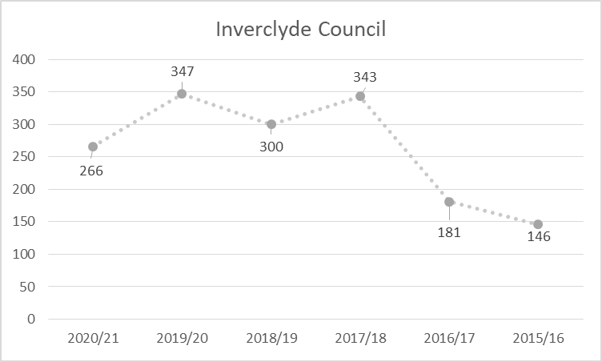
4.9 | The tables below outlines closed complaint breakdown by investigation stage and comparable data volumes for the periods in 2019/18 to 2016/17 inclusive.
 | No of frontline resolution stage 1
 | 2020/21 | 2019/20 | 2018/19 | 2017/18 | 2016/17
Inverclyde Council | 162 | 220 | 214 | 225 | 121
HSCP | 25 | 39 | 17 | 33 | 31
Inverclyde Leisure | 13 | 40 | 29 | 7
Riverside Inverclyde | 0 | 2 | 12

 | No of complaint investigations stage 2
 | 2020/21 | 2019/20 | 2018/19 | 2017/18 | 2016/17
Inverclyde Council | 24 | 20 | 8 | 17 | 23
HSCP | 10 | 27 | 22 | 26 | 25
Inverclyde Leisure | 0 | 0 | 0 | 0
Riverside Inverclyde | 0 | 0 | 1

 | No of complaint investigations escalated stage 2
 | 2020/21 | 2019/20 | 2018/19 | 2017/18 | 2016/17
Inverclyde Council | 12 | 21 | 13 | 21 | 7
HSCP | 1 | 3 | 0 | 0 | 0
Inverclyde Leisure | 1 | 0 | 0 | 0
Riverside Inverclyde | 0 | 0 | 0

4.10 |  | In respect of the complaints received there are occasions where the complaint is partially investigated and either withdrawn or is found not to be appropriate for the complaint handling procedure which is removed from the overall numbers. These are noted in the table below which is largely evidential in the Council’s handling of complaints.
   | Withdrawn
   | 2020/21 | 2019/20 | 2018/19 | 2017/18 | 2016/17
  Inverclyde Council | 15 | 15 | 19 | 25 | 8
  HSCP | 0 | 0 | 0 | 0 | 0
  Inverclyde Leisure | 0 | 0 | 0 | 0
  Riverside Inverclyde | 0 | 0 | 0
   | Service requests
   | 2020/21 | 2019/20 | 2018/19 | 2017/18 | 2016/17
  Inverclyde Council | 0 | 3 | 7 | 6 | 8
  HSCP | 0 | 0 | 0 | 0 | 0
  Inverclyde Leisure | 0 | 0 | 0 | 0
  Riverside Inverclyde | 0 | 0 | 0
   | Not Council related / Invalid
   | 2020/21 | 2019/20 | 2018/19 | 2017/18 | 2016/17
  Inverclyde Council | 2 | 3 | 10 | 4 | 13
  HSCP | 0 | 0 | 0 | 0 | 0
  Inverclyde Leisure | 0 | 0 | 0 | 0
  Riverside Inverclyde | 0 | 0 | 0
4.11 |  | Complaint Trends
4.12 |  | The table below provides a monthly breakdown of complaints received within each service during 1 April 2020 to 31 March 2021. For Inverclyde Leisure, Riverside Inverclyde and HSCP the breakdown is only provided for the annualised volumes.
 | Apr-20 | May-20 | Jun-20 | Jul-20 | Aug-20 | Sep-20 | Oct-20 | Nov-20 | Dec-20 | Jan-21 | Feb-21 | Mar-21 | Totals
Chief Executive Office | 0 | 0 | 0 | 0 | 0 | 0 | 0 | 0 | 0 | 0 | 0 | 0 | 0
Environmental & Public Protection Svs | 11 | 2 | 13 | 0 | 8 | 0 | 12 | 9 | 5 | 2 | 8 | 12 | 82
Finance | 4 | 1 | 2 | 1 | 2 | 3 | 2 | 1 | 3 | 10 | 3 | 2 | 34
Legal & Property Services | 0 | 0 | 3 | 1 | 0 | 0 | 0 | 0 | 0 | 0 | 0 | 0 | 4
Regeneration & Planning | 0 | 1 | 0 | 1 | 0 | 1 | 0 | 0 | 0 | 0 | 0 | 0 | 3
Roads Shared Service | 0 | 1 | 2 | 0 | 4 | 1 | 1 | 1 | 1 | 1 | 6 | 2 | 20
Education | 3 | 1 | 1 | 2 | 4 | 5 | 2 | 4 | 7 | 1 | 2 | 6 | 38
Culture, Communities & Education Resources | 0 | 0 | 0 | 0 | 8 | 0 | 1 | 0 | 0 | 0 | 0 | 1 | 10
Org Develop Policy & Communications | 0 | 0 | 1 | 0 | 2 | 0 | 0 | 0 | 0 | 1 | 0 | 0 | 4
Inverclyde Leisure |  |  |  |  |  |  |  |  |  |  |  |  | 14
Riverside Inverclyde |  |  |  |  |  |  |  |  |  |  |  |  | 0
HSCP |  |  |  |  |  |  |  |  |  |  |  |  | 39
4.13 |  | An interim management restructure was implemented early in 2021 to assist with the Council’s recovery from COVID 19. Future reporting will be reflective of this new structure however could not be reflected in the statistics produced for this annual report as this would affect the comparable data for the report
4.14 |  | Outlined in the chart overleaf is the percentage of complaints received by each service compared against the total number of complaints received. The Chief Executives’ office and Riverside Inverclyde was the only area that that did not receive any complaints over the course of the year.
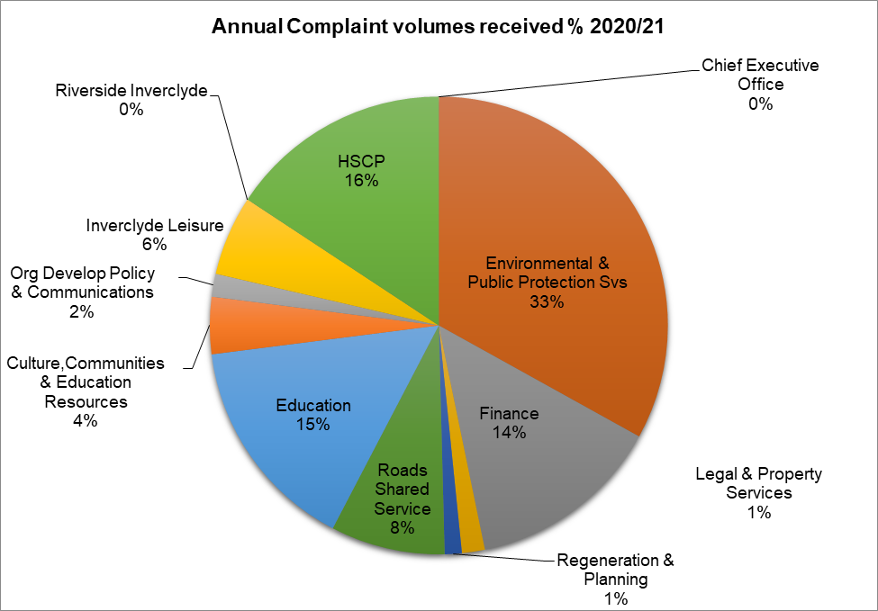

4.15 |  | Timescales
4.16 |  | The Council aim to resolve complaints quickly. Where appropriate this could mean an on-spot-apology and explanation if something has clearly gone wrong and immediate action to resolve a problem. The Council have 5 working days to respond to a complaint within the stage one process.
4.17 |  | In some circumstances the investigating officer will have to make some enquiries before the Council can respond to a complaint. If the Council are unable to resolve the complaint at this stage, the investigating officer will explain why. The Council may decide it is appropriate to extend the time to deal with the complaint by a further five days or in complex cases they may move the complaint to a stage two investigation. In either scenario the Council will keep complainants informed and manage their expectations in respect of timescales.
4.18 |  | A Stage two complaint deals with two types of complaint: those that have not been resolved at stage one and those that are complex and require a more detailed investigation.
4.19 |  | Where a complainant has escalated a complaint to stage two because they remain dissatisfied with the outcome of the Council’s handling a complaint, this is known as an Escalated Stage 2 Investigation.
4.20 |  | When handling a complaint using stage two the Council will;  - Acknowledge receipt of the complaint within three working days;  - Where appropriate, discuss the complaint with the complainant to understand why they remain dissatisfied and seek clarification on the outcome sought; and  - a full written response is provided to the complainant as soon as possible and within 20 working days.
4.21 |  | If the Council’s investigation is likely to take longer than 20 working days, the Council will agree revised timescales with the complainant and keep them updated until complaint is resolved.
4.22 |  | Investigating officers are advised of the required dates for timescales on receipt of the complaint. Additional reminders are in place to support timely completion.
4.23 |  | The Scottish Public Services Ombudsman, Rosemary Agnew wrote to the Chief Executive highlighting concerns around complaint handling timescales within local authorities. The Council will ensure officers are reminded of the importance of managing complaints effectively and keeping complainants updated when the Council are likely to exceed the standard timescales expected.
4.24 |  | The table below outlines the Inverclyde Council’s collective performance measures on timescales management across all stages of the complaint procedure.
Performance measures | Collective Inverclyde Council 2020/21
No of complaints – closed at stage 1 within 5 days  No of complaints – closed at stage 1 within 10 days (time extended) | 169  3
% Complaints Meeting timescale incl those time extended within timescale | 84.5%
Ave working days taken stage 1 complaints | 5 days
No of complaints – closed at stage 2 within 20 days  No of complaints – closed at stage 2 within 25 days (time extended) | 26  0
% Complaints Meeting timescale inc those time extended within timescale | 74.3%
Ave working days taken stage 2 complaints | 16.2 days
No of complaints – closed at escalated stage 2 within 20 days  No of complaints – closed at stage 2 within 25 days (time extended) | 12  0
% Complaints Meeting timescale includes those time extended within timescale | 80%
Ave working days taken escalated stage 2 complaints | 15.1 days
4.25 |  | The tables below outlines the management of complaints within the prescribed timescale broken down by each areas complaint. The comparable data is not available for Inverclyde Leisure as they have adopted the reporting of complaints within the period 2017/18.
 | Inverclyde Council’s Consolidated Performance
Stage 1 Frontline resolution |  | Performance Area | 2020 /21 | 2019 /20 | 2018 /19 | 2017 /18
 |  | No of complaints – closed at stage 1 within 5 days | 138 | 229 | 222 | 214
 |  | % Complaints Meeting timescale including those time extended | 85.2% | 83.6% | 82% | 81%
 |  | Ave working days taken stage 1 | 4.6 | 3.7 | 4.1 | 4.4
Stage 2 Investigation |  | No of complaints – closed at stage 2 within 20 days | 19 | 34 | 21 | 31
 |  | % Complaints Meeting timescale including those time extended | 79.2% | 76.7% | 68% | 76.6%
 |  | Ave working days taken stage 2 | 15.2 | 18 days | 18.1 | 15.5
Stage 2 Escalated Investigation |  | No of complaints – closed at esc stage 2 within 20 days | 11 | 14 | 13 | 18
 |  | % Complaints Meeting timescale including those time extended | 91.7% | 75% | 100% | 85.7%
 |  | Ave working days taken esc stage 2 | 16.6 | 18.3 | 14.0 | 13.8

Inverclyde Council Only
Stage 1 Frontline resolution | Performance Area | 2020/21 | 2019 /20 | 2018 /19 | 2017 /18 | 2016  /17
Stage 1 Frontline resolution | No of complaints – closed at stage 1 within 5 days | 138 | 172 | 171 | 182* | 104
Stage 1 Frontline resolution | % Complaints Meeting timescale inc those time extended | 85.2% | 87% | 80% | 78% | 86%
Stage 1 Frontline resolution | Ave working days taken stage 1 | 4.6 | 3.9 | 4.4 | 3.8 | 3
Stage 2 Investigation | No of complaints – closed at stage 2 within 20 days | 19 | 14 | 7 | 9** | 20
Stage 2 Investigation | % Complaints Meeting timescale inc those time extended | 79.2% | 80% | 88% | 90% | 86%
Stage 2 Investigation | Ave working days taken stage 2 | 15.2 | 16.1 | 18.4 | 16.3 | 11.7
Stage 2 Escalated Investigation | No of complaints – closed at esc stage 2 within 20 days | 11 | 14 | 13 | 18 | 0
Stage 2 Escalated Investigation | % Complaints Meeting timescale inc those time extended | 91.7% | 81.8% | 100% | 86% | 0
Stage 2 Escalated Investigation | Ave working days taken esc stage 2 | 16.6 | 15.7 | 14 | 13.8 | 0

HSCP
Stage 1 Frontline resolution | Performance Area | 2020  /21 | 2019  / 20 | 2018 /19 | 2017  /18 | 2016  /17
Stage 1 Frontline resolution | No of complaints – closed at stage 1 within 5 days | 14 | 39 | 12 | 22 | 30
Stage 1 Frontline resolution | % Complaints Meeting timescale inc those time extended | 56% | 72% | 71% | 88% | 96%
Stage 1 Frontline resolution | Ave working days taken stage 1 | 9.3 | 5.3 | 7.5 | 4.1 | N/A
Stage 2 Investigation | No of complaints – closed at stage 2 within 20 days | 6 | 27 | 13 | 18 | 15
Stage 2 Investigation | % Complaints Meeting timescale inc those time extended | 60% | 74% | 59% | 79% | 60%
Stage 2 Investigation | Ave working days taken stage 2 | 22.3 | 19.5 | 18.2 | 18.2 | N/A
Stage 2 Escalated Investigation | No of complaints – closed at esc stage 2 within 20 days | 1 | 3 | 0 | 0 | 0
Stage 2 Escalated Investigation | % Complaints Meeting timescale inc those time extended | 0% | 0% | 0 | N/A | 0
Stage 2 Escalated Investigation | Ave working days taken esc stage 2 | 27 | 31 | 0 | 0 | N/A

 |  | Inverclyde  Leisure*** |  |  |  | Riverside Inverclyde****
Stage 1 Frontline resolution | Performance Area | 2020 /21 | 2019 /20 | 2018 /19 | 2017 /18 | 2020 /21 | 2019 /20 | 2018  /19
Stage 1 Frontline resolution | No of complaints – closed at stage 1 within 5 days | 13 | 40 | 29 | 5 | 0 | 2 | 12
Stage 1 Frontline resolution | % Complaints Meeting timescale | 100% | 100% | 100% | 83% | N/A | 2 | 100%
Stage 1 Frontline resolution | Ave working days taken stage 1 | 1 | 1 | 1 | 3 | N/A |  | 1.6
Stage 2 Investigation | No of complaints – closed at stage 2 within 20 days | 1 | 0 | 0 | 2 | 0 | 0 | 1
Stage 2 Investigation | % Complaints Meeting timescale | 100% | 0 | 0 | 67% | N/A | 0 | 100%
Stage 2 Investigation | Ave working days taken stage 2 | 10 | 0 | 0 | 13.3 | N/A | 0 | 14
Stage 2 Escalated Investigation | No of complaints – closed at esc stage 2 within 20 days | 0 | 0 | 0 | 0 | 0 | 0 | 0
Stage 2 Escalated Investigation | % Complaints Meeting timescale | 0 | 0 | 0 | N/A | N/A | 0 | 0
Stage 2 Escalated Investigation | Ave working days taken esc stage 2 | 0 | 0 | 0 | 0 | N/A | 0 | 0
*One complaint has been included within stage one resolution as time extension was granted allowing 10 days for the complaint to be resolved and reported within timescales.
** Two complaints have been included in the stage two resolutions as time extension was granted allowing 25 days for the complaint to be resolved and reported within timescale
*** Inverclyde Leisure data only available from the period 2017/18
****Riverside Inverclyde data only available from the period 2018/19
4.26 |  | Services must maintain focus on ensuring complaints received are recorded and that the complaint handling procedure is followed by officers, in particular with regards to timescales to resolve complaints at stage one and stage two. When comparing in isolation Inverclyde Council’s complaint handling performance the Council have noted timescales to resolve complaints have increase in all stages which impacts the average days reported. Most of the delays have been affected during periods when Services were under considerable pressure responding to the COVID19 pandemic.
4.27 |  | The average days to resolve complaints in all stages of the complaint procedure has increased in HSCP’s complaints. Most of the delays have been affected during periods when Services were under considerable pressure responding to the COVID19 pandemic and by management resources available which will be an area for focus in the coming year.
4.28 |  | Complaint Outcomes
4.29 |  | The graph below outlines the outcomes of investigations of all collective complaints following complaint investigation at each of the 3 stages a complaint may be taken through.
 |  | 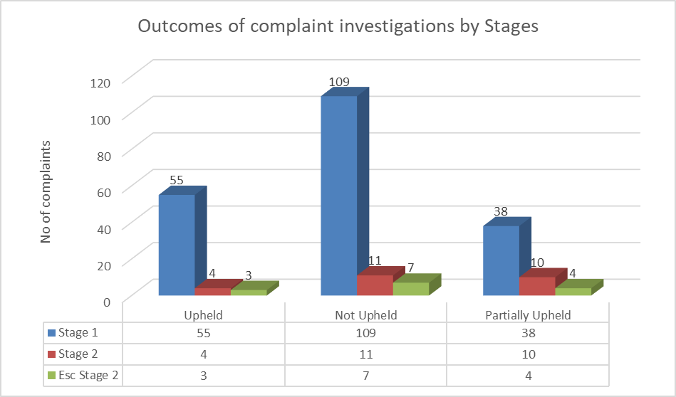
4.30 |  | The pie chart below outlines the collective outcomes of all complaint investigations as a percentage of all complaints received.
 |  | 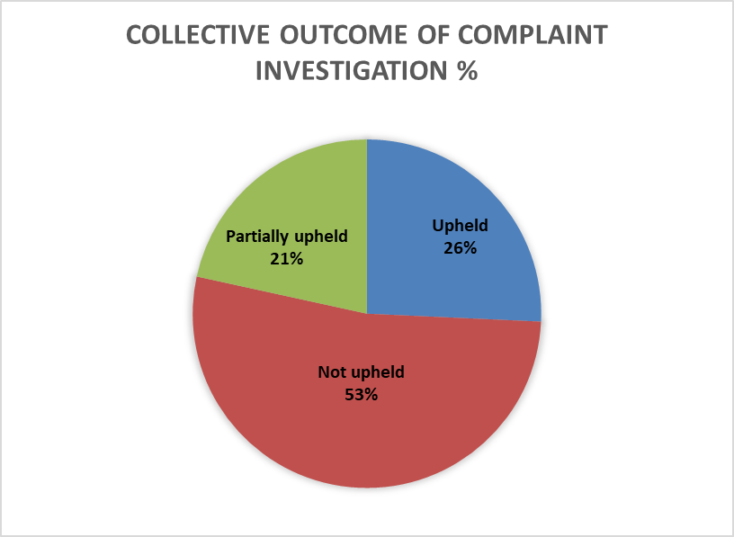
4.31 |  | Complaint themes
4.32 |  | Of the complaints which were upheld or partially upheld, they were examined for key themes. In some situations the complexity of some complaints were multi faceted although the true root cause was used to define this into a single theme. In doing this the Council have only included the complaints from Inverclyde Council only, as this level of information is recorded in the complaint handling system.
4.33 |  | The top complaint theme was for these complaints was where the service delivered was below the expected standards at 42% of all complaints received. This has increased when comparing the complaint themes against the following year.  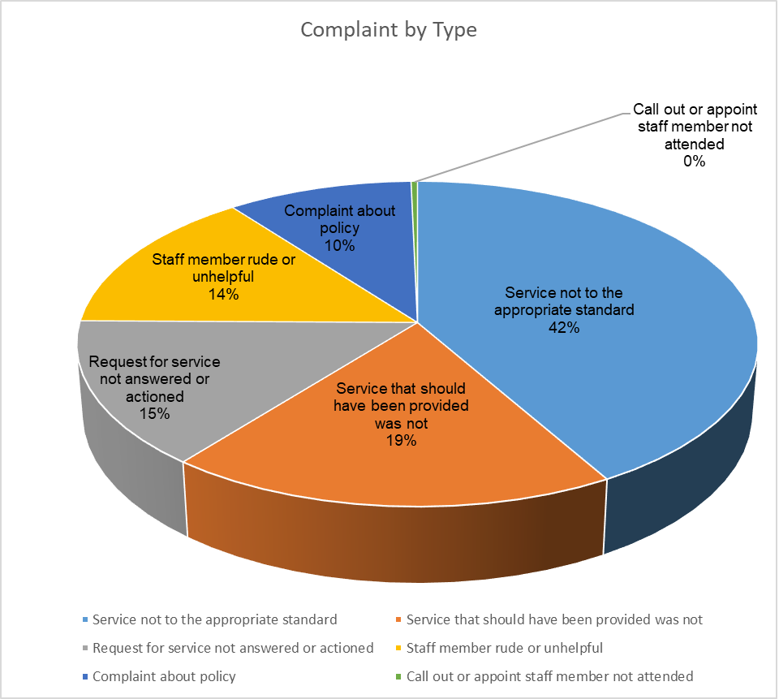
4.34 |  | Learning from complaints
4.35 |  | Inverclyde Council is committed to reflecting on occasions when the Council may not get it right in order to highlight opportunities for improvement. As such, where a complaint has been upheld or partially upheld, the service determines what actions are required to support improvement and prevent a repeat of circumstances that led to the complaint.
4.36 |  | Service improvement recording commenced in November 2016 for Inverclyde Council only. Service improvement tracking requires to be developed for the HSCP as this is not currently in place although work is underway to implement this. Inverclyde Leisure implemented their service improvement tracking in January 2020 which is reflective in the improvements seen in the last quarter of the year.
4.37 |  | The Council publishes the outcomes of complaint investigations and a selection of actions taken as a result of complaints on a quarterly basis.
4.38 |  | It is important that a robust stage two investigation is completed by the investigating officer and that the complainant is provided with all of the relevant information before they are referred to the SPSO to investigate their complaint. This will ensure timely review of cases that are referred to the Ombudsman. Whilst Inverclyde Council have not had any complaints this year where this this has been an issue with our approach it is an important reminder. It is equally important, to ensure that when the SPSO requests information at the investgation stage of the complaint that they are provided with full information at his point rather than waiting to provide this at the provisional decision stage.
4.39 |  | The SPSO has also highlighted that it is important that the Council responds to provisional decisions, if only to say the Council have no comments to add, as it can make a difference to the outcome and wording of the SPSO’s final decision. In circumstances where a complaint is upheld, the SPSO has reminded the Council to confirm to the SPSO whether it has agreed with its final recommendations as this will be reflected in their final decision. Not only does it demonstrate positive outcomes and approaches, it also helps the Council to display its commitment to learning from complaints.
5.00 |  | Scottish Public Services Ombudsman Right of Review
5.1 |  | Following a stage two investigation and written response, if a complainant remains dissatisfied with the outcome of the complaint investigaton they have the right review that decision with the Scottish Public Services Ombudsman (SPSO).
5.2 |  | The table below outlines the number complaints received at the SPSO for Inverclyde Council and HSCP
   |  | Complaints received at the SPSO
   | 2020/21 |  | 2019/20 | 2018/19 | 2017/18 | 2017/16
  Inverclyde Council | 7 |  | 15 | 15 | 15 | 21
  HSCP | 3 |  | 11 | 6
5.3 |  | The Ombudsman investigted 7 complaints for Inverclyde Council during the period 2020/21.
5.4 |  | There were 4 complaints reviewed at the Early Resolution stage of which two were indentified as not being suitable for review as they had been presented prematurely and 2 were identified as being good examples of complaint handling and not taken further.
5.5 |  | There were 3 complaints were assessed at the Advice stage which did not progress through to a review.
5.6 |  | Overall this reflects a reduction of 8 complaints across the 3 areas when comparing to last years data. It should be noted that no cases were reviewed in the period where the complainant was dissatisfied with the Council’s complaint handling.
  Stage | Outcome of Group | Inverclyde Council  2020//21
  Advice | Discretion – alternative action proposed | 0
  Advice | Organisation not in jurisdiction | 0
  Advice | Premature | 0
  Advice | Subject matter not in jurisdiction | 0
  Advice | Unable to proceed | 3
  Advice | Total | 3
  Early Resolution | Cause and impact test not met (s 5 (3)) | 0
  Early Resolution | Discretion – alternative route used or available | 0
  Early Resolution | Discretion – Insufficient benefit would be achieved by investigation | 0
  Early Resolution | Discretion – alternative action proposed | 0
  Early Resolution | Discretion - Good complaint handling | 2
  Early Resolution | Discretion – referred back | 0
  Early Resolution | Member of the public test not met (s 5 (6)) | 0
  Early Resolution | Premature | 2
  Early Resolution | Right of appeal to court/tribunal/Scottish ministers (s 7 (8)) | 0
  Early Resolution | Subject matter not in jurisdiction | 0
  Early Resolution | Time limit (s 10) | 0
  Early Resolution | Unable to proceed | 0
  Early Resolution | Total | 4
  Investigation | Fully upheld | 0
  Investigation | Some Upheld | 0
  Investigation | Not Upheld | 0
  Investigation | Resolved | 0
  Investigation | Total | 0
  Total Complaints |  | 7
5.7 |  | The Ombudsman reviewed three complaints for the HSCP. One complaint was fully upheld, one complaint was not upheld. One complaint was reviewed at the Early Resolution stage and did not progress to a review, this case was identified as an example of good complaint handling too.Overall this reflects a reduction of 8 complaints across the 3 areas when comparing to last years data
5.8 |  | Please note the undernoted table and that comparable data is not available as this is skewed due to the increased granualarity of assessment that the SPSO have implemented.
  Stage | Outcome of Group | HSCP  2020/21
  Advice | Not duly Made or withdrawn | 0
  Advice | Premature | 0
  Advice | Total | 0
  Early Resolution | Not duly made or withdrawn | 0
  Early Resolution | Out of jurisdiction (discretionary) | 0
  Early Resolution | Out of jurisdiction (non-discretionary) | 0
  Early Resolution | Premature | 0
  Early Resolution | Proportionality | 0
  Early Resolution | Resolved | 0
  Early Resolution | Discretion – good complaint handling | 1
  Early Resolution | Discretion – alternative route used or available | 0
  Early Resolution | Discretion – Insufficient benefit would be achieved by investigation | 0
  Early Resolution | Discretion – alternative action proposed | 0
  Early Resolution | Discretion – referred back | 0
  Early Resolution | Subject matter not in jurisdiction | 0
  Early Resolution | Time limit (s 10) | 0
  Early Resolution | Unable to proceed | 0
  Early Resolution | Total | 1
  Investigation | Fully upheld | 1
  Investigation | Some upheld | 0
  Investigation | Not upheld | 1
  Investigation | Not duly made or withdrawn | 0
  Investigation | Total | 2
  Total Complaints |  | 3
6.00 |  | Developments
6.1 |  | The Council implemented the Model Complaint Handling Procedure (MCHP) on 1 April 2021. Given the range of changes that the new MCHP introduced monitoring will be undertaken to embed the procedure of the course of the coming months.
6.2 |  | The changes that are being introduced are to the core text of the revised (MCHP), which is consistent across local authorities and all sectors except NHS. Outlfined below is the over of the key changes that the MCHP will introduce
6.2.1 |  | Structure and presentation  - The core text is standardised across all local authorities and sectors (with additional sector-specific text and examples in each version)  - It is presented in five parts to make relevant information easier to find  - The HSCP and Local Authority MCHPs have been combined
6.2.2 |  | Resolving complaints  - The Council may resolve a complaint by agreeing any action to be taken with the complainant, without making a decision on whether to uphold / not uphold.  - Therefore there must be a clear record of the resolution agreed and signposting to next stage of the procedure if this approach is adopted.  - The complaint system has been updated to capture the new “Resolved” outcome to enable reporting on this outcome to be captured.
6.2.3 |  | Agreeing complaint and outcome sought at stage 2  - The Council must agree the points of complaint and outcome sought with the complainant at the start of stage 2 (investigation)  - Where the points of complaint and outcome sought are clear, this can be done by setting these out in the complaint acknowledgement letter.
6.2.4 |  | Time limit for making complaints  - The six-month timeframe to make a complaint also now applies where the customer wishes to escalate to Stage 2 because they are unhappy with the Stage 1 response.
6.2.5 |  | Supporting staff  - The Council must share relevant parts of the complaint and response with any staff members complained about  - At stage 2, staff members must be given information about the complaint process and support available, and kept updated on any timeframe extensions
6.2.6 |  | Equality and accessibility  - The Council should set out what kind of actions staff may take to support equal access to the complaints process (including for vulnerable groups)  - Organisations will customise this section to reflect local context
6.2.7 |  | Complaints on social media (and other digital platforms)  - As a minimum, organisations must respond to complaints on the organisation’s own social media channels by signposting to the complaint process and support available  - The Council will customise this section to reflect local policy and approach
6.2.8 |  | Contact from MPs/MSPs  - The Council can set out details of local procedures but must ensure they comply with relevant legislation  - Where a complaint is brought by an MP/MSP, the organisation must handle it in line with the CHP and ensure they do not operate a two-tier system
6.2.9 |  | Performance indicators  - The Council will report and publish on complaint statistics in line with performance indicators published by the SPSO  - These are currently being developed, and will include core performance indicators applicable to all sectors (similar to those released in the draft MCHP)  - Additional performance indicators to support benchmarking is being developed in consultation with Local Authority complaint handling networks (LACHN)
6.3 |  | Whilst the SPSO has recommended that all Local Authorities should be completing customer satisfaction surveys regularly to gain true insight on how well they are handling complaints. The standardised approach has been delayed this year to allow the development of a straight through process within the complaint handling system to support capturing this feedback in an efficient manner.
6.4 |  | The complaint handling procedure was implemented into the Council’s Educational Establishments on 21 October 2019. In preparation for this, training was undertaken for staff members investigating complaints and for the support staff who will be responsible for the adminstration of the complaints using the complaint handling procedure. The Education establishments will be handling the stage one complaints and any stage two complaint investigations will continue to be handled by Education Headquarters.
7.0 |  | Positive Comments
7.1 |  | Throughout the year the Council also receives positive comments and compliments from Service User’s across Services. These recognise where employees have gone above and beyond the normal standard of service delivery and these compliments are shared with the service teams concerned.
8.0 |  | Conclusion
8.1 |  | Inverclyde Council is committed to investigating, learning from and taking action as a result of individual complaints where it is found that standards have fallen below the level expected and where services could be improved. By listening to the views of service users who make a complaint, the Council can improve our services.

