# Inverclyde Council

Freedom of Information

Report on information requests received from

1 January 2021 to 31 December 2021

Contents

1. Introduction 3

2. Volume of requests 3

3. The Nature of requests 4

4. Performance 4

5. Exemptions 5

6. Fees 6

7. Time and Cost Involved in Responding to FOIs 6

8. Reviews and Appeals 7

9. Conclusion 7

## Introduction

This report outlines the volumes of information requests received during the period 1 January to 31 December 2021 and provides a performance review across the Council’s processing of these requests. It also considers the use of exemptions, fees, reviews and appeals.

The Freedom of Information (Scotland) Act 2002 (FOISA) and the associated Environmental Information Regulations 2004 (EIRs) provide a statutory right to access information that is held by Scottish Public Authorities. FOISA encourages openness and accountability and helps to build trust between the Council and the public it serves.

## Volume of requests

Inverclyde Council (including the HSCP) received 937 requests for information in 2021 compared to 1042 received in the previous year. This figure represents a 7.9% decrease in the number of information requests received and for the second consecutive year, the Council has seen a decrease in the requests being received. This total comprised of 929 requests under FOISA and 8 under the EIRs. The Council also received 55 Data Subject Access Request (SARs).

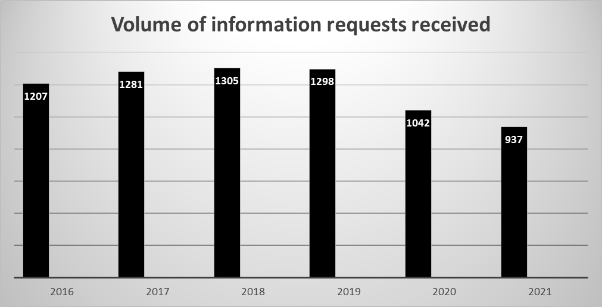

## The Nature of requests

The requests for information have been received from a varied range of sources as noted in the table below. The top three sources of requests have been received from individuals - 42.9%, commercial firms - 18.3% and media and newspaper sources - 15.7%.

| Source of request | % of requests |
| --- | --- |
| Individual | 42.9% |
| Commercial Firm | 18.3% |
| Media / Newspaper | 15.7% |
| Parliamentary Assistant | 9.28% |
| Charity / Third Sector | 4.2% |
| Legal Firm | 2.5% |
| Other | 1.3% |
| Students | 1.28% |
| Trade Union | 1.17% |
| Researchers | 1.06% |
| Client | 0.4% |
| Employee | 0.3% |
| Political Party MSP | 0.1% |

## Performance

The table below compares the Council’s responses to FOIs and EIRs for on time, late and failure to respond rates as well as percentages of key performance indicators which are used by the SIC when comparing performance of other Scottish local authorities. The Council responded to 80% of information requests on time and had a failure rate of 20% for responding late or failing to respond to information requests during 2021. An increase is evident in the number of FOIs/EIRs, which were responded to late when comparing the key performance indicators in 2020. The Council ended the year with 4 requests, which were not responded to, and 188 requests were responded to late.

| Year | No of FOIs | No of EIRs | Total  No of FOIS/EIRs | No of Requests  Responded  On time (20 days) | No of Requests Responded  Late (over 20 days) | No of Failed to Respond to Request |
| --- | --- | --- | --- | --- | --- | --- |
| 2016 | 1193 | 14 | 1207 | 1010 | 151 | 0 |
| 2017 | 1265 | 16 | 1281 | 1063 | 95 | 0 |
| 2018 | 1273 | 32 | 1305 | 1042 | 197 | 0 |
| 2019 | 1282 | 16 | 1298 | 1144 | 119 | 0 |
| 2020 | 1009 | 33 | 1042 | 820 | 187 | 15 |
| 2021 | 929 | 8 | 937 | 748 | 188 | 4 |

During 2020 and continuing into 2021, the number of late responses and failures to respond requests had steadily increased to a level that was a concern for the Council. The focus of officers had been stretched and resources being extended to cover a wider remit during the pandemic. Coming out of the height of pandemic focus on timescales required to be refreshed and revisited with all officers involved in the FOI process within all services. Training was delivered to relevant officers in services to focus the attention on the timescales and technical aspects of the procedure.

Additionally in January 2022, a new FOI workflow summary was developed to improve officer understanding of the FOI process and to introduce escalation points to assist with improving focus on the response timescales being met and the quality of responses being improved. The summary also clearly defined the roles and responsibilities of officers at key stages of the process timescales. There are more stringent measurements in place within services to ensure the appropriate timely actions are taken when responding to requests. The more stringent measures sits alongside a new Day 15 report that is issued weekly to senior managers to highlight cases that may require assistance from managers in order to expedite a prompt response to requests. The CMT along with the Information Governance Team supporting the focus on key actions required each week have assisted in the improving performance in subsequent quarterly performance statistics to date.

**FOI Annual Data FOI performance based on response outcomes**

| On time Response Performance numbers and % | 2016 | 2017 | 2018 | 2019 | 2020 | 2021 |
| --- | --- | --- | --- | --- | --- | --- |
| Number of responses issued within timescales during the year | 1010 | 1063 | 1042 | 1144 | 820 | 748 |
| Percentage of requests answered within timescale | 86% | 92% | 84% | 91% | 80% | 80% |

| FOI not responded to failure rate numbers & % | 2016 | 2017 | 2018 | 2019 | 2020 | 2021 |
| --- | --- | --- | --- | --- | --- | --- |
| Number of request where we failed to respond during the year | 0 | 0 | 0 | 0 | 15 | 4 |
| Number of responses issued late during the year | 151 | 95 | 197 | 119 | 187 | 188 |
| Failure rate for responses issued during the year% | 14% | 8% | 16% | 9% | 20% | 20% |

In February 2022, a Level 1 Intervention was opened by SIC with the Council in connection with its 2021 submitted statistics. This action was taken by SIC as a result of concerns with the Council’s recording for both late responses and requests where the Council failed to respond, which was at a rate of 29% or more in quarter 1 and 20% or more in quarter 2 of 2021. The aim of the intervention is to support the Council to improve its performance with regard to providing timely responses to information requests. In replying to this intervention the Council provided SIC with a written response, along with supporting information, including details of actions taken to address non-compliance with the statutory timescales required under FOISA.

The SIC noted that the Council’s response was comprehensive, and also noted that the Council’s quarter 3 submission in 2021 for both late responses and failures to respond was at a rate of 19.5%, therefore demonstrating a continued improvement in response rates. The SIC are seeking to see a continuation of this downward trend in the next couple of quarterly submissions to match the significant steps the Council has taken to improve performance. The table below shows further reduction in the number of late and not responded to requests as well as the noted increase in the number of on time responses issued up to the most current period’s statistics. This shows the continuing improvement desired for these performance indicators. A full update on this will be provided in the 2022 Annual Report, but is included here given it relates to service performance in 2021.

|  |  |  |  |  |  |
| --- | --- | --- | --- | --- | --- |
| Period | FOI/EIRs responded to  within  Statutory  Timescale | % On time | FOI/EIRs  responded to  out with  Statutory  Timescale | Requests not responded to | % of failed to respond rate |
| Jan - Mar 2021 | 152 | 76% | 32 | 0 | 23% |
| Apr - Jun 2021 | 155 | 60% | 70 | 0 | 37% |
| Jul – Sept 2021 | 180 | 79.6% | 43 | 3 | 20% |
| Oct – Dec 2021 | 269 | 80.5% | 43 | 3 | 19.4% |
| Jan – Mar 2022 | 324 | 90% | 33 | 3 | 10% |
| Apr – Jun 2022 | 344 | 91.5% | 29 | 2 | 9% |

# Exemptions

The majority of requests which have been responded to have resulted in full disclosure of all of the requested information in 745 (80%) of information requests. However, for some requests some information is exempt from disclosure in terms of FOISA or the EIRs. In such instances, FOI or EIR exemptions and exceptions are applied. The table below provides further information as to the use of these exemptions and exceptions. Partial disclosures, where some but not all information was released, accounts for 33 (3.5%) of information requests. The Council relied on exemption or exceptions for all requested information in 85 (9%) of information requests received although this is largely attributable to information sought not being held by the Council or being otherwise accessible.

| **Section** | **Exemption / Exception Cited** | **No of times cited** |
| --- | --- | --- |
| Section (12) | Excessive cost of compliance | 2 |
| Section (17)  Regulation 10(4)a | Information not held | 50 |
| Section (25)  Regulation 6(1)b | Information otherwise accessible | 13 |
| Section (26) | Statutory Prohibition | 0 |
| Section (27) | Future Publication | 0 |
| Section (30) | Substantial prejudice | 4 |
| Section (33),  Regulation 10(5)e | Commercial interests and the economy | 3 |
| Section (34) | Investigations | 0 |
| Section 35  Regulation 10(5)b | Law Enforcement | 8 |
| Section (36)  Regulation 10(5)d | Confidentiality | 4 |
| Section (39) | Health and Safety | 0 |
| Section (38)  Regulation 11 | Personal Information | 9 |
| Regulation 10(5)f | Interests of the supplier of information | 0 |
| Regulation 10 (4)c | Request formulated in too general a manner | 0 |

## Fees

FOISA makes limited provision for refusing requests, which incur an excessive cost and for partially recharging those that would cost the authority more than £100.00 to process. The EIRs allow for the full recharge of the cost of dealing with requests. The table below sets out the number of requests where fees notices were issued. If the applicant does not pay the fees notices within a certain period of time, the request will not be progressed. The Council tends to release the information in the majority of cases without a fee. In relation to EIRs, services are encouraged to charge for information particularly when a significant amount of information is required. The Council has a charging schedule on the Council’s website to assist officers with this.

| Quarterly Period | No of Requests where fees notices issued | No of requests not progressed due to fee notice not paid | No of Requests where fees notice paid |
| --- | --- | --- | --- |
| Oct to Dec 2020 | 0 | 0 | 0 |
| Jan to Mar 2021 | 0 | 0 | 0 |
| Apr to Jun 2021 | 1 | 0 | 0 |
| Jul to Sept 2021 | 0 | 0 | 0 |
| Oct to Dec 2021 | 0 | 0 | 0 |

## Time and Cost Involved in Responding to FOIs

All costs associated with dealing with FOI/EIR requests, reviews and appeals and Data Subject Access Requests are contained within existing budgets. However, information on the time spent and estimated cost (based on the mid-point of the relative salary grade) of dealing with FOI and EIR requests across the Council has been collated since May 2016.

The time spent and estimated cost of dealing with FOI and EIR requests during 1 January to 31 December 2021 is set out in the table below with a comparison data for the same period in previous years. There has been a deterioration in the capturing of this information by services is evident from the recorded figures. Therefore, the undernoted figures are based on the figures recorded and using an average calculation for the average time and average cost associated with dealing with an FOI for those cases that did not have the information recorded to give a representative view of time and estimated costs. Further reminders will be issued to officers involved in the process for discussion within services to remind them of the importance of supplying this information at time of responding to the FOI request

| Period of Time | Time spent in hours | Estimated costs |
| --- | --- | --- |
| 1 January – 31 December 2017 | 1814.4 hours | £30,112.93 |
| 1 January – 31 December 2018 | 1412.20 hours | £23,953.28 |
| 1 January – 31 December 2019 | 1934.95 hours | £39,122.34 |
| 1 January – 31 December 2020 | 1398.02 hours | £29,553.44 |
| 1 January – 31 December 2022 | 1222.34 hours | £24,919.80 |

## Reviews and Appeals

During 2021, of the 937 information requests received, the applicants formally asked the Council to review its decisions on 15 FOISA and 3 EIR requests. The table below outlines the outcome of the reviews. Applicants submitted appeals to the SIC in 8 cases. The SIC upheld the Council’s decision on one appeal and did not uphold the Council’s decision on the other appeal. 6 cases that were referred for a decision from the SIC were withdrawn by the applicant.

| Type of review | Number of reviews |
| --- | --- |
| No of requests for internal reviews | 15 FOISA & 3 EIRs |
| Outcome of internal reviews:   * upheld the Council’s decision * partially upheld the Council’s decision * did not uphold the Council’s decision * internal review submitted outside of timescale | 11  5  1  1 |
| Appeals to Scottish Information Commissioner (SIC) | 8 |
| Outcome of SIC Appeal:  -upheld the Council’s decision  -did not uphold the Council’s decision  -withdrawn by applicant | 1  1  6 |

## Conclusion

The Council’s performance during 2021 was undoubtedly impacted by the Covid-19 pandemic last year. During the year, particularly when volumes were lower training was under taken to support FOI designated officers and those officers involved in responding to requests as well as training for the new Information Governance Management System (Workpro). It is anticipated that the recently implementation of a new system Workpro together with ongoing work on policy, procedures and training will continue to support the improvements required in the coming year’s performance.