Version 1

Inverclyde Council
Sept 2024
Produced by:
Human Resources
Inverclyde Council
Municipal Buildings
GREENOCK
PA15 1LX
Inverclyde Council
Recruitment, Selection, Redeployment and Relocation Procedures (RSRR Procedures)









Document Control

Document Responsibility
Policy Title | Corporate Group | Service
Recruitment, Selection, Redeployment and Relocation (RSRR) |  | OD & HR and Communications

Change History
Version | Date | Comments
1 | September 2024 | Related policy created from amalgamation of existing policies and updates made

Distribution
Corporate Directors, Heads of Service, Trade Unions, ECMT

Policy Review
Updating Frequency | Next Review Date | Responsible Officer
5 years | 2029 | Service Manager ( HR Operations and Health and Safety)

Policy Review and Approval
Name | Action | Date | Communication
Policy and Resources Committee | Approved | 17/09/2024 | Website, ICON, Trade Unions, ECMT

Table of Contents | PAGE
Document Control | 2
Introduction | 4
Recruitment and Selection | 5
Application and Scope | 5
Approximate Recruitment Timescale | 5
Redeployment Register and Advertising | 6
Off Payroll Working | 6
The Advert | 7
Jointly Funded Posts (HSCP) | 11
Recruitment Process | 11
Shortlisting and Selection | 12
Canvassing | 16
Positive Action | 16
Politically Restricted Posts | 16
Safer Recruitment Checks | 16
Employment Commencement | 19
Recruitment of Supply/Sessional employees | 20
Teacher Specific Recruitment Information | 21
Reengagement | 21
Complaints | 21
Redeployment | 24
Reasons for Redeployment | 24
Staff covered by arrangements | 24
Terms of Redeployment | 24
Process | 27
Other Conditions | 27
Right of Appeal | 27
Relocation | 28
General Conditions | 28
Provision of the Scheme | 28
Claim Procedure | 28
Appendix 1 Recruitment & Selection Process (Chief Executive & Chief Officers) | 30
Appendix 2 Redeployment Register: Temporary Employee Redeployment And Termination Procedures | 33
Appendix 3 Relocation Expenses Form | 34

- Introduction

  - Executive Summary

This integrated Recruitment, Selection, Redeployment, and Relocation (RSRR) Procedures of Inverclyde Council aims to establish a comprehensive framework that ensures fair, transparent, and inclusive processes across all related activities in line with the RSRR Policy. By adhering to legislative requirements and best practices, the policy promotes equality and diversity, aiming to attract and retain the best talent, support internal mobility, and facilitate effective employee relocation.

This document has been developed through extensive comparisons with practices from other councils and guidelines from professional bodies such as the Scottish Social Services Council (SSSC) and Advisory, Conciliation and Arbitration Service (ACAS). Key updates include clarifications on conflicts of interest, enhancements in training requirements for panel members, and detailed procedures for handling recruitment complaints and redeployment processes.

The revised policy and procedures will streamline recruitment, selection, redeployment, and relocation processes, ensuring they are aligned with the Council's strategic objectives and legislative requirements. The policy is structured to support the Council’s commitment to being an equal opportunities employer, promoting diversity, and ensuring that all employees and applicants are treated fairly and with respect throughout these processes.

This procedure has incorporated these procedures into one document:
      - Recruitment and Selection Procedure
      - Recruitment and Selection Complaints Procedure
      - Redeployment Policy and Procedure
      - Relocation Procedure

  - Links to legislation

Summary
This procedure considers relevant legislation, including the Equality Act 2010, Employment Rights Act, and the Working Time Regulations, to ensure comprehensive compliance. It promotes fair talent management through adherence to the ACAS Code of Practice, ensuring that all recruitment, selection, redeployment, and relocation activities are conducted fairly and transparently.

Equality and Diversity

The Council is committed to promoting equality and diversity throughout the recruitment and selection process. All activities will comply with the Equality Act 2010, ensuring no candidate is discriminated against based on protected characteristics.

As a Disability Confident Employer, the Council guarantees interviews for disabled applicants who meet the essential criteria for a role, ensuring fair opportunities for candidates with disabilities.

The Council supports the Armed Forces Covenant and ensures fair treatment of current and former members of the armed forces and their families during the recruitment process.

- Scope

This procedure applies to all recruitment, selection, redeployment, and relocation activities within Inverclyde Council. However, it is acknowledged that the terms and conditions specific to the teaching profession may necessitate amendments to address these differences appropriately.

- Procedure Content

  - Recruitment and Selection

    - Application and Scope

This procedure applies equally to all employees and applicants for posts, whether permanent, fixed term, or temporary, irrespective of grade, or profession. A separate procedure applies to the recruitment and selection of the Chief Executive and Chief Officers and is outlined in Section 8.1.

The procedure also applies to the recruitment to supply teaching or casual/sessional work registers. A separate protocol is available which covers the circumstances for engagement of casual/sessional workers.

All existing Council employees, modern apprentices, supply and casual (sessional) workers are entitled to apply for internal vacancies. This includes agency workers who have been on the same assignment for a period in excess of 12 weeks.

Organisational Development, Human Resources & Communications reserve the right to withhold or withdraw any vacancy for redeployment, at any stage of the Recruitment and Selection Process including up to where an appointment has been recommended, as per the Council’s Redeployment Procedure.

Unless there are exceptional circumstances, existing employees who are employed by the Council on a permanent basis and who are appointed to a temporary or fixed term post within the Council should always be given the right of return to their substantive post. However, this right of return is not an automatic entitlement and employees must always discuss this with their current line manager before accepting a move to another post. In exceptional circumstances where a manager believes they are unable to give an employee the right of return to their original post, approval must be sought from the Head of Organisational Development, Human Resources & Communications. The right of return would be to a suitable alternative on the same grade, with this included in the new contract. As above this must be discussed by the manager with their employee before accepting a move to another position.

Training is essential for all managers prior to participating in recruitment panels – at any stage, with specific training for panel chairs. This ensures adherence to fair and consistent recruitment practices and aligns with best practice across other organisations.

Where services intend to give “acting up” opportunities without advertising or restricting advertisements to particular employee groups there should be discussion with HR to ensure a transparent and fair process.

3.1.2 Approximate Recruitment Timescale
Weeks | Recruitment Stage | Notes
 | Vacancy Management | Prior to advertisement posts require to be approved through the vacancy management process. This includes confirmation by Finance, Directors and (in some cases) the Corporate Management Team.
1 & 2 | Advert | Posts advertised for 2 weeks (unless otherwise agreed by Head of Service and HR)
3 & 4 | Shortlisting | Shortlisting should be completed within 2 weeks of the closing date. If this is not possible all applicants should be contacted by the chair of the panel to advise of the delay.
5 & 6 | Hold Interviews | Interviews should be arranged and held within 1-2 weeks after shortlisting
6 | Send Paperwork to HR | After notifying the preferred candidate interview paperwork should be sent directly to HR to start safe recruitment checks
7 - 11 | Safe recruitment completed | Completed within 5 weeks of HR receiving all paperwork dependant on Disclosure timeline
12 | Employee Start Date | Employee start date agreed by service following confirmation from HR that safe recruitment is complete

    - Redeployment Register and Advertising

In the first instance, recruiting managers are expected to check the central redeployment register to identify any potential matches to their vacancy prior to commencing with the recruitment process.

The Service Manager should notify Human Resources of a potential match quoting candidate’s reference number from the register.

Human Resources reserve the right to withhold any vacancy for redeployment, at any stage of the Recruitment and Selection Process.

Human Resources in consultation with the service manager will:

            - Determine the most appropriate source of candidates for a particular post, with regard to best value for the Council and equalities.
            - Determine whether the post is suitable to offer as a secondment for a specified period of time
            - Consult the redeployment register before advertising any vacancy, in accordance with Inverclyde Council’s Redeployment Procedure.
            - Give advice in relation to the recruitment process i.e. drafting advert, job description and person specification, providing examples where necessary

    - Off Payroll Working

IR35 - Off Payroll Working: The Intermediaries Legislation (known as IR35) applies to off-payroll working in the public sector. Where the rules apply, people who work in the public sector through an intermediary will pay employment taxes in a similar way to employees. An intermediary can be the worker’s own limited company, such as a personal service company (PSC), a partnership of which the worker is a partner, or another individual.
The Council is required to assess such workers prior to engagement and, depending on the results, in certain cases will be required to make deductions for Tax and National Insurance from the worker’s invoice before paying the remaining balance.

The Service engaging the worker should carry out the assessment using the HMRC’s Employment Status Service (ESS) tool prior to engagement, and ensure the correct processes are followed to set up and pay the worker. You should choose answers that best match the usual working practices of the engagement. https://www.gov.uk/guidance/check-employment-status-for-tax
Workers employed directly by companies or agencies which are not their own are not included within these regulations as they are taxed directly by the company or agency they are employed by.
Should you require assistance with this or the HMRC tool can you please contact Payroll who should also be advised of details of those who fall into the IR35 category.

Please refer to the Off-payroll working – Guidance for Managers on ICON under Useful Guidance.

    - The Advert

Posts may be advertised internally and externally simultaneously where the internal labour market is likely to produce a limited response, or where the Council desires to attract a wider field of applicants.

For regularly advertised posts a new job advert is not always required. If needed the Service Manager is responsible for drafting an advertisement for the post. The advertisement should include:

- An outline of the requirements of the job
- The essential and desirable criteria for the job
- Job location
- Job tenure (if temporary or fixed term, for how long)
- Contact name and telephone number for informal enquiries
- Genuine occupational requirements

The advertisement must not include language that may be considered discriminatory or ambiguous.

All vacancies (whether restricted internally or opened externally) will be placed on the Scottish Local Government’s National Recruitment Portal https://www.myjobscotland.gov.uk/councils/inverclyde-council/jobs/mjsint). This application standardises the information available from all job applications making it easier to compare like with like and ensures that the relevant information is obtained. Organisational Development, Human Resources & Communications, in consultation with the Head of Service will determine whether it is also necessary to advertise the post via another source e.g. press publications, job centres or utilising a recruitment agency.

My-Job-Scotland is the online recruitment portal for all of Scotland’s local authorities. Managers will use the portal to:
- View vacant post details
- View applications for the post
- Short-list for interview
- Set up interview slots
- Send an invitation to interview e-mail to candidates
- Send a regret e-mail to unsuccessful candidates
- Indicate the preferred candidate

A detailed step-by-step guide on how to use the recruitment portal can be found on ICON.

Vacancies will also be included in the Council’s Internal Vacancy Bulletin (IVB). This bulletin is available on service notice boards and is sent directly to those on the redeployment register and employees on maternity leave. Heads of Service and Service Managers are responsible in ensuring those without access to ICON have the IVB circulated to them.

The suitability of a post for job share will be stated in the advertisement, where necessary. For internal employees with a particular pattern already in place suitability in relation to a new post should be reviewed.

Some government funded employment and training programmes target particular age groups. Such posts include certain Teaching posts within a faith school, or delivering personal care to service users. Such instances are rare and will only occur after careful consideration of the specific needs of the vacancy being filled. Managers must consult Human Resources for guidance in such cases.

Normally any applications received after the closing date will not be accepted as it is the responsibility of the applicant to ensure that their application has been completed before the closing date. Exceptions should be agreed by the panel chair in consultation with HR.

As an equal opportunities employer, Inverclyde Council positively promotes all forms of flexible working and further details are contained within our Family Friendly and Work-Life Balance Policy. As the majority of Council posts can be considered suitable for job share, candidates can choose this option at the application stage. Where a post is deemed not suitable for job share, then the recruiting manager should discuss this with Organisational Development, Human Resources & Communications and the Head of Service. If agreed, the post will be advertised as being unsuitable for job share at the advertising stage.

All received applications should be submitted using the Scottish Local Government’s National Recruitment Portal. Paper applications or Curriculum Vitae (CVs) will not be accepted. In exceptional circumstances alternative arrangements for application will be made.

    - Further Information

An applicant and a manager’s guide to using the portal can be found on ICON under the useful guidance section. Candidates can also gain assistance by contacting Human Resources by telephone, email, textphone or in person at Human Resources Reception.

Personal data including age, marital status, nationality and ethnic origin is not sought on the application form. This type of personal data is sought on a separate document for the purposes of equal opportunities monitoring after an offer of employment has been made and is retained by Organisational Development and Human Resources for analysis.

Figure 1 Pre-Recruitment Procedure Summarised

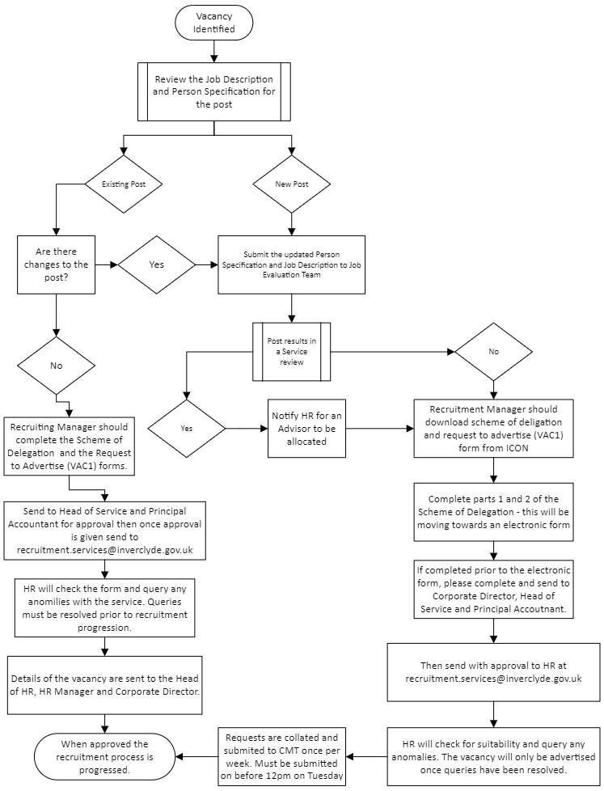

Figure 2 Application to Induction
    - Jointly Funded Posts (HSCP)

There may at times be posts which are jointly funded by a partnership organisation. For this reason, the recruitment & selection process may differ slightly for this type of vacancy in relation to both new and backfilled posts.

The ownership of the recruitment & selection process for this type of post may rest with either of the parties jointly responsible for the post. Applicants will therefore be subject to the recruitment & selection policy & procedures of the organisation responsible for filling the vacancy.

    - Recruitment Process

Anyone involved in the recruitment process who has a personal relationship with a candidate, or may be able to exercise favouritism, should remove themselves from the process. Where there is any doubt, they should take no part in the shortlisting and interview process. For example:
• they are in a close personal relationship with a candidate e.g., husband/wife/spouse, civil partnership, co-habitant.
• they are a relative of a candidate e.g.- daughter/son, sibling, parent, aunt/uncle, cousin etc. including in-laws and step relatives.
• they are a close personal friend of a candidate. e.g. - someone known personally and on a social basis outside of work.
• they are living in the same household as a candidate. e.g. - lodger, step-sibling etc.
• they have previously had a personal relationship with a candidate e.g. – ex-wife/husband/partner etc.
This list is not exhaustive. Where there is a potential perception of a conflict of interest discretion should be used and advice sought from HR

Different types of posts may require different selection techniques. Services may wish to consider the use of additional selection procedures if considered appropriate in combination with a competency-based interview.

Recruiting managers should contact Organisational Development and Human Resources for advice on the appropriate use of these techniques in the first instance. Additional selection procedures should only be used if they have been validated in relation to the job, satisfy equality obligations and are administered by a suitably trained employee.

Examples of additional selection techniques may include:
- The use of assessment centres incorporating a variety of selection techniques – may be beneficial for larger scale recruitment or promoted posts
- Skill/Aptitude tests - For certain posts, skills or aptitude tests may be used to allow candidates’ to demonstrate expertise, e.g., in computer skills, or working with figures. This may also include discussion or engagement with service users or carers. Examples of these can be provided by HR on request.
- Presentations - Candidates may be required to give a presentation on a specified topic using appropriate information technology. The candidate should be advised of the length and format of the presentation.
- Psychological testing - These may be used for certain senior management posts. Such testing will be carried out and evaluated by qualified professionals on behalf of the Council.
- Case studies or scenarios – e.g. giving a candidate examples to work through that replicates a job specific task

Any of the above may be used to indicate future job performance and will be used in conjunction with the candidate’s application and interview to assess his/her suitability for the post.

In all cases where any of the above are used, candidates will be informed prior to interview. Details of any additional selection procedures should be included in the email sent from the recruitment portal.

It is Council policy to consult with, and involve, service users in matters which directly affect their lives. For certain posts, particularly in Social Work, Education and Community Support Services, service users and/or their carers may take part in the Recruitment and Selection process. This may involve consultation in the drawing up of job descriptions and person specifications, formulating questions for interview, followed by participation in interviews.

The decision to shortlist and select a candidate will remain with the Service manager assisted by Human Resources.

Any service users or carers attending interviews will be briefed on the requirements of the post. They will also be briefed on the work history of candidates selected for interview. Information on the candidates’ application forms will therefore be shared with the service user/carer. They will be informed of the Council’s requirement for confidentiality.

Where service users or carers participate in interviews, they will be allocated pre-determined questions to ask each candidate. They will ask the same questions of all candidates. Where children or young people are involved, the interviews will be planned and structured appropriately, and support provided. Throughout the process, the rights of children and young people as set out in the United Nations Convention on the Rights of the Child will be promoted and upheld.

As part of the selection process, a group of service users may meet with candidates individually, supported by an individual who is not a member of the interview panel. This person will relay feedback from these discussions to the panel. This person or persons may be an employee of Inverclyde Council or may be seconded from another organisation with specific expertise in this area.

Service users/carers participating in interviews may be present when the interview panel make their decision. While their opinions will be sought and taken into account, the decision to select will remain with the interview panel.

Candidates for interview will be advised of any participation by service users or carers prior to interview.

    - Shortlisting and Selection

To ensure a positive experience for applicants, shortlisting should be carried out as soon as possible following the closing date of the advert. Ideally interviews should be scheduled to take place two or three weeks after the closing date with adequate notice provided

Inverclyde Council aims to ensure that all candidates, including those who are unsuccessful, have a positive experience during this process. It is important that all candidates feel that they been given full and careful consideration and that they were communicated with in a timely and professional manner.

Interview Panels

In respect of the Council's Equality & Diversity Policy, every effort should be made to ensure that interview panels are balanced with at least one male and one female member.

In appointment panels, for which recruitment is delegated to officers, it is the role of the Chairperson to ensure that appointments are run in accordance with the Recruitment Procedure and all attempts are made to achieve a gender balance on interview panels.

Where the Recruitment Panel consists of a panel of Elected Members and/or parent councils, such appointment panels should strive for gender balance and both male and female recruiters should be on each Panel or where that is not practicable, an HR representative/other officer of appropriate gender should be in attendance to advise the Panel.

There may be occasions where an Elected Member panel composition is fixed based on the principle of political balance and a gender mix may not be possible. In circumstances where it is not possible to have a gender mix on an elected member recruitment panel an additional officer of appropriate gender should attend the panel in an advisory or observing capacity to ensure transparency in the recruitment process.

In some circumstances when recruiting multiple candidates for the same post one panel to select several preferred candidates may be used.

The interview panel needs to be a mix of appropriate staff levels/Grades, which may be service dependent. The recruitment and selection of teachers and promoted staff is a bit different as they follow a different pay structure and the guidance on this can be found in the LNCT arrangements.

Members of the interview panel from the hiring service must be present during all interviews and should also be involved in drawing up the shortlist. An HR Advisor may also be included in the interview panel where necessary. HR may also attend on a random basis to ensure consistency.

Shortlisting
Shortlisting for interview will be based on the essential and desirable criteria for the post as set out in the person specification ensuring that the process is free from discrimination.

In the first instance, candidates who meet all the essential criteria will be identified. Reference will then be made to the desirable criteria to shortlist further in the event of a large volume of applications.

Candidates who have indicated on their application that they have a disability, and who meet the essential criteria for the post, will be shortlisted for interview in line with our Disability Confident Initiative. Should a manager not shortlist a disabled candidate they must be clear on their reasons for excluding candidates from the shortlist e.g. if the essential criteria is not met. Any such decision may be challenged by the candidate or external body e.g. the department of work and pensions (DWP). The recruitment & selection complaints procedure is open to all candidates, internal or external, where an individual feels that they may have been treated unfairly at some stage of the recruitment and selection process. This process can be found in the policies section on ICON.

In addition in line with our Armed Forces Covenant accreditation managers should give positive consideration to veterans for jobs where they meet the essential criteria for the post.

The handling of applications must be closely controlled and monitored by Senior Managers.

Interview Process

All interviews must be conducted in a fair and consistent manner and must be structured and systematic. The panel interview (basic question and answer) has been accepted and used effectively for many years in Local Government and is relatively easy to arrange. It is a good way for panel members to share judgement and discuss matters relating to an interview and candidates immediately following the interview, when it is fresh in the minds of panel members.

Interviews will be scored against the key competencies of the council (1-4). The lower the score the better the interview.

The preferred candidate will be chosen by the interview panel based on his/her qualifications, skills, knowledge and abilities. Interview assessment sheets should be completed throughout by each member of the panel with the preferred candidate’s paperwork sent to HR on completion. Services should retain the other applicants’ assessment sheets for 6 months.

If the preferred candidate wishes to job share the post, the Service Manager will discuss with him/her at interview the sharing of the duties, and the candidate’s preferred working pattern. If job share is suitable the work pattern will be agreed subject to the requirements of the service.

When all interviews are complete and the panel have identified the preferred candidate the chair of the panel should notify:

- The preferred candidate
- The unsuccessful candidates
- Human Resources – via email with relevant documents

When notifying the preferred candidate the chair of the panel should:

- Remind the candidate their offer is subject to satisfying the Council’s safe recruitment checks
- Discuss salary placing (placing beyond the bottom of the scale should be discussed with HR at all times and agreed before safe recruitment commences). This will not be revisited after safe recruitment is complete and the contract has been issued.

The panel will offer feedback to all candidates. Such feedback is to assist the candidate in understanding his/her own performance and in planning for his/her future career. Candidates have the right to see their own application forms, and assessment sheets. Where notes are taken as a memory aid by individual interview panel members, these will be destroyed immediately following the interviews.

Figure 3 Recruitment Process
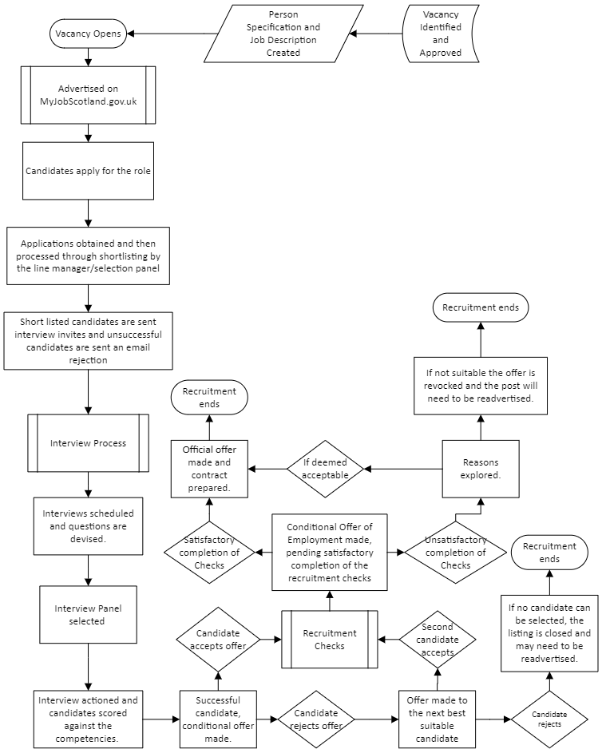

    - Canvassing

The canvassing of Elected Members or employees of the Council, directly or indirectly, in connection with any appointment being made by the Council, shall disqualify the candidate. An Elected Member or employee of the Council shall not attempt to secure an appointment with the Council nor recommend any person for such an appointment or promotion. However, this shall not prevent an Elected Member or employee giving a written reference of a candidate's ability, experience or character where such a reference is requested by the Council. Accordingly, a candidate may list an Elected Member as a referee.

    - Positive Action

The Council follows the principles of ‘positive action’ as outlined in the Equality Act 2010. This can be applied during the recruitment and selection process when a tie breaker situation arises between two (or more) candidates of equal merit. Positive action allows an employer to make an appointment based on a particular protected characteristic possessed by a candidate. This decision should only be based on the evidence of an under-representation of a particular group or tackling disadvantage within the workforce.

This process must only be used in consultation with the Head of Organisational Development, Human Resources & Communications.

    - Politically Restricted Posts

Some posts in the Council are politically restricted by virtue of the Local
Government & Housing Act 1989 and the Local Government Officers (Political Restrictions) Regulations 1990.

Where a political restriction applies this means that the applicant will not be permitted to be involved in, or may be restricted, in political interests or associations. If the post being applied for is politically restricted this will be shown on the job advert. If you are unsure whether this applies to you or a post you wish to apply for, please contact Organisational Development, Human Resources & Communications.

    - Safer Recruitment Checks

The Council carries out certain employment checks to determine the suitability of candidates for a post, for example:
- Confirmation of Right to Work in the UK
- PVG Registration/Standard/Basic Disclosure Check or post April 2026 Level 1 and Level 2 Disclosures.
- Criminal Convictions Form for posts not requiring a PVG/Disclosure.
- SSSC/GTCS registration
- Pre-Employment Health Check
- References - two references (one for internal candidates if moving from one Service area to another) will be requested and one should be from the current line manager
- Confirmation of qualifications required to meet the essential criteria on the person specification - relevant qualifications will be viewed at interview.

Safe recruitment procedures allow Inverclyde Council to ensure the person appointed has the skills, knowledge and qualifications required to carry out the duties of the post, protect his/her health and safety at work, protect vulnerable groups, and ensure he/she is legally entitled to work in the United Kingdom.

Although these checks will be carried out prior to appointment there may be exceptional occasions where an offer of employment is offered subject to satisfactory checks. This must be agreed with HR. All safer recruitment checks must be satisfied otherwise an offer of employment may be withdrawn.

Employees of the council should not give references in respect of relatives or friends. In exceptional circumstances where this is unavoidable the referee should express their interest or nature of relationship and should not in any way be involved in the selection process.

The required checks may vary for each candidate dependent upon the requirements of their post.

It is not Council Policy to access the public social media pages of candidates for the purposes of background checking. However, the Council retains the right to investigate any pertinent information brought to our attention and any such investigation will only be undertaken if the approval of the Head of Organisational Development, Human Resources & Communications has been received.

Pre-employment checks are normally completed within two weeks of interview, or up to five weeks where Disclosure Scotland or PVG is required.

Further information in relation to safe recruitment can be found within the safe recruitment procedure available on ICON or from Human Resources

References
These are normally taken up after interview for the preferred candidate only. In certain circumstances they may be sought prior to interview by the service using the required pro-forma. The content of references will be shared with the Service Manager who chairs the selection panel, normally the manager to whom the post holder will be responsible.

References should be sought by the recruiting manager to cover the past 3 years employment history for external candidates and 1 years employment history for internal appointments. Where 3 years employment history is unattainable character references will be obtained. For external candidates two satisfactory references are required before a formal offer of appointment is issued.. For internal candidates only one reference is required.

Referees should be employment referees, one of which must be the present or most recent employer. School or college leavers may name a Head Teacher or College Principal. Where it is not possible to obtain employment references, character references will be accepted. They should be people who hold positions of responsibility, are familiar with the candidate’s work or good character and are not a family member or close friend.

Teachers require one reference from their previous head teacher. It must be completed on the relevant head teacher report form which is sent to the successful candidate by HR Support. Teachers that are returning to teaching after some time will require two references as per their work history.

Where a candidate applying for a post requiring contact with children or vulnerable adults cannot name a referee from a present employer, he/she will require to provide a third referee.

A copy of the job description, person specification and a questionnaire will be issued to the referees named on the application form. Referees are asked to comment on the person’s skills, expertise and abilities, whether the person has had any absences in the previous two years, and whether there are any disciplinary proceedings pending.

Recruiting managers are responsible for obtaining references. For external candidates this should be written references. For existing Council employees moving internally to a different post this can be either a written or verbal reference (with the person taking the reference filling in the related pro-forma).

Individuals have a right to a copy of information held about them that is covered by the Data Protection Act 1998.

Protection of Vulnerable Groups (PVG) and Disclosure Checking

The PVG scheme is the Scottish vetting and barring scheme replacing Disclosure Scotland for those employees working with vulnerable groups such as children and adults at risk. A large number of jobs do not require a PVG or Disclosure – this only applies to regulated work with children and vulnerable adults.

Where the post requires the postholder to be a member of the PVG scheme this should be discussed, including details of associated financial costs, with candidates at interview.

Further information in relation to this scheme can be found on ICON and on the Disclosure Scotland website

A preferred candidate cannot undertake regulated work unless they have obtained membership of the PVG Scheme.

Should the Disclosure check result in any concerns relevant to the post, the Service Manager will discuss these with the preferred candidate, if necessary in consultation with Human Resources, and relevant procedures to safeguard confidentiality.

For some offences, the Rehabilitation of Offenders Act 1974 allows an individual to withhold information on his/her criminal record where a defined period of time has lapsed from the date of the conviction. Provided the candidate has not been re-convicted of another offence, the original offence can be disregarded.

Posts exempt from the Rehabilitation of Offenders Act 1974 as amended by the Rehabilitation of Offenders Act (Exclusions and Exceptions) Scotland Order 2003 involve regulated work with a vulnerable group.

All other posts that do not require a PVG or a basic disclosure check will complete the Criminal Record Declaration form, which will require candidates to disclose any unspent convictions.

It is a criminal offence to discriminate against someone who has a criminal conviction. This means that having a criminal record will not necessarily debar an individual from working with Inverclyde Council. Overall, if the Service and HR determine that there is a risk then a risk assessment would need to be conducted and the outcome of that may impact on any job offer. This will depend on the nature of the position, together with the circumstances and background of the offences.

For further information, please refer to the Council’s policy on the Recruitment of Ex -Offenders.

Health Screening

Inverclyde Council recognises that the health, safety, and welfare of its employees is paramount. It is essential that health problems, which may impact on an employee’s ability to safely carry out the duties of the post, are identified at an early stage in order to ensure that the individual’s health is not put at risk and that services are delivered effectively and efficiently.

All preferred candidates will require to complete a health questionnaire as organised by our Occupational Health Provider PAM. This may result in a phone call by an Occupational Health Advisor to ensure any conditions are discussed and proposed reasonable adjustments could be made.

Certain occupations, such as those requiring the use of vibrating equipment, will prompt more detailed checks specific to the post.

Where the preferred candidate has a pre-existing medical condition, this will need to be risk assessed and any supports that could be implemented evaluated to support the new employee at work – as per our duty to provide support under the Equality Act 2010. In the unfortunate situation of an employee being determined as ‘unfit for work’ by our Occupational Health Provider, this may result in the withdrawal of the offer.

Access to work may be able to provide support for employees in relation to reasonable adjustments at work. Employees should contact them directly on:

Telephone: 0345 268 8489

Textphone: 0345 608 8753

Further information can be found at www.gov.uk/access-to-work

Essential Qualifications and Registration

The Council has a responsibility to ensure that employees are appropriately qualified for the posts to which they are appointed.

It is important that the preferred candidate meets the essential criteria for the post as detailed within the person specification. The preferred candidate will be required to provide evidence that he/she holds the relevant qualifications & statutory/professional body membership required for the post. SSSC allows candidates to register within 6 months of employment. This should be checked by the chair of the panel at interview and copies will be taken by HR from the preferred candidate during safe recruitment.

Proof of identity and Entitlement to work in the United Kingdom

All candidates will be required to provide certain documentation to evidence his/her identity and entitlement to work in the United Kingdom. This is necessary to comply with legislation relating to immigration.

A link providing guidance on acceptable documentation is given within the email inviting candidates for interview.

Please refer to the UK Visas and Immigration (UKVI) right to work checklist for a list of documents which can be accepted as proof of right to work in the UK. Further guidance on how to carry out right to work checks is available in the UKVI Employer’s Guide to Right to Work Checks.

Criminal Convictions

In the event of the recommended candidate declaring previous criminal offences the Service Manager will discuss with them the nature of the offence, the time elapsed since the offence, and the relevance to the post. Discussions with the candidate will take place in accordance with the Council’s Policy on the Recruitment of Ex- Offenders.

    - Employment Commencement

Authorisation to Start

When a preferred candidate has been approved to start before completion of safe recruitment checks, then appropriate written evidence is required to evidence this with a hard copy of the HR manager’s approval being placed in the personnel file of the candidate.

Formal Offer of Appointment

A written statement of terms and conditions of employment (i.e., contract of employment) will be issued to the preferred candidate either prior to or upon commencement of employment.

Induction

The purpose of induction is to ensure the effective integration of employees into the organisation for the benefit of both parties. All employees require this to assist them understand the Council and their role in delivering services.

All employees should receive induction training as follows:

- Job and Service induction training
- Corporate induction training

Service Managers should consider whether employees changing posts within the Council would also benefit from a refresh in Corporate Induction Training via e-learning.

    - Recruitment of Supply/Sessional employees

General

Some services may require sessional/supply workers to provide cover for absence at short notice, or to deal with a sudden increase in demand for a service.

Comprehensive lists of applicants who possess general core skills for appropriate posts throughout the Council for which supply cover is required, including those who are available at short notice to take up employment may be retained by services.

An advertisement should be placed on the recruitment portal for those wishing to be placed on the sessional/supply list.

In order to speed the process of drawing on individuals when necessary, first time applicants if considered suitable should be interviewed at the time of application.

For non-teaching employees Service Managers can authorise appointments from their sessional registers. For teaching employees and EYECO’s this is managed through the click and go system.

All individuals are subject to the pre-employment checks before being included on any supply/sessional register.

Where an individual is being required to work continuously for 13 weeks or more HR must be notified. Please see temporary employee protocol on ICON for further guidance.

For further information regarding sessional employees please see the sessional worker protocol which can be accessed via ICON or by contacting Human Resources.

Supply Teachers Register

An annual advertisement will be placed on myjobscotland recruitment portal for those wishing to be placed on the teaching supply register.

Available supply appointments are filled using the teacher booker system. Further information on this can be found within the click and go manual.

Further information regarding the use of supply teachers can be found within the SNCT handbook which can be found online at http://www.snct.org.uk/wiki/index.php?title=Table_of_Contents

    - Teacher Specific Recruitment Information

- LNCT 04: Employment of Teachers on Temporary Contracts
This agreement outlines the circumstances under which temporary teaching staff are employed and the process by which these staff can transition to permanent positions within the Council. It ensures that temporary teachers are treated equitably and provides guidance on the recruitment process for such positions. View LNCT 04
- LNCT 05: Appointment of Teachers on Permanent Contracts
This document provides comprehensive guidelines for the recruitment and selection of teachers on permanent contracts, covering all stages of the appointment process from advertising to post-interview procedures. It also emphasizes the Council's commitment to equality and diversity throughout the recruitment process. View LNCT 05
- LNCT 10-2024 Temporary Promoted Posts in Schools
This document covers the procedure for appointment to temporary promoted posts
- LNCT 11: Job Description – PT Primary
This document provides detailed job descriptions for Principal Teachers in primary schools, outlining their roles and responsibilities within the school's leadership structure. It includes specific duties related to curriculum development, staff management, and whole-school policy implementation. View LNCT 11
- LNCT 12: Job Description – PT Secondary
LNCT 12 outlines the job descriptions for Principal Teachers in secondary schools, focusing on leadership, curriculum management, and strategic direction within their subject areas. It ensures clarity in the roles and expectations for Principal Teachers. View LNCT 12
- LNCT 13: Job Description – DHT Primary
This document details the job description for Depute Head Teachers in primary schools, covering their responsibilities in supporting the Head Teacher, managing staff, and overseeing various aspects of school operations and curriculum delivery. View LNCT 13
    - Reengagement

The Council will not normally re-engage an employee who has benefited from an early departure package in a similar role or as a consultant within 12 months of leaving. It is acknowledged, however, that employees may apply for other advertised vacancies during this time. This does not apply in respect of sessional/supply work.

    - Complaints

The Council will endeavor to respond to any concerns the employee or applicant has concerning any aspect of the Recruitment and Selection process.
Submitting a Complaint

When to Submit: If someone feels they have been treated unfairly during the recruitment and selection process, they should submit a complaint to the Head of Organisational Development & Human Resources as soon as possible. Complaints regarding non-appointment should be submitted within 7 days of receiving the interview outcome.

Investigation: The Head of Organisational Development & Human Resources will arrange an investigation involving all participants in the recruitment process. A report and response will typically be issued within 14 days of receiving the complaint.
Further Actions

Meeting Request: If dissatisfied with the initial response, the complainer can request a meeting with Human Resources and the employing service. This meeting should occur within 10 days of the request, and the complainer can be accompanied. The outcome will be communicated at the meeting or shortly thereafter.

External Applicants: The procedure ends here for external applicants.

Existing Employees: If still dissatisfied, existing employees can escalate the complaint through the appropriate grievance procedure, submitting it to the Human Resources (Appeals) Board.
Remedial Action

Process Hold: The selection process may be paused to consider a complaint, decided by the Head of Organisational Development & Human Resources and the Head of Service.

Outcome: Remedial actions aim to resolve complaints and ensure the most suitable candidate is appointed. Financial compensation is not considered.

Figure 4 Recruitment Complaints Procedure
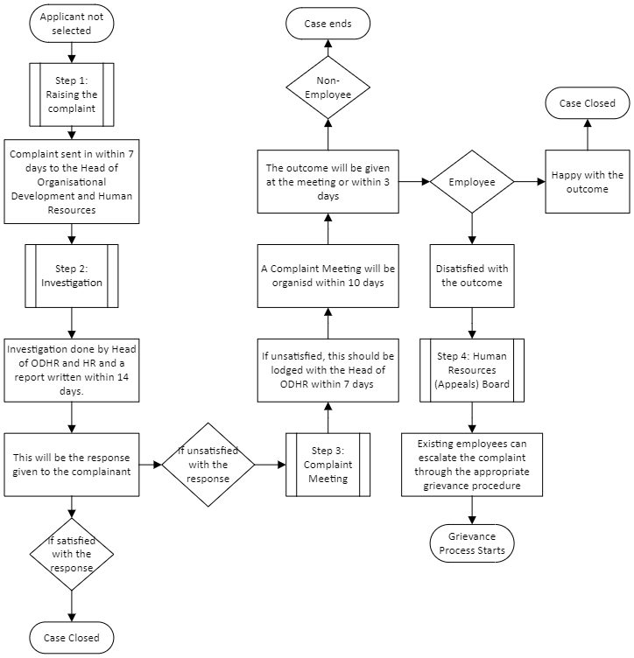

  - Redeployment

    - Reasons for Redeployment
Redeployment within the Council may be necessary as a result of one of the following:

  - Capability
  - Medical grounds
    - Changes in the employee’s capability of carrying out their remit. This will include employees considered as being disabled under the terms and conditions contained in the Equality Act 2010’
    - Performance Issues,
    - Where compulsory redeployment is the outcome of a formal process.

  - Redundancy
  - Efficiency of the Service (where there is no redundancy situation but there would be efficiency improvements resulting from the retirement).
  - Displacement due to budget savings, restructures, job redesign
  - Some Other Substantial Reason (SOSR)
    - For example it is recognised that personal relationships with colleagues can deteriorate or that circumstances outwith the work environment can adversely affect an employee’s ability to function in the job.
    - To be included on the Redeployment Register for SOSR a report into the circumstances would be required, e.g. a recommendation through the Council’s Dignity & Respect at Work Processes. This would also need to be approved by the Head of Organisational Development, Policy & Communications and the relevant Head of Service.

3.2.2 Staff covered by arrangements

- All permanent employees of the Council.
- Temporary Employees as Detailed Below
For temporary employees (as defined in the Temporary Employee Protocol), who are due to be terminated, redeployment to a suitable alternative position or vacancy will be sought in accordance with the undernoted arrangements. Temporary teachers will be dealt with in terms of the relevant Local Negotiating Committee Teachers (LNCT) and Scottish Negotiating Committee Teachers (SNCT) provisions. There can be no guarantee that a suitable alternative position will be found and, if not, this will result in the termination of employment in the normal manner, and with notice in accordance with contractual entitlement.

Please see Appendix 8.2 for more information regarding the Redeployment Register.

Teachers will only be covered where the following are not applicable: LNCT 15- ‘Future Provision - School Accommodation Staffing Policy’, ‘Scottish Schools (Parental Involvement) Act 2006’ and ‘Parental Involvement in Headteacher and Deputy Headteacher Appointments (Scotland) Regulations 2007’.

The Scottish Teachers’ Superannunation Scheme (SPPA) circular 09/2012 referring to redeployment on the grounds of ill health for Teachers may apply. Details of the process to be followed is explained in the Council’s Redeployment Guidelines.

Redeployment is a reasonable adjustment under the Equality Act 2010. If there are no reasonable adjustments that would enable a disabled employee to do their current job, employers must look for suitable alternative vacancies to which the employee can be transferred.

3.2.3 Terms of Redeployment
Redeployment will be looked for with reference to the following terms and conditions, subject to paragraph 2 in respect of Temporary Employees:

- Consideration will only be given to an employee whose circumstances are as detailed in sections 3 and 4 of the policy.
- Organisational Development, Policy & Communications will keep a central Redeployment Register. Consideration will be given to temporarily placing individuals in temporary posts in the interest of utilising an employee’s skills, improving the skills base of an employee, and as a consequence positively affecting absence levels. Employees receiving retraining of some description not with their own service will, however, continue to be paid by their own service.
- Where an employee is included in the Redeployment Register on health grounds a search for a suitable alternative role will commence within their current service, then directorate.

- A suitable alternative post has to be a substantive, temporary or fixed term vacancy - established post i.e. a post is not created to accommodate an individual.

- Pregnant Employees who have commenced their maternity/family leave; or Shared Parental Leave/Adoption Leave who are selected for redundancy, special provisions apply to them. They must be given first refusal on any available suitable alternative.

- A suitable alternative employment opportunity may be at a lower, or similar salary level. Where an employee can demonstrate to management that they meet all essential criteria of a vacant higher salaried post then this may be considered. The job description and person specification for the vacancy will be the factors which determine if there is the possibility of a match. The associated remuneration package is not a determining factor, although any salary differential would have to be “reasonable” as determined by the Head of Organisational Development, Policy & Communications.

- Offers of redeployment will be made at the salary rate attached to the post. Protection in terms of conditions of service and 1 year’s salary protection will apply where redeployment occurs due to reasons of restructure, redundancy or for health reasons when recommended, by the Councils Occupational Health Adviser, as essential. Further details can be found under section 7.

- The redeployment will be subject to consultation with the relevant Head of Service. Should a vacancy be considered appropriate then the employee to be redeployed may be considered without recourse to the advertising process or on a restricted basis (i.e. when limiting leeting to a retricted pool and not advertising competitively, with other employees on the Redeployment Register) and slotted in where they meet the essential critieria for the post. Individuals alternatively may be interviewed as part of the normal recruitment and selection process, depending on the circumstances of the post and subject to agreement by the Head of Organisational Development, Policy & Communications and relevant Head of Service.

- The authorised signatory of a ‘Request to Advertise’ form should consider all requests to advertise a post as potential redeployment opportunities, and, therefore, ensure that the central Redeployment Register is considered prior to the authorisation to advertise a vacancy. A suitable candidate for the vacancy found on the Redeployment Register may circumvent the traditional recruitment and selection process at any stage prior to having made an offer of employment to a candidate.

- In determining the suitability of any offer of alternative employment, cognisance will be taken by HR and the appointing Head of Service of the following factors: pay; status; location; working environment; hours of work; job description; person specification.

- Any offer of alternative employment will be subject to the Council’s safer recruitment practices e.g entitlement to work in UK check, PVG check, Pre- Employment Health Check.

- The redeployment will be subject to a four week trial period during which time the employee and the new service will be able to assess the suitability of the transferee. In the event of either party - employee or service - considering the alternative as unsuitable the reason offered should be captured in writing and reported to the Head of Organisational Development, Policy & Communications. Where the reason is agreed by the Head of Organisational Development, Policy & Communications as a justifiable one, the employee will return to the Redeployment Register and remain attached to their substantive service.

- An employee who rejects the offer of redeployment, which is considered a reasonable match by the Head of Organisational Development, Policy & Communications, without good reason may result in their dismissal taking effect subsequent to the employee having, in the view of the Head of Organisational Development, Policy & Communications, unreasonably refused the offer of a suitable alternative post. Employees will be given 2 working days to consider an offer. The Head of Organisational Development, Policy & Communications has discretion to extend the two day period for acceptance in appropriate cases.

- When determining whether a suitable offer of redeployment has been made, a variety of factors require to be considered including rate of pay, duties of the job, location, any family friendly issues. The deciding factor will be where an employee has no justifiable reason for refusing a job that the employer deems a suitable alternative offer of employment.

- Where possible, the period on the Redeployment Register will be determined at the outset. In determining the period for redeployment, consideration will be given to a number of factors, eg. the remaining sickness allowance of an employee, the expiry date of the existing contract of employment, how long a service can maintain an employee on redeployment who may be on restricted duties or work placement. Where staff are displaced as a result of a service review /budget saving the custom & practice for employees is a maximum of 12 weeks and will be agreed by Head of Service and HR, in consultation with Trade Union, Budgetary and financial constraints will also be a key determining factor when deciding on the period for redeployment. For example, when the Council carries out its annual budget review, or where redundancies are necessary, redeployment periods will be determined based on the financial circumstances of the Council at that time.

- Financial liability will remain with employing service up until the beginning of the trial after which it is new service. If trial does not work out liability returns to employing service. There have been occasions however e.g if a funded post, where the new service has agreed to meet, where applicable, half salary protection costs.

- Depending upon the circumstances, a time period for employees of up to 6 months (inclusive of notice period) will be set for redeployment at the point of the redeployment process commencing. This timescale may be extended in exceptional circumstances for an additional 6 months (for example, due to serious health issues) by the Head of Organisational Development, Policy & Communications and relevant Head of Service.

- If no suitable alternative employment is found, then the employee’s dismissal will take effect and the contract of employment will be terminated at the end of the redeployment and notice period.

- Restructure -.In circumstances in which post(s) have been removed from the organisational structure as a result of organisational change the employee(s) in the post(s) find themselves in a displacement situation.

- Where more than one employee is affected by an organisational change and all options under the voluntary redeployment and voluntary severance routes are entirely exhausted, the Council will identify which employee is displaced by applying the Displacement Selection Criteria Matrix. Details are contained in the Voluntary Severance Policy., and the employee will be placed ion the Redeployment Register.

- The Council will attempt to avoid compulsory redundancy where practicable but where an employee(s) are displaced from their job(s), have gone through the redeployment process without success and do not wish to opt for voluntary severance, then a report will be prepared for the Policy and Resources Committee to advise of the position and to seek authority to make a displaced employee or employees compulsory redundant. Any severance payment made will be the same that is offered under voluntary severance. All appropriate notice periods will apply.

- Retraining will be available within reasonable boundaries, that is to say with reference to previous experience, qualifications already gained, time and cost constraints. This process should be considered immediately and is the responsibility of senior management within the transferee service to instigate.

3.2.4 Process
An Employee Information Pack on Redeployment is issued to employees at the point they are included on the Council’s Redeployment Register.

3.2.5 Other Conditions

Where an employee, has been redeployed because of a service restructure/ redundancy situation the following additional conditions will apply:
- Where the alteration results in a move to a post which has earnings lower than the employee’s previous salary then a Certificate of Material Change will be issued. This certificate has the effect of protecting pension rights for a period of ten years, by recognising the employee’s most advantageous salary arrangements over the prescribed period.
- Where the alteration results in a move to a post which has earnings lower than the employee’s previous salary then pay protection on a cash conserved basis will apply for up to one year.
The Certificate of Material Change detailed in paragraph above (ii) will also be applicable to employees who have been redeployed due to the ill health criteria, as outlined by Strathclyde Pension Fund Scheme and whose earnings are now lower than their previous salary.

3.2.6 Right of Appeal

Where a dismissal is due to the expiry or termination of a temporary/fixed term contract, then the right of appeal is one internal stage and to a Corporate Director (or nominated senior officer not previously involved). For all other dismissals, the right of appeal will be to the Human Resources Appeal Board or HR Appeals Panel (Officers), for absence related dismissals.

An employee who is of the opinion that their circumstances have been considered unfavourably can raise a grievance using the Council’s Grievance Procedure, subject to the terms of that Procedure.

  - Relocation

    - General Conditions
The Council wishes to encourage its employees to live within the Inverclyde area to promote population and economic growth. Relocation expenses will therefore only be applicable where an employee moves into the Inverclyde area. Any expense payments are made from Service budgets.

It is expected that the move will take place within 1 year of taking up employment.

In considering claims, the following criteria will be applied:
- Considering an employee’s normal means of travel, whether it is considered unreasonable or impractical for the employee to commute from present home to new place of employment.
- Any expenses must have been necessarily and actually incurred.
- Expenses will be recovered on a proportionate basis from the employee should she or he fail to complete 2 years service from the date of the move. A declaration to this effect will require to be signed by participants. Any repayment due must be made before the employee leaves the service of the Council.

3.3.2 Provision of the Scheme
The items of actual expenditure for which reimbursement may be claimed are as follows:
- The actual cost of moving furniture and personal effects for which not less than 3 quotations must be submitted for consideration at the time of claiming reimbursement. This may include the cost of storage up to a maximum of 4 months.
- In respect of both the sale and purchase of a house; the cost of legal fees, stamp duty, estate agents, fees for sale, the cost of private advertising, reasonable cost of redemption of mortgage and surveyors valuation fees.
- The total amount that the Council may reimburse to any employee for relocation expenses will be worth up to £8,000 (£5,000 for costs associated with buying and selling a house, plus up to a further £3,000 for temporary accommodation within the Inverclyde area), providing that they move to Inverclyde within the first year of appointment.

    - Claim Procedure

Enquiries as to whether the allowances may be payable should be raised with the Head of Organisational Development, Human Resources, Policy and Communications (OD, HR, Policy & Communications) prior to appointment or actual expenditure being incurred.

Receipts for expenditure must accompany all claims for payment incurred.

The claim form should be submitted to the Head of OD, HR, Policy & Communications who should satisfy themselves that the claim complies the agreed policy. There will be an Electronic Form created between 2024 and 2025, which will follow the same process and replace the original form.

Once approved, OD, HR, Policy & Communications will take a photocopy of the completed pro-forma and pass the original (and quotations and receipts) to Finance Services for subsequent payment.

The photocopy of the completed pro-forma will be retained by OD, HR, Policy & Communications within the employee’s personal file and the timescale referred to in paragraph 1.3 (c) will be monitored to ensure the employee fulfils the two years of service requirement. Once the Electronic Form has been created, the completed form will be stored electronically in the same way.

Parts A, B and C of the form should be completed by the employee. Please see Appendix 8.3.

Appendices

APPENDIX 1

RECRUITMENT & SELECTION POLICY (CHIEF EXECUTIVE & CHIEF OFFICERS)

- INTRODUCTION

  - General

The principles outlined above in relation to fair, consistent and safe recruitment and selection practices apply to the recruitment and selection of Chief Executive and Chief Officer posts. There are some differences in terms of the composition of panels and selection processes.

It is the Council's policy to make every effort to ensure that interview panels are balanced with at least one male and one female member.There may be occasions where an Elected Member panel composition is fixed based on the principle of political balance and a gender mix may not be possible. In circumstances where it is not possible to have a gender mix on an elected member recruitment panel an additional officer of appropriate gender should attend the panel in an advisory or observing capacity to ensure transparency in the recruitment process.

- COMPOSITION OF PANELS

  - Chief Executive Post

2.1.1 The shortlisting panel for the recruitment of Chief Executive should involve 6 Elected Members reflecting the political balance of the Council. The Council Leader will chair the panel and all members will have equal voting rights. The final stage in the process will be candidates attending a formal interview with all Elected Members of the Council. Appointment of the Chief Executive will follow a secret ballot process, conducted in successive rounds until a majority of those present and voting is secured for one candidate.

  - Director Posts

For each Director post, a panel comprising the Council Leader plus 5 Elected Members, along with the Chief Executive, all with equal voting rights should be used. The Council Leader will chair the Panel.

The Elected Members on the panel should include the committee chairperson(s) with whom the Director will primarily work. This means, for purposes of clarification, that if there are 3 Director posts, then there could be three appointments panels, each with a different composition.

  - Head of Service Posts

For Heads of Service appointments the Chief Executive chairs the panel which should comprise:

- The Chief Executive
- The Director who is line manager
- One other Director as agreed by Corporate Management Team
- Three members of the Council, including relevant chairperson

All with equal voting rights

Note For the Chief Executive and all Chief Officer Posts, where members have representation on recruitment panels, this should be in accordance with the principal of political balance.

An HR Representative would also be present on the appointment panels, in an advisory capacity.

Elected Members will not be involved in the selection of third tier posts i.e Service Manager level or below

3. RECRUITMENT OF SENIOR MANAGEMENT STAFF TO HSCP JOINT POSTS

3.1. General

The composition of the recruitment panel for the appointment to the position of Corporate Director, (Chief Officer) HSCP is as follows:

- Two Councillor members from the Inverclyde IJB
- Two Greater Glasgow & Clyde non-executive members from Inverclyde IJB
- The Council Chief Executive
- The Chief Executive of the Greater Glasgow & Clyde Health Board

The chairperson of the appointment panel would normally be the chairperson of the IJB.

The composition of the recruitment panel for the appointment to the position of HSCP Head of Service is as follows:

- Two Councillor members from the IJB
- Two Greater Glasgow & Clyde non-executive members from Inverclyde IJB
- The Council Chief Executive or their representative
- The Chief Executive of the Greater Glasgow & Clyde Health Board or their representative
- Corporate Director / Chief Officer HSCP

The chairperson of the appointment panel would normally be either the Council Chief Executive or Health Board Chief Executive.

The ownership for the recruitment & selection process of this type of post may rest with either of the parties jointly responsible for the post. Applicants will therefore be subject to the recruitment & selection policy & procedures of the organisation responsible for filling the vacancy.

- SELECTION PROCEDURES TO BE FOLLOWED BY PANELS

  - Process

Candidates will be selected for final interview on the basis that they are considered suitable for appointment to the post.

The selection panels will be involved in the short-leeting process. Shortlisting for interview will be based on the essential and desirable criteria for the post as set out in the person specification ensuring that the process is free from discrimination.

The short-leeting may go through several stages as candidates move through the recruitment process.

The format of the recruitment interview should involve candidates delivering a short presentation on a given topic, followed by a series of set questions.

The use of a peer appraisal should be part of the recruitment process for Chief Officer appointments. This will provide additional information for the interview panel to consider and weigh in the balance when selecting the individual for appointment.

Consideration may also be given to the use of an assessment centre process (for example, occupational personality questionnaires) for Chief Executive and Director level appointments.

All appointment panels for Chief Executive and Chief Officer Posts will go through a process of selection by secret ballot, with the chair of the panel moving through successive ballots (when required) which eliminate the candidates(s) with the smallest or smaller vote until a majority is achieved. It being noted that in the event of equality voting there is no casting vote available to the chair and in this eventuality it would be for the Chair to determine whether or not to have any further voting procedures.

APPENDIX 2

REDEPLOYMENT REGISTER: TEMPORARY EMPLOYEE REDEPLOYMENT AND TERMINATION PROCEDURES

- < 2 years service – Redeployment Register checked, at employee or managers request for up to a 6 week period, to be agreed between Head of Service and HR, but ending no later than the contractual notice end date.

Management must advise the employee, in accordance with the Temporary Employee Protocol, that the end of a fixed term /temporary appointment is being considered and the reasons for this. The employee must be invited to a meeting with management to discuss the circumstances, to establish whether the contract might be extended or whether there is any alternative work the employee could do.

If no suitable alternative vacancy found then the employee’s dismissal shall take effect – if suitable redeployment found and agreed to by the employee then existing contract will be terminated by mutual consent, in writing,and subsequent offer of employment in new role offered at rate for the post (no salary protection consideration).
- >2 years service – Redeployment Register checked at employee or manager’s request for up to a 12 week period, to be agreed between Head of Service and HR, but ending no later than the contractual notice end date.

Management must advise the employee, in accordance with the Temporary Employee Protocol, that the end of a fixed term /temporary appointment is being considered and the reasons for this. The employee must be invited to a meeting with management to discuss the circumstances, to establish whether the contract might be extended or whether there is any alternative work the employee could do.

If no suitable alternative vacancy found then the employee’s dismissal shall take effect and the contract terminated with redundancy payment, in redundancy situation – if suitable redeployment found and agreed to by the employee then existing contract will be terminated by mutual consent, in writing, and subsequent offer of employment in new role offered at rate for the post (no salary protection consideration).

Notwithstanding the above, the Council may exercise discretion in exceptional circumstances (Head of OD, Policy & Communications in consultation with Chief Financial Officer & relevant Head of Service) e.g where any employee with over 2 year’s temporary service is to be displaced and face a “redundancy” situation and where an alternative post is sourced but at a substantially reduced grade. In such cases employees may be eligible for salary protection up to a maximum of 1 year.

APPENDIX 3

RELOCATION EXPENSES FORM
RELOCATION EXPENSES CLAIM FORM

Instructions for Completion
This form should be completed when making a claim for reimbursement of removal expenses where the new residence is within the boundaries of Inverclyde.

The intention to claim reimbursement must be discussed with the appropriate Head of Service and Head of OD, HR, Policy and Communications in advance in order to make sure that the criteria will be met.

Parts A, B & C should be completed by the employee, Part D must be completed by the employing Service providing a finance expenditure code and approval by the Head of Service and forwarded to the Head of OD, HR, Policy and Communications for authorisation.

Part A – Employee Details

Name:

NI Number:

Previous Address:
(before relocation)

New Address:
(after relocation)

Date of Appointment:

Job Title/Service:

Previous Employer:

Previous Employer Address:

Part B – Expenditure Statement
You must submit all original accounts and receipts with this form detailing all expenditure incurred. Photocopies will not be accepted.

The maximum relocation expenditure redeemable is £8,000 (see paragraph 2 (d) of Relocation Policy for further information on breakdown)

It may, therefore, be necessary for you to adjust some of the figures you detail below in order that the total at the bottom of the net column does not exceed the maximum of £8,000. If net figures are reduced it may be necessary, if appropriate, to reduce the VAT being claimed.
Please remember to only detail the amount you are claiming in the columns below as your original accounts/receipts will show the Council the total amount of expenses that you actually incurred.

Expenditure | Net Cost | VAT | Total
Removal Expenses

Van Rental

Legal Fees, Buying etc

Legal Fees, Selling etc

Estate Agents

Private Advertising

Survey Fees

Storage of Furniture

Temporary Accommodation

TOTAL CLAIMED

Part C – Certificate of Agreement
I certify that all statements given above by me on this form are true and correct to the best of my knowledge. I realise that if it is found that such information is false or that I have withheld information, I am liable to disciplinary procedures.

I agree to refund any monies paid, or such part thereof, if any, as the Council as its discretion may decide, should I fail to complete 2 years of service from the date of the move. Acceptance of notice by the Council does not invalidate this agreement.

Signed: |  | Date:

Part D – Authorisation
The cost of relocation expenses is payable by the service. In order to progress the form a budget code must be provided (obtainable from Finance) and authorisation must be given by the Head of Service or designated Senior Officer.

Finance Expenditure Code: __________________________

Signed: |  | Date:

Part E - HR Use Only
To be completed by the Head of OD, HR, Policy and Communications

I have examined the foregoing claim and inspected the various attached receipts and certify that to the best of my knowledge it is in compliance with the agreed policy and operating regulations.

Signed: |  | Date:

