  Health  Remember to register with a GP and dentist in your new area.  Education  You can study full and part-time and are eligible to apply for Student Funding. We have included some colleges and universities below.    Colleges  West College Scotland  City of Glasgow College  Glasgow Clyde College  Glasgow Kelvin College  Edinburgh College  Universities  University of the West of Scotland  University of Glasgow  Glasgow Caledonian University  Strathclyde University  The University of Edinburgh  Edinburgh Napier University  Heriot-Watt University |  | Useful Contacts  There are a number of organisations that can help you to resettle in your chosen area.  Your Voice  01475 728628  Inverclyde Community Trust  01475 553300  Positive Action in Housing  0141 353 2220  Refuweegee  0141 401 0756  Maryhill Integration Network  0141 946 9106  Govan Community Project  0800 310 0054         | Positive Asylum Decision  - This guide provides a list of organisations that can provide support to those recently granted refugee status.    New to Scotland Team  (Inverclyde HSCP)  01475 715365  refugeeandmigration@inverclyde.gov.uk

Positive Decision  If you have been granted refugee status and are residing in Inverclyde, your information will automatically be shared by Mears with the New to Scotland Team at Inverclyde HSCP.      You will need to vacate your Mears accommodation, and the funds on your ASPEN card will cease within 28 days of receiving your decision.  e-VISA  From 1st November 2024, Home Office will no longer be printing Biometric Residence Permits. You should be provided with login details to access your e-VISA and prove your immigration status.  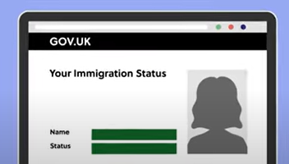 | 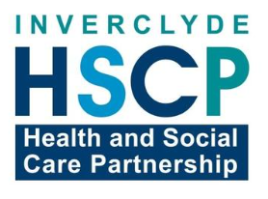  Housing  If you plan on living in Inverclyde, the New to Scotland or The Housing Options and Homeless Advice Service will help you find accommodation.  Housing Options and Homeless Advice Service  01475 715880  Housing Elsewhere  If you intend to move to another area, out with Inverclyde, please contact the below organisations for help:    Migrant Help    0808 8010 503  Scottish Refugee Council  0808 1967 274    Glasgow City Council  0141 222 7352    Edinburgh City Council  0131 200 2000 | Finances  You now have permission to claim  benefits and work in the UK.    Universal  Credit  Money on your ASPEN card will stop, and you will need  to make a claim for Universal Credit.  0800 328 5644  Bank Accounts  Universal Credit/other benefits will need  to be paid into a bank account, so you  will need to open one as soon as possible  and you can do this by visiting various banks.        

