**ESOL Courses**

# English for Speakers of Other Languages learning opportunities are available in YOUR local area FREE of Charge.

**Available to anyone living in the Inverclyde area aged 16+. We are offering FREE ESOL courses that will cover:**

* **ESOL support covering speaking, listening, reading and**

**writing**

* **Employability & ICT/computing support**

**Your English level will be assessed at your registration meeting. This is nothing to worry about. The**

**assessment is to make sure that you are placed in an appropriate learn-**

**ing session for your English level.**

**You will be given a short reading and writing test, there is no time limit**

**and you will be advised of your**

**English level as soon as the test is finished.**

**You can achieve an SQA certificate / accreditation as part of the course if required.**

**To register for ESOL courses contact CLD via Call: 01475 715450 or Email:** [**CLD.Admin@inverclyde.gov.uk**](mailto:CLD.Admin@inverclyde.gov.uk)

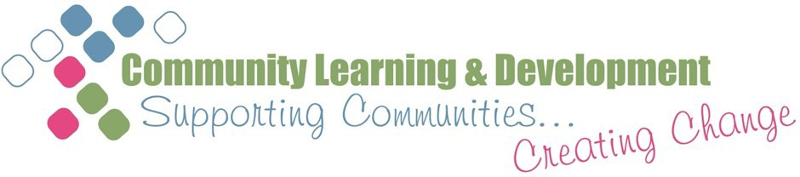

**What you can expect attending ESOL sessions?**

CLD offer two main services for those wishing to learn English in Inverclyde.



INTENSIVE ESOL COURSES

CLD offer up to 3 sessions per week of English consisting of 2 ESOL sessions and a Language in Practice (LIP) session. Learners can achieve an SQA qualification relevant to the level of the ESOL

provision. There are options for learners to be supported to attend college once you are ready. A minimum attendance of 90% of

classes is expected to keep your space on this course. Creche facili- ties will be available for some intensive courses. This service is run in 12 week blocks of learning starting in January, April and August.

If so, we are offering FREE ESOL

courses that will cover:

• Conversational ESOL

• Accreditation - SQA ESOL National Units & Core Skills

• Life in the UK & Citizenship

support

• Employability & general reading & writing support

SINGLE ESOL WEEKLY SESSIONS

For those that are unable to commit to the intensive ESOL courses. There will be options for you to learn at a pace that suits yourself as you may have other commitments. There will also be

opportunities to learn about ICT/Computing such as Microsoft Word, Internet and Email.

