








e-Learning Guidelines

August 2025

Contents

1. Getting started! 6

2. Popup Blocker 9

3. Audio Settings 11

4. Using e-Learning 13

5. Forgotten Password 16

6. What courses should I do? 22

Introduction
We want our staff to be skilled, motivated and driven to deliver excellent customer services to the residents of Inverclyde, which means that your continual learning and development is important to us.
This is why we offer e-Learning through a platform called Brightwave, which allows you to access over 300 courses on a range of topics for your own personal development. We also offer face to face training via the CourseBooker section on ICON.
Not only are you able to access these e-Learning courses from a computer desk at work, you can access these courses from the comfort of your own home from your laptop, tablet or smart phone. This booklet will give you a step by step guide on how you can do this.
One of the most important areas where you will see
e-Learning being used is in conjunction with your Positive Conversation. By reviewing your personal objectives and training needs with your line manager/supervisor, you will be able to work through the courses you need via Brightwave. As the Performance Appraisal process is designed around the Council’s Core Competencies, a guide has been created to assist with identifying relevant e-Learning topics to support each competency. This guide can be found on the Learning and Development page on ICON.
If you have any particular questions, please contact the Organisational Development Team on ext. 2740.

Who can use e-Learning?
Everyone can. If you do not have access to a PC at work, then you can log in at home using the link on Page 6. Otherwise, arrangements can be made for you to use the training suite
at Princess House at Port Glasgow, local libraries and/or St Stephen’s Enterprise Centre, when it is most convenient for you to use a PC to develop your skills.

When can you use e-Learning?
Bite size e-Learning courses (15 mins) are accessible during the working day but longer courses (90 mins) must be approved by your line manager. All courses are also accessible from your home computer using your unique employee number.
All training will be linked to your Positive Conversation objectives which your line manager/supervisor will cover with you.

What happens next?
Ask your line manager if you may access e-Learning at a time that suits your workload.
Some courses incorporate audio and video clips, therefore you need to use earphones to undertake these courses.
Once you complete an e-Learning course, it is logged against your employee number as your personal training record, and will be monitored to confirm completion against your Positive Conversation objectives.
If you are undertaking a course and decide to withdraw from it before completing, when you go back to it the system will remember where you left off, and provide you with the opportunity to start from there or go back to the beginning. In some instances though, if too much time has lapsed then you may not get this option, and you will have to restart the course from the beginning.
Some courses have certificates awarded on completion.

Getting started!

Registration

Step 1

Logging in at Work
Go to the Council’s ICON computer screen. Click on the ‘Learning & Development’ heading on the right hand side of the page.
Here you can choose between undertaking a face to face corporate training course by booking through Course Booker, or undertaking an e-Learning course of your choice at your desk, or from your computer at home.

Logging in at Home
If you are trying to access from home the link is as follows:
http://tracking.brightwave.co.uk/LNT/Inverclyde/Login.aspx

For this purpose, please click on e-Learning and you will be taken to the registration screen below.
Once you have opened up the e-Learning link, you will be taken to the registration screen below. If you are a first time user, there are a few steps you will need to go through.
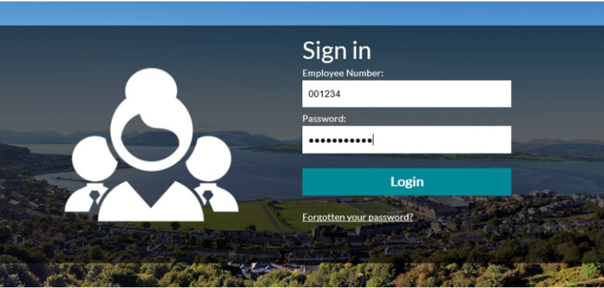
- Firstly, type in your employee number. This is on your payslip and Council ID card.
- Your employee number must be six digits, so make sure you add any necessary zero’s to the beginning of the number, as in the example above.
- Your password for your first log in is your last name. Make sure you use any appropriate capital letters,
i.e. Smith or McLean.

Step 2
You now need to register as a new user and change your password to something you will remember.

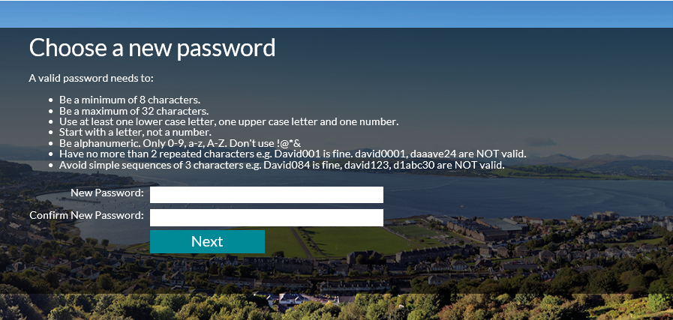

Step 3
Once you have registered your password, you will be asked to provide an answer to a memorable question. This is for security purposes and will help you reset the password should you forget it.

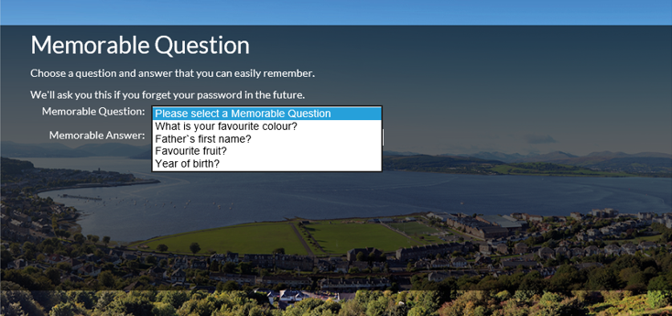

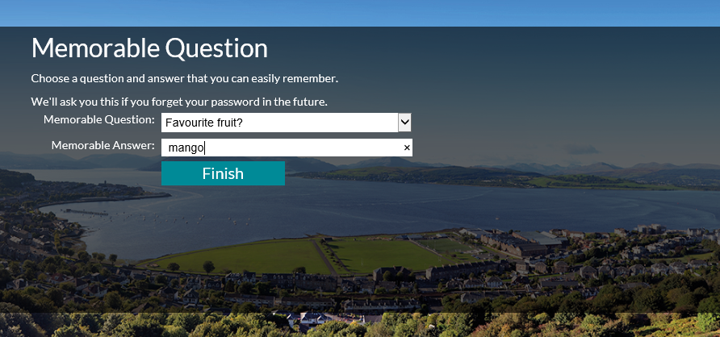

Select ‘finish’ and that is the registration process complete. Before you get started on your new course you need to turn off your popup blocker. The next section explains how to do this.

Popup Blocker
Before you get started you may need to turn off your popup blocker. If you don’t do this, your courses may not work properly and the following message may appear.



Steps
- To disable the popup blocker in Internet Explorer, click on the three dots in the top right-hand corner.
- Then click on more tools
- Then click on Internet Options
- Then untick the turn on popup blocker box
- Select Apply
Once you have done this, you will be able to start your courses. See the next page for screenshots of the above steps.

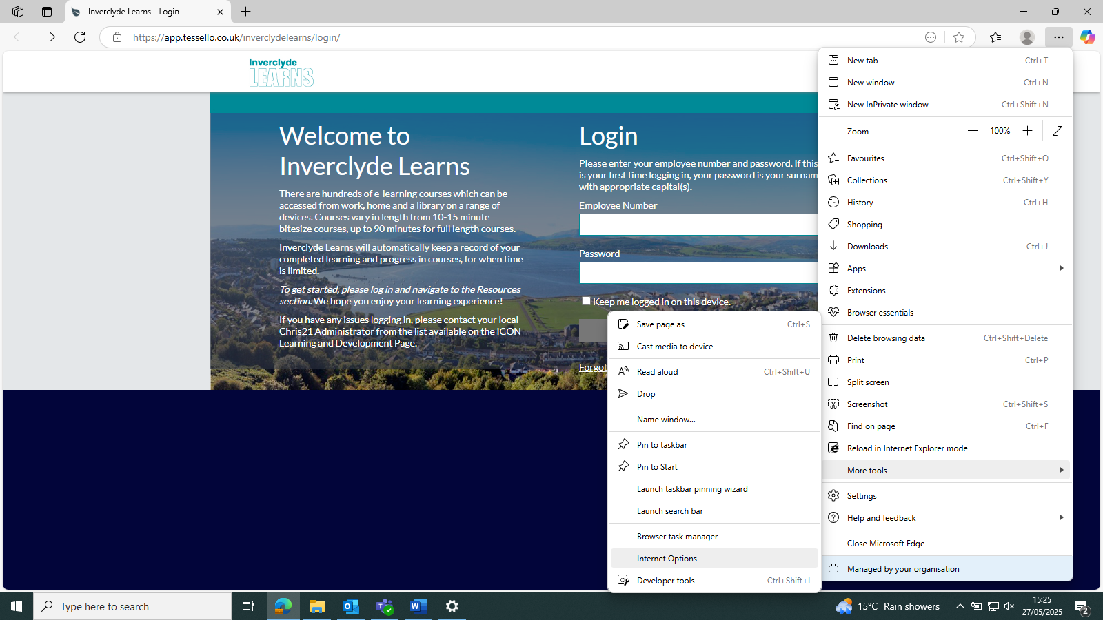

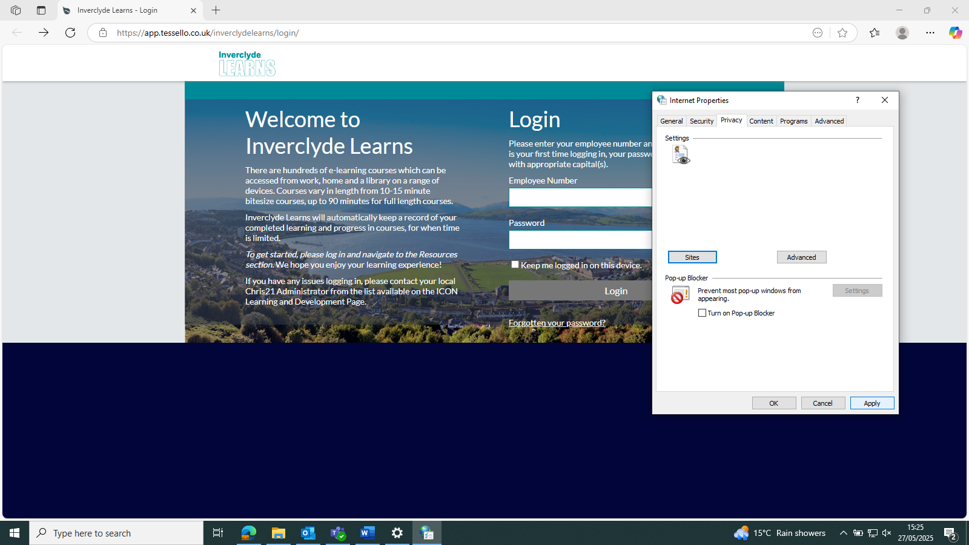

Audio Settings

Please note some courses contain audio. If you are not able to hear the audio using the Internet Explorer web browser, please try the following options:

Option 1 (*see screenshots on the next page)

- Click on the three dots in the top right-hand corner.
- Then select more tools
- Then select internet options
- Then select 'Advanced.'
- Scroll down until you find 'Multimedia' and select 'play sounds in webpage.'
- Select apply, then okay.
- Close the course and reload. The audio should now work.
- Please note that these settings will not be saved, so next time you log in you will need to apply the above settings again.
OR

Option 2
Open the course using the Edge or Google Chrome web browsers.

*Screenshots for Audio Settings, Option 1

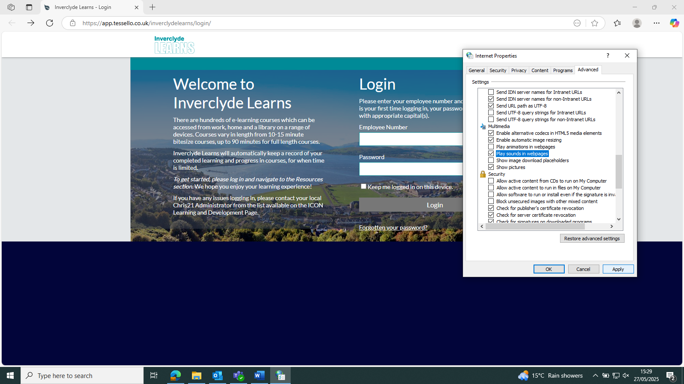

Using e-Learning

Step 1

This is the e-Learning home page.

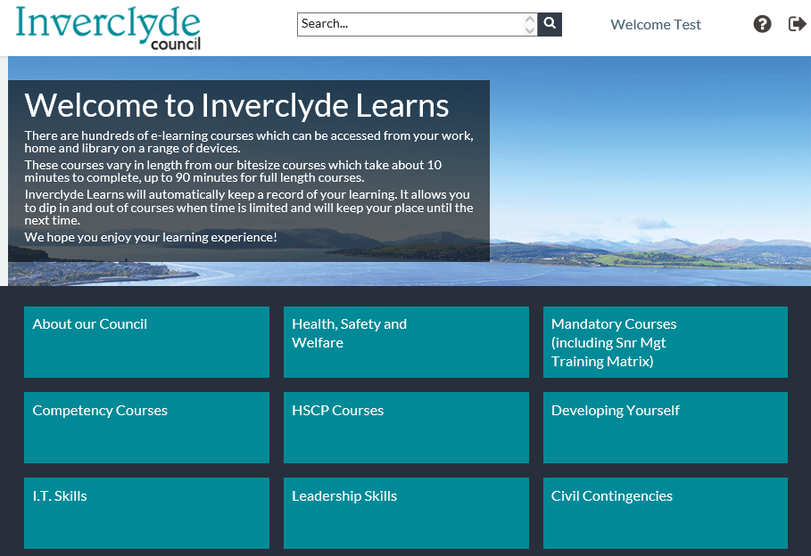

Step 2

Click on the box to open up a category

Each box on the home page represents a category of courses.

Step 3

Here we have opened up the Developing Yourself category. At the top, you will see a brief description of the types of courses in this category.
Below this, you will see a range of sub categories called Programmes.

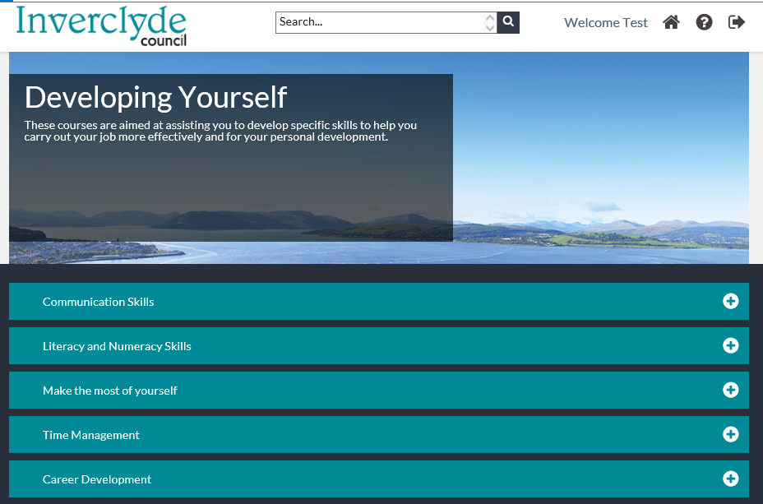
To go back a page, click the home icon.
Do not use the button as this will take you out to the password screen.

Click on the arrow to
see a list of all the courses available in this programme.

Step 4
Here we have opened up the Time Management programme.
You can now see all the courses which relate to managing your time.
To find out more information about a course, click the “I” button.

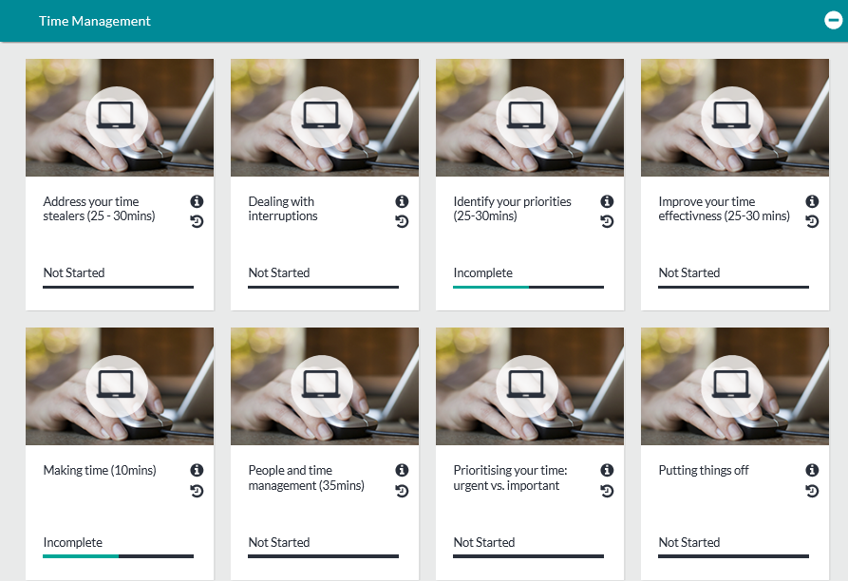
To view your history for each course, click on the clock button.
This bar will tell you if you have completed the course or not.

Step 5

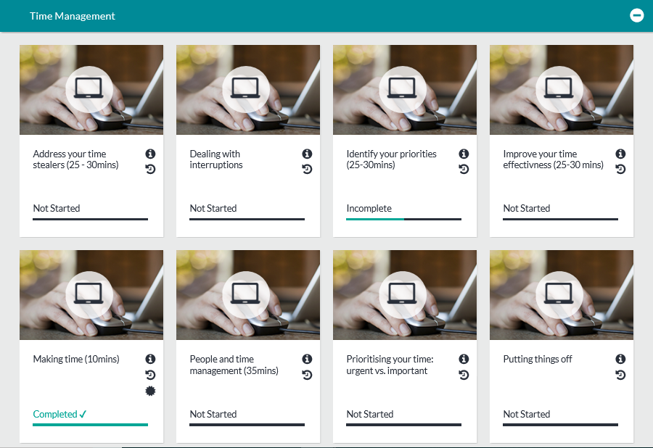
Some courses have certificates which you can print out for your training records. These courses are identified by the star button.

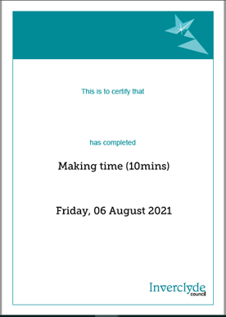

Joe Bloggs

Forgotten Password

For new users, password will be in a different format. Please use your surname, with appropriate capitals, upon first login (e.g., Smith / McDonald); username will still be Employee Number.

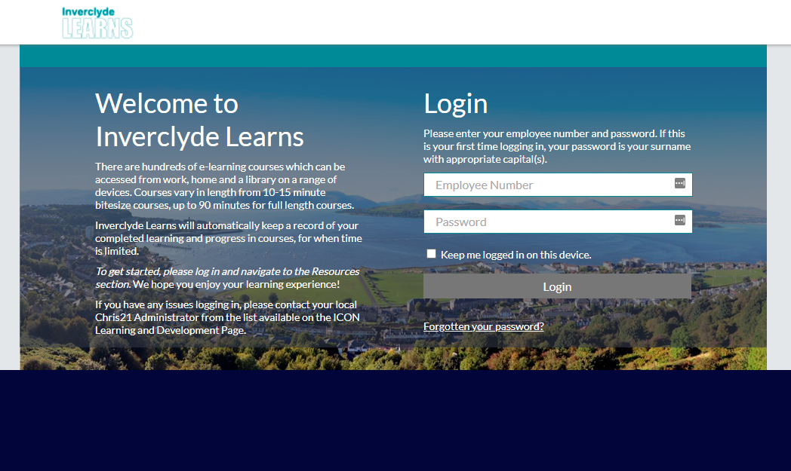

If an existing user has an email address setup on their account they can click the ‘Forgotten your password?’ link to reset their password.

They will need to enter their:
Employee number
Last name, and then select Next

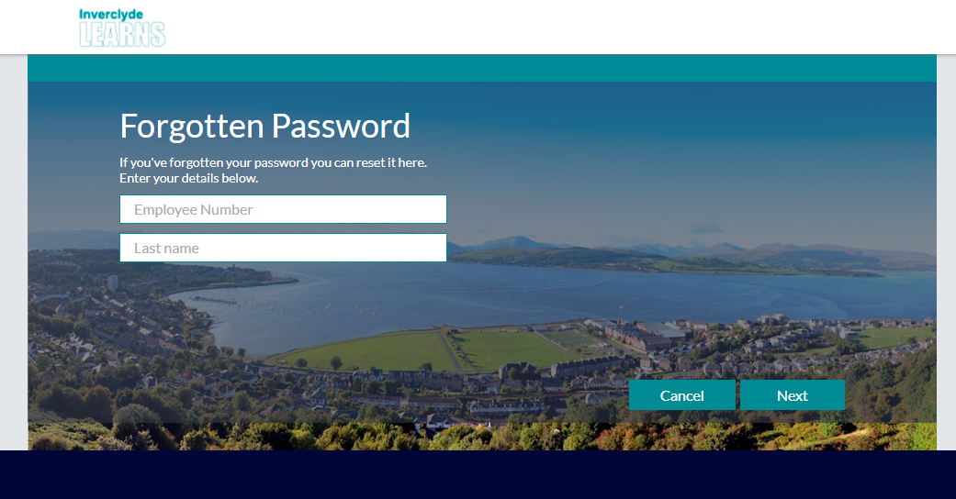

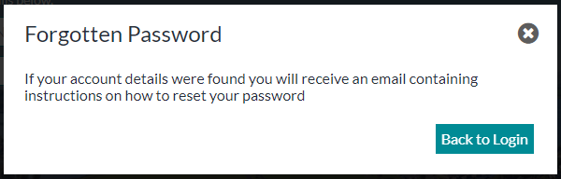

IMPORTANT: If the user enters their password incorrectly 3 times this will lock their account and they will need an Administrator to reset their password. The password will reset to the user’s surname with appropriate capital(s).

New Users: All new users will be asked to reset their password at this point, following the same instructions as below. From this point in the process, the guide is applicable to both existing and new users.

Create a new password, using the parameters specified on the screen.

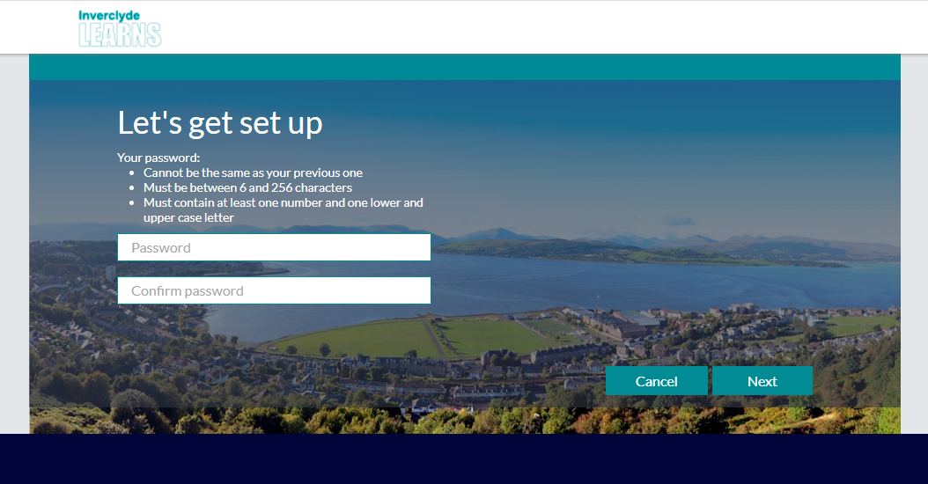

Select a new memorable question and answer.

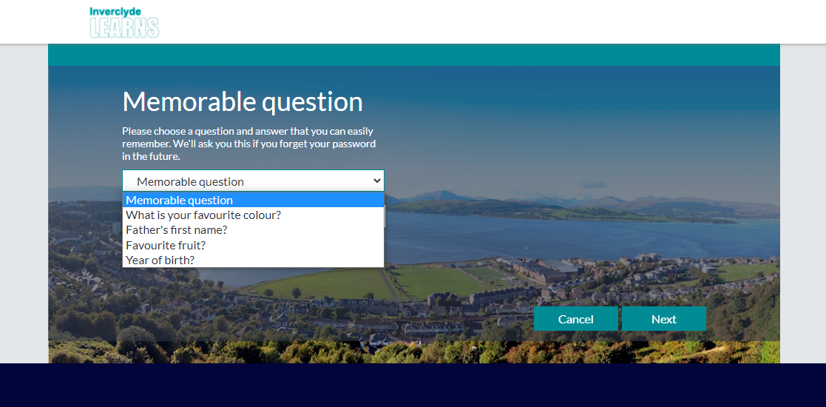

Read and accept the platform Terms of Use.

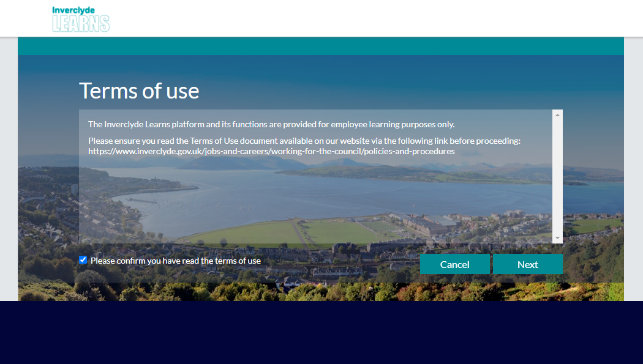

Read and accept the Privacy Agreements and select Finish.

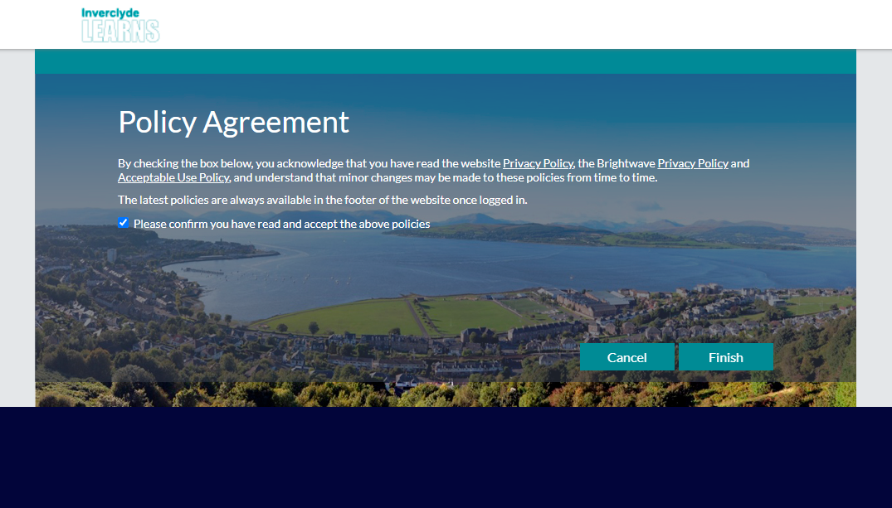

The user will then land on the Inverclyde Learns Homepage

What courses should I do?

The training matrix explains which courses emplyees should do and how frequently this should be refreshed. Many of these courses are availavle at e-learning. This includes mandatory courses appropriate to an employees role.

There are a wide range of other e-learning courses which, while not compulsory, will still benefit your learning and development.

Corporate Training Matrix  M - Mandatory  R – Recommended  AR - As Required |  | Training Delivery |  |  |  |  |  |  |  |  |  |  |  |  | Frequency
 |  |  | Elected Members | CO/Service Director | Head of Service | Service Manager | Team Leaders | Supervisors | Office Based Staff - Line Manager | Office Based Staff | Operational Staff - Access to pc | Operational Staff - non pc user | Volunteers | Consultants
General | Corporate induction | E-Learning | M | M | M | M | M | M | M | M | M | AR |  |  | New start induction
 | Cyber Security | E-Learning | M | M | M | M | M | M | M | M | M | AR | AR | AR | New start induction
 | Data Protection - GDPR | E-Learning | M | M | M | M | M | M | M | M | M | AR | AR | AR | New start induction
 | Health and Safety Induction (General) | E-Learning | M | M | M | M | M | M | M | M | M | AR | AR | AR | New start induction
 | Information Governance - An Introduction | E-Learning | M | M | M | M | M | M | M | M | M | AR | AR | AR | New start induction
 | Information Security (PC users) | E-Learning | M | M | M | M | M | M | M | M | M |  | AR | AR | New start induction
 | Display Screen Equipment (DSE) and Workstation Safety | E-Learning | M | M | M | M | M | M | M | M | M | AR | AR | AR | 2 yearly
 | Job Evaluation : Legislation | E-Learning |  | M | M | M | M | R |  |  |  |  |  |  | One off
 | Procurement Awareness | E-Learning |  | M | M | M | M | R |  |  |  |  |  |  | One off
 | Finance |  |  | M | M | M | AR |  |  |  |  |  |  |  | One off
Elected Members | Elected Members Induction | E-Learning | M |  |  |  |  |  |  |  |  |  |  |  | New start induction
 | Code of Conduct for Elected Members | E-Learning | M |  |  |  |  |  |  |  |  |  |  |  | New start induction
Managers Mandatory Courses | Supporting Employee Attendance | Blended : ecourse & face to face/teams |  | M | M | M | M | M | M |  |  |  |  |  | Full course once then 3 yearly refresher
 | Dignity & Respect, Discipline & Grievance | Blended : ecourse & face to face/teams |  | M | M | M | M | M | M |  |  |  |  |  | Full course once then 3 yearly refresher
 | Positive Conversations | E-Learning |  | M | M | M | M | M | M |  |  |  |  |  | Full course once then 3 yearly refresher
 | Recruitment & Selection | Blended : ecourse & face to face/teams |  | M | M | M | M | M | M |  |  |  |  |  | Full course once then 3 yearly refresher
 | Succession Planning | E-Learning |  | M | M | M | M |  |  |  |  |  |  |  | Full course once then 3 yearly refresher
 | Equality & Diversity Awareness | E-Learning |  | M | M | M | M | M | M | M | M | AR |  |  | Full course once then 2 yearly refresher
 | Records Management | E-Learning |  | M | M | M | M | M | M | M | M | AR |  |  | One off
 | Fire Safety Module | E-Learning |  | M | M | M | M | M | M | M | M | AR |  |  | 2 yearly
 | IOSH for Senior Executives | Face to Face |  | M | M | M | M |  |  |  |  |  |  |  | 5 yearly
 | Website Accessibility | E-Learning |  | M | M | M | M | AR |  |  |  |  |  |  | One off
Manager Desirable Courses | Customer & Service User Complaint Handling Procedure | E-Learning |  | R | R | R | R | R |  |  |  |  |  |  | Within 2 years of start
 | Corporate Risk Management | E-Learning |  | R | R | R | R | R |  |  |  |  |  |  | Within 2 years of start
 | Data Breach Training | E-Learning |  | R | R | R | R | R |  |  |  |  |  |  | Within 2 years of start
 | Data Protection - Impact Assessment Training | E-Learning |  | R | R | R | R | R |  |  |  |  |  |  | Within 2 years of start
 | Freedom of Information - Scotland | E-Learning |  | R | R | R | R | R |  |  |  |  |  |  | Within 2 years of start
 | Information Risk & Information Asset Management | E-Learning |  | R | R | R | R | R |  |  |  |  |  |  | Within 2 years of start
General Desirable Courses | Anti Bribery | E-Learning |  | R | R | R | R | R | R |  |  |  |  |  | Within 6 months of start
 | Anti-money laundering | E-Learning |  | R | R | R | R | R | R |  |  |  |  |  | Within 6 months of start
 | Recruitment Portal | E-Learning |  | R | R | R | R | R | R |  |  |  |  |  | Within 3 months of start
Specific | Some employees are required to undertake specific training and updates in order to fulfil their role. Such training may not be included within this Training Matrix; therefore the identification and fulfilling of these requirements remains the responsibility of the Manager.
 | Detail below specific courses employees should attend

Technical support contacts
ICT Servicedesk ext. 2345 servicedesk@inverclyde.gov.uk
Organisational Development & HR Team ext. 2740 human.resources@inverclyde.gov.uk or coursebooker@inverclyde.gov.uk
If you require further assistance, please contact your CHRIS21 administrator within your service who may be able to assist.
If you are unsure who this is, please see the list of contacts on the Learning and Development page on ICON: http://icon/hr/employee-development/learning-development/.

If they are unable to help, please contact ICT or HR.
We hope you enjoy these on-line learning opportunities.

More courses will continue to be developed through our joint working partnership with the Clyde Valley Training Consortium, to update and compliment the catalogue of courses provided.

Get in touch
Job ref 3775 e-Learning Designed by Corporate Communications
Phone: 01475 712740
Email: human.resources@inverclyde.gov.uk
Write to: Organisational Development,
Policy & Communications Inverclyde Council
Municipal Buildings Greenock Inverclyde PA15 1LX
www.inverclyde.gov.uk

