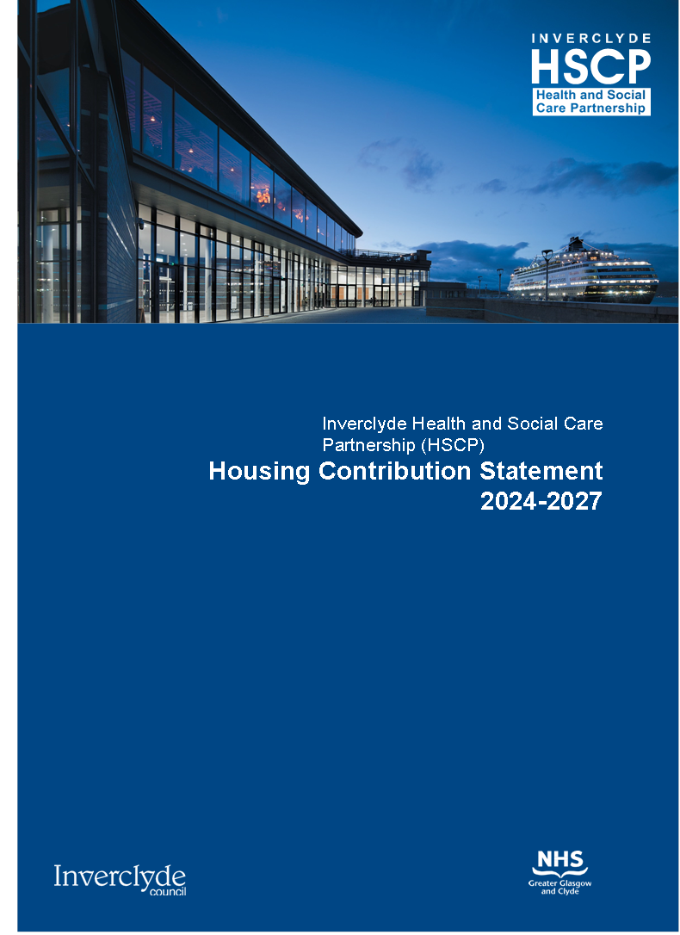

**Terminal**, Inverclyde’s new cruise ship visitor centre and community facility was officially opened on 25 August 2023. The project, led by Inverclyde Council, is part of the £1 billion Glasgow City Region City Deal funded by the Scottish and UK governments, with contributions from Peel Ports and the George Wyllie Foundation via Dunard Fund. The facility features an arrivals and departures hall, Scott’s restaurant and bar, and the Wyllieum, an exhibition and gallery space due to open in 2024, paying tribute to famous artist George Wyllie who worked in Greenock and lived in Gourock.

*Photo: David Barbour Photography*

**This document can be made available in other languages, large print, and audio format upon request.**

**Arabic**



**Cantonese**

8 Cantonese

**Gaelic**



**Hindi**



**Kurdisch**

Li ser daxwazê ev belge dikare bi zimanên din, çapa mezin, û formata dengî peyda bibe.

**Mandarin**

8 Mandarin

**Polish**



**Punjabi**

8 Punjabi

**Soraini**

ئەم بەڵگەنامەیە دەتوانرێت بە زمانەکانی تر و چاپی گەورە و فۆرماتێکی دەنگی لەسەر داواکاری بەردەست بکرێت.

**Tigrinya**

እዚ ሰነድ እዚ ብኻልእ ቋንቋታት፡ ብዓቢ ፊደላትን ብድምጺ ቅርጽን ምስ ዝሕተት ክቐርብ ይኽእል።

**Urdu**



**Ukrainian**

За запитом цей документ може бути доступний іншими мовами, великим шрифтом та аудіоформатом.

Contents

1. Introduction 4

2. Partnership Working and Governance 5

3. Shared Outcomes and Local Service Priorities 7

HSCP Strategic Commissioning Plan 7

Local Housing Strategy Vision 7

Community Justice Outcome Plan 8

4. Shared Evidence of Housing Needs 9

6. Housing Resources & Investment Summary 14

7. Action Plan 16

8. References 27

9. Glossary of Terms 28

# Introduction

As part of their duties to produce Strategic Commissioning Plans, all Integration Joints Boards must demonstrate how they have considered local housing needs for their service users. Suitable and appropriate housing is a key element in supporting individuals and families to maintain their health, wellbeing, and independence.

To demonstrate this, all IJBs are obligated to produce a Housing Contribution Statement (HCS) as part of their overall Strategic Commissioning Plans. These statements set out the working arrangements, shared resources, and aligned strategic priorities with local housing services and identify how they will work together to ensure adequate housing is available for all users of health and social care.

This Housing Contribution Statement will be a key part of the Integration Joint Board's (IJB) Strategic Plan.

This Inverclyde Housing Contribution Statement (HCS) has been developed in partnership with Inverclyde Housing Services and Inverclyde Health and Social Care Partnership. The statement acknowledges.

* people’s right to live at home or within a homely setting.
* that suitable, quality housing contributes to reducing health inequalities; and
* that housing successfully contributes towards the area’s repopulation, regeneration and economic growth objectives.

The Statement aims to ensure that people live in quality homes which are well connected to jobs and to thriving local communities which support positive health and wellbeing.

Housing has an important influence on health inequalities in Scotland through affordability, housing quality, fuel poverty, and the role of housing in community life. This Statement articulates the strategic links between Housing and Health and Social Care and highlights the shared outcomes and service priorities identified in the HSCP Strategic Commissioning Plan and the Local Housing Strategy (LHS) <https://www.inverclyde.gov.uk/assets/attach/16899/Inverclyde-Local-Housing-Strategy-2023-2028.docx>

### Background to Housing Contribution Statements

Housing Contribution Statements were introduced in 2013 and provided a link between the strategic planning process in housing at a local level and that of health and social care. It is a statutory requirement, set out in the Statutory Guidance and Advice note to support the Public Bodies (Joint Working) (Scotland) Act 2014. The guidance advises Integration Authorities, Health Boards and Local Authorities on their responsibility to involve Housing Providers to support the achievement of outcomes for Health and Social Care.

# Partnership Working and Governance

## Partnership Working

Inverclyde HSCP has a strong working relationship with Registered Social Landlords (RSLs) operating locally. There is a positive track record of collaboration between both organisations and strong representation on various local governance and strategic planning groups. This section identifies some of the key groups where the HSCP and Housing Services work together.

## Housing Groups

### Inverclyde Local Housing Strategy Steering Group

On the 2nd November 2023, Inverclyde Council’s Environment & Regeneration Committee approved the Inverclyde Local Housing Strategy 2023-2028. Approval was also granted for an LHS implementation strategy which determined that the steering group used to oversee LHS development is retained to oversee implementation. The objectives of this group are to:

* Track progress and measure impact via Local Housing Strategy monitoring and evaluation – LHS update reports.
* Ensure that Local Housing Strategy outcomes are linked effectively into other strategic plans across Inverclyde partnerships,
* Consider investment priorities and maximise shared resources,
* Exchange information and outcome data,
* Review outputs from monitoring updates and make recommendations to drive Local Housing Strategy action points which are off track.

This group has a wide membership including representation from the HSCP.

### 

### LHS Delivery Groups

Representatives from Inverclyde HSCP and Homelessness Services HSCP participate in all LHS Delivery Group’s when relevant, however have regular representation on delivery groups for LHS Outcome 2 and LHS Outcome 3 due to overlapping nature of objectives between the LHS and HSC. Each delivery group reports into the overall LHS Steering Group. The Inverclyde Registered Social Landlord (RSLs) are actively involved in all LHS Delivery Groups.

### Housing Partnership Group

Inverclyde has successfully established a multi-agency Housing Partnership Group (HPG) with responsibility for delivering on the actions contained within the HCS. The HPG has been instrumental in delivering on several actions of the HCS and have developed Local Housing Strategy (LHS) delivery groups with a focus on each of the four identified outcomes for the people of Inverclyde.

## HSCP Groups

### Strategic Planning Group (SPG)

The Public Bodies (Joint Working) (Scotland) Act 2014 requires that a Strategic Planning Group (SPG) be formed to oversee the production and implementation of the Strategic Commissioning Plan. The SPG is accountable to the Integration Joint Board (IJB).

To promote the Housing sector’s role in Health and Social Care integration, a representative from both the council’s Housing Strategy team and Inverclyde Housing Association Forum are included on the Health and Social Care Partnership’s SPG. In addition, there is a representative from the Inverclyde Housing Association Forum on the Integration Joint Board.

### Locality Planning Groups (LPGs)

Inverclyde HSCP has established two locality planning groups. These LPGs will provide a bridge between strategic planning, assessment of needs, and the coordination and development of services across their respective area. The localities have been defined by the SPG working in collaboration with partners and communities. It is anticipated the LPGs will complement the wider Community Planning Partnership (CPP) locality structures. We want to ensure a range of voices are heard; it is anticipated that representatives from the Housing Sector will be members of the LPGs as they develop along with our carers, HSCP professionals and out third, voluntary and independent sector.

We believe people are one of the most important assets in Inverclyde, we will collaborate closely with the people of Inverclyde and learn from their experience, we can more effectively support their health and improve how we deliver our services. We will continue to deliver and develop our two locality planning groups, having focused conversations in our communities about what matters most to our people.

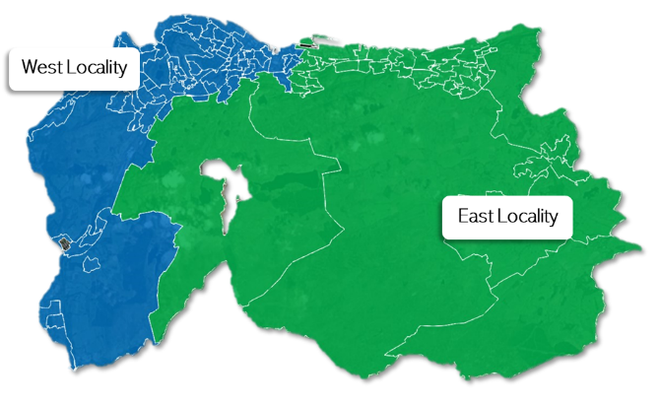

Our East locality covers the communities of Kilmacolm, Port Glasgow and East Greenock.

Our West locality covers Greenock Central, Greenock West, Gourock, Inverkip and Wemyss Bay.

# Shared Outcomes and Local Service Priorities

## HSCP Strategic Commissioning Plan

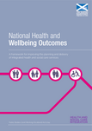The Nine National Health and Wellbeing Outcomes Supporting documents - National health and wellbeing outcomes framework - gov.scot (www.gov.scot) are relevant for all housing stakeholders working together to deliver on better Health and Social Care outcomes. The Inverclyde Health and Social Care Strategic Commissioning Plan details how we can best meet the national outcomes and continue our commitment to improving outcomes for the people of Inverclyde. The vision within the Strategic Commissioning Plan was created by the people of Inverclyde through our stakeholder engagement.

Inverclyde HSCP's vision is that:

***“Inverclyde is a compassionate community, working together to ensure people live active, healthy, and fulfilling lives.”***

Aligning with the national outcomes and addressing local concerns and values, the HSCP’s new Strategic Commissioning Plan (2024-27) identified four strategic priorities which it aims to achieve. Inverclyde HSCPs Strategic priorities are:

* Provide Early Help and Intervention.
* Improve support for Wellbeing and Recovery.
* Support Inclusive, Safe and Resilient Communities.
* Strengthen Support to Families and Carers.

Our strategic priorities compliment the LHS vision and places housing at the centre of strategic ambitions for Inverclyde including the objectives of the Inverclyde Alliance to grow the economy and population, regenerate communities and reduce inequalities.

## Local Housing Strategy Vision

Co-produced with LHS delivery partners, stakeholders, residents and communities, the 2023-2028 Local Housing Strategy vision for Inverclyde is that:

Vision for Inverclyde Local Housing Strategy:
Housing makes a strong contribution to ensuring Inverclyde is a place of choice, by delivering quality and affordable homes, a strong sense of community and a culture of wellbeing.

The LHS vision includes:

* a focus on housing led regeneration and place making to assist with repopulation and to ensure a holistic and collaborative approach to placemaking.
* a commitment to enhance the quality of housing choices by improving low demand housing stock.
* improving the range of housing options, making it easier for households to access affordable housing that meets their needs, particularly working age households.
* pursuing a collaborative approach to implementing preventative housing solutions that contribute positively to health and well-being.
* addressing housing disrepair and fuel poverty in Inverclyde to improve affordability and housing quality.
* To achieve this vision and realise the strategic ambitions of the Inverclyde Alliance Local Outcomes Improvement Plan (LOIP) <https://www.inverclyde.gov.uk/assets/attach/16435/6008-Inverclyde-Alliance-Partnership-Plan.pdf> and Inverclyde Economic Regeneration Strategy, the four Local Housing Strategy priorities have been defined:

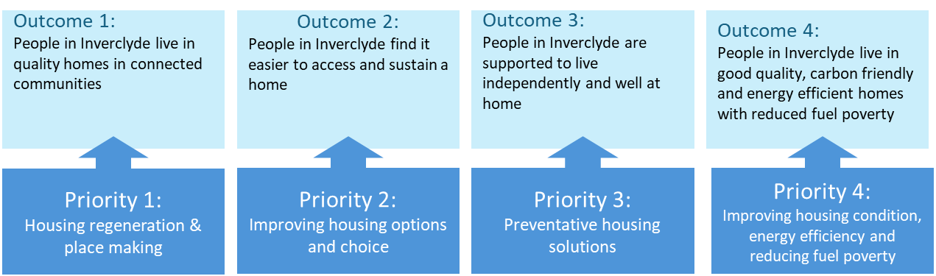

* Each LHS outcome will be delivered by focusing on the priority activities identified.
* The evidence, key issues and actions for each LHS outcome are set out in the new LHS. Guiding the delivery of the LHS are the principles set out by the Christie Commission on the Delivery of Public Services in Scotland. These include commitments to collaboration, efficiency, innovation, prevention, and tackling inequality.
* The Local Housing Strategy Steering Group will build on the strong partnerships already in place in Inverclyde, recognising that achieving the Local Housing Strategy outcomes will require a collective effort from delivery partners, stakeholders, communities, and the people of Inverclyde.

## Community Justice Outcome Plan

The draft Inverclyde Community Justice Outcome Improvement Plan (CJOIP) is built around the four national aims for Community Justice identified by the Scottish Government. However, locally the Inverclyde Community Justice Partnership identified a further local outcome:

**Improve Housing and Homelessness outcomes for individuals in the Justice System**

This local outcome will help ensure the effective implementation of the Sustainable Housing on Release for Everyone (SHORE) standards, as well as implementing other local actions to support those in the justice system to access and sustain an appropriate home.

# Shared Evidence of Housing Needs

The Housing (Scotland) Act 2014 [Housing (Scotland) Act 2014 (asp 14) (legislation.gov.uk)](https://www.legislation.gov.uk/asp/2014/14/enacted/data.xht?view=snippet&wrap=true) places a responsibility on local authorities to prepare a LHS that is supported by an assessment of housing need and demand.

The new draft Housing Need and Demand Assessment (HNDA3) helped us to inform the new LHS and set our Housing Supply Targets. This draft HNDA3 is in the process of being formally approved by the Centre for Housing Market Analysis. The following was taken from the local Housing Supply Target paper.

## Housing Supply Targets

The Housing Need and Demand Assessment (HNDA3) provides a statistical estimate of how much additional housing will be required to meet all future housing need and demand in the area. The housing estimates produced by the needs assessment provide the starting point for setting a Housing Supply Targets (HST) within the Local Housing Strategy. The Housing Supply Targets sets out the estimated level of additional housing that can be delivered on the ground and informs the definition of the Housing Land Requirement within the Local Development Plan.

|  |  |
| --- | --- |
| **Principle Scenario Projection of New Households** | |
| **Owner Occupation** | **0** |
| **Private Rent** | **0** |
| **Below Market Rent** | **0** |
| **Social Rent** | **180** |
| Total | 180 |

**Table 5.1: Glasgow City Region Housing Market Partnership – Housing Need and Demand Assessment 3**

Local Housing Strategy Guidance (2019) requires the Housing Supply Targets to take a policy view informed by the Housing Need and Demand Assessment estimate, of the number and type of dwellings that can realistically be delivered over the period of the Local Housing Strategy. The need assessment total estimate figure of 180 new homes over the next 19 years, is not considered to be a realistic starting point for setting Housing Supply Targets. In setting Housing Supply Targets, the need for housing investment to realise the Inverclyde’s wider ambitions for social and economic regeneration is essential. A bold ‘policy on’ approach to setting Housing Supply Targets which moves beyond demographic projections and reflects wider economic and placemaking strategies for Inverclyde is central to driving regeneration and has been the basis for setting the Housing Supply Targets.

Therefore, taking the Housing Need and Demand Assessment estimates, the Minimum All Tenure Housing Land Requirement and other economic and regeneration factors into account; an annual Housing Supply Targets for Inverclyde has been set at **187 units per annum** with a target of **75 affordable** dwellings per annum and **112 market** dwellings per annum between 2023-2028.

## Wheelchair Accessible Housing Policy

In 2019, the Scottish Government issued guidance to all local authorities requiring them to set LHS targets to support the delivery of more wheelchair accommodation across all housing tenures. Following a ‘Specialist Housing Review’ in Inverclyde a new Wheelchair Accessible Housing Policy was approved for inclusion in the Inverclyde Local Development Plan where the Council will seek the provision of 5% wheelchair accessible housing on new build development sites of 20 units or more. Furthermore, the Inverclyde Strategic Housing Investment Programme (SHIP) (2023- 2028) outlines the requirement that all new affordable housing developments are now required to provide wheelchair accessible housing.

Inverclyde is distinct in comparison to the other seven authorities that constitute the strategic planning authority for the Glasgow city region, Clydeplan <https://www.clydeplan-sdpa.gov.uk/> due to its declining population and this presents problems for predicting future housing requirements. Inverclyde’s Strategic Needs Assessment (SNA) was approved in 2022. It provides the HSCP Strategic Commissioning Plan with an evidence base for the underlying demographics and health and care needs of the Inverclyde population. The information is used to help shape the Strategic priorities and actions within the Strategic Commissioning Plan.

The table below sets out a housing profile summary for Inverclyde, outlining some of the headline factors that feature as part of the needs assessment. The data and information were taken from multiple sources including national datasets such as:

* Population and Households - National Registers of Scotland,
* Tenure profile - Scottish Government Housing Statistics (2019)
* Stock profile - Scottish House Condition Survey
* Income - CACI and Register of Scotland data (2018)
* House Price –Scottish Government Housing Statistics (House sale price) and
* UK House Price Index

*Figures are for the most recent year published and available.*

***Table 1: Summary Housing Profile***

|  |  |  |  |
| --- | --- | --- | --- |
| **Factor** | **Inverclyde** | **Analysis** | **National** |
| **Population** | Between 2022 and 2032, the population of Inverclyde is projected to continue to decline by 6% from 76,313 to 71,413 people | Although the population of Inverclyde is expected to decline over the next ten years, this is against the backdrop of an ageing population. Between 2022 to 2032 the older population is expected to grow as people live longer, whilst younger and working age populations are expected to decline. The working age population is projected to decrease by 15% between 2022 -2032 whilst the 65+ age cohorts will increase by 18% overall.  The declining working age population will have a major impact on the sustainability of local communities in Inverclyde. Undoubtedly, the reversal of economic decline and depopulation will depend on Inverclyde’s ability to attract and retain a working population. | There has been an increase in Scotland’s population of 1% over the same period. |
| **Households** | In 2021, there were an estimated 37,958 households living in Inverclyde, an increase of 3% since 2001. | This growth is significantly lower than the national rate | Households increased by 15% across Scotland over the same period. |
| **Tenure Profile** | Owner Occupation – 57%  Social Housing – 25%  Private Rented Sector – 13%  Empty Dwellings - 4% | There has been a 2% increase in private rented sector properties since the publication of the last LHS. | Owner Occupation – 59%  Social Housing – 23%  Private Rented Sector – 14%  Empty Dwellings - 4% |
| **Stock Profile** | Age profile of the current housing stock is new with 70% of dwellings in Inverclyde built after 1945.  54% of all dwellings in Inverclyde are flats with just 46% houses.  57% of dwellings in Inverclyde have up to two bedrooms | There is a major mismatch between the needs and aspirations of local households and the profile of homes available in Inverclyde. There is evidence of an oversupply of 2 and 3-bedroom homes, with low demand housing concentrated in tenemental stock. Low demand homes are also concentrated in the most disadvantaged communities in Inverclyde, with limited quality options for households in employment or who require larger family homes | 69% of housing in Scotland was built after 1945.  Inverclyde has a significantly higher proportion of flats than is the case in Scotland where 36% of dwellings are flatted.  The number of dwellings in Inverclyde which have up to two bedrooms is higher than Scotland (50%). |
| **House Price** | In 2020, the average house price in Inverclyde was £135,302.  House prices have grown steadily in Inverclyde over the last decade (by 28% overall) with growth slowing over the last 5 years at 17%. | Analysis of housing market affordability in Inverclyde reveals that homeownership is firmly out of reach to low-income households primarily driven by the income poverty experienced in the area. For households on lower incomes, housing affordability is particularly challenging with analysis revealing they must spend almost 6.5 times their income to purchase a home at the lower quartile price. | 40% lower than the Scottish average house price at £188,902. |
| **Income and Housing Cost** | The average income in Inverclyde is £31,165 per annum.  More than half of the Inverclyde population (53%) earn less than £25,000 per annum with lower quartile incomes of £12,827. | As part of the insight to inform the LHS, the Council conducted housing affordability analysis to test the value of local incomes to meet housing costs across a range of housing tenures. The analysis demonstrates the affordability pressures faced by local households when devoting 30% of household income to housing costs.  Analysis found that 39% of households cannot afford social rented housing. There is also clear evidence of affordability pressures in the Inverclyde PRS, with households on low to moderate incomes unable to afford market rents. A household requires to earn up to £23,450 to be able to afford the average PRS rent if they devote 30% of their income to housing costs. This is significantly beyond lower quartile incomes in Inverclyde (£13k). | Average incomes in Inverclyde are 21% below the Scottish average of £37,767. |

# Key Issues and Challenges Summary

It is acknowledged that the extent and nature of housing challenges faced by Inverclyde are in many ways unique. As a result, some national policy and funding mechanisms will not work in the Inverclyde context. To address this, the Local Housing Strategy sets out a range of ambitious and tailored solutions within an outcome delivery framework that enables ongoing collaboration across local and national government, public bodies and third sector agencies.

For the Inverclyde area, there are a unique set of challenges when compared to the rest of Scotland including depopulation, a rapidly declining working age population, high levels of empty properties and areas of low housing demand. These are interlinked with the need for physical regeneration aligned to economic growth strategies and improvements in health and wellbeing. It is therefore vital that the vision and priorities contribute towards delivering some of the major strategic objectives of Inverclyde.

Informed by resident feedback and housing system analysis, partners and stakeholders came together to define the major barriers that should be overcome in the Inverclyde Local Housing Strategy to enable housing-led regeneration and promote placemaking. Key local challenges which drive the need for future partnership, investment and delivery activity include the following:

* Image highlighting the local key issues for housing:
  1. The Scottish Government's policy focus which provides greater funding for new build housing than investment in regenerating existing housing,
  is problematic for Inverclyde.

  2. New build social housing activity places existing loAsw demand housing stock at further risk.

  3. Future affordable housing delivery programmes should focus on wheelchair accessible and adapted housing to meet the needs of households with health and disability issues.

  4. As well as housing investment in low demand stock; placemaking, environmental improvements and community development activity will be key components in building a set of regeneration masterplans in Inverclyde.

  5. Engaging owners in mixed tenure investment projects has been problematic in trying to advance regeneration.

  6. Creating opportunities to encourage commercial development is central to attracting and retaining working age households in Inverclyde as is addressing the lack of intermediate housing tenures for those not eligible for social housing.
  

# Housing Resources & Investment Summary

Scheme of assistance/Private Sector Housing Grants

|  |  |  |  |  |  |
| --- | --- | --- | --- | --- | --- |
| **Year** | **Number of Adaptations** | **Spend** | **Care and Repair Costs** | **Small Repairs Costs** | **Total Costs** |
| **£000s** | **£000s** | **£000s** | **£000s** |
| 20/21 | 133 | 493 | 89 | 40 | 622 |
| 21/22 | 162 | 603 | 89 | 40 | 732 |
| 22/23 | 128 | 560 | 90 | 40 | 690 |

|  |  |
| --- | --- |
| **Year** | **Budget** |
| **£000s** |
| 23/24 | 840 |
| 24/25 | 853 |

Note - Although the budget for aids and adaptations is delegated to the IJB, spend an operational management are carried out by the Council’s Public Protection Service as part of the Scheme of Assistance

Homelessness budget

|  |  |
| --- | --- |
|  | **2023/24** |
| **Objective heading** | **£000s** |
| Employee Costs | 1,087 |
| Property Costs | 352 |
| Supplies & Services | 43 |
| Transport & Plant Costs | 5 |
| Administration Costs | 72 |
| Client Commitments | 218 |
| Payments to Other Bodies | 218 |
| Income | (-764) |
|  | **1,231** |

There is currently a temporary Rapid Rehousing support team in place which has become an essential component of the housing options and homelessness service advice service. Located within the Inverclyde Centre, the team is accessible to those in need, fostering strong early-stage relationships for those hardest to reach, via collaboration with Registered Social Landlord's and being the consistent point of contact for any tenancy concerns. The team supports continuity after housing is secured helping to maintain tenancies. A review of the overall homelessness service is under way to ensure the service is future proofed and providing the best service for the residents of Inverclyde.

Rapid Rehousing Transition Plan

RRTP funds and one-off earmarked funding being used towards delivering Housing First approach wrap around support.

|  |  |
| --- | --- |
|  | **£000s** |
| Carry forward from 22/23 | 180 |
| Funding for 23/24 | 44 |
| **Total planned spend over 23/24 and 24/25** | 224 |

Support for people New to Scotland

Housing support for refugees arriving via resettlement schemes is provided via non -recurring funding from the Home Office for arrivals in Inverclyde. This includes supporting people into permanent accommodation in the area through work with Registered Social Landlord's, provision of furniture and white goods as required and support from staff within the New to Scotland team, to establish themselves in a tenancy, and with wider integration into the local community. There is similar provision for those arriving from Ukraine funded by Scottish Government which includes the Homes for Ukraine funding provided directly to Registered Social Landlord's to improve voids which are then ringfenced for Ukrainian nationals. There is no funding provided by Home Office for asylum seekers within hotel or dispersed accommodation who receive positive decisions. The New to Scotland team support includes access to health, education, social security benefits, English language provision and social connections/ activities.

Housing support budgets within other services of the HSCP

|  |  |  |
| --- | --- | --- |
|  | **2022/23 spend** | **2023/24 budget** |
|  | **£000s** | **£000s** |
| Older People | 4 | 0 |
| Physical Disability | 159 | 302 |
| Learning Disability | 3,841 | 3,717 |
| Mental Health | 708 | 1,007 |
| Neil Street Project | 412 | 428 |
| Addiction Services | 289 | 346 |
| Homelessness | 120 | 80 |
|  | **5,534** | **5,880** |

* The figure above is for supported living and housing support so may include some costs of care.

|  |  |  |  |  |
| --- | --- | --- | --- | --- |
|  |  |  |  |  |

# Action Plan

A robust action plan has been agreed to progress the Local Housing Strategy. Actions are aligned to each of the four Outcomes in the LHS. It has been agreed at the wider Housing Partnership Group that relevant actions to be included within the Housing Contribution Statement could be adopted directly from the LHS Action plan.

This approach will remove any duplication in activity and reporting.

Listed below are the key actions within the Local Housing Strategy action plan that relate to HSCP need and demand.

**LHS Outcome 2: People in Inverclyde find it easier to access and sustain a home.**

|  |  |  |  |  |
| --- | --- | --- | --- | --- |
| Action No. | Action(s) and Commitments for Outcome Delivery | Sub Actions | Target/ End Point | Action Lead/ Co-ordinator |
| 2.2. | Improve advice, assistance, and access to the Private Rented Sector including the rent deposit guarantee scheme, financial advice and information on rights and responsibilities | 1. Review of information, advice, and support materials to households in or seeking Private Rented Sector housing | 2024 | Private Rented Sector Officer |
| 1. Improve and market information, advice, and support services to PRS tenants | 2025 | Private Rented Sector Officer |
| 2.4 | Transform the temporary accommodation model in Inverclyde to provide more community-based tenancies with support and decommission the Inverclyde Centre. | 1. Quantify demand and implement suitable temporary accommodation model to meet demand for specific groups (victims of domestic abuse, care experienced young people, refugees, MAPPA and prison leavers) | 2026 | Housing Options Service |
| 1. Develop decommissioning plan for Inverclyde Centre | 2025 |
| 1. Improve dispersed accommodation acquisition Plan in conjunction with Registered Social Landlords Partners | 2025 |
| 2.5 | Deliver 'wraparound’ housing support models for households experiencing multiple and severe disadvantage | 1. Develop rapid rehousing support team to meet the needs of households experiencing severe and multiple disadvantage. | 2024 | Housing Options Service |
| 1. Quantify demand and enhance the provision of supported accommodation for households experiencing severe and multiple disadvantage. | 2026 |
| 1. Develop personal housing plan process in partnership with HSCP Resource Group | 2024 |
| 2.6 | Continue to provide housing and support to asylum seekers and refugees as part of the Inverclyde Alliance repopulation strategy | 1. Review Local Housing Strategy objectives and Inverclyde Population Strategy to improve alignment. | 2024 | Housing Strategy  Repopulation Officer  Housing Options  Service |
| 1. Integrate Local Housing Strategy Delivery Group with Refugee Integration Team | 2024 |
| 1. Ongoing engagement across Registered Social Landlords partners to identify opportunities to support resettlement. | Ongoing |
| 1. Review capacity and effectiveness of housing and support model aligned to resettlement proposals | 2025 |
| 1. Improve our understanding of the housing and related support needs of ethnic minority groups and others who experience disadvantage and inequality, including asylum seekers and refugees | 2028 |
| 2.7. | Develop a collaborative housing options model in Inverclyde based on consistent advice, needs assessment, referrals and case management tools for all frontline staff and services engaging with people at risk of homelessness | 1. Provide universal housing options advice and assistance model and optimise support assessment tools. | 2024 | Housing Options  Service |
| 1. Develop multi-agency referral and consent to share framework. | 2024 |
| 1. Develop case management model to enable coordinated partner interventions. | 2024 |
| 1. Promote housing options advice and information across public sector bodies aligned to delivery of new ‘Ask and Act’ duty. | 2024 |
| 1. Multi-agency roll-out of Housing Options Training Toolkit | 2025 |
| 2.8 | Develop capacity to deliver the right intensity of person-led housing support which prevents homelessness and enables tenancy sustainment | 1. Improve awareness and access to housing support services for households at risk of homelessness. | 2024 | Housing Options  Service |
| 1. Develop housing support planning tools and reporting frameworks. | 2024 |
| 1. Develop multi-agency case management model which enables resettlement and housing sustainment | 2025 |
| 2.9. | Ensure that the housing needs of  individuals in prison are addressed  consistently and at an early stage by fully implementing and embedding  the Sustainable Housing on Release for  Everyone (SHORE) standards across Inverclyde (National Strategy for Community Justice- Scottish Government:2022) | 1. Improve the reliability of data between Inverclyde Council and Registered Social Landlords with respect to the admissions of Inverclyde residents into SPS custody and liberations from SPS custody. | 2024 | Community Justice |
| 1. Engage with local housing providers and Scottish Prison Service on current issues around SHORE implementation in Inverclyde. | 2024 | Community Justice |
| 1. Support the Scottish Government in the creation of a standardised template to deliver a more collaborative and consistent approach to housing options advice and support. | 2025 | Community Justice |
| 1. Consider the local implications on refreshed national SHORE standards and implications for the policy in Inverclyde. | 2025 | Community Justice |
| 1. Commence the Inverclyde SHORE standards policy for Inverclyde including revised indicators and measures. | 2026 | Community Justice |
| 1. Embed SHORE standards in Inverclyde. | 2026/27 | Community Justice |
| 2.10 | Continue to improve housing outcomes across a range of measures for young people, including care leavers and young adults with complex needs | 1. Map housing and support needs of young people, including previously looked after children, to identify gaps in insight and baseline needs assessment. | 2026 | Housing Strategy  HSCP Children’s Services  Registered Social Landlords |
| 1. Review care pathways for care experienced young people and young adults with complex needs. | 2026 |
| 1. Develop processes and procedures to plan housing outcomes for young adults based on their housing need. | 2026 |
| 1. Ensure consistent approach to identifying and planning for housing needs of young adults across Inverclyde. | 2026 |
| 1. Review Young People’s Housing Strategy and develop updated strategy. | 2026 |

**LHS Outcome 3: People in Inverclyde are supported to live independently and well at home.**

|  |  |  |  |  |
| --- | --- | --- | --- | --- |
| Action No. | Action(s) and Commitments for Outcome Delivery | Sub Actions | Target/ End Point | Action Lead/ Co-ordinator |
| 3.1 | Build on the existing success from the River Clyde Homes ‘Wellbeing at Home’ developments and consider the feasibility of extending this model further. | 1. Two additional Wellbeing at Home complexes to be delivered 1/4/25. | 2025 | HSCP Health & Community Care |
| 1. RG and SMcL to provide narrative. | 2025 |
| 1. Evaluate the impact and potential improvements | 2025 |
| 3.2 | Develop specialist housing evidence bases for inclusion within the local development plan. | 1. Review specialist housing evidence bases and local/ national policies. | 2026 | Housing Strategy |
| 1. Review existing wheelchair accessible housing targets across all tenures in Inverclyde, success of the policy and determine future requirements. | 2026 |
| 1. Review national datasets in relation to specialist housing in Inverclyde and outline projections. | 2026 |
| 1. Undertake new data analysis of specialist housing need in Inverclyde and project estimations of housing need in Inverclyde. | 2026 |
| 3.3 | Develop good practice guides for housing design and support models that meet the needs of a range of client groups and carers including dementia, autism, learning disability | 1. Carry out desk-based research to identify opportunities for client group friendly housing | 2027 | Housing Strategy |
| 1. Investigate opportunities for existing and new stock in Inverclyde to support such client groups. | 2027 |
| 1. Implement dementia-friendly housing design standards | 2027 |
| 1. Ensure visual impairment design standards are met. | 2027 |
| 1. Use evidence base to support local Registered Social Landlord to deliver upgrade work which supports people with a wide range of needs to maintain independence. | 2027 |
| 3.4 | Project future investment requirements which arise from an aging population with growing needs for property adaptations and improve evidence for funding adaptations through enhance information sharing | 1. Carry out research evaluation of the projected future needs of Inverclyde’s aging population and identify future unmet needs. | 2027 | Housing Strategy |
| 1. Develop and implement information sharing protocols to evidence the evaluation work. | 2027 |
| 1. Estimate future investment requirements and report on costed options to meet the needs for future property adaptations. | 2027 |
| 3.5 | Maximise the use of assistive technology including telecare, telehealth and wearable tech to enable people with particular housing needs to live independently and well at home | 1. Share knowledge of assistive technology in use, its uptake and its effectiveness. (through Registered Social Landlords managers visiting demonstrator house on annual basis) | 2027 | HSCP Integrated Technology Service |
| 1. Cascade this information downwards to housing officers and other practitioners | 2027 |
| 1. Include these actions into the HSCP Digital Strategy | 2027 |
| 3.6 | Work in partnership with legal services to develop and improve information sharing protocols on pipeline need for specialist housing to ensure early planning and commissioning across housing, health and care partners | 1. Develop and implement data sharing arrangements and GDPR (General Data Protection Regulation) protocols | 2024 | Housing Strategy  Public Protection |
| 1. Analyse requirements across the partners, including information gaps | 2024 |
| 1. Develop data sharing partnership and processes to assess current and future specialist housing requirements. | 2024 |
| 1. Develop reporting mechanisms to ensure best use of data insights. | 2024 |
| 1. Develop shared evidence base | 2024 |
| 3.7 | Increase tenure choice for older people by encouraging the delivery of intermediate and market housing options. | 1. Carry out research to understand current and future housing options for older people and investment requirements across tenure. | 2028 | Housing Strategy |
| 1. Explore delivery of Intermediate Housing and Shared Ownership opportunities through Affordable Housing Policy | 2028 |
| 1. Deliver older persons housing through Registered Social Landlords newbuild programmes. | 2028 |
| 1. Improve access to older person housing through development of proactive housing advice and information. | 2028 |
| 3.8 | Review and update the Registered Social Landlords Acquisition programme and processes for purchasing specialist housing. | 1. Review of specialist housing acquisition processes. | 2026 | Housing Strategy |
| 1. Identification of specialist housing requirements in Inverclyde | 2026 |
| 1. Update the Inverclyde Acquisition Programme and Strategy accordingly as per the findings of the 2025 review. | 2026 |
| 1. Implement targeted programme of property acquisitions in partnership with Registered Social Landlords | Ongoing |
| 3.9 | Review provision of site requirement and services for gypsy/ travellers in Inverclyde. | 1. Review existing draft Policy and Procedural Guidelines on the Management of Unauthorised Encampments by Gypsy/Travellers in Inverclyde | 2028 | Housing Strategy |
| 1. Review existing data sources in relation to gypsy/ travellers (local, regional and national) to determine housing requirements of this group. | 2028 |
| 1. Update and finalise draft Policy and Procedural Guidelines on the Management of Unauthorised Encampments by Gypsy/Travellers in Inverclyde. | 2028 |
| 1. Publish findings of review, including recommendations on future requirements for the Gyspy/ Travellers community in Inverclyde. | 2028 |
| 3.10 | Review armed forces covenant and Registered Social Landlords allocation policies to ensure the housing requirements of the Armed.  Forces Community have fully been accounted for | 1. Review armed forces covenant. | 2025 | Housing Strategy  Registered Social Landlords |
| 1. Review Registered Social Landlords allocation policies. |
| 1. Update Registered Social Landlords allocation policies accordingly. |

# References

Equalities Act - <https://www.legislation.gov.uk/ukpga/2010/15/contents>

Fairer Scotland Duty - <https://www.gov.scot/publications/fairer-scotland-duty-guidance-public-bodies/>

Inverclyde Alliance Local Outcomes Improvement Plan (LOIP) <https://www.inverclyde.gov.uk/assets/attach/16435/6008-Inverclyde-Alliance-Partnership-Plan.pdf>

Inverclyde HSCPs Strategic Commissioning Plan – [HSCP Strategies, Policies and Plans - Inverclyde Council](https://www.inverclyde.gov.uk/health-and-social-care/strategies-policies-and-plans)

Inverclyde’s Local Housing Strategy – [HSCP Strategies, Policies and Plans - Inverclyde Council](https://www.inverclyde.gov.uk/health-and-social-care/strategies-policies-and-plans)

Locality Planning Group - <https://www.gov.scot/publications/localities-guidance/documents/>

Public Bodies (Joint Working) (Scotland) Act 2014 - Public Bodies (Joint Working) (Scotland) Act 2014: statutory guidance - gov.scot (www.gov.scot)

Nine National Health and Wellbeing Outcomes Supporting documents - National health and wellbeing outcomes framework - gov.scot (www.gov.scot)

The Housing (Scotland) Act 2014 [Housing (Scotland) Act 2014 (asp 14) (legislation.gov.uk)](https://www.legislation.gov.uk/asp/2014/14/enacted/data.xht?view=snippet&wrap=true)

Population and Households - National Registers of Scotland [Home | National Records of Scotland (nrscotland.gov.uk)](https://www.nrscotland.gov.uk/)

Scottish Government Housing Statistics (2019) - <https://www.gov.scot/publications/housing-statistics-scotland-2019-key-trends-summary/documents/>

Stock profile - Scottish House Condition Survey <https://www.gov.scot/publications/scottish-house-condition-survey-2021-key-findings/documents/>

Income - CACI AND Register of Scotland data (2018)

House Price –Scottish Government Housing Statistics (House sale price)

UK House Price Index [UK House Price Index (data.gov.uk)](https://landregistry.data.gov.uk/app/ukhpi/?lang=en)

# Glossary of Terms

|  |  |
| --- | --- |
| **CJOIP** | Community Justice Outcome Plan |
| **CPP** | Community Planning Partnership |
| **HCS** | Housing Contribution Statement |
| **HDNA** | Housing Need and Demand Assessment |
| **HPG** | Housing Partnership Group |
| **HSCP** | Health and Social Care Partnerships |
| **HST** | Housing Supply Target |
| **IJB** | Integration Joint Board |
| **LDP** | Local Development Plan |
| **LHS** | Local Housing Strategy |
| **LOIP** | Local Outcomes Improvement Plan |
| **LPG** | Locality Planning Group |
| **PRS** | Private Rented Sector |
| **REGISTERED SOCIAL LANDLORDS** | Registered Social Landlord |
| **SHIP** | Strategic Housing Investment Programme |
| **SHORE** | Sustainable Housing on Release for Everyone |
| **SNA** | Strategic Needs Assessment |
| **SPG** | Strategic Planning Group |