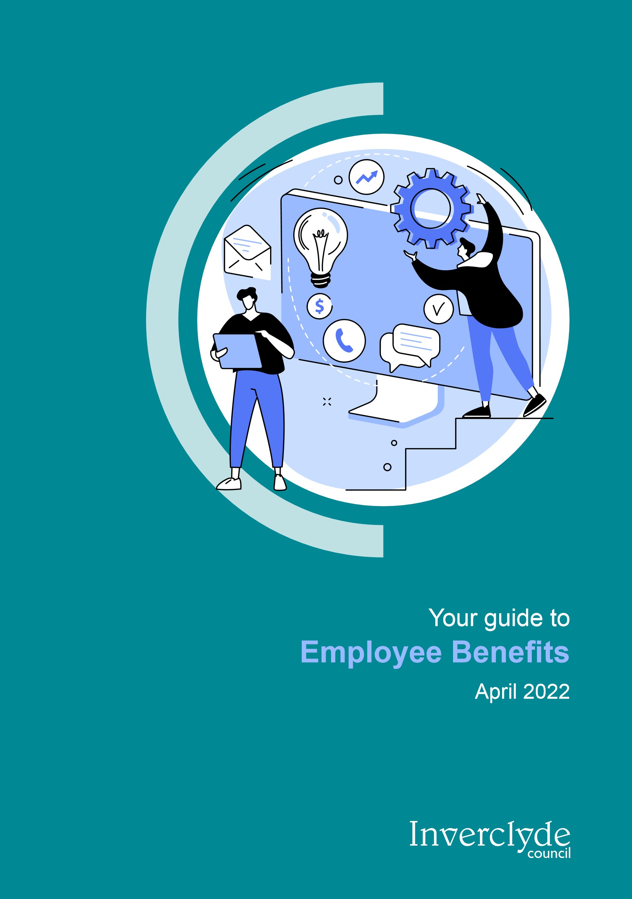

# Introduction

At Inverclyde Council, we recognise that our employees are our most valuable asset. This booklet is designed to provide an overview of all of the benefits available to you as an Inverclyde Council Employee.

Benefits offered by the Council include excellent terms and conditions of employment, discounts at a range of local companies, pension schemes, eye test reimbursement, cycle to work scheme, work life balance and flexi-time opportunities, a range of discounts through the Kaarp employee benefits scheme, occupational health support, car mileage scheme, saving schemes and a thorough learning and development programme - to name a few!

# Buying and Banking Leave Scheme

The Buying and Banking Leave Scheme is part of a wider package of benefits aimed at enabling employees to achieve a healthy work-life balance as follows;

* To give employees greater flexibility and choice over how and when they take their holidays (must be agreed in advance of the relevant holiday year commencing);
* To promote a culture of work-life balance;
* To align the taking of holidays with the needs of each service.
* To enable employees to purchase holidays through two windows a year

Further information can be found in the Buy and Bank Leave Policy.

# Terms and Conditions

## Holiday entitlement

Inverclyde Council offers excellent terms and conditions for all employees. The holiday entitlement for local government employees is up to 33 days per year depending on the length of service.

In addition, local government employees will receive seven days fixed public holidays, which include Christmas Day, Boxing Day, 1st of January, 2nd of January (or the following working day, if these holidays are on Saturday or Sunday), and also Good Friday, Easter Monday, and May Day Holiday. For more information please refer to the Conditions of Service Document.

Teachers annual leave provisions are in accordance with Part 2 Section 5 of the SNCT handbook.

# Salary Protection

The Council has a salary protection policy that currently protects the salary of permanent employees redeployed into a post which is graded lower than the employees previous salary, as a result of organisational change, any pay protection is on a cash conserved basis for one year.

Conservation for teachers is in accordance with Part 2 Section 1 of the SNCT handbook.

# Continuous Service

Many new employees to Inverclyde Council come to us from other local authorities and public sector organisations. If this is the case then service from previous organisations will be recognised for the purpose of enhancing certain statutory entitlements such as annual leave, maternity pay, sickness allowance and redundancy pay.

# Relocation and Repopulation Packages

The Council wishes to encourage its employees to live within the Inverclyde area in order to promote population and economic growth. Relocation expenses will therefore be applicable where an employee moves into the Inverclyde area.

Further information is available from Organisational Development and Human Resources (OD & HR).

# Living Wage Employer

Inverclyde Council is a Living Wage accredited employer and applies the Living Wage as the first point of our pay scale to ensure all employees are paid the real Living Wage. This currently exceeds the National Minimum wage and the National Living Wage for workers over 23 years old. For more information please visit **www.livingwage.org.uk**.

# Health and Wellbeing

## Free Eye Examination

Standard eye examinations are free in Scotland however the free eye exam does not cover the requirements of work related DSE test. Therefore, an eye examination, which will be paid for by the Council, will reveal whether there is any defect of sight which may adversely affect your ability to carry out work at a visual display unit. The Council will provide you with a voucher which can be taken to any Specsavers Optician. This will entitle you to an eye examination in relation to your work and contribution towards corrective eyewear if required for work.

## Cycle to Work Scheme

This scheme is a government approved salary sacrifice initiative allowing you to hire a bike and accessories for up to £1000 for the purpose of cycling to work (or part of the journey). The hire is free of Tax and National Insurance. Keep an eye on ICON for information on the next launch date of the scheme alternatively contact OD & HR on 01475 712740.

## Occupational Health Support

Inverclyde Council offers a generous sickness benefit scheme which gives you up to a maximum of six months full pay and six months half pay in the event of illness. This is subject to qualifying criteria. In addition, the occupational health service offers support to people with long term sickness, a musculoskeletal condition, or a stress-related condition. Based on the occupational specialist’s report, reasonable adjustments in the work place will be made in order to enable the employee to return to work as soon as possible.

## Healthy Working Lives

This scheme is strongly supported by the Scottish Government and it helps to improve health, safety and wellbeing at

Inverclyde Council in a structured and productive way. Inverclyde Council and HSCP currently hold the Gold Award for this initiative!

All activities which are organised to maintain the Healthy Working Lives Gold award are promoted to everyone via ICON and service contacts who distribute to their teams who do not have access to ICON on a regular basis.

You can find out more information on Healthy Working Lives here: **www.healthyworkinglives.scot**.

# Learning and Development

Our e-learning platform, Brightwave, has been developed over time by the Organisational Development team alongside the Clyde Valley Training Consortium and it provides a wide variety of e-learning courses.

We want our staff to be skilled, motivated and driven to deliver excellent customer service to the residents of Inverclyde. This means your continual learning and development is important to us. You can learn through on-the-job training, face-to-face courses and e-Learning.

You can book yourself on to any of our face-to-face courses via the CourseBooker on ICON. The corporate course planner is updated every six months. Also, you can also access all e-learning courses from the comfort of your own home on a laptop, PC, tablet and/or smart phone. For more information on all of the above please see the Learning and Development page on ICON or contact your line manager.

One of the most important areas where you will see our training programmes being used is in conjunction with your Performance Appraisal. Your manager and you will indicate areas for improvement and create systematic plans for your personal and professional development.

# Financial Benefits

## Pension Scheme

Inverclyde Council offers a generous pension scheme to both local government and teaching employees.

The local government pension scheme is administered by the Strathclyde Pension Fund and Inverclyde Council currently contributes 19.3% pensionable pay to your pension account.

For teachers the Scottish Teachers’ Superannuation Scheme (STSS) is administered by the Scottish Public Pension Agency and Inverclyde Council currently contributes 23% pensionable pay to your pension account.

Other benefits include tax-free lump sums in exchange for some of your pension, death in service protection etc. Further details are available on ICON or from OD & HR.

## Car Mileage Allowance

Inverclyde Council is a small local authority area, so you’ll be pleased to know that your job will not require an excessive amount of driving. However, if you do require to use your car for business purposes you will be reimbursed in the form of a mileage allowance.

## Savings and Investments

As an Inverclyde employee, you have the option of joining the Scotwest Credit Union. Scotwest serves the employees working for public service organisations and Colleges of Further Education within the West of Scotland and their families. It has over 19,000 members, and is now one of the largest Credit Unions in the UK.

## www.scotwest.co.uk

Employees can also access independent financial advice, through our providers, Blythswood Associates.

**www.blythswood.co.uk**

# Local Discounts

There are fantastic discounts available to Inverclyde Council employees at the following places;

* **Waterfront Cinema** Reduced tickets prices on Thursdays and Tuesdays
* **Inverclyde Leisure** 50% off initial joining fee for all memberships
* **Inverclyde Physiotherapy** £5 off all physiotherapy appointments
* **Duo Menswear, Gourock** 5% discount, earned via customer rewards scheme
* **Twice New Clothes, Greenock** 10% Discount off purchases on Thursdays and Saturdays (excluding sale items)
* **Kilted Kin, Greenock** 10% discount off any purchase, including jewellery (excludes hires and sale items)
* **My Kitchen, Gourock** 10% discount off total food bill, valid for groups up to 8 people
* **Pampered Pets, Greenock** 10% off full grooms for all dog breeds
* **Opal Hair, Greenock** £10 discount on colour services and

£5 off cut and blow-dry services

* **JD Gyms, Greenock** Use of gym free of charge for one day
* **Copperbox Boutique, Greenock** 10% discount on in-store purchases (online discount available through email, details on website)
* **Vodafone** Access to their Employee Advantage Scheme offering a range of discounts and offers, for more information sign up via their website
* **Hilton Hotels** Up to 25% off leisure breaks and best available rates at participating UK, Ireland and continental

European hotels as well as 15% off Hampton by Hilton Hotels

**For full range of local discounts** visit the local discounts page on Icon (http://icon/employee-benefits/local-discounts/)

# Other Discounts

**Kaarp** is a web-based discount site which you can access at:

## www.kaarp.co.uk

(User Name: INVERCLYDE Password: BENEFITS).

A number of discounts and offers are available here including:

* Discounted theme park entry and days out vouchers. E.g. Alton Towers, Edinburgh Dungeons.
* Special deals on private medical care, travel insurance etc.
* Money off fitness supplies and spa break vouchers.
* Fantastic deals on hotels and car hire.
* Deals for shops including Currys, The Hut, Letterbox Gifts, Kind Clothing, etc.

# Further Information

Information relating to all employee benefits is available on ICON; **http://icon/employee-benefits**

All policies and procedures mentioned in this booklet are on ICON; **http://icon/hr/policy-a-z**

If you have any questions regarding employee benefits you can discuss them with your line manager.

The OD and HR team are also here to advise you, so if you would like to speak to them directly you can call them on 01475 712740. Employees without access to ICON please contact your manager or OD & HR for further information on any of the benefits listed.

**Get in touch**

**Phone:**

01475 712740

**Email:**

human.resources@inverclyde.gov.uk

**Write to:**

Organisational Development,

Policy & Communications

Inverclyde Council

Municipal Buildings

Greenock

Inverclyde PA15 1LX

**www.inverclyde.gov.uk**